AWS Certified

Solution Architect Associate

* Sony Shrestha

Table of Contents

AWS Global Infrastructure 22

Availability Zone 22

Region 23

Edge Location 23

Regional Endpoints 23

AWS Local Zone 23

AWS Wavelength 23

Regional Edge Cache 24

How to choose an AWS Region? 24

Global and Regional Services 25

Global Services 25

Regional Services 25

IAM (Identity and Access Management) 26

Introduction 26

Features 26

How can users access AWS? 26

AWS Management Console 26

AWS CLI 27

AWS SDK 27

Authentication methods 27

Identities 27

Access 27

Users 28

Groups 28

Roles 29

Policies 29

Introduction 30

Types of policies 30

IAM Policies Structure 31

Example IAM Policy 32

IAM Policy Conditions 33

IAM Policy for S3 35

IAM Permission Boundaries 35

IAM Roles vs Resource Based Policies 36

IAM – Security 36

MFA (Multi-Factor Authentication) 36

Password Policy 37

IAM Security Tools 37

IAM Credential Report 37

IAM Access Advisor 37

IAM Best Practices 37

IAM Policy Evaluation Logic 38

Determination Rules 38

IAM Policy Simulator 39

AWS Security Token Service (STS) 39

CloudShell 40

Billing 41

Billing Information 41

Budget 42

Budget Types 42

EC2 (Elastic Cloud Compute) 43

Introduction 43

EC2 Configuration Options 43

EC2 User Data and Metadata 43

Instance Metadata Query 44

EC2 Instance type 44

Security Group 45

Classis Ports to know 45

SSH Summary 46

Amazon Machine Image (AMI) 46

EC2 in real world 47

Methods to access EC2 instance 47

EC2 Pricing Model 48

On demand 48

Spot 48

Reserved Instance 49

Dedicated Hosts 49

Dedicated Instance 49

Savings Plan 50

EC2 Lifecycle 51

How to terminate Spot Instance? 52

Spot Block 53

Spot Fleet 53

EC2 Fleet 54

Features of EC2 54

Elastic Load Balancing 54

EC2 Autoscaling 54

EC2 Status Check and Monitoring 54

EC2 Placement Groups 55

Cluster Placement Groups 55

Spread Placement Groups 56

Partition Placement Groups 57

EC2 Hibernate 58

EC2 Nitro 58

EC2 - vCPU 58

EC2 - Optimizing CPU options 58

EC2- Capacity reservation 59

Public IP vs Private IP vs Elastic IP 59

Network Interfaces (ENI, ENA, EFA) 60

ENI (Elastic Network Interface) 60

ENA (Elastic Network Adapter) 61

EFA (Elastic Fabric Adapter) 61

Block and File Storage 62

EBS (Elastic Block Storage) 62

Introduction 62

EBS Snapshot 62

AMI 63

EBS Volume Types 64

EBS Multi-Attach 65

Migrate EC2 volume 65

EBS Encryption 65

Encrypt an Unencrypted EBS volume 65

Encrypted Root Device Volumes and Snapshots 66

Copying and Sharing AMIs and Snapshots 66

RAID with EBS 68

DLM (Data Lifecycle Management) 68

EC2 Image Builder 68

EC2 Instance Store 69

EBS vs Instance Store 69

Amazon Elastic File System (EFS) 69

Amazon FSx 70

Introduction 70

Amazon FSx for Windows File Server 70

Amazon FSx for Lustre 70

FSx File System Deployment Options 71

AWS DataSync 71

AWS Storage Gateway 71

Introduction 71

Types of Gateway 72

AWS Storage Gateway Summary 73

Amazon FSx File Gateway 74

AWS Backup 74

AWS Storage Options 74

Scalability, High Availability and Load Balancing 75

Scalability 75

High Availability 75

Load Balancing 75

Elastic Load Balancer 75

Introduction 75

ELB – Features 76

Types of Load balancer 77

Health Check 78

Path Patterns 79

Session State and Session Stickiness 79

Session State 79

Session Stickiness 79

Cross Zone Load Balancing 80

Cross-Zone Load Balancing with respect to Load Balancer 80

SSL/TLS 81

Introduction 81

Load Balancer - SSL Certificates 81

SNI- Server Name Indication 81

Introduction 81

Elastic Load Balancers- SSL Certificates wrt SNI 81

Connection Draining 82

Auto Scaling Group 82

Introduction 82

AutoScaling Policies 83

ASG - Monitoring 83

ASG - Custom Metric 83

ASG - Scaling Cooldowns 84

ASG - Termination Policy 84

ASG - Termination Protection 84

Good Metrics to scale on 84

Lifecycle Hooks 84

Standby State 85

Launch Template vs Launch Configuration 85

Databases 86

Relational vs Non-Relational 86

Operational vs Analytical 86

RDS 87

Introduction 87

Advantages over using RDS versus deploying database on EC2 87

Backups 87

Maintenance Windows 88

Storage Auto Scaling 88

Read Replicas 88

Multi-AZ (Disaster Recovery) 89

Difference between RDS Multi-AZ and Read Replicas 89

RDS - from Single AZ to Multi AZ 90

RDS - Security Network and IAM 90

RDS - IAM Authentication 90

RDS - Security Encryption 90

RDS - Encryption Operations 91

RDS - Database Ports 91

Amazon RDS Anti-Patterns and Alternatives 91

RDS for Solutions Architect 92

Aurora 93

Introduction 93

Key Features 93

Aurora DB Cluster 94

Serverless 94

Backups 94

Fault Tolerance 95

Aurora Replicas vs MySQL Replica 95

Aurora - Multi-Master 96

Aurora - High Availability and Read Scaling 96

Aurora - Security 96

Aurora Replicas- Auto Scaling 96

Aurora - Custom Endpoints 96

Global Aurora 96

Aurora Machine Learning 97

Aurora for Solutions Architect 97

ElastiCache 98

Introduction 98

ElastiCache - DB Cache 98

ElastiCache - User Session Store 98

Redis vs Memcached 99

Redis Use Case 99

Scaling ElastiCache 100

ElastiCache - Cache Security 101

Patterns for ElastiCache 102

ElastiCache for Solutions Architect 102

Route 53 103

DNS Terminologies 103

Parts of Fully Qualified Domain Name 103

Domain Registrars 103

Introduction to Route 53 104

Records 104

CNAME vs Alias 105

Route 53 – Hosted Zones 106

Route 53 - TTL 106

Route 53- Alias Records Targets 106

Routing Policy 107

Routing Policy- Simple 107

Routing Policy- Weighted 107

Routing Policy- Latency-based 107

Routing Policy- Failover 107

Routing Policy- Geolocation 108

Routing Policy- Multi-value 108

Routing Policy- Geoproximity 108

Route 53- Traffic flow 108

Route 53 - Health Checks 109

Health Checks - Monitor an Endpoint 109

Health Checks - Calculated Health Checks 109

Health Checks- Private Hosted Zones 109

Migrate to/from Route 53 109

Route 53 Resolver 110

Domain Registrar vs DNS Service 110

3rd Party Registrar with Amazon Route 53 110

Elastic Beanstalk 111

Introduction 111

Components 111

Supported Platforms 111

Use case 111

Amazon S3 112

Introduction 112

S3 - Cross Account Access 113

S3 - Versioning 113

S3 - Encryption 113

SSE-S3 114

SSE-KMS 114

SSE-C 114

Client-Side Encryption 114

Encryption in transit (SSL/TLS) 114

S3 - Security 114

IAM Policies, Bucket Policies and Access Control List 114

S3 Security - Other 115

S3 - Bucket Policies 115

Authorization Process 115

S3 Websites 116

S3 - CORS (Cross Origin Resource Sharing) 116

S3 - Consistency Model 117

MFA with Amazon S3 117

S3 - MFA Delete 118

S3 - Default Encryption 118

Default Encryption vs Bucket Policies 118

S3 - Access Logs 119

S3 - Replication (CRR and SRR) 120

S3 - Pre-signed URLs 120

S3 Charges 120

S3 Storage Classes 120

S3 Standard 121

S3 Intelligent Tiering 121

S3 Standard- Infrequent Access 121

S3 One Zone- Infrequent Access 122

S3 Glacier 122

S3 Glacier Deep Archive 122

S3 Lifecycle Rules 124

S3 Lifecycle Scenarios 125

S3 Analytics - Storage Class Analysis 125

S3 - Baseline Performance 125

S3 - KMS Limitation 126

S3 - Multi-Part upload 126

S3 - Byte-Range Fetches 126

S3 - Transfer Acceleration 127

S3 - Copy API 127

S3 Select and Glacier Select 127

S3 Event Notifications 128

S3 Requester Pays 128

S3 Object Lock and Glacier Vault Lock 129

S3 Object Lock 129

Glacier Vault Lock 129

Retention Period 130

Legal holds 130

S3 for Solutions Architect 130

Amazon Athena 131

Introduction 131

Optimizing Athena for Performance 132

Athena for Solutions Architect 132

AWS CloudFront 133

Introduction 133

CloudFront vs S3 Cross Region Replication 134

CloudFront - Origins 134

CloudFront - Geo Restriction 135

CloudFront - Signed URL/Signed Cookies 135

CloudFront – Pricing 136

CloudFront - Multiple Origin and Path Pattern 136

CloudFront - Origin Groups 136

CloudFront - Field Level Encryption 137

CloudFront - Origin Access Identity (OAI) 137

Caching based on Request Headers 137

Unicast IP vs Anycast IP 138

AWS Global Accelerator 139

Introduction 139

Similarities between CloudFront and Global Accelerator 139

Difference between CloudFront and Global Accelerator 139

Snow Family 140

Introduction 140

Snow Families 140

Snowcone 140

Snowball and Snowball Edge 141

Snowmobile 141

Edge Computing 141

Introduction 141

Snow Family - Edge Computing 142

AWS OpsHub 142

Solution Architecture: Snowball into Glacier 142

AWS Transfer Family 143

Decoupling Applications 144

Patterns of application communication 144

Decoupling your applications 144

SQS (Simple Queuing Service) 145

Introduction 145

SQS - Queue Types 145

SQS - Standard Queue 145

SQS - FIFO Queue 145

Ordering data into SQS 146

SQS - Security 146

SQS - Queue Access Policy 146

SQS - Message Visibility Timeout 147

SQS - Dead Letter Queue 147

SQS - Delay Queue 148

SQS - Long Polling 148

SQS - Request-Response Systems 149

SQS with Auto Scaling Group (ASG) 149

SNS (Simple Notification Service) 150

Introduction 150

SNS - How to publish 150

SNS - Security 151

SNS - FIFO Topic 151

SNS - Message Filtering 151

SNS + SQS: Fan Out 152

Application: S3 Events to multiple queues 152

SNS FIFO + SQS FIFO: Fan Out 152

Kinesis 153

Introduction 153

Components of Kinesis 153

Kinesis Data Streams 153

Kinesis Data Firehouse 154

Kinesis Data Analytics 155

Kinesis Data Streams vs Firehouse 155

Ordering data into Kinesis 155

SQS vs SNS vs Kinesis 156

Amazon MQ 157

Introduction 157

MQ - High Availability 157

Containers on AWS 158

ECS 158

Introduction 158

ECS Launch Type 158

IAM Roles with ECS 159

Load Balancing for EC2 Launch Type 159

ECS tasks invoked by Event Bridge 160

ECS Scaling 160

ECS Rolling Updates 161

Fargate 163

Introduction 163

IAM Role with Fargate 163

Load Balancing for Fargate 163

Data Volumes - EFS File Systems 163

Amazon EKS (Elastic Kubernetes Service) 164

Serverless Services 165

Lambda 166

Introduction 166

Lambda Pricing 167

Lambda Functions Invocations 167

Lambda Functions Concurrency 167

Lambda limits to know – per region 168

Lambda@Edge 168

Amazon DynamoDB 169

Introduction 169

Features of DynamoDB 169

Basics of DynamoDB 170

DynamoDB Accelerator (DAX) 170

DAX vs ElastiCache 170

DynamoDB - Read/ Write Capacity Modes 170

DynamoDB - Streams 171

DynamoDB - Global Tables 171

DynamoDB – Time To Live (TTL) 172

DynamoDB – Indexes 172

DynamoDB – Transactions 172

DynamoDB - Security 172

On-Demand Backup and Restore 173

Point-in-Time Recovery (PITR) 173

DynamoDB for Solutions Architect 173

AWS API Gateway 174

Introduction 174

API Gateway Deployment Types/ Endpoint Types 174

Edge-Optimized Endpoint 174

Regional Endpoint 174

Private Endpoint 174

API Gateway – Caching 175

API Gateway – Throttling 175

API Gateway – Usage Plans and API Keys 175

API Gateway – Security 175

IAM Permissions 175

Lambda Authorizer (formerly Custom Authorizers) 176

Cognito User Pools 176

API Gateway – Security (Summary) 176

Same Origin Policy 177

CORS (Cross Origin Resource Sharing) 177

AWS Cognito 178

Introduction 178

Components of AWS Cognito 178

AWS Cognito - User Pools (CUP) 178

AWS Cognito - Federated Identity Pools 178

AWS Cognito Sync 179

AWS SAM (Serverless Application Model) 180

Redshift 181

Introduction 181

Redshift – Backups 181

Redshift – Pricing 181

Redshift – Security 182

Redshift – Availability 182

Redshift – Snapshots and Disaster Recovery 182

Loading data into Redshift 182

Redshift Spectrum 183

Redshift for Solutions Architect 183

Glue 184

Neptune 185

Introduction 185

Neptune for Solutions Architect 185

ElasticSearch/ OpenSearch 186

Introduction 186

ElasticSearch for Solutions Architect 186

CloudWatch 187

Introduction 187

CloudWatch Metrics 187

Introduction 187

EC2 Detailed Monitoring 187

CloudWatch Custom Metrics 188

CloudWatch Dashboards 188

CloudWatch Logs 188

Introduction 188

CloudWatch Logs – Metric Filter & Insights 188

CloudWatch Logs – S3 Export 189

CloudWatch Logs – Subscriptions 189

CloudWatch Logs - Aggregation Multi-Account and Multi-Region 189

CloudWatch Logs for EC2 189

CloudWatch Logs Agent and Unified Agent 189

CloudWatch Alarm 190

Introduction 190

CloudWatch Alarm Targets 190

EC2 Instance Recovery 190

CloudWatch Alarm - Good to know 191

CloudWatch Events 191

Introduction 191

Amazon EventBridge 192

Introduction 192

Amazon EventBridge Schema Registry 192

Amazon EventBridge vs CloudWatch Events 192

AWS CloudTrail 193

Introduction 193

CloudTrail Events 193

Management Events 193

Data Events 193

CloudTrail Insight Events 194

CloudTrail Events Retention 194

AWS Config 195

Introduction 195

Config Rules 195

AWS Config Resources 196

Config Rules – Remediation 196

Config Rules – Notifications 197

STS (Security Token Service) 198

Introduction 198

Using STS to Assume a Role 198

AWS Organizations 204

Introduction 204

Benefits of AWS Organizations 204

Multi Account Strategies 204

Organizational Units (OU) 205

SCP (Service Control Policies) 205

SCP Hierarchy 206

AWS Organization- Moving Accounts 206

AWS Resource Access Manager (RAM) 208

Introduction 208

RAM - VPC Example 209

AWS Single Sign-On (SSO) 210

Introduction 210

Encryption 211

Types of Encryption 211

Asymmetric Encryption 211

Symmetric Encryption 211

Encryption in flight (SSL) 211

Server-Side encryption at rest 211

Client-Side Encryption 212

AWS KMS (Key Management Service) 213

Introduction 213

Use case 213

Data Encryption Keys 213

Types of CMKs 214

Symmetric vs Asymmetric CMK 214

Copying Snapshots across regions 215

KMS Key Policies 215

Copying Snapshots across accounts 216

KMS Automatic Key Rotation 216

KMS Manual Key Rotation 216

KMS Alias Updating 217

SSM Parameter Store 218

Introduction 218

SSM Parameter Store Hierarchy 218

Standard and advanced parameter tiers 219

Parameter Policies 219

Sample Password Policies 219

Retrieve parameters stored 220

Retrieve parameters stored using lambda function 221

AWS Secret Manager 222

Introduction 222

AWS Secrets Manager vs SSM Parameter Store 222

CloudHSM 223

Introduction 223

CloudHSM – High Availability 223

KMS vs CloudHSM 223

AWS Shield 225

Introduction 225

AWS Shield Standard 225

AWS Shield Advanced 225

AWS WAF (Web Application Firewall) 226

Introduction 226

AWS Firewall Manager 227

Introduction 227

GuardDuty 228

Introduction 228

Amazon Inspector 229

Introduction 229

Amazon Macie 230

Introduction 230

CIDR 231

Introduction 231

Understanding CIDR – Subnet mask 231

CIDR – Rules and Guidelines 232

Public IP vs Private IP (IPv4) 232

VPC 233

Default VPC 233

Introduction to VPC 233

VPC - Subnet (IPv4) 233

Internet Gateway 234

Egress-only Internet Gateway 234

Baston Hosts 235

NAT Instance 236

NAT Gateway 236

NAT Gateway with High Availability 237

NAT Gateway vs NAT Instance 237

DNS Resolution in VPC 238

Security Groups and NACL (Network Access Control List) 239

Security group 239

NACL 239

Ephemeral Ports 240

VPC - Reachability Analyzer 241

VPC Peering 241

VPC Endpoints 242

VPC Flow Logs 243

Site to Site VPN 244

AWS VPN CloudHub 245

Direct Connect (DX) 245

Introduction 245

Direct Connect – Connection Types 246

Direct Connect – Encryption 246

Direct Connect – Resiliency 246

Direct Connect Gateway 247

Without and With Direct Connect Gateway 248

AWS PrivateLink (VPC Endpoint Services) 249

Transit Gateway 249

Introduction 249

Transit Gateway – Share Direct Connect between multiple accounts 250

Transit Gateway - Site-to-Site VPN ECMP 250

VPC – Traffic Mirroring 251

IPv6 252

Introduction 252

IPv6 in VPC 252

IPv6 Troubleshooting 252

Costs in AWS 253

Networking Costs 253

Minimizing egress traffic network cost 253

S3 Data Transfer Pricing – Analysis for USA 254

Pricing NAT Gateway vs Gateway VPC Endpoint 254

Disaster Recovery 255

Introduction 255

RPO and RTO 255

Disaster Recovery Strategies 255

Backup and Restore 256

Pilot Light 256

Warm standby 256

Multi-Site/ Hot Site Approach 256

Disaster Recovery Tips 256

Migration Services 258

Database Migration Service (DMS) 258

Introduction 258

AWS Schema Conversion Tool (SCT) 258

Data Migration – Continuous Replication 259

Server Migration Service 259

Migration hub 259

Application Discovery Service 259

AWS DataSync 259

AWS Backup 259

Other Services 261

Continuous Integration 261

Continuous Delivery 261

Technology Stack for CICD 261

CloudFormation 262

Introduction 262

Benefits 262

Deploying CloudFormation templates 262

CloudFormation Building Blocks 263

QuickStart 264

AWS Step Functions 264

AWS SWF (Simple Workflow Service) 264

EMR 265

AWS OpsWorks 265

AWS Workspaces 265

AppSync 265

Cost Explorer 266

Elastic Transcoder 266

Well Architectured Framework 267

General Guiding Principles 267

Well Architectured Framework - 5 pillars 267

Operational Excellence 267

Security 267

Reliability 268

Performance efficiency 268

Cost optimization 269

AWS Well-Architectured Tool 269

Trusted Advisor 269

Introduction 269

Trusted Advisor Checks Example 270

On-premises Services with AWS 271

Caching Strategies in AWS 272

Amazon Resource Name (ARN) 273

Dead Letter Queue (DLQ) 274

# AWS Global Infrastructure

1. Availability Zone
2. Region
3. Edge Location

If you do not specify of configure a default region, then us-east-1 will be chosen by default

US East (N. Virginia) is the oldest region and must of the services are firstly available in this region.

Note:

240 countries 200 Edge Locations 80 availability zone 25 regions 12 Reginal Edge Location

Data Center-> Collection of servers

## Availability Zone

* Consists of one or more physically separated data centers, each with redundant power, networking, and connectivity, housed in separate facilities.
* Min=2, max=6, usually=3 (Number of AZ within a region)
* Characteristics of Availability Zone
  + They are physically separated
  + They use separate power grids
  + They are connected among themselves within a region through low-latency links
  + Fault tolerance- If one Availability zone gets out of service, other should not get impact
  + Allows for high availability
* An availability zone is associated with a single region
* Availability Zone contains server you are renting, and it is where you deploy your applications
* To coordinate Availability Zones across accounts, you must use the *AZ ID*, which is a unique and consistent identifier for an Availability Zone.
* An Availability Zone is represented by a region code followed by a letter identifier; for example, ***us-east-1a.***
* You can also use Elastic IP addresses to mask the failure of an instance in one Availability Zone by rapidly remapping the address to an instance in another Availability Zone.
* To ensure that resources are distributed across the Availability Zones for a region, AWS independently map Availability Zones to names for each AWS account. For example, the Availability Zone ***us-east-1a*** for your AWS account might not be the same location as us-east-1a for another AWS account.
* AZs are physically separated within a typical metropolitan region and are located in lower risk flood plains.

## Region

* Physical location
* Collection of multiple availability zones
* Min=2, max=6, usually=3 (Number of AZ within a region)
* Characteristics of Region
  + Fully independent and isolated- if one region gets impact, other will not be affected
  + Resource and service specific- resources are not automatically replicated across regions.
* Note that there is a charge for data transfer between regions.

## Edge Location

* Point of Presence
* Mini data center
* Cache content for faster delivery of content to users
* There are more edge locations than availability zones and regions
* It is not used to launch resources like EC2 instance. It is just used to cache content.

## Regional Endpoints

* When you work with an instance using the command line interface or API actions, you must specify its regional endpoint.
* An endpoint is a URL that is the entry point for a web service.
* For example, https://dynamodb.us-west-2.amazonaws.com is an entry point for the Amazon DynamoDB service.

## AWS Local Zone

* With AWS Local Zones, you can easily run highly-demanding applications that require single-digit millisecond latencies to your end-users.
* Run latency sensitive applications
* Places AWS services closer to end users

## AWS Wavelength

* AWS Wavelength enables developers to build applications that deliver single-digit millisecond latencies to mobile devices and end-users.
* AWS Wavelength brings AWS services to the edge of the 5G network, minimizing the latency to connect to an application from a mobile device.

## Regional Edge Cache

* Sits between CloudFront Origin server and Edge Location
* Regional Edge Cache has a larger cache-width than each of the individual Edge Locations
* There are 12 regional edge caches.

## How to choose an AWS Region?

1. Compliance
   1. Compliance with data governance and legal requirements
2. Proximity
   1. Proximity to customers
   2. Reduced latency
3. Available services
   1. New services and features are not available in every region
4. Pricing
   1. Pricing varies region to region and is transparent in the service pricing page

# Global and Regional Services

## Global Services

1. IAM
2. CloudFront
3. WAF
4. Route 53
5. CloudTrail
6. AWS Organizations

## Regional Services

1. EC2
2. Elastic Beanstalk
3. Lambda
4. Rekognition

# IAM (Identity and Access Management)

## Introduction

1. It controls authentication and authorization within an AWS account.
2. IAM is not used for application-level authentication.
3. IAM is eventually consistent. It means if you make a change and then you immediately try to read from IAM, you might not see that change.

## Features

IAM offers following features

1. Centralized control of your AWS account
2. Shared access to your AWS account
3. Granular permissions
4. Identity Federation (including Active Directory, Facebook, LinkedIn, etc.)
5. Multifactor Authentication
6. Provide temporary access for users/devices and services where necessary
7. Allows you to set up your own password rotation policy
8. Integrates with many different AWS services
9. Supports PCI DSS Compliance

## How can users access AWS?

To access AWS, we have three options

1. AWS Management Console-> protected by password + MFA
2. AWS Command Line Interface (CLI)-> protected by access keys
3. AWS Software Development Kit-> protected by access keys

### AWS Management Console

1. Allows you to access your AWS account and manage resources using web browser
2. Root user is created when we initially sign up for your account. He has unrestricted access to your account, and it cannot be restricted.
3. For best practice, use root user for first time access. After that create separate users for day-to-day activities.
4. For best practice, protect root user with MFA (Multi-Factor Authentication). It is sometimes called 2-factor authentication because you have to enter 2 things your password and code sent to phone.
5. Following tasks can only be performed by root user:
   * Deleting account
   * Changing email address
   * Changing service plan

### AWS CLI

1. It is called programmatic way to access your AWS account
2. Open source
3. To configure: **aws configure**
4. To list IAM users: **aws iam list-users**

### AWS SDK

1. It is called programmatic way to access AWS services
2. AWS Software Development Kit (SDK)
3. Programmatic way to access AWS services
4. Supports
   1. SDKs (JavaScript, Python, PHP, .NET, Ruby, Java, Go, Node.js, C++)
   2. Mobile SDKs (Android, iOS,..)
   3. IoT Device SDKs (Embedded C, Arduino,..)
5. Ex: AWS CLI is built on AWS SDK for Python

## Authentication methods

1. Console password
   1. use to login to AWS Management Console
2. Access keys
   1. used for programmatic access
   2. Access AWS using CLI or SDK
   3. Access keys are generated through AWS Console.
   4. Access Key ID-> Username
   5. Secret Access Key-> Password
   6. At any time, there can only be maximum two active access keys.
3. Server certificates
   1. uses SSL/TLS certificates

## Identities

1. who can access your resources
2. Can be
   1. Root Users
   2. Individual Users
   3. Groups
   4. Roles

## Access

1. what are the resources they can access
2. can be
   1. Policies
   2. Customer managed Policies
   3. AWS managed Policies
   4. Permissions boundaries

## Users

* Person or application who need to access AWS resources
* IAM users can be created to represent applications, and these are known as “service accounts”.
* Each IAM user has three main components:
  + A username.
  + A password.
  + Permissions to access various resources.
* You can have up to 5000 users per AWS account.
* Each user account has a friendly name and an ARN which uniquely identifies the user across AWS.
* A unique ID is also created which is returned only when you create the user using the API, CLI.
* The Access Key ID and Secret Access Key can only be used once and must be regenerated if lost.
* New users have no permissions when first created – they can only login to the AWS console
* You only get to view the user’s password, access key ID and secret access key once. If you lose them, you must regenerate them. So, save them in a secure location.
* When a user is created, two types of access can be granted:
  + Programmatic Access
    - If programmatic access is provided, secret access key and access key id will be generated
  + AWS Management Console Access
    - If AWS Management Console Access is provided, password will be generated that can be used to login through console.
    - We can select between custom password and autogenerated password
* We can check **Require password reset** option. Checking this means users must create a new password at next sign-in. By checking this, users automatically get **IAMUserChangePassword** policy to allow them to change their own password.
* There are 3 options to set permissions while creating user
  + Add user to group
  + Attach existing policy directly
  + Copy permissions from existing user

## Groups

* Group of users who have common access controls
* Groups are collections of users and have policies attached to them.
* A user doesn’t have to belong to a group
* Users can belong to multiple groups. Users can be members of up to 10 groups.
* You cannot nest groups (groups within groups). Group can only contain users not another group.
* A group is not an identity and cannot be identified as a principal in an IAM policy

## Roles

Assumed, no long-term credential, temporary credential, federated account, can delegate using roles, no credential associated with roles

* An IAM role is similar to an IAM user, in that it is an AWS identity with permission policies that determine what the identity can and cannot do in AWS. However, instead of being uniquely associated with one person, a role is intended to be assumable by anyone who needs it.
* A role does not have standard long-term credentials such as a password or access keys associated with it. Instead, when you assume a role, it provides you with temporary security credentials for your role session.
* Roles are created and then “assumed” by trusted entities and define a set of permissions for making AWS service requests.
* With IAM Roles you can delegate permissions to resources for users and services without using permanent credentials (e.g. username and password).
* There are no credentials associated with a role (password or access keys).
* A role can be assigned to a federated user who signs in using an external identity provider.
* Assign permissions to AWS services
* Common Roles
  + EC2 Instance Roles
  + Lambda Function Roles
  + Roles for CloudFormation

## Policies

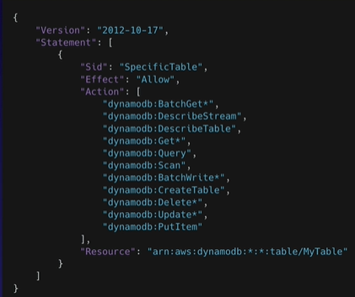

### Introduction

* Policies are documents that define permissions and can be applied to users, groups and roles.
* Policy documents are written in JSON (key value pair that consists of an attribute and a value).
* All permissions are implicitly denied by default.
* The most restrictive policy is applied.
* Each statement in IAM Policy matches an AWS API request.
* Action in policy contains service_name:action_name
* Some action might contain * which means all API request that starts with. Ex: dynamodb:Get* implies all API requests that start with Get
* There are two types of policies:
  + AWS Managed policies
  + Customer Managed Policies
* AWS Managed Policies cannot be edited
* Policies should be attached for it to become effective. Only attached policies have effect

### Types of policies

1. Identity-based policies
2. Resource-based policies
3. IAM permissions boundaries
4. AWS Organizations Service Control Policies (SCP)
5. Session Policies

#### Identity-based IAM Policies

1. Can be applied to users, groups, and roles
2. There is no principal in identity-based policy
3. JSON permission policy documents that control what actions an identity can perform, on which resources and under what conditions
4. Inline Policies
   1. Inline policies have 1-1 relationship with the user, group, or role
   2. Inline policy is created for specific user, group, and role
   3. We can’t share them among users or roles or groups
   4. If the user to which inline policy is attached is deleted, that policy will get deleted alongside
5. Managed Policies
   1. They can be either AWS-managed or customer managed
   2. AWS managed are created and managed by AWS
   3. Customer managed are created and managed by you
   4. Managed policies are standalone policies that can be attached to multiple entities (multiple users, groups, or roles)

#### Resource based IAM Policies

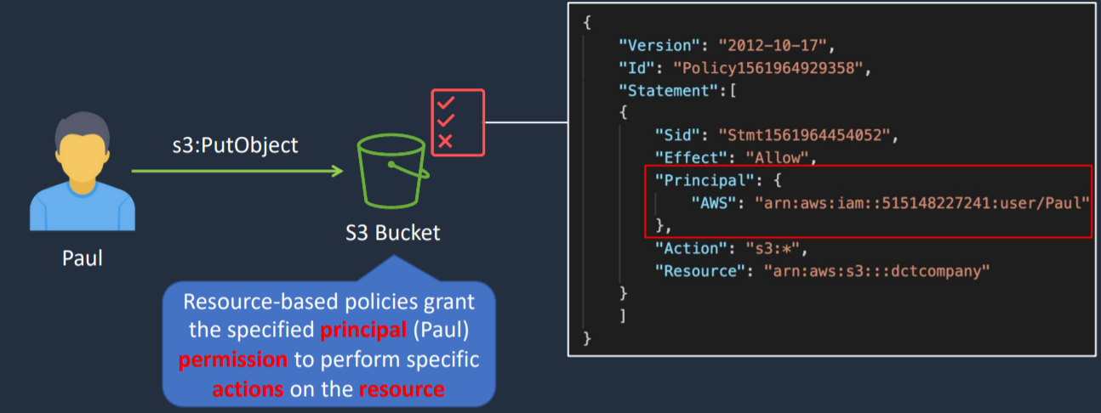

1. Resource-based policies are JSON policy documents that you attach to a resource such as Amazon S3 bucket, DynamoDB table, etc.
2. Resource based policy contains principal in it.
3. Resource based policies can also be attached to IAM Role
4. With IAM Role, we have Trust Policy and Permissions Policy.
5. Trust Policy is an example of resource-based policy whereas a permissions policy is an identity-based policy.

#### IAM Permission Boundaries

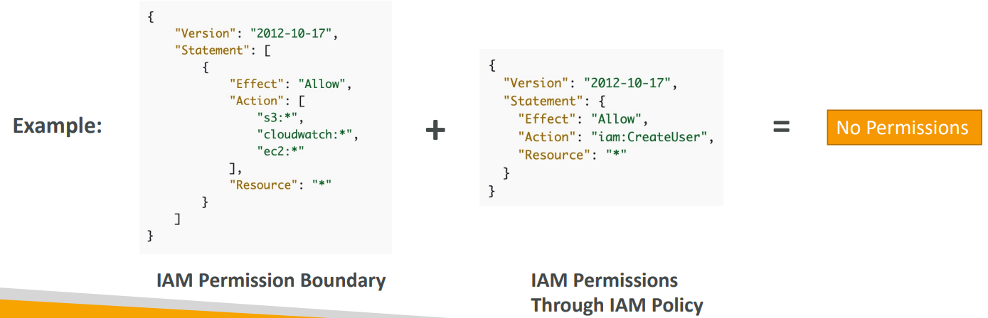

Suppose a user has an IAM Permission Boundary which says allow everything on S3, CloudWatch and EC2. This is boundary for that user. He can now do things within S3, CloudWatch and EC2. On top of this IAM permission is defined through IAM Policy where it is saying user is allowed to create IAM user. Now, user won’t be able to create IAM user because allowing user to create IAM user is beyond the permission boundary of that user.

1. IAM Permission Boundaries are supported for users and roles (not groups)
2. If organizations SCP, Permissions boundary and Identity-based policy exist, intersection of all these is effective permissions for that user

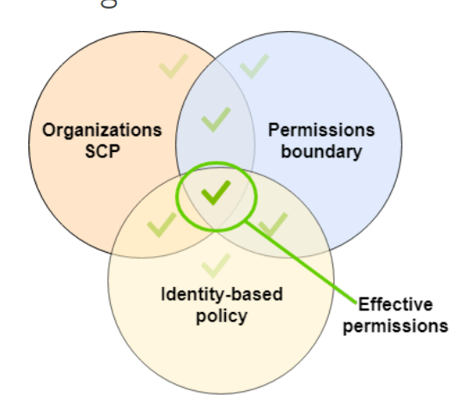

### IAM Policies Structure

1. Version
2. Id: an identifier for the policy (optional)
3. Statement: one or more individual statements (required)
   1. Sid: statement identifier (optional)
   2. Effect: allow or deny (required) -> whether to allow or deny access
   3. Action: list of actions that this policy allows or denies (required)
   4. Principal: account/user/role to which this policy applies to
   5. Resource: list of resources to which the actions are applied to
   6. Condition: condition that specifies when will policy remain effective

Required fields of policy-> effect, action

### Example IAM Policy

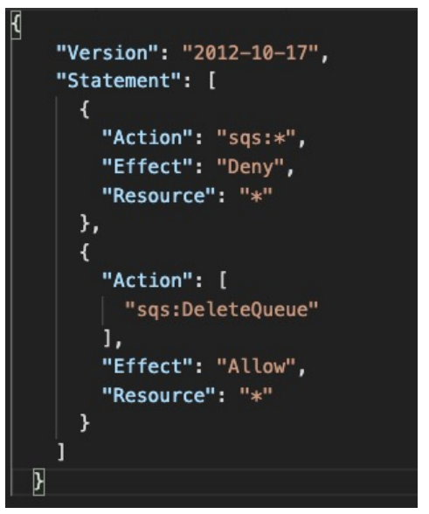

1. Can you perform sqs:CreateQueue?

No, Since all actions in SQS is denied

1. Can you perform sqs:DeleteQueue?

No, There is deny in top part and there is allow in lower part. So, there is conflict. As soon as there is explicit deny, the decision is going to be deny.

1. Can you perform ec2:DescribeInstances?

No, Since there is no explicit deny and also no explicit allow.

### IAM Policy Conditions

1. Way to make IAM policies a bit more restrictive based on a condition

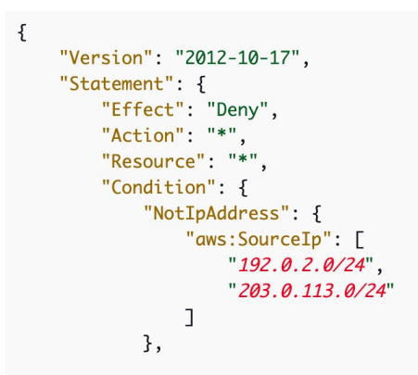

Restrict client IP from which API calls are being made

Note: SourceIP is for where the client is for where client is located

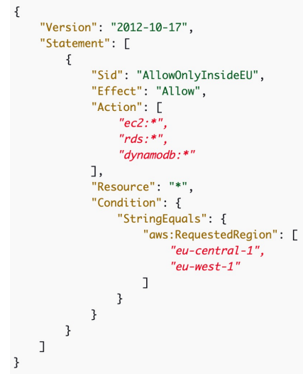

Restrict the region the API calls are made to

Note: RequestedRegion is where you are trying to make request to.

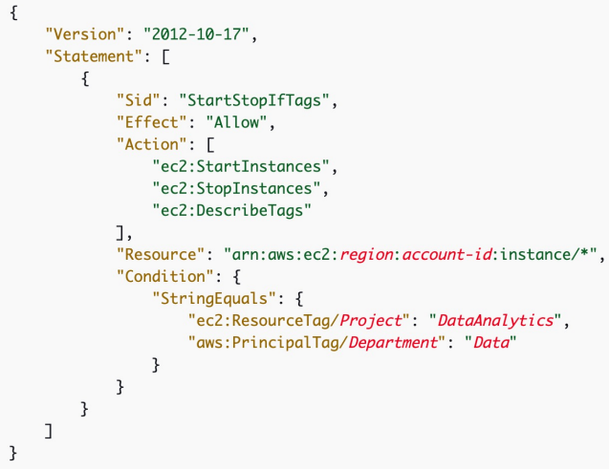

Resource based on tag

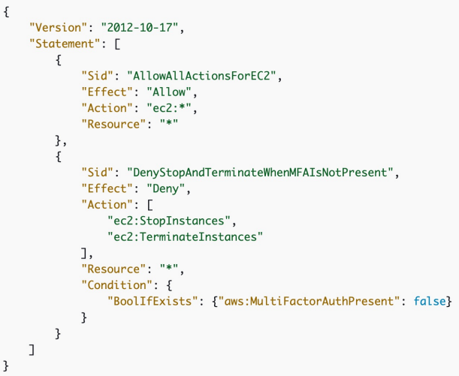

Force MFA

### IAM Policy for S3

Just / implies for that bucket

/* implies within that bucket

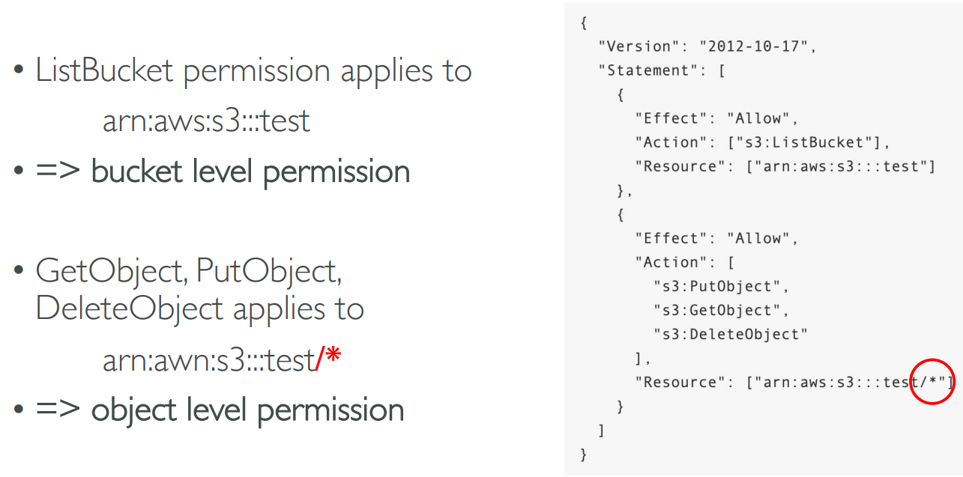

## IAM Roles vs Resource Based Policies

1. When you assume a role (user, application, or service), you give up your original permissions and take the permissions assigned to the role
2. When using a resource-based policy, the principal does not have to give up his permissions and he does not lose the permissions
3. Example
   1. User in account A needs to scan a DynamoDB table in Account A and dump it in an S3 bucket in Account B.
      1. This is use case for resource-based policy because if we use IAM role to do some stuff in account B for S3 bucket then you cannot do anything back on your DynamoDB table in Account A

## IAM – Security

1. MFA
2. Password Policy

### MFA (Multi-Factor Authentication)

1. Password you know + device you own, 6-digit token is generated
2. MFA devices options in AWS are
3. Virtual MFA Device
   1. Google Authenticator (phone only)
   2. Authy (multi-device)-> supports multiple tokens on a single device i.e. you can add as many users as you want in your MFA device.
4. U2F Security Key (Universal 2nd Factor Security Key)
   1. USB
   2. Physical device like Yubikey
   3. Supports for multiple root and IAM users using a single security key
5. Hardware MFA Devices
   1. Provided by Gemalto (3rd party)
   2. Provided by SurePassID (3rd party)

### Password Policy

In AWS, we can setup a password policy

1. Set a minimum password length (password length must be between 6 and 128)
2. Require specific character types
   1. Include uppercase letters
   2. Lowercase letters
   3. Numbers
   4. Non-alphanumeric characters
3. Allow all IAM users to change their own passwords
4. Require users to change their password after some time (password expiration) -> Value can be between 1 and 1095 days
5. Prevent password re-use (Number of passwords to remember must be between 1 and 24)
6. Default Password Policy includes
   1. Minimum password length is 8 characters
   2. Include a minimum of three of the following mix of character types: uppercase, lowercase, numbers, and ! @ # $ % ^ & * ( ) _ + - = [ ] { } | '
   3. Must not be identical to your AWS account name or email address

## IAM Security Tools

1. IAM Credential Report (account level)
2. Access Advisor (user level)

### IAM Credential Report

1. Account level
2. A report that lists all your account’s users and the status of their various credentials like passwords, access keys and MFA devices
3. Used for auditing and compliance

### IAM Access Advisor

1. User level
2. Shows the service permissions granted to a user and when those services were last accessed
3. This information can be used to revise your policies and grant users with least privilege

## IAM Best Practices

1. Do not use root account except for AWS account setup
2. One physical user=One AWS user
3. Assign users to groups and assign permissions to groups
4. Create a strong password policy
5. Use and enforce the use of MFA
6. Create and use roles for giving permissions to AWS services
7. Use Access Keys for Programmatic Access (CLI/SDK)
8. Audit permissions of your account with the IAM Credentials Report
9. Never share IAM users and access keys
10. Get started using permissions with AWS managed policies
11. Use customer managed policies instead of inline policies

## IAM Policy Evaluation Logic

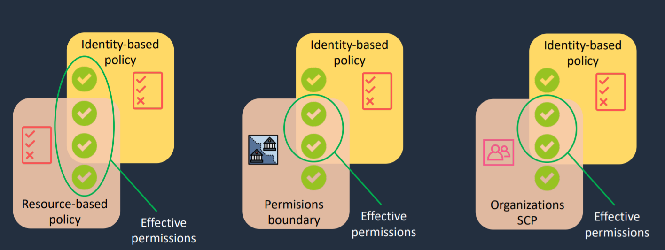

### Determination Rules

1. By default, all requests are implicitly denied (though root user has full access)
2. An explicit allow in an identity-based or resource-based policy overrides this default
3. If a permissions boundary, organizations SCP, or session policy is present, it might override the allow with an implicit deny
4. An explicit deny in any policy overrides any allows

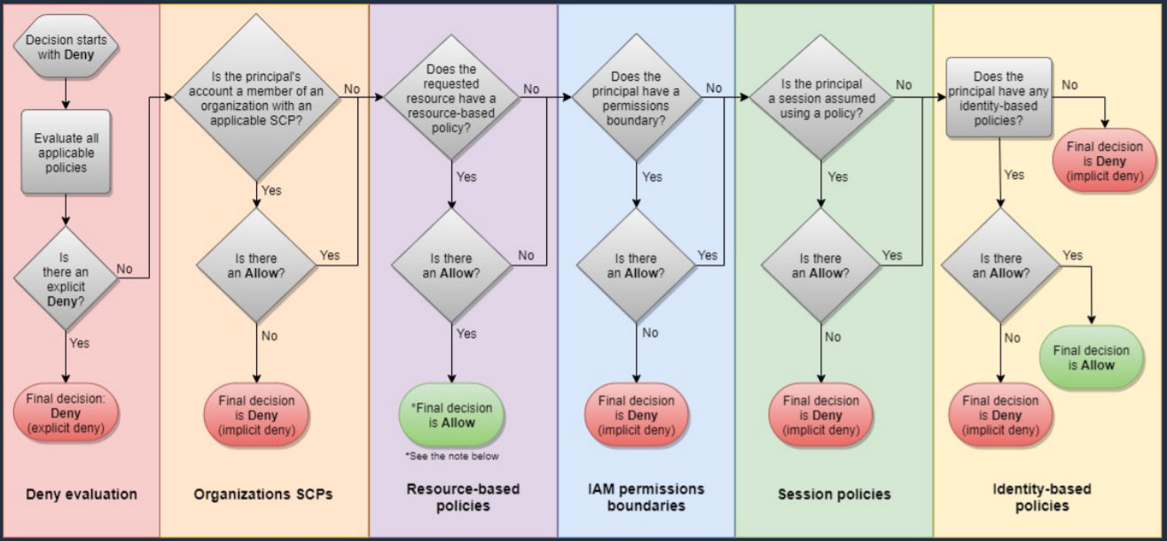

## IAM Policy Simulator

1. Test, understand and validate effect of access control policies
2. Enables you to simulate policies being applied to users and view what permissions they should granted or restricted
3. https://policysim.aws.amazon.com/home/index.jsp

## AWS Security Token Service (STS)

1. Provides short term temporary credentials
2. Temporary credentials include:
   1. AccessKeyId
   2. SecretAccessKey
   3. Expiration
   4. SessionToken
3. Temporary credentials are used with identity federation, delegation, cross-account access and IAM roles

# CloudShell

1. Alternative to using terminal in cloud
2. Available in few regions only
3. Can increase or decrease font size
4. Can add multiple terminals
5. Can upload and download files

# Billing

## Billing Information

1. By default, IAM user does not have permission to access Billing & Cost Management Dashboard
2. For this, we need to go to root account-> My Account-> Scroll down to section called IAM User and Role Access to Billing Information-> Check option Activate IAM Access-> Update

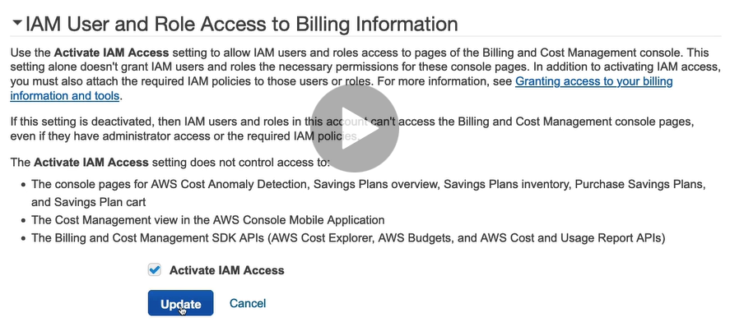

# Budget

## Budget Types

1. Cost budget
2. Usage Budget
3. Reservation Budget
4. Saving Plan

Budget can be set based on actual or forecasted value.

# EC2 (Elastic Cloud Compute)

## Introduction

* Elastic Cloud Compute
* Infrastructure as a Service
* Allows you to rent and manage virtual servers in the cloud
* Has elastic compute power: It can grow and shrink based on load in your application
* Are not serverless
* You are able to provision an EC2 instance at the click of a button
* You can also use pre-configured template called AMI (Amazon Machine Image) to launch your resources.
* You will receive 750 compute hours per month on Free Tier Plan. t2.micro is part of AWS free tier.
* You can deploy your applications directly to EC2 instances.
* Amazon EC2 instances can run the Windows, Linux, or MacOS operating systems.
* **Integrated**
  + EC2 is integrated with most AWS services such as S3, RDS, and VPC to provide a complete, secure solution
* **Secure**
  + EC2 works in conjunction with VPC to provide a secure location
* **It mainly consists of following capabilities**
  + **Renting virtual server**
  + **Storing data on virtual drives (EBS)**
  + **Distributing incoming traffic (ELB)**
  + **Scaling (ASG)**

## EC2 Configuration Options

1. Operating System (OS): Linux, Windows, Mac OS
2. How much compute power and cores (CPU)
3. How much random-access memory (RAM)
4. How much storage space
   1. Network-attached (EBS & EFS)
   2. Hardware (EC2 Instance Store)
5. Network card - speed of the card, public IP address
6. Firewall rules - Security Group
7. Bootstrap Script (configure at first launch)- EC2 User Data

## EC2 User Data and Metadata

1. User Data
   1. It is possible to bootstrap our instances using an EC2 User data script.
   2. Bootstrapping means launching commands when a machine starts.
   3. This script runs only once i.e., when the instance first starts
   4. EC2 User data is used to automate boot tasks such as
      1. Installing updates
      2. Installing software
      3. Downloading common files from the Internet
   5. EC2 User Data Script runs with the root user
   6. User data is limited to 16KB.
   7. To view user data Use command: curl <http://169.254.169.254/latest/user-data>
2. Metadata
   1. Instance metadata is data about your instance that you can use to configure or manage the running instance.
   2. Instance metadata is available at <http://169.254.169.254/latest/meta-data>
3. User data and metadata are not encrypted.

## Instance Metadata Query

1. The Instance Metadata Query tool allows you to query the instance metadata without having to type out the full URI or category names.

Note

When we create an EC2 Instance, a public IP address and a private IP address is also generated. Next time on stopping same instance and starting it again, new public IP address will be generated while private IP address will still remain same.

## EC2 Instance type

1. AWS has the following naming convention:
   1. m5.2xlarge
   2. m=instance class
   3. 5=generation
   4. 2xlarge=size within the instance class
2. General Purpose
   1. Balance between compute, memory, and networking
   2. t2.micro is General Purpose EC2 Instance
   3. t..m
3. Compute Optimized
   1. Great for compute-intensive tasks that requires high performance processors
   2. Batch processing
   3. Media transcoding
   4. High performance computing (HPC)
   5. Scientific modeling and Machine Learning
   6. Dedicated gaming servers
   7. c
4. Memory optimized
   1. Fast performance for workloads that process large data sets in memory
   2. r
5. Storage Optimized
   1. Great for storage intensive tasks that require high sequential read and write access to large data sets on local storage
   2. i…d
6. Accelerated Computing

## Security Group

1. Firewall at instance level
2. They control how traffic is allowed into or out of our EC2 instance
3. Contains only allow rules
4. Stateful
5. Security Group rules can reference by IP or by Security Group
6. By default, all inbound traffics is blocked. All outbound traffic is authorized.
7. Can be attached to multiple instances
8. Locked down to a region/ VPC combination. i.e., If we switch to new region or if new VPC is created, we need to create new Security Group
9. Security Group lives outside the EC2- if traffic is blocked the EC2 instance won’t even see it
10. It is good to maintain one separate security group for SSH access
11. If your application is not accessible (time out), then it is a security group issue
12. If your application gives “connection refused” error, then it is an application error or it is not launched
13. Changes to security groups take effect immediately.

## Classis Ports to know

1. 22 - SSH (Secure Shell)- log into a Linux instance
2. 21 – FTP (File Transfer Protocol)- upload files into a file share
3. 22 - STFP (Secure File Transfer Protocol)-upload files using SSH
4. 80 - HTTP - access unsecured websites
5. 443 - HTTPS - access secured websites
6. 3389 - RDP (Remote Desktop Protocol)- log into a Windows Instance

## SSH Summary

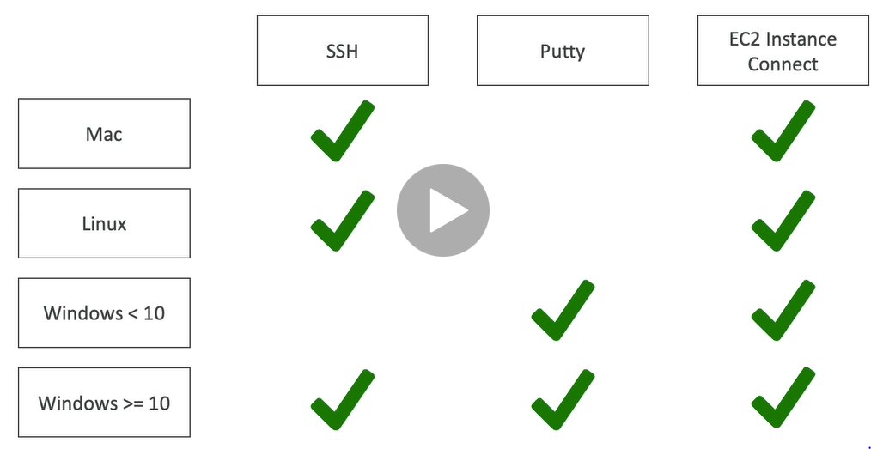

Note

To use EC2 Instance Connect, we need to add inbound rule in Security Group sections for SSH.

## Amazon Machine Image (AMI)

* An Amazon Machine Image (AMI) is a special type of virtual appliance that is used to create a virtual machine within the Amazon Elastic Compute Cloud.
* An AMI includes the following:
  + One or more [**EBS**](https://digitalcloud.training/certification-training/aws-certified-cloud-practitioner/aws-storage/) snapshots, or, for instance-store-backed AMIs, a template for the root volume of the instance
  + Launch permissions that control which AWS accounts can use the AMI to launch instances.
  + A block device mapping that specifies the volumes to attach to the instance when it’s launched.
* AMIs come in three main categories:
  + **Community AMIs** – free to use, generally you just select the operating system you want.
  + **AWS Marketplace AMIs** – pay to use, generally come packaged with additional, licensed software.
  + **My AMIs** – AMIs that you create yourself.
* AMIs are regional. You can only launch an AMI from the region in which it is stored.
* You can copy AMI’s to other region using console, command line or the API.

## EC2 in real world

1. Deploy a database: Deploy a database to EC2 gives you full control over the database.
2. Deploy a web application: Deploy web application to multiple availability zones to make web application highly available.

## Methods to access EC2 instance

1. AWS Management Console
2. Secure Shell (SSH)
3. EC2 Instance Connect (EIC)
4. AWS Systems Manager
5. AWS Management Console

* You are able to configure and manage instances via a web browser.

1. Secure Shell (SSH)

* Allows you to connect to your instance from local laptop using SSH Client and keys
* Puttygen converts .pem(privacy enhanced mail) file to .ppk (putty private key)

1. EC2 Instance Connect

* Browser based connection
* Allows you to connect to instance without using SSH client and keys and directly using terminal in web browser
* For this, you must grant IAM users permission to push public key to the instance.

1. AWS System Manager

* Allows you to manage EC2 instances via a web browser or CLI

Note: The most common way to connect to Linux EC2 instance is via Secure Shell (SSH). For this key pair is generated.

A key pair consists of a private key and a public key, which proves your identity when connecting to an EC2 instance.

When user connects to SSH Client laptop, he uses private key. When he connects to EC2 instance, he uses public key.

## EC2 Pricing Model

1. On demand
2. Spot
3. Reserved Instance
4. Dedicated Hosts
5. Savings Plans

### On demand

1. Fixed price in which you are billed based on instance type used
2. You pay for what you use
   1. For Linux or Windows: billing per second, after the first minute
   2. All other operating systems- billing per hour
3. No contract
4. Use on-demand instances when
   1. You cannot make upfront payment or long-term commitment
   2. Your applications have unpredictable workloads that cannot be interrupted
   3. Your applications are under-development
   4. Your applications will not run for more than a year

### Spot

1. Spot instance lets you take advantage of unused EC2 capacity
2. Your request is available only if capacity is available
3. Use Spot instance when
   1. Your application is not concerned about start and stop time of execution
   2. Your workload can be interrupted
   3. Useful for workloads that are resilient to failure
   4. Not suitable for critical jobs or databases
   5. Applications that are only feasible at very low compute prices.
   6. Users with an urgent need for a large amount of additional compute capacity.
4. You can save upto 90% off on-demand prices
5. You pay for spot that is in effect at the beginning of each hour
6. If Amazon terminate your instances you do not pay, if you terminate you pay for the hour.
7. Define max spot price and get the instance while current spot price<your max
8. If current spot price>your max price you can choose to stop or terminate your instance with a 2 minute grace period.
9. Spot Instances are not good for:
   1. Persistent workloads
   2. Critical jobs
   3. Databases

### Reserved Instance

1. Allows you to commit to a specific instance type for 1 or 3 years e.g. You want to reserve t2.micro instance type
2. Use reserved instance when
   1. Applications with steady state or predictable usage
   2. Your application has steady state usage, and you can commit for 1 or 3 years
   3. You can make upfront payment
   4. Your application requires capacity reservation
3. You can save upto 75% off on-demand prices using Standard Reserved Instance
4. You are required to sign a contract of 1 or 3 years
5. You can pay all-upfront, partial upfront or no upfront. All upfront for maximum term earns the highest discount
6. Standard RI, Convertible RI, Scheduled RI
7. Standard Reserved Instances can be used to change Availability Zone, Instance Size (Linux), networking type. For this ModifyReservedInstances API is used. (75% discount)
8. Convertible Reserved Instances can be used to change Availability Zone, Instance Size (Linux), networking type along with family, OS, tenancy, payment option. For this ExchangeReservedInstances API is used. (54% discount)
9. Scheduled RIs are available to launch within the time window you reserve. With Scheduled Reserved Instances, you can reserve capacity that is scheduled to recur daily, weekly, or monthly, with a specified start time and duration, for a one-year term. Scheduled RI has minimum 1200 hours per year.
10. Payment can be done as All Upfront, Partial Upfront and No Upfront.

### Dedicated Hosts

1. Allows you to pay for physical server that is dedicated to running your instances. No other AWS customer is going to have applications running on this server. The server basically belongs to you
2. Use dedicated hosts when
   1. You want to bring your own server-bound software license from vendors like Microsoft and Oracle
   2. You have regulatory or corporate compliance requirements around tenancy model
3. You can save upto 70% off on-demand prices
4. You can bring your existing per-core, per-socket and per-VM software licenses.
5. Available as On-Demand or with Dedicated Host Reservation.
6. Each dedicated host can only run one EC2 instance size and type.
7. Most expensive option.
8. Billing is per host.

### Dedicated Instance

1. Virtualized instances on hardware just for you.
2. Also uses physically dedicated EC2 servers.
3. Does not provide the additional visibility and controls of dedicated hosts (e.g. how instance are placed on a server).
4. Billing is per instance.
5. May share hardware with other non-dedicated instances in the same account.
6. Available as On-Demand, Reserved Instances, and Spot Instances.
7. Cost additional $2 per hour per region.

### Savings Plan

1. You do not commit for specific instance type instead you commit to compute usage (measured per hour) for 1 to 3 years
2. Use savings plan when
   1. You want to lower your bill across multiple compute services
   2. You want flexibility to change compute services, instance types, OS or regions
3. You can save upto 72% off on-demand prices
4. Savings can be shared across various compute services like EC2, Fargate and lambda
5. Compute Savings Plan
   1. 1 or 3 years
   2. Hourly commitment to usage of Fargate, Lambda and EC2
   3. Any region, family, size, tenancy, and OS
6. EC2 Savings Plan
   1. 1 or 3 years
   2. Hourly commitment to usage of EC2 within selected region and instance family
   3. Any size, tenancy, and OS

Note

Billed per second, minimum of 1 minute for Amazon Linux and Ubuntu in On-demand, Reserved and Spot forms

Billed per hour, minimum of 1 hour for Windows and commercial Linux distros like Red Hat EL and SUSEES

EBS Volume attached to EC2 Instance is billed per second with the minimum of 1 minute.

## EC2 Lifecycle

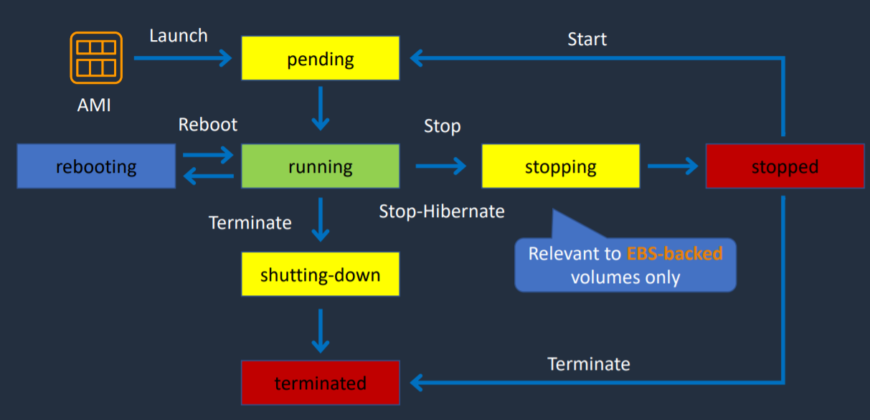

1. If your instance uses Instance Store volume, then you cannot hibernate the instance
2. Stopping EC2 instances
   1. Only applicable for EBS backed instances
   2. No charge for stopped instances
   3. EBS volumes remain attached, and they are chargeable
   4. Data in RAM is lost
   5. Instance is migrated to different host
   6. Private IPv4 addresses and IPv6 addresses are retained
   7. Public IPv4 addresses are released
   8. Any Associated Elastic IPs are retained
3. Hibernating EC2 Instances
   1. Applies to on-demand or reserved Linux instances
   2. Contents of RAM are saved to EBS volume
   3. Must be enabled for hibernation when launched
   4. Specific prerequisites apply
   5. When started
      1. The EBS root volume is restored to its previous state
      2. The RAM contents are reloaded
      3. The processes that were previously running on the instance are resumed
      4. Previously attached data volumes are reattached, and the instance retains its instance ID
4. Rebooting EC2 instance
   1. Equivalent to an OS reboot
   2. DNS name and all IPv6 and IPv4 addresses are retained
   3. Does not affect billing
5. Retiring EC2 Instances
   1. Instances may be retired if AWS detects irreparable failure of the underlying hardware that hosts the instance
   2. When an instance reaches its scheduled retirement date, it is stopped or terminated by AWS
6. Terminating EC2 Instances
   1. Deleting the EC2 instance
   2. Cannot recover a terminated instance
   3. By default, root EBS volumes are deleted
7. Recovering EC2 Instances
   1. CloudWatch can be used to monitor system status checks and recover instance if needed
   2. Applies if the instance becomes impaired due to underlying hardware/platform issues
   3. Recovered instance is identical to original instance

## How to terminate Spot Instance?

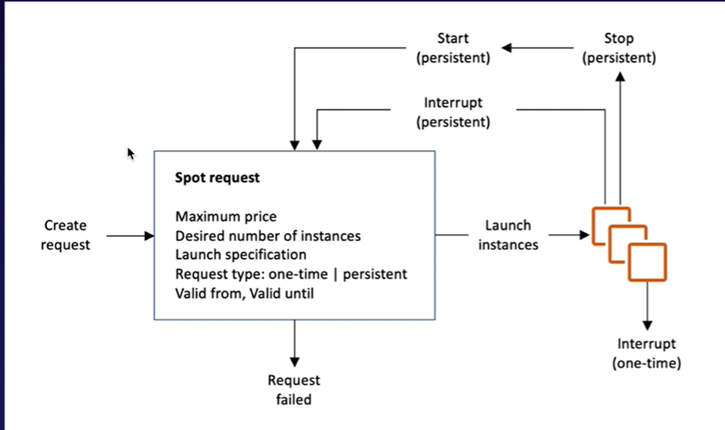

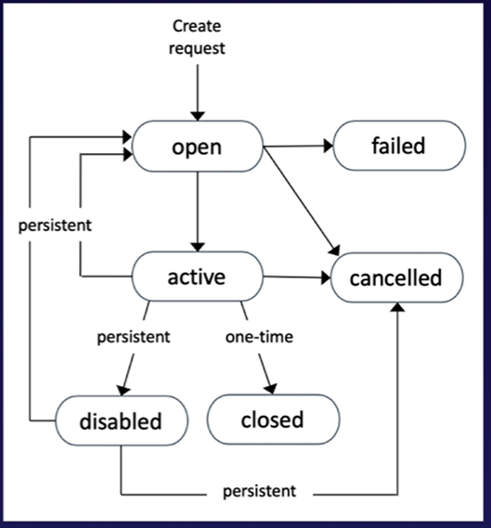

1. The hourly Spot price varies depending on capacity and region.
2. First of all, we will create a spot request where we need to specify
   1. Maximum price
   2. Desired number of instances
   3. Launch Specification
   4. Request type-One time/Persistent
   5. Valid From, Valid Until
3. There are two type of request
   1. One time Request: As soon as instance is launched based on your request, your spot request will go away
   2. Persistent Request: Spot request will remain from valid from to valid until period of time. If somehow instance gets interrupted, spot request will get back into action and it will re-start spot instances for you. If you terminate instance but your spot request is still active, spot request will be smart enough to launch instances.
4. You can only cancel Spot Instances requests that are open, active, or disabled
5. Cancelling a Spot Request does not terminate instances. It is our responsibility to terminate instances not AWS responsibility.
6. You must first cancel a Spot Request and then terminate the associated Spot instances.

## Spot Block

1. Requirement: Uninterrupted for 1-6 hours
2. Pricing is 30%-45% less than on-demands

## Spot Fleet

1. A spot fleet is a collection of Spot Instances and optionally, on-demand instances.
2. It attempts to launch the number of Spot Instances and On-demand Instances to meet the target capacity you specified in the Spot fleet request.
3. The request for Spot Instances is fulfilled if there is available capacity and the maximum price you specified in the request exceeds the current Spot price.
4. Spot fleet will try and match the target capacity with your price restraints.
5. You can have the following strategies with Spot Fleets
   1. capacityOptimized
      1. spot instances will come from the pool with optimal capacity.
   2. Diversified
      1. The spot instances are diversified across all pools.
   3. lowestPrice
      1. this is the default strategy.
      2. Spot instances will come from the pool with the lowest price.
   4. InstancePoolsToUseCount
      1. Spot instances are distributed across the number of Spot Instance pools you specify.
6. Spot Fleets allow us to automatically request Spot Instances with the lowest price

## EC2 Fleet

1. Launches and maintains specified number of Spot/On-Demand/Reserved Instances in a single API call

## Features of EC2

1. Elastic Load Balancing
2. EC2 Autoscaling

### Elastic Load Balancing

1. Automatically distributes your incoming traffic across multiple EC2 instances
2. Types
   1. Classic Load Balancer
   2. Application Load Balancer
   3. Gateway Load Balancer
   4. Network Load Balancer

### EC2 Autoscaling

1. Scale up or scale down based on workload in your application
2. Reduces impact of system failure and improves availability of your applications
3. You can also use autoscaling with Aurora and DynamoDB

## EC2 Status Check and Monitoring

Two types of checks are performed

1. System Status Checks
   1. Checking underlying hardware in which your EC2 instance is running
   2. Problem in system status check needs to be fixed by AWS
2. Instance Status Checks
   1. Checking configurations of EC2 Instance and making sure that instance is operational
   2. Problem in instance status check needs to be fixed by customer

## EC2 Placement Groups

1. Sometimes you want control over how EC2 Instances are placed (EC2 Instance placement strategy)
2. When you create a placement group, you specify one of the following strategies for the group
   1. Cluster - clusters instances into a low-latency group in a single AZ
   2. Spread - spreads instances across underlying hardware (max 7 instances per group per AZ)- critical applications
   3. Partition - spreads instances across many different partitions (which rely on different sets of racks) within an AZ
3. The name you specify for a placement group must be unique within your AWS account.
4. Only certain types of instances can be launched in a placement group (Compute Optimized, GPU, Memory Optimized, Storage Optimized)
5. You cannot merge placement groups.
6. You can move an existing instance into a placement group. Before you move the instance, the instance must be in the stopped state. You can move or remove an instance using the AWS CLI or AWS SDK, you cannot do it via the console yet.

### Cluster Placement Groups

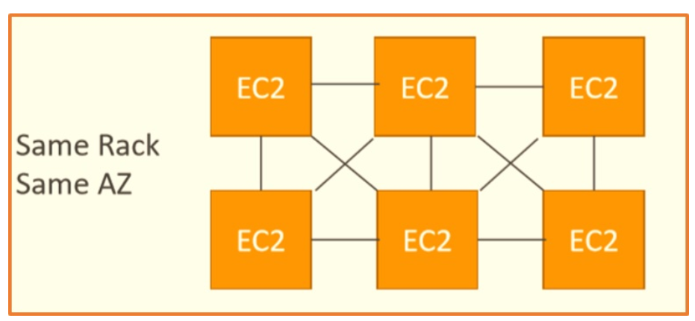

1. All instances are in same rack (same hardware) and same AZ
2. Pros
   1. High network throughput (10 Gbps bandwidth between instances)
   2. Low latency
3. Cons
   1. If the rack fails, all instances fail at the same time
4. Use case
   1. Big Data job that needs to complete fast
   2. Application that needs extremely low latency and high network throughput
   3. Enables to achieve the low-latency network performance necessary for tightly coupled node-to-node communication that is typical of HPC applications

### Spread Placement Groups

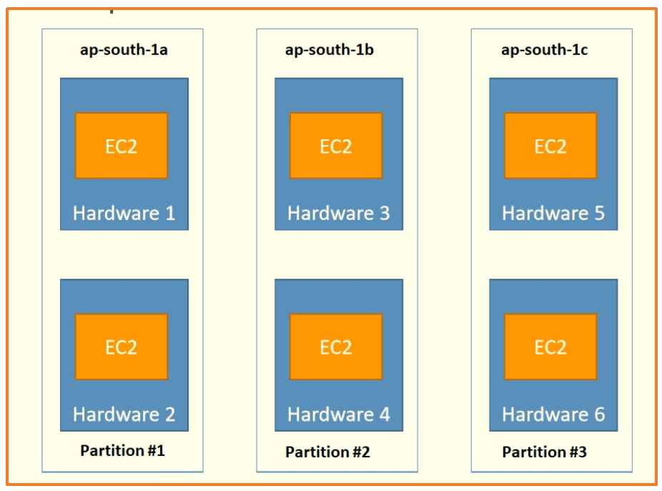

1. All the instances are on different physical hardware
2. Instances are in different hardware in different AZ
3. Pros
   1. Can span across Availability Zones (AZ)
   2. Reduced risk of simultaneous failure
4. Cons
   1. Limited to 7 instances per AZ per placement group
5. Use case
   1. Application that needs to maximize high availability
   2. Critical Applications where each instance must be isolated from failure from each other

### Partition Placement Groups

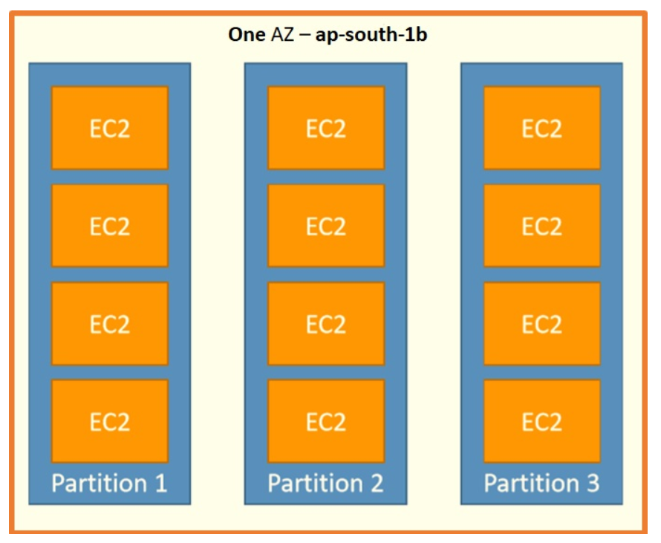

1. Within one AZ, span multiple partitions, and what is partition, an isolation created by AWS in their data centers which is a physical boundary and ensures one partition's availability does not affects others.
2. Pros
   1. Can span across multiple AZs in the same region
   2. Upto 100s of EC2 instances
   3. Instances in a partition do not share racks with the instances in the other partitions
   4. A partition failure can affect many EC2 but won’t affect other partitions
   5. EC2 instances get access to partition information as metadata
   6. This strategy is typically used by large distributed and replicated workloads such as Hadoop, Cassandra, and Kafka.
3. Cons
   1. Upto 7 partitions per AZ
4. Use case
   1. HDFS
   2. HBase
   3. Cassandra
   4. Kafka

When we start our EC2 instance, the following happens:

1. Operating system boots up
2. User data script is run (bootstrap scripts)
3. Applications start (can take some time)

## EC2 Hibernate

1. If the instance is hibernated, the operating system is told to perform hibernation (suspend-to-disk). Hibernation saves the content from the instance memory (RAM) to your Amazon EBS root volume.
2. When you start your instance out of hibernation:
   1. The Amazon EBS root volume is restored to its previous state
   2. The RAM contents are reloaded
   3. The processes that were previously running on the instance are resumed
   4. Previously attached data volumes are re-attached, and the instance retains its instance ID
3. With EC2 Hibernate, the instance boots much faster. The operating system does not need to reboot because the in-memory state (RAM) is preserved. This is useful for:
   1. Long running processes
   2. Services that take time to initialize
   3. Saving the RAM state
4. Available for On-demand Instances and Reserved Instances
5. Available for AMI- Amazon Linux 2, Linux AMI, Ubuntu, and Windows
6. Instance size- not supported for bare metal instances
7. Instance families include C3, C4, C5, M3, M4, M5, R3, R4 and R5
8. Instance RAM must be less than 150 GB
9. To enable hibernation, we should check **Enable hibernation as an additional stop behavior** option in Stop – Hibernate behaviour at the time of launching instance
10. To enable hibernation, root volume must be encrypted.
11. Root Volume: must be large, EBS, encrypted, **not Instance Store**
12. Much faster to boot up because you do not need to reload the operating system
13. Instances cannot be hibernated for more than 60 days

## EC2 Nitro

1. Underlying Platform for the next generation of EC2 instances
2. New virtualization technology
3. Allows for better performance
   1. Better networking options (enhanced networking, HPC, IPv6)
   2. Higher Speed EBS (Nitro is necessary for 64,000 EBS IOPS-max 32,000 on non-Nitro)

## EC2 - vCPU

1. Multiple threads can run on one CPU (multithreading)
2. Each thread is represented as a virtual CPU (vCPU)

## EC2 - Optimizing CPU options

1. EC2 instances come with combination of RAM and vCPU
2. In some cases, you may want to change the vCPU options:
   1. # of CPU cores- you can decrease it, helpful if you need high RAM and low number of CPU
   2. # of threads per core- disable multithreading to have 1 thread per CPU, helpful for high performance computing (HPC) workloads
3. Specified during instance launch

## EC2- Capacity reservation

1. Capacity Reservations ensure you have EC2 capacity when needed
2. No need for 1- or 3-year commitment
3. Capacity access is immediate, you get billed as soon as it starts
4. Specify
   1. AZ in which to reserve capacity (only one)
   2. Number of instances for which to reserve capacity
   3. Instance attributes including the instance type, tenancy and platform/OS

## Public IP vs Private IP vs Elastic IP

1. Networking has two sorts of IPs:
   1. IPv4
   2. IPv6
2. When you have a public IP, you are accessible over the Internet.
3. When you have a private IP, you are only accessible within your private network.
4. Public IP
   1. Public IP means the machine can be identified on the Internet (www)
   2. Must be unique across the whole web (no two machines can have same public IP)
   3. Can be geo-located easily
   4. Associated with private IP address on the instance
   5. Cannot be moved between instances
5. Private IP
   1. Private IP means the machine can only be identified on a private network only
   2. The IP must be unique across the private network
   3. But two different private networks (two companies) can have same IPs.
   4. Machines connect to Internet using an Internet Gateway
   5. Only a specified range of IPs can be used as private IP
6. Elastic IP
   1. It is also a public IP, but it is static IP address
   2. When you stop and then start an EC2 instance, it can change its public IP
   3. If you need to have a fixed public IP for your instance, you need an Elastic IP
   4. An Elastic IP is a public IPv4 you own as long as you don’t delete it
   5. You can attach it to one instance at a time
   6. With Elastic IP address, you can mask the failure of an instance by rapidly remapping the address to another instance
   7. You can only have 5 Elastic IP in your account (you can ask AWS to increase that)
   8. After we create an Elastic IP, we will be charged for it until it is associated with some other instance. So, quickly associate Elastic IP with instance.
   9. Associated with a private IP address on the instance
   10. Can be moved between instances and Elastic Network Adapters
7. When we stop and start instance, public IP address is released
8. When we reboot instance, public IP address is retained

## Network Interfaces (ENI, ENA, EFA)

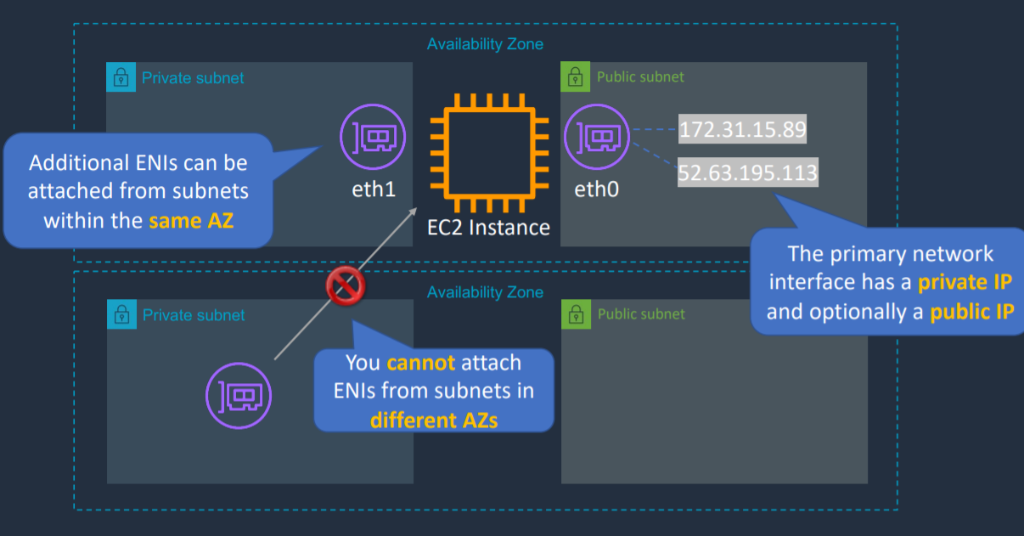

### ENI (Elastic Network Interface)

1. Logical component in a VPC
2. Virtual network card on your EC2 instance
3. When an EC2 instance is launched, it is going to have an ENI attached to it automatically and then you can add additional ones.
4. The ENI can have following attributes
   1. Primary private IPv4, one or more secondary IPv4
   2. One Elastic IP (IPv4) per private IPv4
   3. One public IPv4
   4. One or more Security Groups
   5. A MAC address
   6. A source/destination check flag
   7. A description of what the ENI is
5. You can create ENI independently and attach them on the fly on EC2 instances for failover
6. ENI that is created at the time of instance creation will get terminated on termination of corresponding instance
7. ENI that is created independently will remain even when instance gets terminated
8. Basic adapter type for when you don’t have any high-performance requirements
9. Can use with all instance types
10. Bound to a specific AZ. Additional ENIs can be attached from subnets within the same AZ. You cannot attach ENIs from subnets in different AZs

### ENA (Elastic Network Adapter)

1. Enhanced networking performance
2. Higher bandwidth and lower inter-instance latency
3. Must choose supported instance type
4. Uses single root I/O virtualization (SR-IOV) to provide high-performance networking capabilities on supported instance types.
5. There is no additional charge for using enhanced networking
6. Depending on your instance type, enhanced networking can be enabled using two methodologies
   1. Elastic Network Adapter (ENA): which supports network speeds of up to 100 Gbps for supported instance types
   2. Intel 82599 Virtual Function (VF) interface: which supports network speeds of up to 10 Gbps for supported instance types

### EFA (Elastic Fabric Adapter)

1. Use with High Performance Computing and MPI and ML use cases
2. Tightly coupled applications
3. A network device that you can attach to your Amazon EC2 instance to accelerate High Performance Computing (HPC) and machine learning applications.
4. EFA can use OS-bypass. OS-bypass enables HPC and machine learning applications to bypass the operating system kernel and to communicate directly with the EFA device. It makes it a lot faster with a lot lower latency
5. Can use with all instance types
6. Not supported with Windows currently, only Linux

Note

Both ENIs and EIPs can be remapped to a different instance in same AZ.

EIPs can be remapped across AZs. But ENIs cannot be remapped across AZs.

Note

After creating EC2 instance (Windows) and RDP, wait for at least 4 min to generate password

# Block and File Storage

## EBS (Elastic Block Storage)

### Introduction

* Block storage service
* Like physical hard drive, network drive
* Accessible to a single EC2 instance at a time
* Data persists even when instance is not running
* Recommended for
  + Quickly accessible data
  + Long-term data storage
  + Running a database on an instance
* EBS volume data persists independently of the life of the instance.
* EBS volumes do not need to be attached to an instance.
* You can attach multiple EBS volumes to an instance.
* You cannot attach an EBS volume to multiple instances (use Elastic File Store instead).
* EBS volumes must be in the same AZ as the instances they are attached to. EBS Volumes are bound to a specific AZ.
* Root EBS volumes are deleted on termination by default.
* Extra non-root volumes are not deleted on termination by default.
* The behavior can be changed by altering the “DeleteOnTermination” attribute.
* Free Tier: 30 GB of free EBS storage of type General Purpose SSD per month.
* To migrate an EBS volume across AZ
  + Take a snapshot
  + Restore snapshot to another AZ

### EBS Snapshot

* Make a backup (snapshot) of your EBS volume at a point in time
* Does not provide granular backup (not a replacement for backup software).
* They are incremental, which means that only the blocks on the device that have changed after your last snapshot are saved in the new snapshot.
* Even though snapshots are saved incrementally, the snapshot deletion process is designed so that you need to retain only the most recent snapshot in order to restore the volume.
* Not necessary to detach volume to do snapshot, but recommended
* When you create a snapshot for an EBS volume that serves as a root device, you should stop the instance before taking the snapshot.
* You cannot create snapshots from instances for which hibernation is enabled.
* You cannot create snapshots from hibernated instances.
* However, you can take a snap while the instance is running
* We can copy snapshots in another region. New copied snapshot can be encrypted at the time of copying snapshot.
* Snapshots are stored on S3
* Snapshot can be used to create AMI
* EBS volumes are AZ specific but snapshots are region specific.
* Use case
  + Can be used to migrate a system to a new AZ or region
  + Can be used to convert an unencrypted volume to an encrypted volume

### AMI

1. An Amazon Machine Image (AMI) is a special type of virtual appliance that is used to create a virtual machine within the Amazon Elastic Compute Cloud.
2. An AMI includes the following:
   1. One or more [**EBS**](https://digitalcloud.training/certification-training/aws-certified-cloud-practitioner/aws-storage/) snapshots, or, for instance-store-backed AMIs, a template for the root volume of the instance
   2. Launch permissions that control which AWS accounts can use the AMI to launch instances.
   3. A block device mapping that specifies the volumes to attach to the instance when it’s launched.
3. AMIs come in three main categories:
   1. Community AMIs
      1. free to use, generally you just select the operating system you want.
   2. AWS Marketplace AMIs
      1. pay to use, generally come packaged with additional, licensed software.
   3. My AMIs
      1. AMIs that you create yourself.
4. AMIs are regional. You can only launch an AMI from the region in which it is stored.
5. You can copy AMI’s to other region using console, command line or the API.
6. You can select AMI based on
   1. Region
   2. Operating System
   3. Architecture (32-bit or 64-bit)
   4. Launch Permissions
   5. Storage for the root device
      1. Instance store
      2. EBS Backed Volumes
7. All AMIs are categorized as either backed by Amazon EBS or backed by Instance Store.
8. For EBS Volumes: the root device for an instance launched from the AMI is an Amazon EBS volume created from an Amazon EBS snapshot.
9. For Instance Store Volumes: The root device for an instance launched from the AMI is an Instance Store volume created from a template stored in Amazon S3.
10. There are couple of ways to create AMI
    1. Create snapshot of volume and create an image from snapshot
    2. Create image from instance
       1. When an AMI is created from EC2 Instance, it will automatically shut down OS and then it will take a snapshot of each volume attached to Instance and then create the AMI from snapshot.
11. On launching instance from AMI, we can change AZ of new instance as AMI is stored in S3

### EBS Volume Types

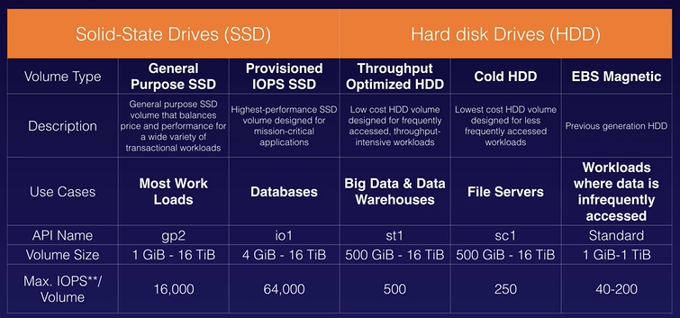

1. EBS Volumes come in 6 types
   1. gp2/gp3 (SSD)-> General Purpose SSD
      1. General purpose SSD volume that balances price and performance for a wide variety of workloads
      2. Boot volume – supported
      3. Multi-attach – not supported
   2. io1/io2 (SSD)-> Provisioned IOPS SSD
      1. Highest performance SSD volume for mission-critical low-latency or high-throughput workloads
      2. Critical business applications with sustained IOPS performance
      3. Great for databases workloads
      4. Boot volume – supported
      5. Multi-attach - supported
   3. st1 (HDD)-> Throughput Optimized HDD
      1. Low-cost HDD volume designed for frequently accessed, throughput-intensive workloads
      2. Big Data, Data Warehouse, Log Processing
      3. Cannot be boot volume
      4. Multi-attach – not supported
   4. sc1 (HDD)-> Cold HDD
      1. Lowest cost HDD volume designed for less frequently accessed workloads
      2. Cannot be boot volume
      3. Multi-attach – not supported
2. Only gp2/gp3 and io1/io2 can be used as boot volumes
3. gp2: IO increases if the disk size increases
4. io1: can increase IO independently

### EBS Multi-Attach

1. io1/io2 family
2. Attach same EBS volume to multiple EC2 instances in the same AZ
3. Each instance has full read and write permissions to the volume
4. Up to 16 instances can be attached to a single volume

### Migrate EC2 volume

1. To migrate EC2 volumes from one AZ to another, take a snapshot of it, create an AMI from the snapshot and then use the AMI to launch the EC2 instance in a new AZ.
2. To move an EC2 volume from one region to another, take a snapshot of it, create an AMI from the snapshot and then copy the AMI from one region to the other. Then use the copied AMI to launch the new EC2 instance in the new region.

### EBS Encryption

1. You can encrypt both the boot and data volumes of an EC2 instance
2. Encryption is supported by all EBS volume types. All instance families support encryption
3. When you create an encrypted EBS volume, you get the following
   1. Data at rest is encrypted inside the volume
   2. All the data in flight moving between instance and volume is encrypted
   3. All snapshots created from the volume
   4. All volumes created from those snapshots
4. EBS Encryption leverages keys from KMS (AES-256)

### Encrypt an Unencrypted EBS volume

Option 1

1. Create an EBS snapshot of volume (Snapshot of unencrypted EBS volume is also unencrypted)
2. Encrypt the EBS snapshot (using copy)
3. Create new EBS volume from snapshot (the volume will also be encrypted)
4. Now you can attach the encrypted volume to the original instance

Option 2

1. Create a Snapshot of the unencrypted root device volume
2. Create a copy of the Snapshot and select the encrypt option
3. Create an AMI from the encrypted Snapshot
4. Use that AMI to launch new encrypted instances

### Encrypted Root Device Volumes and Snapshots

1. Snapshots of encrypted volumes are encrypted automatically.
2. Volumes restored from encrypted snapshots are encrypted automatically.
3. You can share snapshots, but only if they are unencrypted. These snapshots can be shared with other AWS accounts or made public.
4. You can now encrypt root device volumes upon creation of the EC2 instance.

### Copying and Sharing AMIs and Snapshots

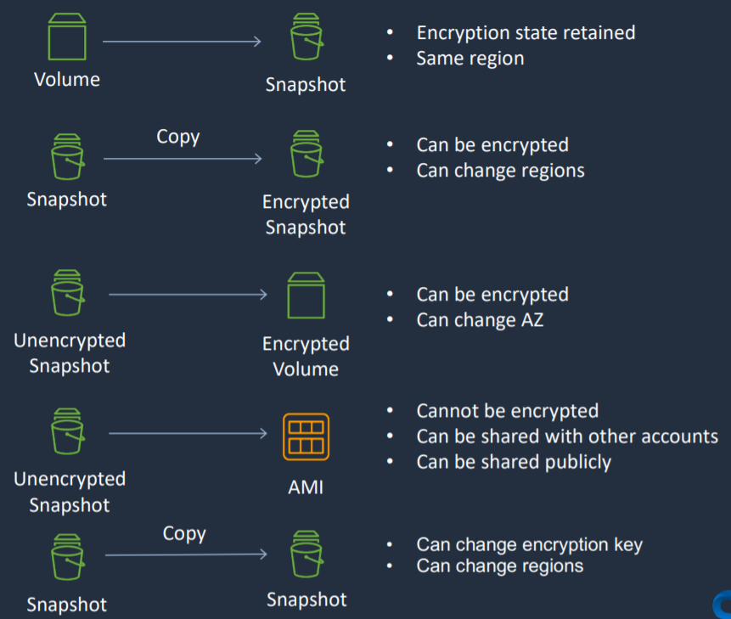

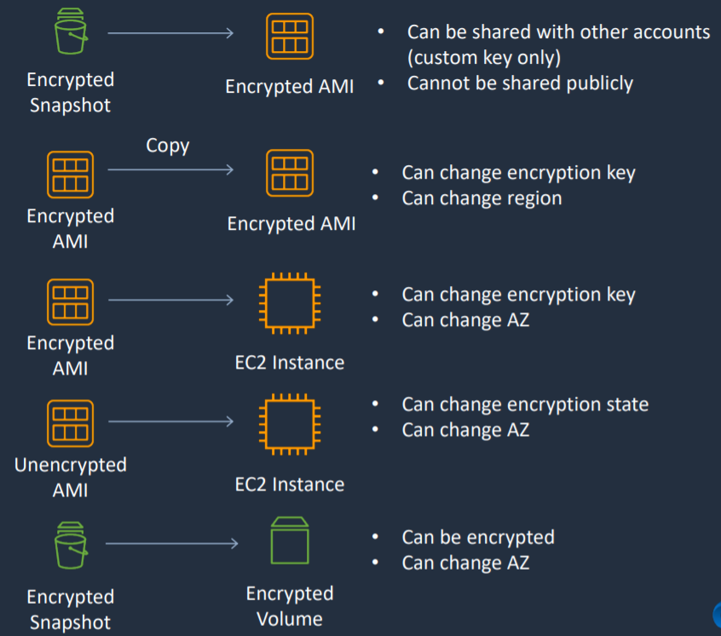

1. When a snapshot is created from EBS Volume, encryption state is retained, and the snapshot is in same region. I won’t be in AZ now but will be in same region.
2. If we take a snapshot and then we want to copy it and create an encrypted snapshot, we can do that. We now have a encrypted snapshot and while we do this we can also optionally change the region in which we want the encrypted snapshot.
3. If we have an unencrypted snapshot, we can create an encrypted volume. So at the time we create a volume from the snapshot, we can choose to encrypt it. And we can also change the AZ, but not the region.
4. If we have an unencrypted snapshot, we can also create an AMI. However, it cannot be encrypted. When we create an AMI it is backed by the snapshot. In other words, this AMI is connected to this snapshot and this is not encrypted, so the AMI cannot be encrypted. You can share AMI with other accounts and share it publicly as well
5. If we have a snapshot and we want a copy to create another snapshot. In this case, we can change the encryption key if it is encrypted, and we can change regions.
6. From an encrypted snapshot, we can create an encrypted AMI. This can be shared with other account, but only if you have a custom encryption key. They cannot be shared publicly
7. From an encrypted AMI, we can copy it to create another encrypted AMI. When we do that we can change encryption key and region.
8. From encrypted AMI we can create EC2 Instance. You can change the encryption key and AZ as you create the instance.
9. From unencrypted AMI we can create EC2 Instance. You can change the encryption key and AZ as you create the instance.
10. From encrypted snapshot, encrypted volume can be created. You can change AZ at this time

### RAID with EBS

1. RAID stands for Redundant Array of Independent disks
2. Not provided by AWS, you must configure through your OS
3. RAID 0 and RAID 1 are potential options on EBS
4. RAID 5 and RAID 6 are not recommended by AWS
5. RAID 0 is used for striping data across disks (performance)
   1. Use 2 or more disks
   2. If one disk fails, the entire RAID set fails
6. RAID 1 is used for mirroring data across disks (redundancy/fault tolerance)
   1. If one disk fails, the other disk is still working
   2. Data gets sent to two EBS volumes at the same time

### DLM (Data Lifecycle Management)

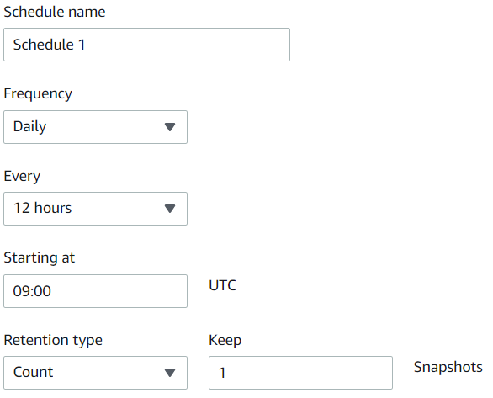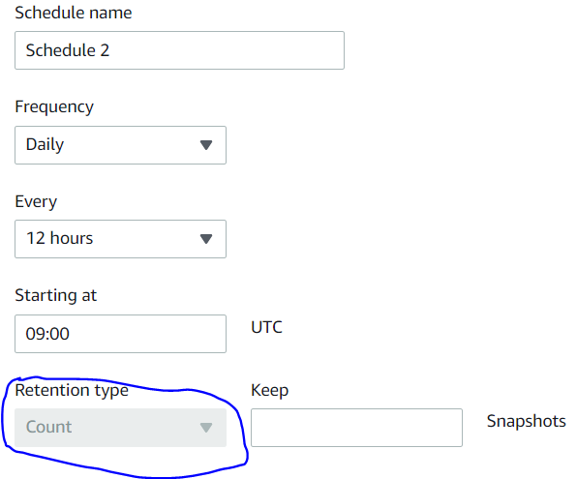

1. Automates the creation, retention, copy and deletion of EBS Snapshots and AMIs
2. Resources that can be targeted can be
   1. Instance
   2. Volume
3. Tag should be added to target only resources of the selected type that have these tags.
4. Schedule
   1. It specifies when to perform DLM action
   2. All schedules must have the same retention type. You can specify the retention type for Schedule 1 only. Schedules 2, 3, and 4 inherit the retention type from Schedule 1. Each schedule can have its own retention count or period.
   3. We can add upto 4 schedules
   4. For retention type Count -> Value must between 1 and 1000
   5. For retention type Age -> It must be between 1 day and 100 years

### EC2 Image Builder

1. Tool that we can use to actually create, customize, manage, and distribute our EC2 images
2. Image Builder provides **a one-stop-shop to automate image management processes**.
3. Customers can generate an automated pipeline with an intuitive wizard in the AWS console to produce compliant Linux and Windows Server images for use on AWS and on-premises.
4. Image creation can be scheduled or created manually

## EC2 Instance Store

* If you need high performance hardware disk, use EC2 Instance Store
* Local storage that is physically attached to host computer and cannot be removed
* Storage is temporary as data loss occurs when EC2 instance is stopped
* Are ephemeral or temporary
* Recommended for
  + Temporary storage need
  + Faster with higher I/O speed
  + Good for buffer/cache/scratch data/temporary content
* Instance store volumes cannot be detached/reattached.
* Instance store volume root devices are created from AMI templates stored on S3

## EBS vs Instance Store

1. Instance Store volumes cannot be stored. If the underlying host fails, you will lose your data.
2. EBS backed instances can be stopped. You will not lose the data on this instance if it is stopped.
3. You can reboot both, you will not lose your data.
4. By default, both root volumes will be deleted on termination. However, with EBS volumes, you can tell AWS to keep the root device volume.

## Amazon Elastic File System (EFS)

* Hierarchical structure
* EFS works with EC2 instances in multi-AZ
* Can be mounted by multiple EC2 instances can be mounted in EC2 or on-premises servers
* Can connect to instance in another VPC
* Can concurrently connect 1 to 1000s of EC2 instances, from multiple AZs.
* Uses NFSv4.1 protocol
* Only supports the Linux file system
* More expensive than EBS
* By default, you can create up to 10 file systems per account.
* There are two performance modes:
  + Performance Mode
    - “General Purpose” performance mode (default)-> latency sensitive use cases
    - “Max I/O” performance mode-> higher latency, throughput, highly parallel (big data, media processing)
  + Throughput mode: Set how your file system’s throughput limits are determined
    - Bursting (1 TB= 50 MiB/s + burst of up to 100MiB/s) -> throughput scales with file system size
    - Provisioned (set your throughput regardless of storage size e.g., 1GiB/s for 1 TB storage) -> throughput fixed at specified amount
* Storage Tiers
  + Standard- for frequently accessed files
  + Infrequent access (EFS-IA): lower price to store, cost to retrieve files
  + Lifecycle management feature
    - Transition into IA
      * Transition files from Standard to Standard-Infrequent Access
      * None
      * 7 days since last access
      * 14 days since last access
      * 30 days since last access
      * 60 days since last access
      * 90 days since last access
    - Transition out of IA
      * None
      * On first access
* In EFS, in terms of consistency, it is always Read After Write Consistency

## Amazon FSx

### Introduction

1. Fully managed service
2. Launch 3rd party high-performance file systems on AWS
3. FSx for Windows File Server
4. FSx for Lustre
5. FSx for NetApp ONTAP

### Amazon FSx for Windows File Server

1. Provides fully managed native Microsoft Windows file system
2. Supports Windows-native file system features
3. Full support for the SMB protocol, Windows NTFS, and Microsoft Active Directory (AD) integration
4. Access Control Lists (ACLs), shadow copies and user quotas
5. Can be accessed from your on-premises infrastructure
6. Can be configured to be Multi-AZ (high availability)
7. Data is backed up daily to S3

### Amazon FSx for Lustre

1. Lustre is a type of parallel distributed file system, for large-scale computing
2. The name Lustre is derived from Linux and Cluster
3. Provides a POSIX-complaint file system interface
4. High Performance file system optimized for fast processing of workloads such as
   1. High Performance Computing (HPC)
   2. Machine learning
   3. Video processing
   4. Financial processing
   5. Electronic design automation (EDA)
5. Works natively with S3, letting you to transparently access your S3 objects as files
6. Your S3 objects are presented as files in your file system, and you can write your results back to S3
7. Can be used from on-premises servers

### FSx File System Deployment Options

1. Scratch File System
   1. Temporary storage
   2. Data is not replicated
   3. Use case
      1. Short term processing
      2. Optimize costs
2. Persistent File System
   1. Long term storage
   2. Data is replicated within same AZ
   3. Use case
      1. Long term processing
      2. Sensitive data

## AWS Storage Gateway

### Introduction

1. Bridge between on-premises data and cloud data in S3
2. Service that enables you to connect your on-premises storage to AWS

### Types of Gateway

#### File Gateway

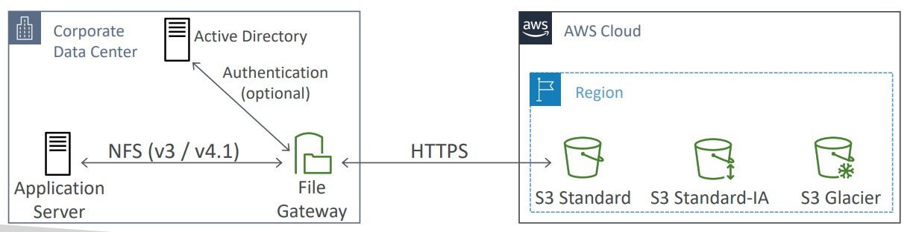

1. Way of connecting your on-premises infrastructure to S3
2. Using NFS and SMB protocol
3. Integrated with Active Directory (AD) for user authentication
4. Supports S3 Standard, S3 IA, S3 One Zone IA
5. Store and retrieve files as objects in Amazon S3
6. Use with on-premises applications, and EC2 based applications that need file storage in S3 for object-based workloads
7. Most recently used data is cached in file gateway

#### Volume Gateway

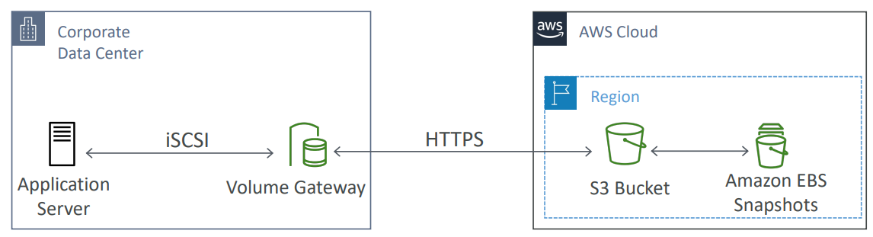

1. Block storage using iSCSI protocol backed by S3
2. Backed by EBS snapshots which can help restore on-premises volumes
3. Two types of Volume Gateway
   1. Cached Volume Mode: the entire dataset is stored on S3 and a cache of the most frequently accessed data is cached on-site
   2. Stored Volume Mode: the entire dataset is stored on-site and is asynchronously backed up to S3

#### Tape Gateway

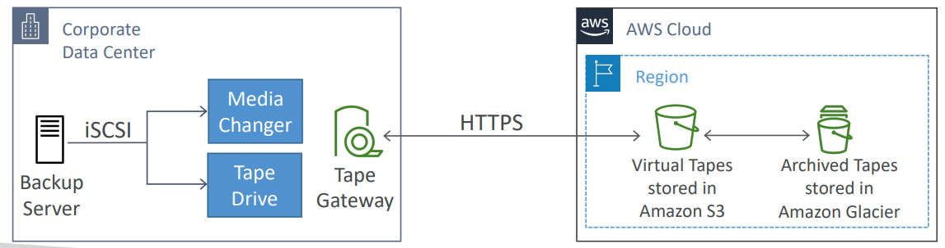

1. Used for backup and uses popular backup applications like NetBackup, Backup Exec, Veeam, etc.
2. When creating virtual tapes, you select one of the following sizes: 100GB, 200 GB, 400 GB, 800 GB, 1.5 TB and 2.5 TB
3. A tape gateway can have up to 1500 virtual tapes with a maximum aggregate capacity of 1 PB
4. All data transferred between the gateway and AWS storage is encrypted using SSL
5. All data stored by tape gateway in S3 is encrypted server-side with Amazon S3-Managed Encryption Keys (SSE-S3)
6. Virtual Tape Library (VTL) backed by Amazon S3 and Glacier
7. Back up data using existing tape-based processes (and iSCSI interface)
8. Works with leading backup software vendors

#### Storage Gateway - Hardware Appliance

1. Using Storage Gateway means you need on-premises virtualization
2. Otherwise, you can use a Storage Gateway Hardware Appliance
3. You can buy it on amazon.com
4. Works with File Gateway, Volume Gateway, Tape Gateway

### AWS Storage Gateway Summary

1. On premises data to the cloud-> Storage Gateway
2. File access / NFS- user auth with Active Directory-> File Gateway (backed by S3)
3. Volumes/ Block Storage/ iSCSI-> Volume gateway (backed by S3 with EBS snapshots)
4. VTL Tape Solution/ Backup with iSCSI-> Tape Gateway (backed by S3 and Glacier)
5. No on-premises virtualization-> Hardware Appliance

## Amazon FSx File Gateway

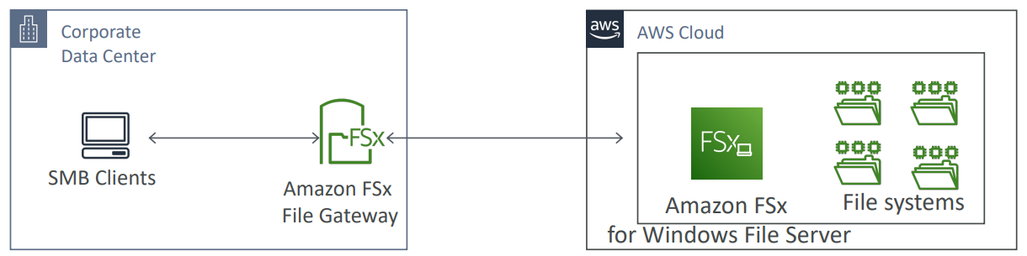

1. Native access to Amazon FSx for Windows File Server
2. Local cache for frequently accessed data
3. Windows native compatibility (SMB, NTFS, Active Directory,..)
4. Useful for group file shares and home directories

## AWS Storage Options

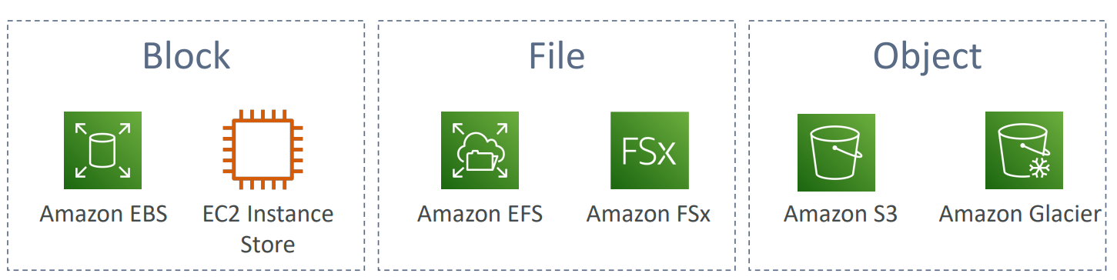

# Scalability, High Availability and Load Balancing

## Scalability

1. Scalability means that an application/system can handle greater loads by adapting
2. There are two kinds of scalability
   1. Vertical Scalability
   2. Horizontal Scalability (=elasticity)
3. Vertical Scalability
   1. Increasing the size of the instance
   2. Scale up/down
   3. t2.micro-> t2.large
   4. Common for non-distributed systems such as a database
   5. There is usually a limit to how much you can vertically scale
   6. Limitation is that you have a single point of failure
4. Horizontal Scalability
   1. Increasing the number of instances/ systems for your application
   2. Scale out/in
      1. Scale out- add new instance
      2. Scale in- remove existing instance
   3. Common for distributed systems
   4. No limitations on scaling
   5. Provides greater resiliency

## High Availability

1. High availability means running your application/ system in at least 2 AZ
2. Goal of high AZ is to survive a data center loss

## Load Balancing

1. Distribute incoming traffic to multiple downstream instances

## Elastic Load Balancer

### Introduction

1. Managed load balancer
2. It is integrated with many AWS services
   1. EC2, EC2 Auto Scaling Groups, Amazon ECS
   2. Route 53, AWS WAF, AWS Global Accelerator
   3. AWS Certificate Manager (ACM), CloudWatch
3. If your application stops responding, ELB is going to respond with a 504 error. 504 means gateway timeout and this means that your application is having an issue
4. Distributes incoming traffic a single AZ or multiple AZs
5. Only 1 subnet per AZ can be enabled for each ELB
6. Ensure at least /27 subnet and make sure there are at least 8 IP addresses available for ELB to scale
7. ELBs can be Internet facing or internal-only
8. Internet facing ELB
   1. ELB nodes have public IPs
   2. Routes traffic to the private IP addresses of the EC2 instances
9. Internal only ELB
   1. ELB nodes have private IPs
   2. Routes traffic to the private IP addresses of the EC2 instances

### ELB – Features

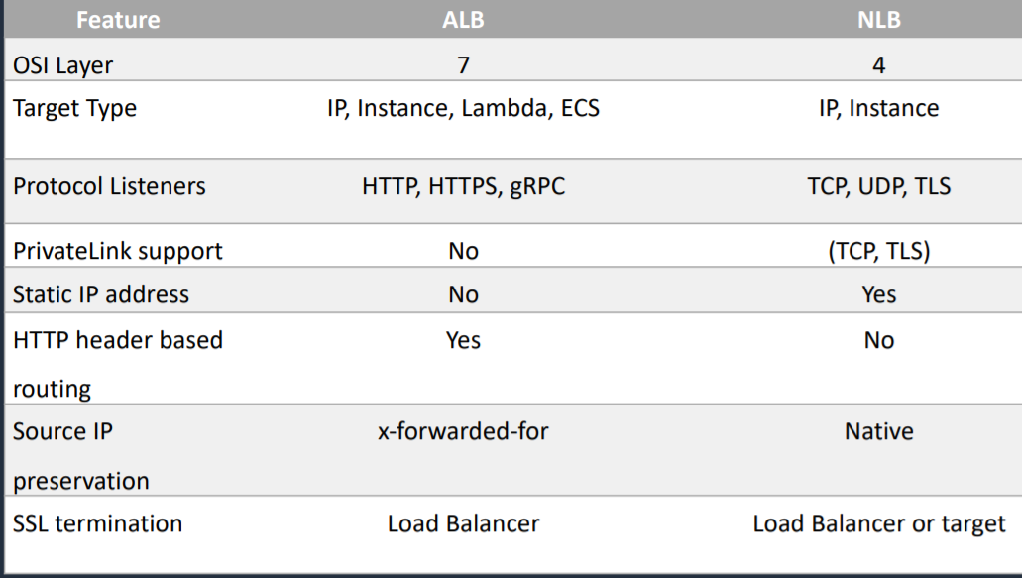

NLB- Private Link Support, Static IP

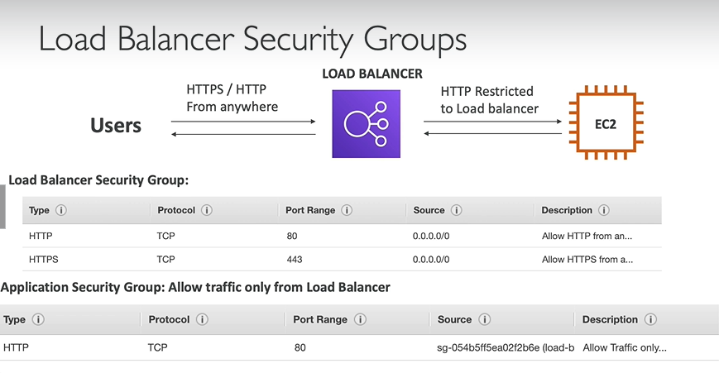

### Types of Load balancer

1. Classic Load Balancer
2. Application Load Balancer
3. Network Load Balancer
4. Gateway Load Balancer

#### Classic Load Balancer

1. Layer 4 (TCP)
2. Layer 7 (HTTP, HTTPS)
3. Unhealthy threshold value can be between 2 and 10. This is number of health checks to be performed before determining that the instance is unhealthy (default=2)
4. Healthy threshold value can be between 2 and 10. This is number of health checks to be performed before determining that the instance is unhealthy (default=10)

#### Application Load Balancer

1. Layer 7 (HTTP, HTTPS)
2. Operates at Application Layer
3. Are application aware
4. Support for HTTP/2 and WebSocket
5. Load balancing to multiple HTTP applications across machines (target groups)
6. Load balancing to multiple applications on the same machine
7. Support redirects (from HTTP to HTTPs for example)
8. Routing tables to different target groups
   1. Routing based on path in URL (example.com/users and example.com/posts)
   2. Routing based on hostname in URL (one.example.com and other.example.com)
   3. Routing based on source IP address
   4. Routing based on Query String, Headers (example.com/users?id=123&order=false)
9. ALB can route to multiple target groups which can be
   1. EC2 instances
   2. ECS tasks
   3. Lambda functions
   4. IP addresses- must be private IP
10. The application servers do not see the IP of the client directly
    1. The true IP of the client is inserted in the header X-Forwarded-For
    2. We can also get Port (X-Forwarded-port) and proto (X-Forwarded-Proto)

#### Network Load Balancer

1. Layer 4 (TCP, UDP)
2. Operates at Transport Layer
3. Handles millions of requests per seconds
4. Less latency-> 100 ms (vs 400 ms for ALB)
5. NLB has one static IP per AZ, and supports assigning Elastic IP
6. NLB are used for extreme performance, TCP or UDP traffic
7. Not included in the AWS free tier
8. Target Groups (target type can be)
   1. EC2 instances
   2. Lambda function
   3. IP Addresses- must be private IPs
   4. Application Load Balancer
9. For NLB, we do not have security groups configured. So, we need to allow all traffic from anywhere in instance level.

#### Gateway Load Balancer

1. Layer 3 – IP packets
2. Operates at Network Layer
3. Deploy, scale, and manage a fleet of 3rd party network virtual appliances in AWS
4. Used in front of virtual appliances such as firewalls, IDS/IPS, and deep packet inspection systems
5. Combines the following functions
   1. Transparent Network Gateway- single entry/exit for all traffic
   2. Load Balancer- distributes traffic to your virtual appliances
6. Uses GENEVE protocol on port 6081
7. Target Groups
   1. EC2 instances
   2. IP Addresses- must be private IPs

### Health Check

1. Health checks are crucial for load balancers
2. They enable load balancer to know if instances it forwards traffic to are available to reply to requests
3. The health check is done on a port and a route (/health is common)
4. If the response is not 200 (ok), then the instance is unhealthy
5. Health checks
   1. EC2 – EC2 status checks
   2. ELB – Uses ELB health checks in addition to EC2 status checks
6. Health Checks grace period
   1. How long to wait before checking the health status of the instance
   2. Auto Scaling does not act on health checks until grace period expires

### Path Patterns

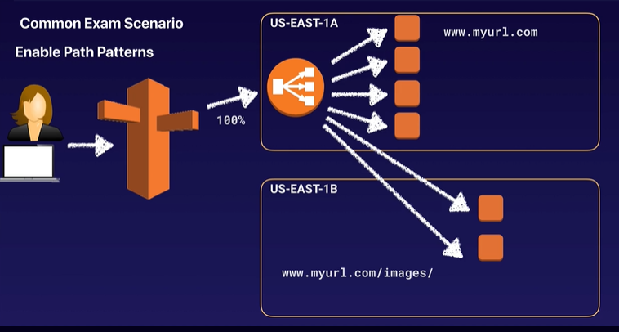

1. This is known as path-based routing.
2. Allows you to direct traffic to different EC2 instances based on the URL contained in the request.
3. For example, you can route general requests to one target group and requests to render images to another target group.

## Session State and Session Stickiness

### Session State

1. Session-state data can be stored in DynamoDB Table.
2. It can also be stored in ElastiCache

### Session Stickiness

#### Introduction

1. It is possible to implement stickiness so that the same client is always redirected to same instance behind a load balancer
2. This works for Classic Load Balancers and Application Load Balancers
3. The “cookie”: used for stickiness has an expiration date you control
4. Enabling stickiness may bring imbalance to the load over the backend EC2 instances
5. Classic load balancer Sticky sessions allow you to bind a user’s session to a specific EC2 instance. This ensures that all requests from the user during the session are sent to the same instance.
6. You can enable Sticky Sessions for Application Load Balancers as well, but the traffic will be sent at the Target Group Level rather than individual EC2 instance.

#### Sticky Sessions - Cookie Names

1. Application based Cookies
2. Duration based Cookies

* This setting is enabled in target group level.
* For application-based cookies, cookie names have to be specified individually for each target group. However, for duration-based cookies, AWSALB is the only name used across all target groups.
* If you are using multiple layers of Application Load Balancers, you can enable sticky sessions across all layers with application-based cookies. However, with duration-based cookies, you can enable sticky sessions only on one layer, because AWSALB is the only name available.

1. Application-based Cookies
   1. Cookie name must be specified for each target group
   2. Don’t use AWSALB, AWSALBAPP, AWSALBTG (reserved for use by the ELB)
2. Duration-based Cookies
   1. Cookie generated by the load balancer
   2. Cookie name is AWSALB for ALB, AWSELB for CLB

## Cross Zone Load Balancing

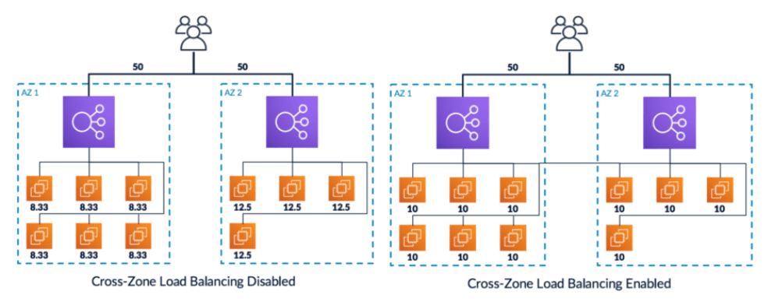

1. Cross Zone Load Balancing enables you to load balance across multiple availability zones.
2. With Classic Zone Load Balancing
   1. Each load balancer instance distributes evenly across all registered instances in all AZ
3. Without Classic Zone Load Balancing
   1. Requests are distributed in the instances of the node of the Elastic Load Balancer

## Cross-Zone Load Balancing with respect to Load Balancer

1. Classic Load Balancer
   1. Disabled by default
   2. No charges for inter AZ data if enabled
2. Application Load Balancer
   1. Always on (cannot be disabled)
   2. No charges for inter AZ data
3. Network Load Balancer
   1. Disabled by default
   2. You pay charges ($) for inter AZ data if enabled

## SSL/TLS

### Introduction

1. SSL Certificate allows traffic between your clients and your load balancer to be encrypted in transit (in-flight encryption)
2. SSL refers to Secure Sockets Layer used to encrypt connections
3. TLS refers to Transport Layer Security, which is newer version
4. Public SSL certificates are issued by Certificate Authorities (CA)
5. SSL Certificates have an expiration date and must be renewed regularly

### Load Balancer - SSL Certificates

1. The load balancer uses an X.509 certificate (SSL/TLS server certificate)
2. You can manage certificates using ACM (AWS Certificate Manager)
3. You can create/ upload your own certificates alternatively

## SNI- Server Name Indication

### Introduction

1. SNI solves the problem of loading multiple SSL certificates onto one web browser (to serve multiple websites)
2. It is a “newer” protocol and requires the client to indicate the hostname of the target server in the initial SSL handshake
3. The server will then find the correct certificate or return the default one
4. Only works for ALB & NLB, CloudFront
5. Does not work with CLB

### Elastic Load Balancers- SSL Certificates wrt SNI

1. Classic Load Balancer
   1. Support only one SSL certificate
   2. Must use multiple CLB for multiple hostname with multiple SSL certificates
2. Application Load Balancer
   1. Supports multiple listeners with multiple SSL certificates
   2. Uses Server Name Indication (SNI) to make it work
3. Network Load Balancer
   1. Supports multiple listeners with multiple SSL certificates
   2. Uses Server Name Indication (SNI) to make it work

## Connection Draining

1. Feature naming
   1. For CLB - Connection Draining
   2. For ALB & NLB - Deregistration Delay
2. It will give some time to complete “in-flight requests” while the instance is de-registering or unhealthy
3. It is a **process** that ensures that existing, in-progress requests are given time to complete when the instance is de-registering
4. Once the connection is drained, ELB will stop sending new requests to the EC2 instance which is de-registering
5. Between 0 to 3600 seconds (default:300 seconds)
6. Can be disabled (set value to 0)
7. Set to a low value if your requests are short

## Auto Scaling Group

### Introduction

1. The goal of Auto Scaling Group (ASG) is to:
   1. Scale out (add EC2 instances) to match an increased load
   2. Scale in (remove EC2 instances) to match a decreased load
   3. Ensure we have a minimum and a maximum number of machines running
   4. Automatically register new instances to a load balancer
   5. ASG can terminate instances marked as unhealthy by an LB (and hence replace them)
2. Number of instances in ASG
   1. Minimum size
   2. Actual Size/ Desired Capacity
   3. Maximum Size
3. ASGs have following attributes
   1. A launch configuration
      1. AMI + Instance Type
      2. EC2 User Data
      3. EBS Volumes
      4. Security Groups
      5. SSH Key Pair
   2. Minimum Size/ Maximum Size/ Initial Capacity
   3. Network + Subnets Information
   4. Load Balancer Information
   5. Scaling Policies
4. ASG cannot span across VPC
5. ASGs use launch configurations or Launch Templates
6. IAM roles attached to an ASG will get assigned to EC2 instances
7. ASG is free. You pay for the underlying resources being launched

### AutoScaling Policies

1. Dynamic Scaling Policies
   1. Target Tracking Scaling
      1. Most simple and easy to set-up
      2. Example: I want the average ASG CPU to stay at around 40%
   2. Simple/Step Scaling
      1. When a CloudWatch alarm is triggered (CPU>70%), then add 2 units
      2. When a CloudWatch alarm is triggered (CPU<30%), then remove 1
   3. Scheduled Actions
      1. Anticipate a scaling based on known usage patterns
      2. Ex: increase the min capacity to 10 at 5 pm on Fridays
2. Predictive Scaling
   1. Continuously forecast load and schedule scaling ahead

### ASG - Monitoring

1. Group Metrics (ASG)
   1. Data points about the ASG
   2. 1 minute granularity
   3. No charge
   4. Must be enabled on our own
   5. Metrics is calculated as average not min or max
2. Basic Monitoring (Instances)
   1. Instances sending metrics to CloudWatch
   2. 5-minute granularity
   3. No charge
3. Detailed Monitoring (Instances)
   1. Instances sending metrics to CloudWatch
   2. 1 minute granularity
   3. Charges apply

### ASG - Custom Metric

1. It is not always compulsory to scale based on metrics provided by AWS. We can create our custom metric like number of connected users

### ASG - Scaling Cooldowns

1. Used with simple scaling policy to prevent AutoScaling from launching or terminating before effects of previous activities are visible
2. After a scaling activity happens, you are in the cooldown period (default 300 seconds)
3. During the cooldown period, the ASG will not launch or terminate additional instances (to allow metrics to stabilize)

### ASG - Termination Policy

1. Controls which instances to terminate first when a scale-in event occurs
2. Default Termination Policy
   1. Find the AZ which has the greatest number of instances
   2. If there are multiple instances in the AZ to choose from, delete the one with the oldest launch configuration
   3. ASG tries to balance the number of instances across AZ by default

### ASG - Termination Protection

1. Prevents Auto Scaling from terminating protected instances

### Good Metrics to scale on

1. CPU Utilization
2. RequestCountPerTarget
3. Average Network In/ Out
4. Any Custom Metric

### Lifecycle Hooks

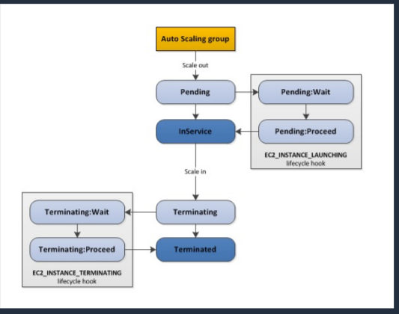

1. Used to perform custom actions by pausing instances as the ASG launches or terminates them
2. By default, as soon as an instance is launched in the ASG, it is in service
3. You have the ability to perform extra steps before the instance goes in service (Pending state)
4. You have the ability to perform some actions before the instance is terminated (Terminating state)
5. Use case
   1. Run a script to download and install software after launching
   2. Pause an instance to process data before a scale-in (termination)

### Standby State

1. Used to put an instance in the InService state into the Standby state
2. This gives you an opportunity to update or troubleshoot the instance without worrying about it getting terminated

### Launch Template vs Launch Configuration

1. Both requires ID of AMI, instance type, a key pair, security groups and other parameters that you use to launch EC2 instances (tags, EC2 User Data)
2. Launch Configuration (legacy)
   1. Must be re-created every time
3. Launch Template (newer)
   1. Recommended by AWS going forward
   2. Can have multiple versions
   3. Create parameters subsets (partial configuration for re-use and inheritance)

Note

If you need the IPv4 address of your end user, look for the X-Forwarded-For header.

Instances monitored by ELB are reported as InService or OutofService.

Load balancers have their own DNS name. You are never given an IP address.

# Databases

## Relational vs Non-Relational

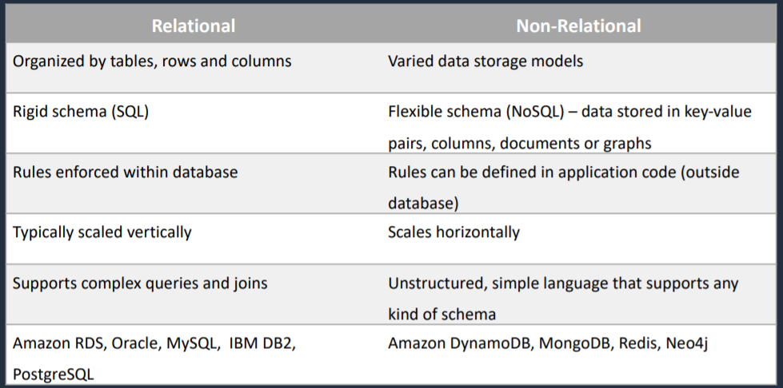

Relational Database scales vertically.

Non-Relational Database scales horizontally.

## Operational vs Analytical

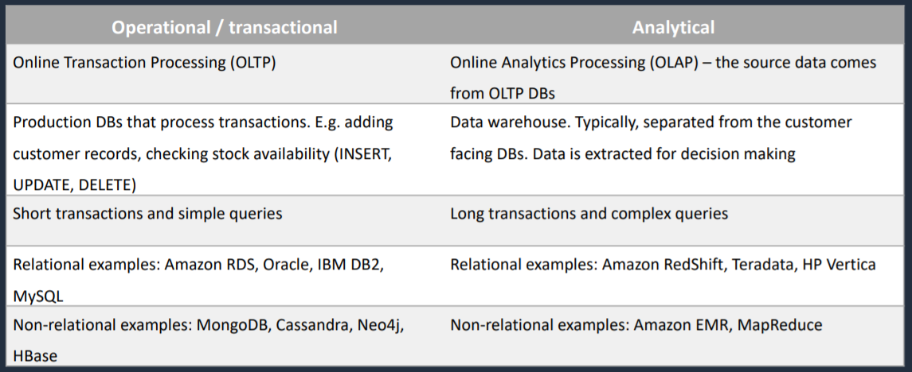

# RDS

## Introduction

1. RDS stands for Relational Database Service
2. It is managed database service that use SQL as a query language
3. RDS is not serverless
4. It allows you to create databases in the cloud that are managed by AWS
   1. Postgres
   2. MySQL
   3. MariaDB
   4. Oracle
   5. Microsoft SQL Server
   6. Aurora (AWS Proprietary database)
5. AWS manages database with automatic software patching, automatic backups, operating system management and more.

## Advantages over using RDS versus deploying database on EC2

1. RDS is a managed database service
   1. Automated provisioning, OS patching
   2. Monitoring dashboards
   3. Maintenance windows for upgrades
   4. Continuous backups and restore to specific timestamp (Point in Time Restore)
   5. Read replicas for improved read performance
   6. Multi-AZ setup for disaster recovery
   7. Scaling capacity (vertical and horizontal)
   8. Storage backed by EBS (gp2 or io1)
2. BUT You cannot SSH into your instance

## Backups

1. Backups are automatically enabled in RDS
2. Automated backups
   1. Daily full backup of database (during the maintenance window)
   2. Transaction logs are backed-up by RDS every 5 minutes
   3. Allows you to recover your database to any point in time within a retention period
   4. Retention period can be between one and 35 days (7 days default)
   5. It will take a full daily snapshot and we will also store transaction logs throughout the day and when we do a recovery, AWS will first choose the most recent daily backup and then apply the transaction logs relevant to that day and this allows you to do point in time recovery down to a second within the retention period.
   6. Automated backups are enabled by default and the backup data is stored in S3 and you get free storage space equal to the size of your database. So if you have an RDS instance of 10 Gb, you will get 10 Gb worth of storage
   7. Backups are taken within a defined window.
   8. During the backup window, storage I/O may be suspended while your data is being backed up and you may experience elevated latency.
3. DB Snapshots
   1. Manually triggered by the user
   2. Retention of backup for as long as you want
   3. They are stored even after you delete the original RDS instance, unlike automated backups
   4. Backs up the entire database instance, not just individual databases
   5. For single AZ database instances there is a brief suspension of I/O
   6. For multi-AZ Server, I/O activity is briefly suspended on primary
   7. For Multi-AZ MariaDB, MySQL, Oracle, and PostgreSQL the snapshot is taken from the standby
4. Whenever you restore either an Automated Backup or a manual Snapshot, the restored version of the database will be a new RDS instance with a new DNS endpoint.

## Maintenance Windows

1. Operating system and database patching can require taking the database offline
2. These tasks take place during a maintenance window
3. By default, a weekly maintenance window is configured. But you can choose your own maintenance window.

## Storage Auto Scaling

1. Helps you increase storage on your RDS database instance dynamically
2. When RDS detects you are running out of free database storage, it scale automatically
3. Avoid manually scaling your database storage
4. You have to set Maximum Storage Threshold (maximum limit for DB storage)
5. Automatically modify storage if
   1. Free storage is less than 10% of allocated storage
   2. Low storage lasts at least 5 minutes
   3. 6 hours have passed since last modification
6. Useful for applications with unpredictable workloads
7. Supports all RDS database engines (MariaDB, MySQL, PostgreSQL, SQL Server, Oracle)

## Read Replicas

1. It used for performance improvement and scaling
2. It is not used for disaster recovery
3. It is available for following databases
   1. Oracle
   2. MySQL Server
   3. PostgreSQL
   4. MariaDB
   5. Aurora (Not in SQL)
4. Up to 5 read replicas
5. You can have read replicas of read replicas
6. Each read replicas will have its own DNS end point
7. Within AZ, Cross AZ, or Cross Region
8. Replication is asynchronous, so reads are eventually consistent
9. Read/ Write happens in main database
10. Read happens in read replica. Read replicas are used for SELECT (=read) only kind of statements (not INSERT, UPDATE, DELETE)
11. Must have automatic backups turned on in order to deploy a read replica
12. Can be promoted to master, this will break the read replica
13. Network Cost
    1. In AWS, there is a network cost when data goes from one AZ to another
    2. In RDS Read Replicas, network cost within same region is free. Network between region is paid.

## Multi-AZ (Disaster Recovery)

1. Synchronous replication
2. One DNS Name- automatic app failover to standby
3. Increase availability
4. Not used for scaling
5. Read and write happens only in Primary instance. No read and write happens in Standby instance
6. It is available for following databases
   1. SQL Server
   2. Oracle
   3. MySQL Server
   4. PostgreSQL
   5. MariaDB (Not in Aurora)

## Difference between RDS Multi-AZ and Read Replicas

|  |  |
| --- | --- |
| **Multi-AZ Deployments** | **Read Replicas** |
| a) Synchronous replication – highly durable | a) Asynchronous replication – highly scalable |
| b) Only database engine on primary instance is active | b) All read replicas are accessible and can be used for read scaling |
| c) Automated backups are taken from standby | c) No backups configured by default |
| d) Always span two AZ within a single region | d) Can be within an AZ, Cross-AZ or Cross-Region |
| e) Database engine version upgrades happen on primary | e) Database engine version upgrade is independent from source instance |
| f) Automatic failover to standby when a problem is detected | f) Can be manually promoted to a standalone database instance |

## RDS - from Single AZ to Multi AZ

1. Zero downtime operation (no need to stop DB)
2. Just click on “modify” for the database
3. The following happens internally
   1. A snapshot is taken
   2. A new DB is restored from the snapshot in a new AZ
   3. Synchronization is established between the two databases

## RDS - Security Network and IAM

1. Network Security
   1. RDS Databases are usually deployed within a private subnet, not in a public one
   2. RDS security works by leveraging security groups- it controls which IP/security group can communicate with RDS
2. Access Management
   1. IAM policies help control who can manage AWS RDS (through RDS API)
   2. Traditional username and password can be used to login into the database
   3. IAM based authentication can be used to login into RDS MySQL and PostgreSQL

## RDS - IAM Authentication

1. IAM database authentication works with MySQL and PostgreSQL
2. You do not need a password, just authentication token obtained through IAM and RDS API calls
3. Auth token has a lifetime of 15 minutes

## RDS - Security Encryption

1. At rest encryption
   1. You can only enable encryption for an Amazon RDS DB instance when you create it, not after the database instance is created
   2. DB Instances that are encrypted cannot be modified to disable encryption
   3. Once your RDS instance is encrypted, the data stored at rest in the underlying storage is encrypted, as are its automated backups, read replicas and snapshots.
   4. You cannot have
      1. An encrypted read replica of an unencrypted database instance
      2. An unencrypted read replica of an encrypted database instance
   5. You cannot restore an unencrypted backup or snapshot to an encrypted database instance
   6. The same KMS key is used if in the same region as the primary
   7. If the read replica is in a different region, a different KMS key is used
   8. Transparent Data Encryption (TDE) available for Oracle and SQL Server
2. In-flight encryption
   1. SSL certificates to encrypt data to RDS in flight
   2. Provide SSL options with trust certificate when connecting to database
   3. To enforce SSL
      1. PostgreSQL: rds.force_ssl=1 in the AWS RDS Console (Parameter Groups)
      2. MySQL: Within the DB: GRANT USAGE ON *.* TO ‘mysqluser’@’%’ REQUIRE SSL

## RDS - Encryption Operations

1. Encrypting RDS backups
   1. Snapshots of unencrypted RDS databases are un-encrypted
   2. Snapshots of encrypted RDS databases are encrypted
   3. Can copy a snapshot into an encrypted one
2. To encrypt an un-encrypted RDS database
   1. Create a snapshot of the unencrypted database
   2. Copy the snapshot and enable encryption for the snapshot
   3. Restore the database from encrypted snapshot
   4. Migrate applications to the new database, and delete the old database

AWS responsibility- No SSH access

## RDS - Database Ports

1. MySQL – 3306
2. MariaDB – 3306 (same as MySQL)
3. Oracle RDS – 1521
4. PostgreSQL – 5432
5. MSSQL Server – 1433
6. Aurora – 5432 (if PostgreSQL compatible) or 3306 (if MySQL compatible)

## Amazon RDS Anti-Patterns and Alternatives

When not to use Amazon RDS

1. Anytime you need a database type other than MySQL, MariaDB, SQL Server, Oracle, PostgreSQL
2. You need root access to the OS (e.g. install software such as management tools)
3. Lots of large binary objects (BLOBs) -> S3
4. Automated Scalability -> DynamoDB
5. Name/Value data structure -> DynamoDB
6. Data is not well structured or unpredictable -> DynamoDB
7. Other database platforms like IBM DB2 or SAP HANA -> EC2
8. Complete control over the database -> EC2

## RDS for Solutions Architect

1. Operations
   1. Small downtime when failover happens when maintenance happens
   2. Scaling in read replicas
2. Security
   1. AWS is responsible for OS security
   2. We are responsible for setting up KMS, security groups, IAM policies, authorizing users in database and enforcing use of SSL
3. Reliability
   1. Multi AZ feature
4. Performance
   1. Performance depends on EC2 instance type, EBS volume type
   2. Ability to add read replicas
   3. Has storage auto-scaling feature if enabled
   4. Manual scaling of instances
5. Cost
   1. Pay per hour based on provisioned EC2 and EBS

# Aurora

## Introduction

1. Serverless
2. Aurora is a proprietary technology from AWS (not open source)
3. Is cloud optimized
4. MySQL and PostgreSQL are both supported as Aurora database
5. 5x performance improvement over MySQL on RDS
6. 3x performance of Postgres on RDS
7. Aurora storage automatically grows in increments of 10GB, upto 128 TB
8. Compute resources can scale up to 32vCPUs and 244GB of memory
9. Aurora can have 15 replicas while MySQL has 5, and the replication process is faster
10. Aurora costs more than RDS (20% more)
11. 2 copies of your data is contained in each availability zone, with minimum of 3 AZ, 6 copies of data
12. Aurora is designed to transparently handle the loss of up to 2 copies of data without affecting write availability and up to 3 copies without affecting read availability
13. Aurora storage is also self-healing. Data blocks and disks are continuously scanned for errors and repaired automatically
14. Three types of Aurora Replicas are available
    1. Aurora Replicas (currently 15)- automated failover is only available with Aurora Replicas
    2. MySQL Read Replicas (currently 5)
    3. PostgreSQL (currently 1)

## Key Features

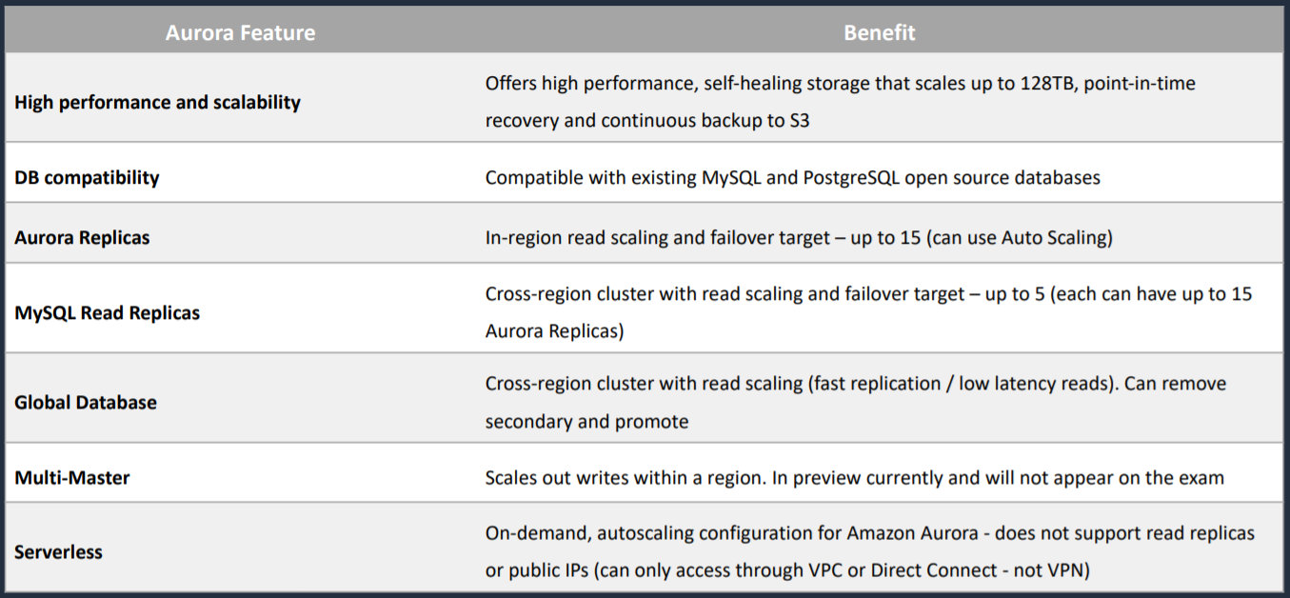

## Aurora DB Cluster

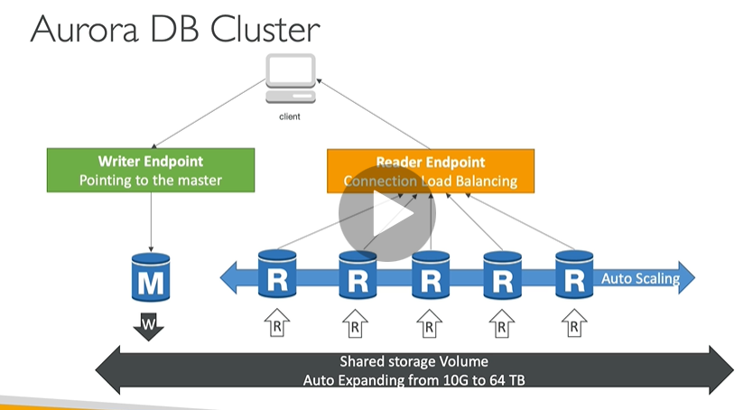

## Serverless

1. On-demand, autoscaling configuration Amazon Aurora.
2. An Aurora Serverless DB cluster automatically starts up, shuts down, and scales capacity up or down based on your application’s needs.
3. Does not support read replicas or public IPs
4. Can only access through VPC or Direct Connect – not VPN

## Backups

1. Automated backups are always enabled on Amazon Aurora DB instances. Backups do not impact database performance.
2. You can also take snapshots with Aurora. This also does not impact on performance.
3. You can share Aurora Snapshots with other AWS accounts.

## Fault Tolerance

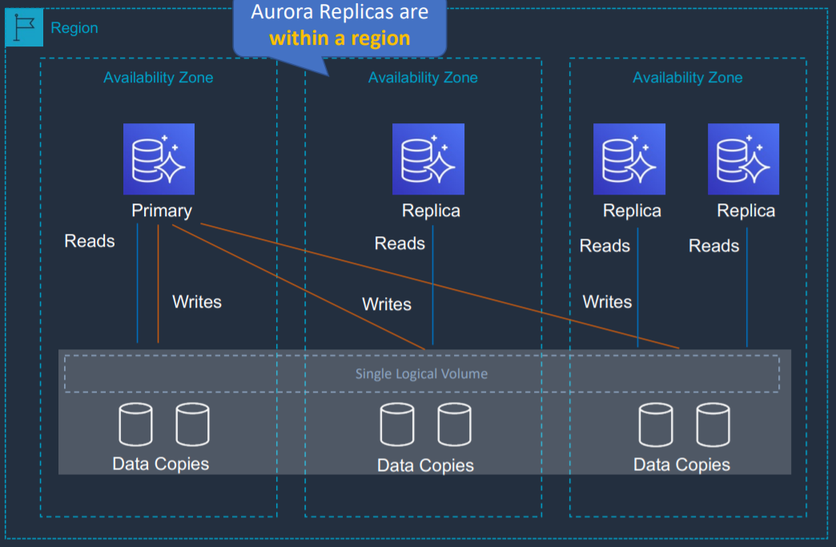

1. Aurora replicas can be in different AZ but is in same region
2. Aurora Fault Tolerance
   1. Fault tolerance across 3 AZs
   2. Up to 15 aurora replicas with sub-10 ms replica lag
   3. Can promote Aurora Replica to be a new primary or create new primary
   4. Set priority on Aurora Replicas to control order of promotion
   5. Can use Autoscaling to add replicas

## Aurora Replicas vs MySQL Replica

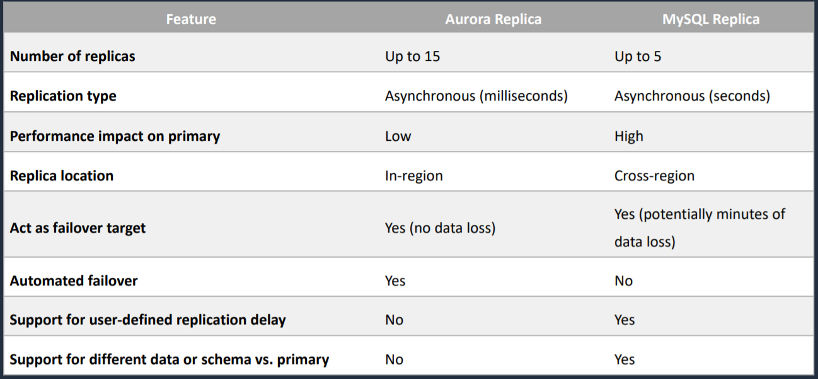

## Aurora - Multi-Master

1. In case you want immediate failover for write node
2. All nodes allow read/writes
3. Available for MySQL only
4. Up to four read/write nodes
5. Single region only
6. You cannot have cross region replicas

## Aurora - High Availability and Read Scaling

1. 6 copies of your data across AZ
   1. 4 copies out of 6 needed for write
   2. 6 copies out of 6 copies for reads
2. One Aurora instance takes writes (master)
3. Automated failover for master in less than 30 seconds
4. Support for Cross Region Replication

## Aurora - Security

1. Similar to RDS
2. Encryption at rest using KMS
3. Encryption in flight using SSL
4. Automated backups, snapshots and replicas are also encrypted
5. Possibility to authenticate using IAM token (same method as RDS)
6. You are responsible for protecting the instance with security groups
7. You cannot SSH

## Aurora Replicas - Auto Scaling

1. It is possible to scale read replicas of Aurora

## Aurora - Custom Endpoints

1. Define a subset of Aurora instances as a custom endpoint
2. Example: run analytical queries on specific replicas
3. Reader endpoint is generally not used after defining Custom Endpoints

## Global Aurora

1. Aurora Cross Region Read Replicas
   1. Useful for disaster recovery
2. Aurora Global Database (recommended)
   1. 1 primary region (read/write)
   2. Upto 5 secondary (read-only) regions, replication lag is less than 1 second
   3. Upto 16 read replicas per secondary region
   4. Helps for decreasing latency
   5. Promoting another region (for disaster recovery) has an RTO (recovery time of) < 1 minute

## Aurora Machine Learning

Supported services

1. Amazon SageMaker
2. Amazon Comprehend

## Aurora for Solutions Architect

1. Operations
   1. Less operations
   2. Auto scaling storage
2. Security
   1. AWS is responsible for OS security
   2. We are responsible for setting up KMS, security groups, IAM policies, authorizing users in database and enforcing use of SSL
3. Reliability
   1. Multi AZ, highly available possibly more than RDS due to Aurora Serverless option, Aurora Multi-Master option
4. Performance
   1. 5x performance due to architectural optimizations
   2. Up to 15 read replicas (only 5 for RDS)
5. Cost
   1. Pay per hour based on provisioned EC2 and storage usage

# ElastiCache

## Introduction

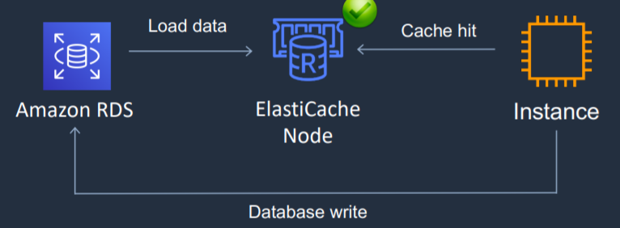

1. Managed, serverless
2. In-memory databases
3. ElastiCache is to get managed Redis or Memcached
4. It is a key/value store
5. Often used for storing session state
6. Helps make your application stateless
7. Can be put in front of databases such as RDS and DynamoDB
8. ElastiCache nodes run on Amazon EC2 instances, so you do need to choose an instance type when you launch your database cluster
9. Using ElastiCache involves heavy application code changes

## ElastiCache - DB Cache

1. Application queries ElastiCache, if not available, get from RDS and store in ElastiCache
2. Helps relieve load in RDS
3. Cache must have an invalidation strategy to make sure only the most current data is stored there

## ElastiCache - User Session Store

1. User logs into any of the application
2. The application writes the session data into ElastiCache
3. The user hits another instance of our application
4. The instance retrieves the data, and the user is already logged in

## Redis vs Memcached

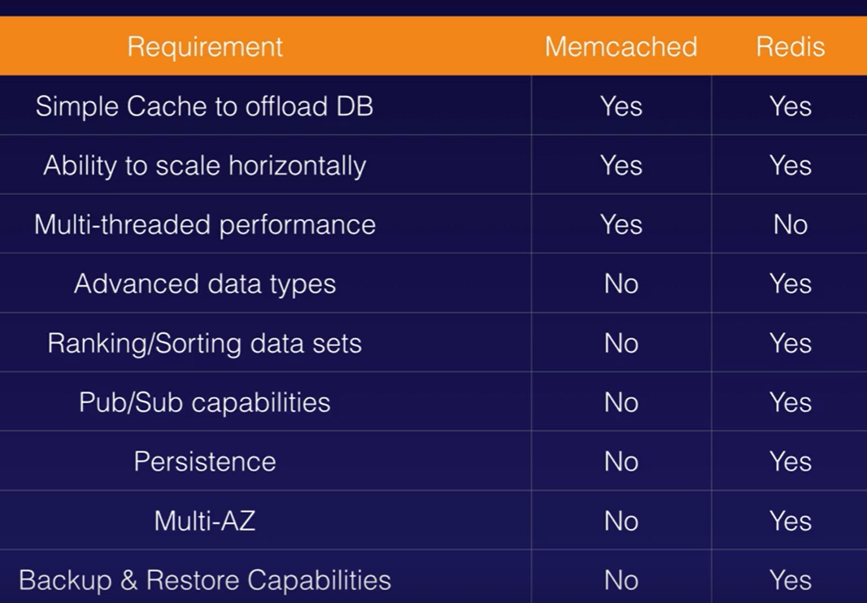

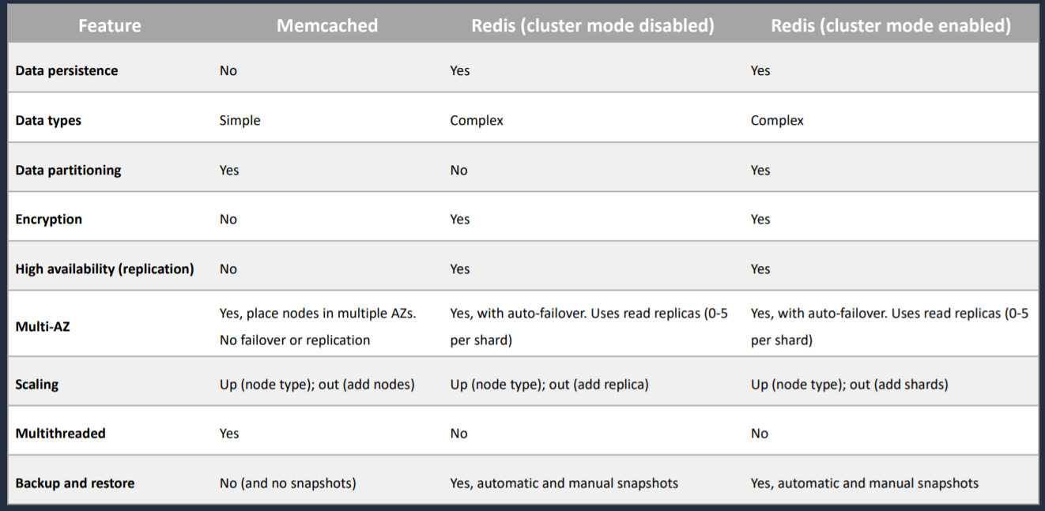

Redis is multi-AZ. You can do backups and restores of Redis.

Memcached - Multi-node for partitioning of data

Redis- encryption

## Redis Use Case

1. Gaming Leaderboards are computationally complex
2. Redis Sorted Sets guarantee both uniqueness and element ordering
3. Each time a new element is added, it is ranked in real tie, then added in correct order

## Scaling ElastiCache

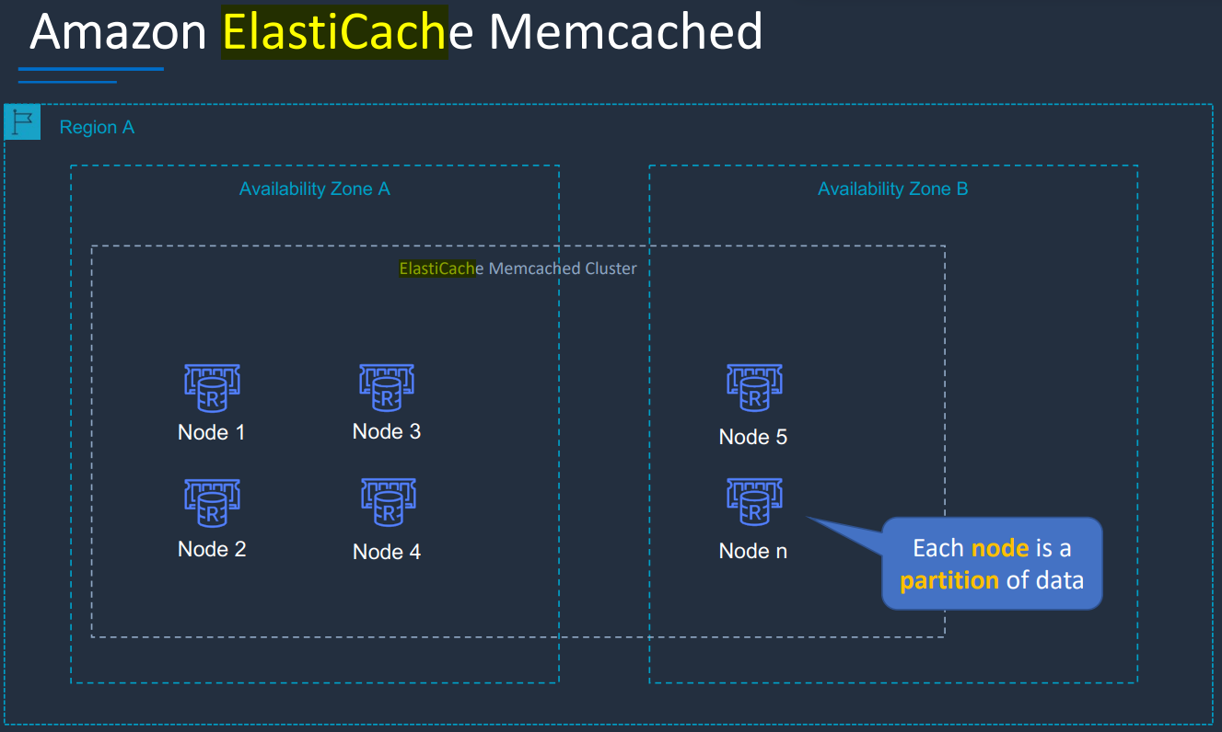

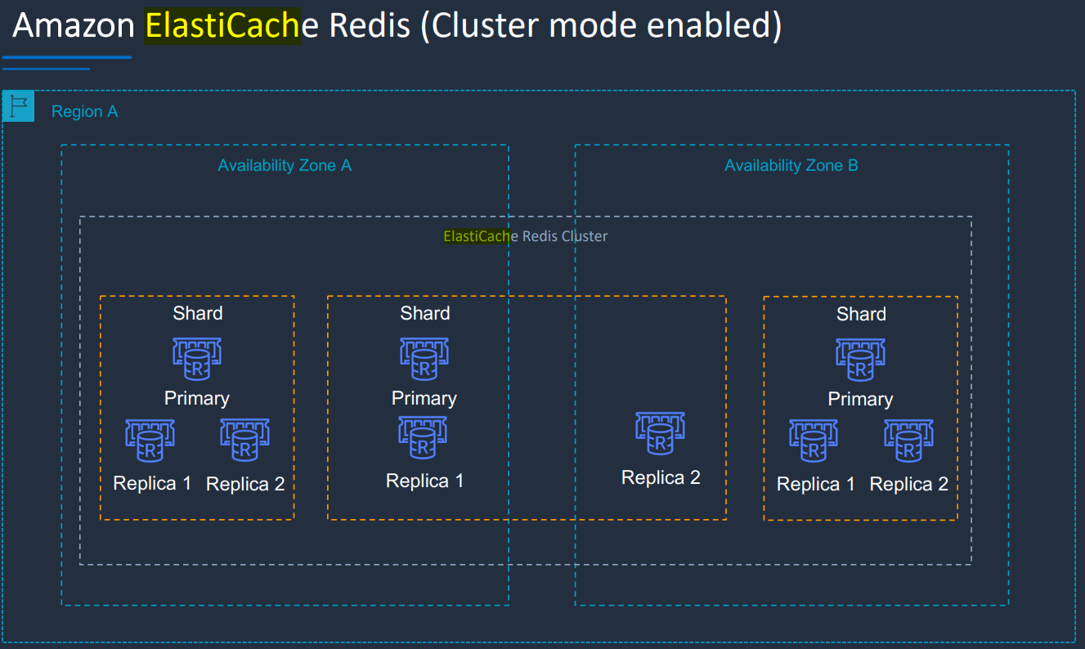

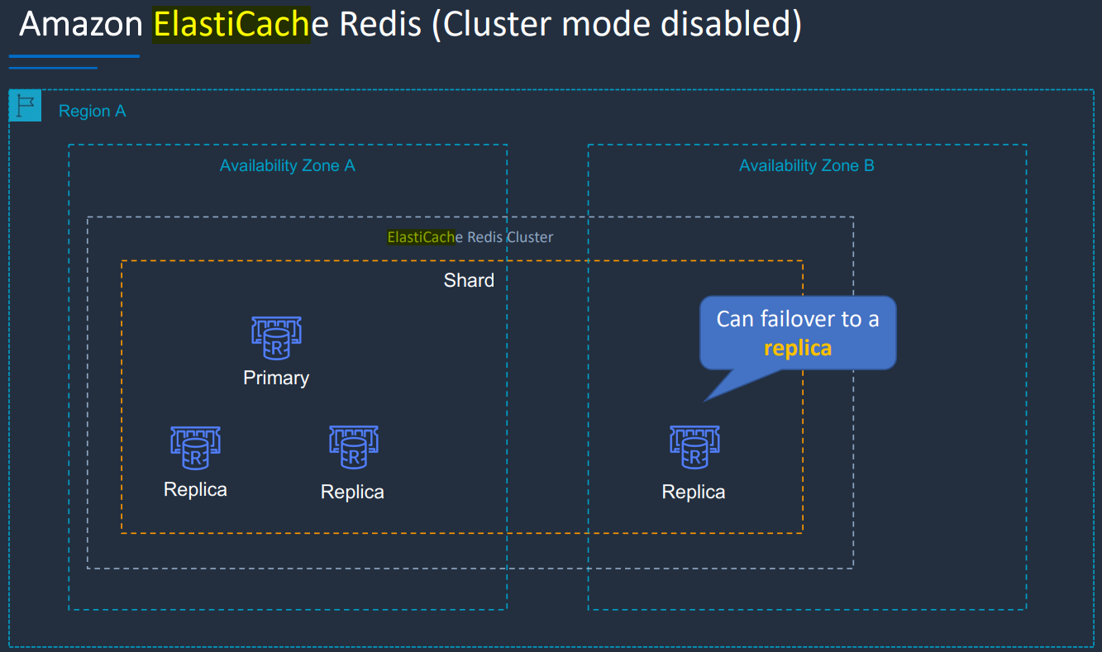

Memcached

1. Add nodes to a cluster
2. Scale vertically (node type) – must create a new cluster manually

Redis

1. Cluster mode disabled
   1. Add replica or change node type – creates a new cluster and migrates data
2. Cluster mode enabled
   1. Online resharding to add or remove shards; vertical scaling to change node type
   2. Offline resharding to add or remove shards change node type or upgrade engine (more flexible than online)

## ElastiCache - Cache Security

1. All caches in ElastiCache
   1. Do not support IAM authentication
   2. IAM policies on ElastiCache are only used for AWS API-level security
2. Redis AUTH
   1. You can set a “password/token” when you create a Redis cluster
   2. This is an extra level of security of your cache (on top of security groups)
   3. Support SSL in flight encryption
3. Memcached
   1. Supports SASL-based authentication (advanced)

## Patterns for ElastiCache

1. Lazy Loading
   1. All the read data is cached
   2. Data can become stale in cache
2. Write Through
   1. Adds or updates data in cache when written to a DB
   2. No stale data

## ElastiCache for Solutions Architect

1. Operations
   1. Same as RDS
2. Security
   1. AWS is responsible for OS security
   2. We are responsible for setting up KMS, Security Groups, IAM policies, users (Redis Auth), enforcing use of SSL
3. Reliability
   1. Clustering
   2. Multi AZ
4. Performance
   1. Sub millisecond performance
   2. In memory read replicas for sharding
5. Cost
   1. Pay per hour based on EC2 and storage usage

# Route 53

## DNS Terminologies

1. Domain Registrar
   1. Amazon Route 53
   2. GoDaddy
2. DNS Records
   1. A
   2. AAAA
   3. CNAME
   4. NS
3. Zone File
   1. Contains DNS records
4. Name Server
   1. Resolves DNS queries
5. Top Level Domain (TLD)
   1. .com
6. Second Level Domain (SLD)
   1. amazon.com

## Parts of Fully Qualified Domain Name

<http://api.www.example.com>

TLD-> .com

SLD-> example.com

Sub Domain-> [www.example.com](http://www.example.com)

Domain Name-> api.www.example.com

http-> Protocol

FQDN (Fully Qualified Domain Name)-> <http://api.www.example.com>

## Domain Registrars

1. To ensure uniqueness of domain names across the Internet
2. Each domain name becomes registered in a central database known as WhoIS database
3. Popular domain registrars include:
   1. Amazon
   2. GoDaddy.com
   3. 123-reg.co.uk

## Introduction to Route 53

1. Domain Name System (DNS) service that routes user to application by translating domain name to IP addresses
2. Route 53 is also a Domain Registrar-> helps in domain name registration
3. Performs health checks on AWS resources
4. Supports hybrid architecture
5. Is used for disaster recovery by re-routing traffic from one instance to instance in another region
6. Integrates with ELB, S3, and CloudFront as endpoints.
7. The only AWS service which provides 100% availability SLA
8. Why Route 53?
   1. 53 is a reference to the traditional DNS port
9. You can transfer domains to Route 53 only if the Top-Level Domain (TLD ) is supported
10. You can transfer a domain from Route 53 to another registrar by contacting AWS Support

## Records

1. How you want to route traffic for a domain
2. Each record contains
   1. Domain/ Subdomain name: example.com
   2. Value: 123.456.789.123
   3. RecordType: A or AAAA
   4. Routing Policy: how route 53 responds to queries
   5. TTL: amount of time the record cached at DNS Resolvers
3. Route 53 supports following DNS record types
   1. A – maps a hostname to IPv4
   2. AAAA – maps a hostname to IPv6
   3. NS – Name Servers for the Hosted Zone
   4. CNAME – maps a hostname to another hostname
      1. The target is a domain name which must have a A or AAAA record
      2. Cannot create a CNAME record for the top node of a DNS namespace
      3. Ex: you cannot create for example.com, but you can create for [www.example.com](http://www.example.com)
   5. Alias Records
      1. Maps a hostname to an AWS resource
      2. Unlike CNAME, it can be used for the top node of a DNS namespace E.g. example.com
      3. Alias record is always of type A/AAAA for AWS resources (IPv4/IPv6)
      4. They have native health check capability
      5. Automatically recognizes changes in the resource’s IP addresses
      6. You cannot set TTL. Its set automatically by Route 53
   6. PTR Records: used to convert IP address to domain name, opposite of A record

## CNAME vs Alias

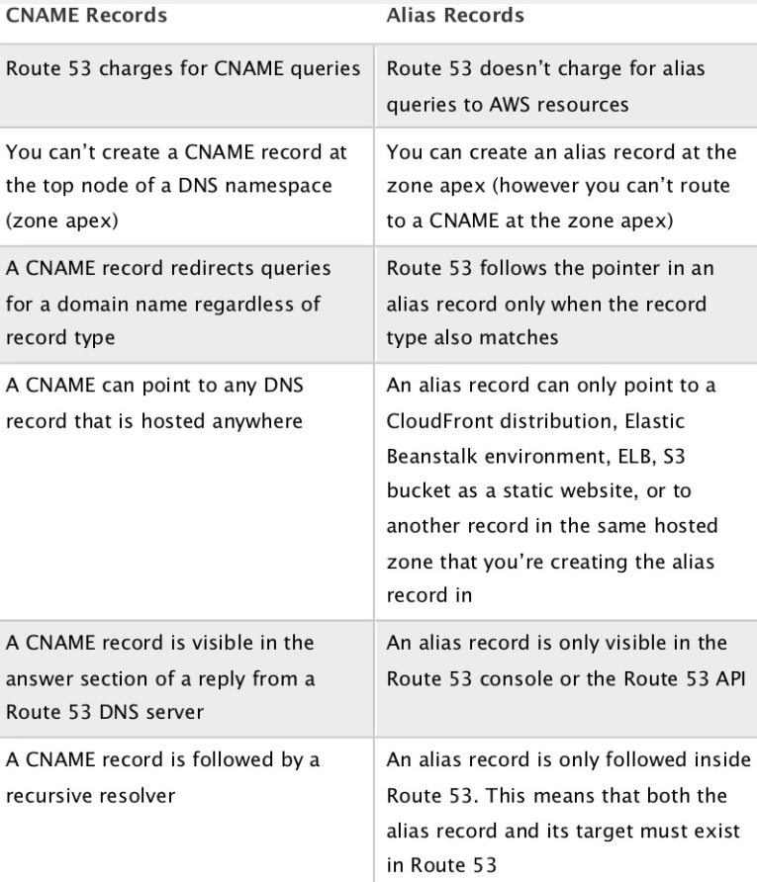

## Route 53 – Hosted Zones

1. A container for records that define how to route traffic to a domain and its subdomain
2. Public Hosted Zones
   1. Allows anyone from Internet to query your record
   2. Contains records that specify how to route traffic on the Internet (public domain names)
3. Private Hosted Zones
   1. Allows querying only from private network like your VPC
   2. Contains records that specify how you route traffic within one or more VPCs (private domain names)
   3. For private hosted zones you must set the following VPC settings to “True”
      1. enableDnsHostname
      2. enableDnsSupport
4. You pay $0.5 per month per hosted zone

## Route 53 - TTL

1. Time to Live
2. Time period for which result of record is cached into client machine
3. High TTL
   1. E.g. 24 hr
   2. Less traffic on route 53
   3. Possibly outdated records
4. Low TTL
   1. E.g. 60 sec
   2. More traffic on Route 53
   3. Records are outdated for less time
   4. Easy to change records
5. Except for Alias records, TTL is mandatory for each DNS record

## Route 53 – Alias Records Targets

1. Elastic Load Balancers
2. CloudFront Distributions
3. API Gateway
4. Elastic Beanstalk environments
5. S3 Websites
6. VPC Interface Endpoints
7. Global Accelerator
8. Route 53 record in the same hosted zone
9. You cannot set an ALIAS record for an EC2 DNS name

## Routing Policy

1. Define how Route 53 responds to DNS queries
2. Route 53 supports the following routing policies
   1. Simple
   2. Weighted
   3. Failover
   4. Latency based
   5. Geolocation
   6. Multi-value Answer
   7. Geoproximity

### Routing Policy - Simple

1. Route traffic to a single resource
2. Can specify multiple values in the same record
3. If multiple values are returned, a random one is chosen by the client
4. When alias is enabled, specify only one AWS resource
5. Cannot be associated with health checks

### Routing Policy - Weighted

1. Control the % of the requests that go to each specific resource
2. Assign each record a relative weight
   1. Traffic (%)= weight for a specific record/ Sum of all the weights for all records
   2. Weights don’t need to sum up to 100
3. DNS records must have the same name and type
4. Can be associated with Health Checks
5. Use cases
   1. Load balancing between regions
   2. Testing new application versions
6. Assign a weight of 0 to a record to stop sending traffic to a resource
7. If all records have weight of 0, then all records will be returned equally

### Routing Policy - Latency-based

1. Redirect to the resource that has the least latency close to us
2. Helpful when latency for users is a priority
3. Latency is based on traffic between users and AWS Regions
4. Can be associated with Health Checks (has a failover capability)

### Routing Policy - Failover

1. Route traffic to healthy instance
2. There will be primary and secondary record. Primary record should be associated with health check
3. Active-Passive

### Routing Policy - Geolocation

1. Different from latency-based
2. This routing is based on user location
3. Specify location by continent, country or by US State (if there is overlapping most precise location is selected)
4. Should create a “Default” record (in case there is no match on location)
5. Use case
   1. Website localization
   2. Restrict content distribution
   3. Load balancing
6. Can be associated with Health Checks

### Routing Policy - Multi-value

1. Use when routing traffic to multiple resources
2. Route 53 return multiple values/resources
3. Can be associated with Health Checks (return only values for healthy resources)
4. Upto 8 healthy records are returned for each Multi-Value query
5. Multi-Value is not a substitute for having an ELB

### Routing Policy - Geoproximity

1. Route traffic to your resources based on geographic location of users and resources
2. Ability to shift more traffic to resources based on the defined bias
3. To change the size of the geographic region, specify bias values
   1. To expand (1 to 99) – more traffic to the resource
   2. To shrink (-1 to -99) – less traffic to the resource
4. Resources can be
   1. AWS resources (specify AWS region)
   2. Non-AWS resources (specify latitude and longitude)
5. You must use Route 53 Traffic Flow (advanced) to use this feature

## Route 53 - Traffic flow

1. Simplify the process of creating and maintaining records in large and complex configurations
2. Visual editor to manage complex routing decision trees
3. Configurations can be saved as Traffic Flow Policy
   1. Can be applied to different Route 53 Hosted Zones (different domain names)
   2. Supports versioning

## Route 53 - Health Checks

1. HTTP Health Checks are only for public resources
2. Health check-> Automated DNS failover
   1. Health checks that monitor an endpoint
   2. Health checks that monitor other health checks (calculated health checks)
   3. Health checks that monitor CloudWatch Alarms (helpful for private resources)
3. Health checks are integrated with CloudWatch metrics

### Health Checks - Monitor an Endpoint

1. About 15 global health checks will check the endpoint health
   1. Healthy/Unhealthy Threshold- 3 (default)
   2. Interval- 30 sec (can be set to 10 sec- higher cost)
   3. Supported protocol- HTTP, HTTPS, and TCP
   4. If >18% of health checkers report the endpoint is healthy, Route 53 considers it Healthy. Otherwise, it is Unhealthy
   5. Ability to choose which locations you want Route 53 to use
2. Health checks pass only when the endpoint responds with 2xx and 3xx status codes
3. Health Checks can be setup to pass/fail based on text in the first 5120 bytes of the response

### Health Checks - Calculated Health Checks

1. Combine the results of multiple health checks into a single Health Check
2. You can use OR, AND or NOT
3. Can monitor upto 256 child health checks
4. Specify how many of the health checks need to pass to make the parent pass
5. Usage
   1. Perform maintenance to your website without causing all health checks to fail

### Health Checks- Private Hosted Zones

1. Route 53 health checkers are outside the VPC
2. They cannot access private endpoints (private VPC or on-premises resource)
3. You can create a CloudWatch Metric and associate a CloudWatch Alarm, then create a Health Check that checks the alarm itself

## Migrate to/from Route 53

1. You can migrate from another DNS provider and can import records
2. You can migrate from Route 53 to another registrar
3. You can migrate a hosted zone to another AWS account
4. You can also associate a Route 53 hosted zone with a VPC in another account
   1. Authorize association with VPC in the second account
   2. Create an association in second account

## Route 53 Resolver

1. It enables us to work either our on-premises DNS Server and our Route 53 DNS Servers so that we can bring the two together and get resolution of domain names that are either in hosted zones and Route 53 or in our internal DNS Servers
2. Types of Route 53 Resolver
   1. Outbound Endpoints
   2. Inbound Endpoints

## Domain Registrar vs DNS Service

1. You buy or register your domain name with a Domain Registrar typically by paying annual charges (E.g. GoDaddy, Amazon Registrar Inc,..)
2. Domain Registrar usually provides you with a DNS service to manage your DNS records
3. But you can use another DNS service to manage your DNS records
4. Ex: purchase the domain from GoDaddy and use Route 53 to manage DNS records
5. Domain Registrar!=DNS Service. But every Domain Registrar usually comes with some DNS features

## 3rd Party Registrar with Amazon Route 53

1. If you buy your domain on a 3rd party registrar, you can still use Route 53 as the DNS Service provider
   1. Create a Hosted Zone in Route 53
   2. Update NS Records on 3rd party website to use Route 53 Name Servers

Note

ELBs do not have pre-defined IPv4 addresses; you resolve to them using a DNS name.

You can buy domain names directly with AWS

It can take up to 3 days to register depending on the circumstances

# Elastic Beanstalk

## Introduction

* Serverless compute service that allows you to deploy your web application or web services on Cloud
* It is not used to deploy your application on-premises
* Monitors application health via a health dashboard
* Elastic Beanstalk is ideal if you have a PHP, Java, Python, Ruby, Node.js, .NET, Go, or Docker web application.
* Beanstalk is free but you pay for the underlying instances

## Components

1. Application
2. Application version
3. Environment
   1. Collection of AWS services running an application version
   2. Tiers: Web Server Environment Tier & Worker Environment Tier
   3. You can create multiple environments (dev, test, prod, ..)

## Supported Platforms

1. Go
2. JavaSE
3. Java with Tomcat
4. .NET Core on Linux
5. .NET on Windows Server
6. Node.js
7. PHP
8. Python
9. Ruby
10. Packer Builder
11. Single Container Docker
12. Multi-container Docker
13. Preconfigured Docker
14. If not supported, you can write your custom platform

## Use case

* Deploy a scalable Java-based web application to AWS

# Amazon S3

## Introduction

1. “Infinitely scaling” storage
2. Objects are stored in bucket
3. Buckets must have a globally unique name
4. Buckets are defined at regional level
5. This is because when a bucket is created, a web address is created. If a bucket is created in Northern Virginia (default region), it will create a web address <https://acloudguru.s3.amazonaws.com/>. If a bucket is created in Ireland, it will create a web address <https://acloudguru.eu-west-1.amazonaws.com/>
6. Naming convention
   1. No uppercase
   2. No underscore
   3. 3-63 characters long
   4. Not an IP
   5. Must start with lowercase letter or number
7. Objects consist of
   1. Key
      1. Key is the full path. Key is composed of prefix + object_name
      2. S3://my-bucket/my_file.txt
      3. S3://my-bucket/my_folder1/another_folder/my_file.txt
   2. Value
      1. content of the body
      2. Max object size is 5 TB (5000 GB)
      3. If uploading more than 5 GB, must use “multi-part upload”
   3. Version ID (if versioning is enabled)
   4. Tags
   5. Metadata
   6. Subresources
      1. Access Control Lists
      2. Torrent
8. Not suitable to install an operating system and databases on.
9. Buckets cannot be created within other buckets
10. Amazon S3 is a public service
11. To connect to S3 using private connection, S3 Gateway Endpoint can be used
12. 100 buckets per account by default
13. Storage class is set at object level

Note

1. Each version, if you want it to be public and you go in for each and every version and make it public.
2. Every time you make something public, even if latest version become public, it does not necessarily make the other versions public. You have to go in and do that individually.
3. If we delete individual versions, individual version of file will get deleted.
4. Deleting file itself will not actually delete file it will instead add a delete marker on top of objects.
5. On deleting delete marker, we will be able to access files.

## S3 - Cross Account Access

There are 3 different ways to share S3 buckets across accounts

1. Using Bucket Policies and IAM
   1. Applies across entire bucket
   2. Programmatic access only
2. Using Bucket ACLs and IAM
   1. Applies to individual objects
   2. Programmatic access only
3. Cross-account IAM Roles
   1. Programmatic and Console access

## S3 - Versioning

1. It is enabled at the bucket level
2. Same key overwrite will increment the version: 1,2,3,…
3. It is the best practice to version your buckets
   1. Protect against unintended deletes
   2. Easy roll back to previous version
4. Any file that is not versioned prior to enabling versioning will have version “null”
5. Once enabled, versioning cannot be disabled, only suspended
6. Suspending versioning does not delete previous versions
7. When we delete a file, it is not deleted permanently, a delete marker is added on top.
8. To delete permanently, we need to delete both object and delete marker.

## S3 - Encryption

1. Encryption can be performed in object level or bucket level.
2. When default encryption is enabled in bucket level, encryption will be performed for every file uploaded into that bucket.
3. Encryption in Transit
   1. SSL/TLS
4. Encryption at rest (server side)
   1. S3 Managed Keys – SSE-S3 (amazon manages all the keys)
   2. AWS Key Management Service, Managed Keys – SSE-KMS
   3. Server-Side Encryption with Customer Provided Keys – SSE-C
5. Client-Side Encryption

### SSE-S3

1. Encryption using keys handled and managed by Amazon S3
2. Object is encrypted server side
3. AES-256 encryption type
4. Must set header: “x-amz-server-side-encryption”: “AES256”

### SSE-KMS

1. Encryption using keys handled and managed by KMS
2. Object is encrypted server side
3. Must set header: “x-amz-server-side-encryption”: “aws:kms”

### SSE-C

1. Encryption using data leys fully managed by customer outside of KMS
2. HTTPS must be used. HTTPS is mandatory for SSE-C.
3. Server-side encryption
4. Encryption key must be provided in HTTP headers, for every HTTP request made

### Client-Side Encryption

1. Clients must encrypt data themselves before sending to S3
2. Clients must decrypt themselves when retrieving from S3

### Encryption in transit (SSL/TLS)

1. Encryption in flight is also called SSL/TLS

## S3 - Security

### IAM Policies, Bucket Policies and Access Control List

IAM Policies

1. IAM Policies are identity-based policies that are attached to IAM users, groups or roles
2. Principal element is not required in the policy
3. Specify what actions are allowed on what AWS resources

Bucket Policies

1. Bucket Policies are resource-based policies
2. Can only be attached to Amazon S3 buckets
3. Has principal element

S3 Access Control Lists (ACLs)

1. AWS generally recommends using S3 bucket policies or IAM policies rather than ACLs
2. Can be attached to a bucket or directly to an object

### S3 Security - Other

1. Networking
   1. Supports VPC Endpoint
2. Logging and Audit
   1. S3 Access Logs can be stored in other S3 bucket
   2. API calls can be logged in AWS CloudTrail
3. User Security
   1. MFA Delete- MFA can be required in versioned buckets to delete objects
   2. Pre-signed URLs- URLs that are valid only for a limited time

## S3 - Bucket Policies

1. JSON based policies
   1. Resources: buckets and objects
   2. Actions: Set of API to Allow or Deny
   3. Effect: Allow/Deny
   4. Principal: the account or user to apply policy to
2. Used for
   1. Grant public access to the bucket
   2. Force objects to be encrypted at upload
   3. Grant access to another account (Cross Account)

## Authorization Process

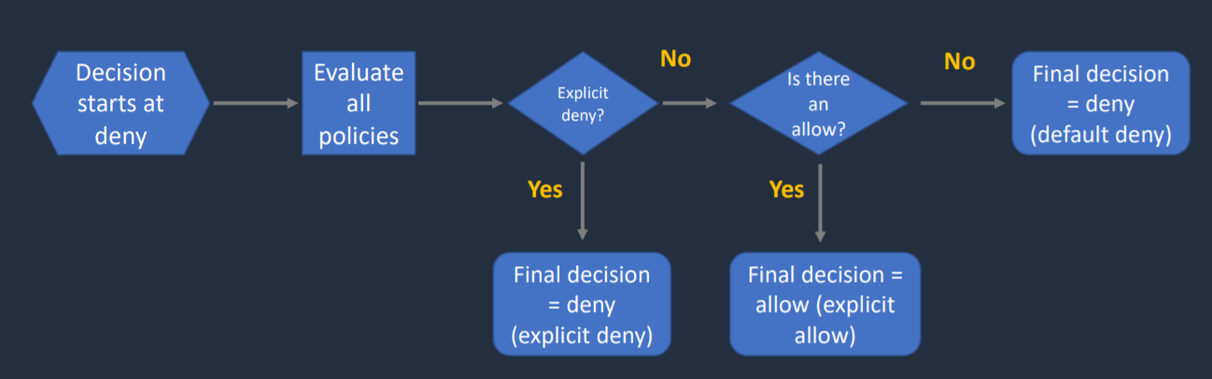

## S3 Websites

1. S3 can host static websites and have them accessible on the www
2. The website URL will be
   1. <bucket-name>.s3-website-<AWS-region>.amazonaws.com
   2. <bucket-name>.s3-website.<AWS-region>.amazonaws.com
3. If you get a 403 (Forbidden) error, make sure the bucket policy allows public reads

## S3 - CORS (Cross Origin Resource Sharing)

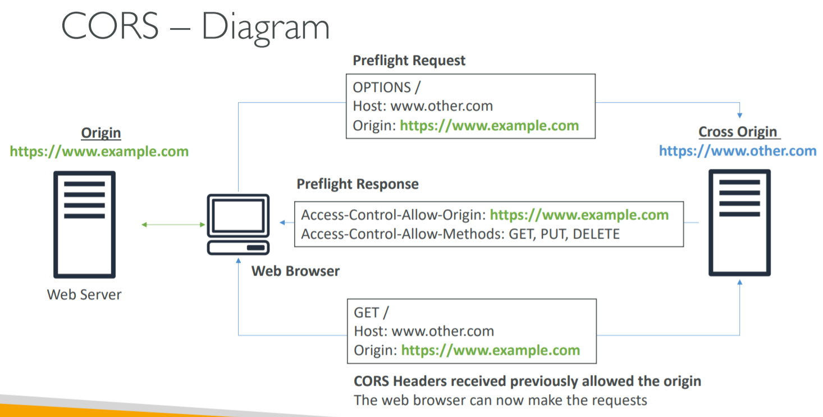

1. CORS means Cross Origin Resource Sharing
2. Web Browser based mechanism to allow requests to other origins while visiting the main origin
3. An origin is a protocol, domain, and port
   1. E.g. <https://www.example.com> (implied port is 443 for HTTPS, 80 for HTTP)
4. Same origin: <http://example.com/app1> and <http://example.com/app2>
5. Different origins: <http://www.example.com> and <http://other.example.com>
6. The request won’t be fulfilled unless the other origin allows for the request, using CORS Headers (ex: Access- Control-Allow-Origin)
7. If website_1 needs to access resource on website_2 through a web browser, then, website_2 needs to have CORS setting to allow request to be done otherwise the web-browser is going to block it.
8. If a client does a cross-origin request on our S3 bucket, we need to enable correct CORS headers
9. You can allow for a specific origin or for * (all origins)
10. CORS header should be defined in cross origin bucket not in first origin bucket
11. This is enabled through settings
    1. Access-Control-Allow-Origin
    2. Access-Control-Allow-Methods
    3. Access-Control-Allow-Headers

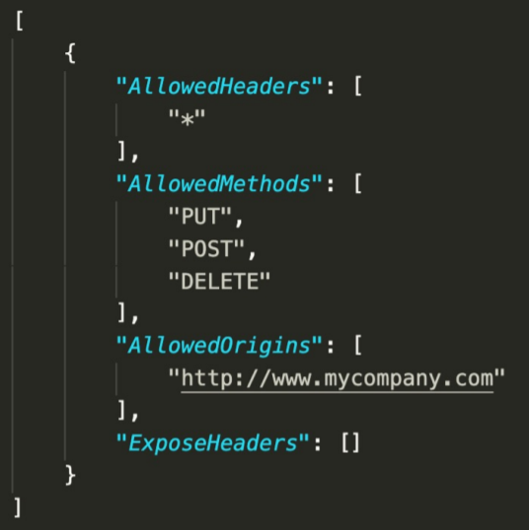

## S3 - Consistency Model

1. Available at no additional cost, without any performance impact
2. How does data consistency work for S3?
   1. Read after Write consistency for PUTS of new objects
      1. This means if you write a new file and read it immediately afterwards, you will be able to view that data.
   2. Eventual Consistency for overwrite PUTS and DELETES (can take some time to propagate)
      1. If you update an existing file or delete a file and read it immediately, you may get the older version, or you may not. Basically changes to objects can take a little bit of time to propagate.

## MFA with Amazon S3

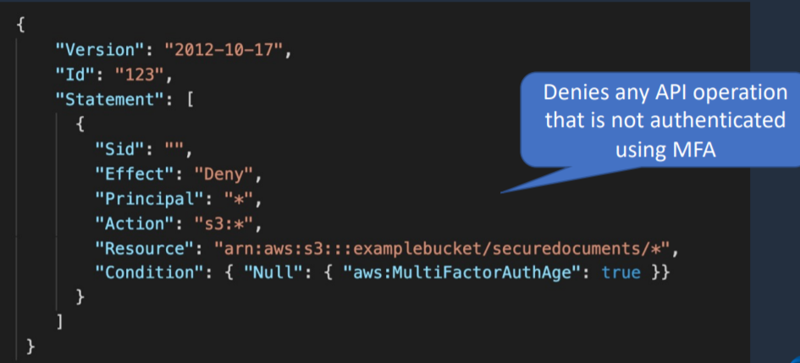

1. Used to enforce another authentication factor (MFA code) when accessing AWS resources (not just S3)
2. Enforced using the aws:MultiFactorAuthAge key in a bucket policy

## S3 - MFA Delete

1. To use MFA-Delete, enable versioning on S3 bucket
2. MFA-Delete currently can only be enabled using CLI
3. The x-amz-mfa request header must be included in the above request
4. Only the bucket owner (root account) (not even admin) can enable/disable MFA-Delete
5. You will need MFA to
   1. Permanently delete an object version
   2. Suspend versioning on the bucket
   3. Changing the versioning state of a bucket
6. You won’t need MFA for
   1. Enabling versioning
   2. Listing deleted versions
7. Versioning can be enabled by
   1. Bucket owners (root account)
   2. AWS account that created the bucket
   3. Authorized IAM users
8. MFA delete can be enabled by
   1. Bucket owner (root account)

## S3 - Default Encryption

1. You can set default encryption on a bucket so that all new objects are encrypted when they are stored in the bucket
2. The objects are encrypted using server-side encryption
3. There is no change to the encryption of objects that existed in the bucket before default encryption was enabled

## Default Encryption vs Bucket Policies

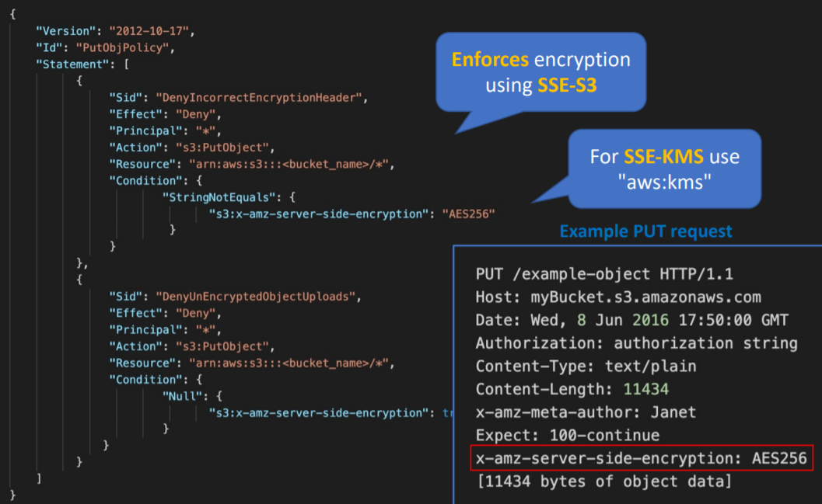

1. We can “force encryption” by using bucket policy and refuse any API call to PUT an S3 object without encryption headers.
2. Another way is to use the “default encryption” option in S3. If unencrypted object is uploaded into bucket, it will be encrypted using default encryption option. If the object is already encrypted, it will not be re-encrypted.
3. Note: Bucket Policies are evaluated before “default encryption”
4. If we need to force encryption mechanism of SSE-S3, you need to use bucket policy.
5. If the requirement is we need to encrypt every single object being encrypted into bucket, then we should use “Default Encryption”.
6. “Default Encryption” will not apply same encryption mechanism to all files. It is just making sure that if an object is uploaded in unencrypted manner, then it will automatically be encrypted using “default encryption” mechanism.

## S3 - Access Logs

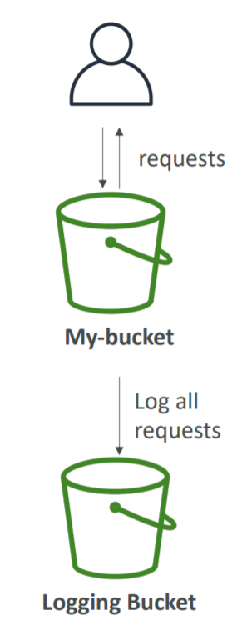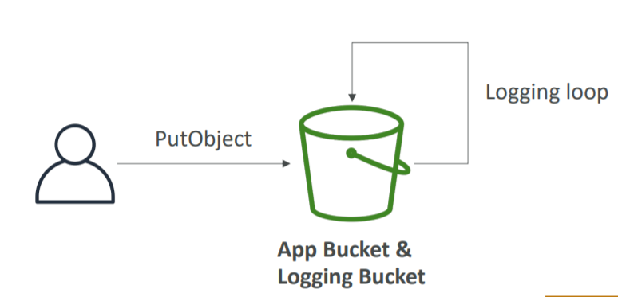

1. For audit purpose, you may want to log all access to S3 buckets
2. Any request made to S3, from any account, authorized or denied, will be logged into another S3 bucket.
3. That data can be analyzed using data analysis tools or Amazon Athena
4. Disabled by default
5. Only pay for the storage space used
6. By enabling server access logging, S3 console will automatically update your bucket access control list (ACL) to include access to the S3 log delivery group.
7. Must grant write permissions to the Amazon S3 Logs Delivery group on destination bucket
8. S3 Access Logs: Warning
   1. Do not set your logging bucket to be the monitored bucket
   2. It will create a logging loop and your bucket will grow in size exponentially

## S3 - Replication (CRR and SRR)

1. Replicate data between two objects asynchronously
2. Must enable versioning in both source and destination
3. Types of S3 Replication are
   1. Same Region Replication (SRR)
   2. Cross Region Replication (CRR)
4. Buckets can be in different accounts
5. After activating replication, only new objects are replicated (not retroactive)
6. For delete operations
   1. Deleting individual versions or delete markers will not be replicated.
   2. Can replicate delete markers from source to target (optional setting-> Delete Marker Replication)
   3. Deletions with a version ID are not replicated (to avoid malicious deletes)
7. There is no chaining of replication
   1. If bucket 1 has replication into bucket 2, which has replication into bucket 3
   2. Then objects created in bucket 1 are not replicated to bucket 3

## S3 - Pre-signed URLs

1. Can generate pre-signed URLs using SDK or CLI
   1. For downloads (easy, can use CLI)
   2. For uploads (harder, must use SDK)
2. You have all same permissions as the IAM user who has created that signed URL
3. Valid for a default of 3600 seconds, can change timeout with –expires-in [TIME_BY_SECONDS] argument
4. Examples
   1. Allows only logged-on users to download a premium video on your S3 bucket
   2. Allow an ever-changing list of users to download files by generating URLs dynamically
   3. Allow temporarily a user to upload a file to a precise location in our bucket

## S3 Charges

1. Storage
2. Request
3. Data Retrievals
4. Data transfer
5. Management and Replication
6. Transfer acceleration
7. Cross Region Replication Pricing

## S3 Storage Classes

1. Amazon S3 Standard- General Purpose
2. Amazon S3 Standard- Infrequent Access (IA)
3. Amazon S3 Intelligent Tiering
4. Amazon S3 One Zone Infrequent Access
5. Amazon Glacier
6. Amazon Glacier Deep Archive

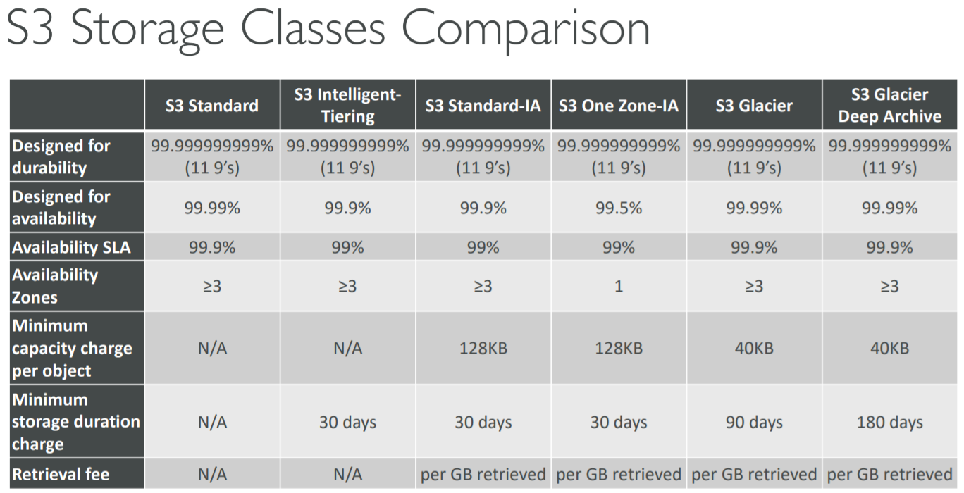

### S3 Standard

1. General purpose storage
2. Data is stored across multiple availability zones
3. Recommended for
   1. Data that are frequently accessed
4. Durability of 99.999999999%
5. Availability of 99.99%

### S3 Intelligent Tiering

1. Automatically moves your data to most cost-effective storage class
2. Automatic cost savings
3. Data is stored across multiple availability zones
4. Recommended for
   1. Data with unknown or changing access pattern like new app or data lake
5. Durability of 99.999999999%
6. Availability of 99.9%

### S3 Standard- Infrequent Access

1. Data is accessed less frequently but requires rapid access (millisecond access)
2. Cheaper than S3 Standard
3. Data is stored across multiple availability zones
4. Recommended for
   1. Data which is not frequently accessed but requires rapid access (millisecond access)
5. Durability of 99.999999999%
6. Availability of 99.9%

### S3 One Zone- Infrequent Access

1. Data is accessed less frequently but requires rapid access (millisecond access)
2. Costs 20% less than S3 Standard Infrequent Access
3. Data is stored in single availability zone
4. Data can be lost
5. Recommended for
   1. Data which is not frequently accessed but requires rapid access (millisecond access)
   2. Availability and Durability is not so essential
   3. Used for storing secondary backup copies of on-premises data
6. Durability of 99.999999999%
7. Availability of 99.5%

### S3 Glacier

1. Cold Storage for archival data
2. Data Retrieval takes longer time
3. 3 retrieval options:
   1. Expedited 1-5 min
   2. Standard 3-5 hours
   3. Bulk 5-12 hours
4. Data is stored in multiple availability zones
5. Recommended for
   1. Storage of archival data
6. Durability of 99.999999999%
7. Each item in Glacier is not called Object. It is called Archive. Each archive can be a file of upto 40 TB.
8. Archives are not store in Bucket. They are stored in Vaults.
9. Minimum storage duration of 90 days

### S3 Glacier Deep Archive

1. Like S3 Glacier but longer access time
2. 2 retrieval options:
   1. Standard 12 hours
   2. Bulk 48 hours
3. Cheapest of all S3 options
4. Data is stored in multiple availability zones
5. Recommended for
   1. Long-term archival data which is accessed once or twice a year
   2. Retaining data for regulatory compliance requirement
6. Durability of 99.999999999%
7. Minimum storage duration of 180 days

RRS (Reduce Redundancy Storage) -> S3 One Zone – IA

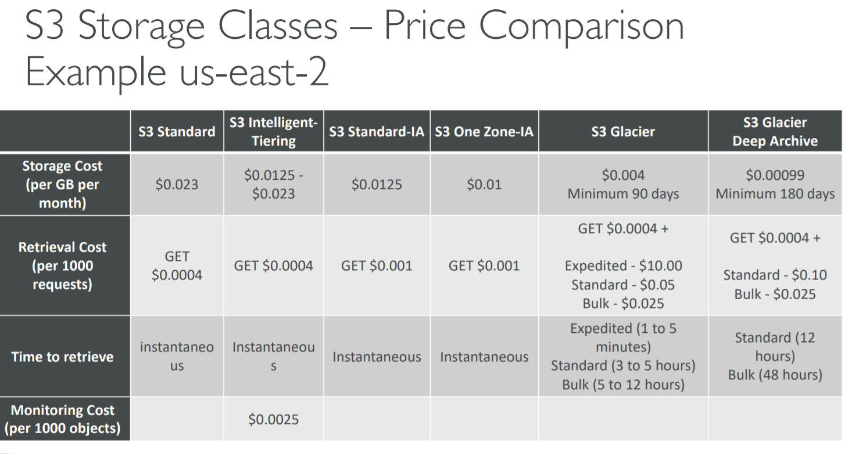

## S3 Lifecycle Rules

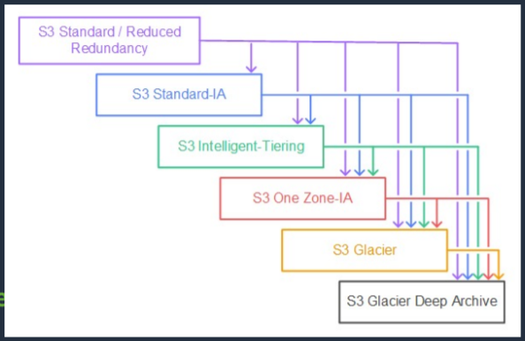

1. You can transition objects between storage classes
2. For infrequently accessed objects, move them to STANDARD_IA
3. For archive objects, you don’t need in real-time, GLACIER or DEEP_ARCHIVE
4. Moving objects can be automated using a lifecycle configuration
5. S3 Lifecycle Rules
   1. Transition actions
      1. It defines when objects are transitioned to another storage class
      2. Move objects to Standard IA class 60 days after creation
      3. Move to Glacier for archiving after 6 months
   2. Expiration actions
      1. Configure objects to expire (delete) after some time
      2. Access log files can be set to delete after 365 days
      3. Can be used to delete old versions of files (if versioning is enabled)
      4. Can be used to delete incomplete multi-part uploads
   3. Rules can be created for a certain prefix (ex- s3://mybucket/mp3/*)
   4. Rules can be created for certain objects tags (ex- Department: Finance)
6. Lifecycle Management can be applied to current versions and previous versions.

## S3 Lifecycle Scenarios

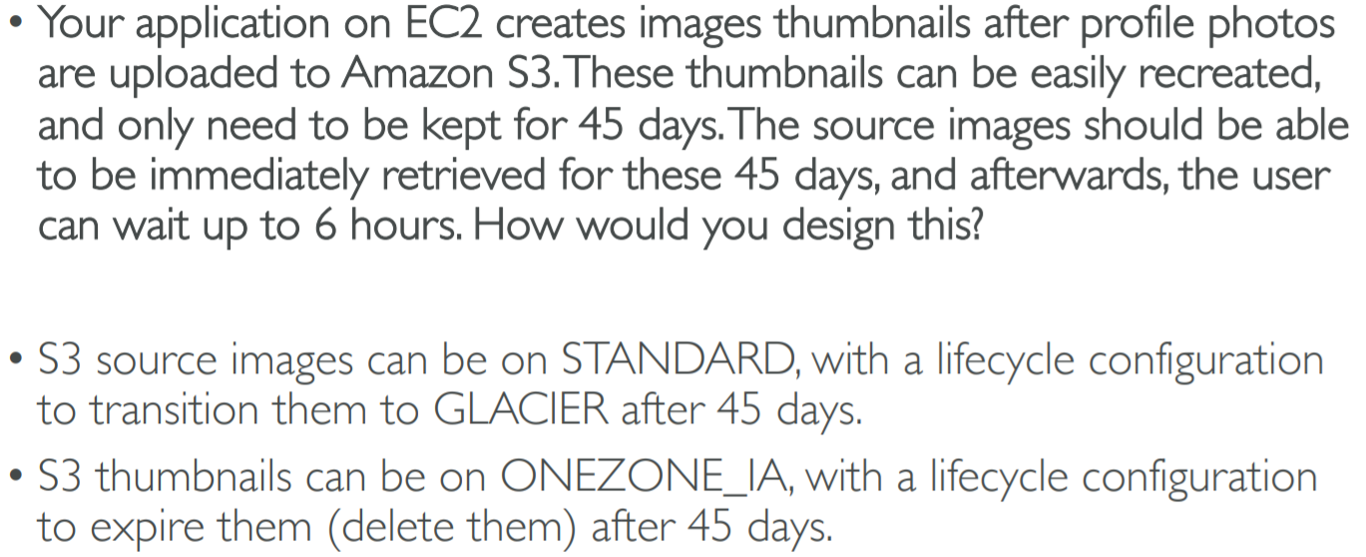

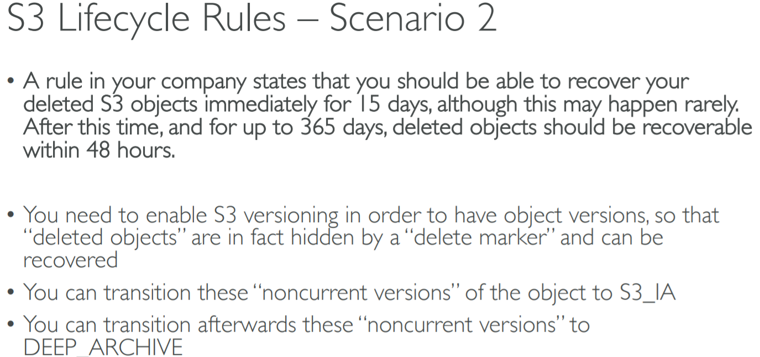

## S3 Analytics - Storage Class Analysis

1. You can setup S3 Analytics to determine when to transition objects from Standard to Standard_IA
2. Does not work for ONEZONE_IA or GLACIER
3. Report is updated daily
4. Takes about 24hrs to 48hrs to first start

## S3 - Baseline Performance

1. Your application can achieve at least 3,500 PUT/COPY/POST/DELETE and 5,500 GET/HEAD requests per second per prefix in a bucket
2. There are no limits to the number of prefixes in a bucket
3. Example (object_path => prefix)
   1. Bucket/folder1/sub1/file => /folder1/sub1
   2. Bucket/folder1/sub2/file => /folder1/sub2
   3. Bucket/1/file => /1/
   4. Bucket/2/file => /2/
4. If you spread reads across all four prefixes evenly, you can achieve 22,000 requests per second for GET and HEAD

## S3 - KMS Limitation

1. If you use SSE-KMS, you may be impacted by the KMS limits
2. When you upload, it calls the GenerateDataKey KMS API
3. When you download, it calls the Decrypt KMS API
4. Count towards the KMS quota per second (5500, 10000, 30000 req/s based on region)
5. You can request a quota increase using the Service Quotas Console

## S3 - Multi-Part upload

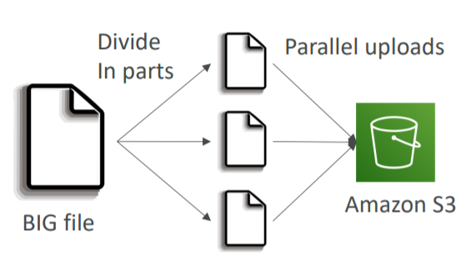

1. Recommended for files > 100MB
2. Must use for files > 5GB
3. Can be used for objects from 5 MB up to 5 TB
4. Can help parallelize uploads (speed up transfer)

## S3 - Byte-Range Fetches

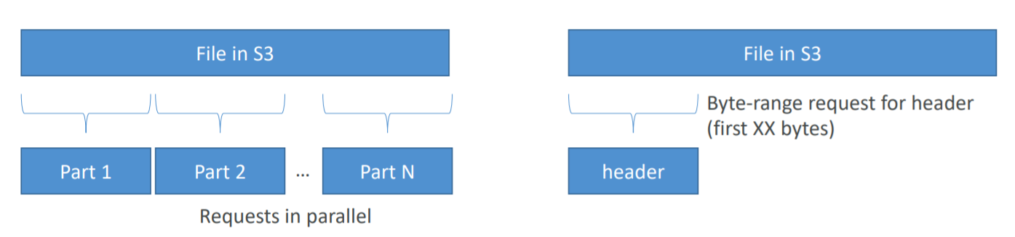

1. Parallelize GETs by requesting specific byte ranges
2. Better resilience in case of failures
3. Can be used to retrieve only partial data (for example the head of a file)

## S3 - Transfer Acceleration

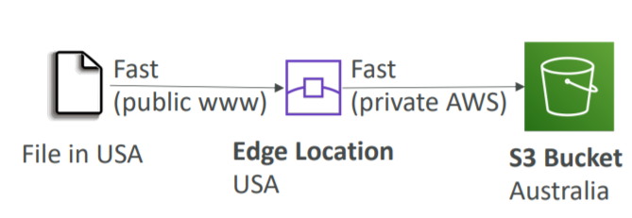

1. Increase transfer speed by transferring file to an AWS edge location which will forward the data to the S3 bucket in the target region
2. Compatible with multi-part upload
3. You will get a distinct URL to upload to as:
   1. acloudguru.s3-accelerate.amazonaws.com
4. AWS only charges if there is a performance improvement
5. It is enabled at the bucket level
6. Cannot be disabled, can only be suspended

## S3 - Copy API

1. Copy objects up to 5 GB in size
2. The copy operation can be used to
   1. Generate additional copies of objects
   2. Rename objects
   3. Change object metadata
   4. Change the copy’s storage class or encryption at rest status
   5. Move objects across AWS locations/regions

## S3 Select and Glacier Select

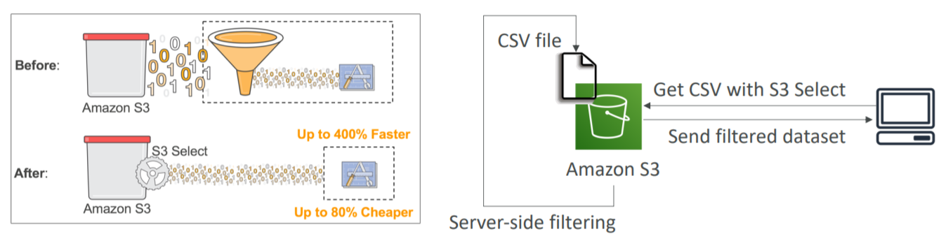

1. Retrieve less data using SQL by performing server-side filtering
2. Can filter by rows and columns (simple SQL statements)
3. Less network transfer, less CPU cost client-side
4. 400% performance increase
5. Get data by rows or columns using simple SQL expressions
6. Glacier Select allows you to run SQL queries against Glacier directly

## S3 Event Notifications

1. Some events happen in S3 bucket which may be ObjectCreated, ObjectRemoved, ObjectRestored, Replication. You want to react to all these events happening. This is possible through S3 Event Notification
2. Object name filtering is possible (*.jpg)
3. Use case
   1. Generate thumbnails of images uploaded to S3
4. Possible targets are
   1. SNS
   2. SQS
   3. Lambda function
5. Can create as many “S3 events” as desired
6. S3 event notifications typically deliver events in seconds but can sometimes take a minute or longer
7. If you want to make sure that every single event notification is delivered, then you need to enable versioning
8. If two writes are made to a single non-versioned object at the same time, it is possible that only a single event notification will be sent
9. If you want to ensure that an event notification is sent for every successful write, you can enable versioning on your bucket.

## S3 Requester Pays

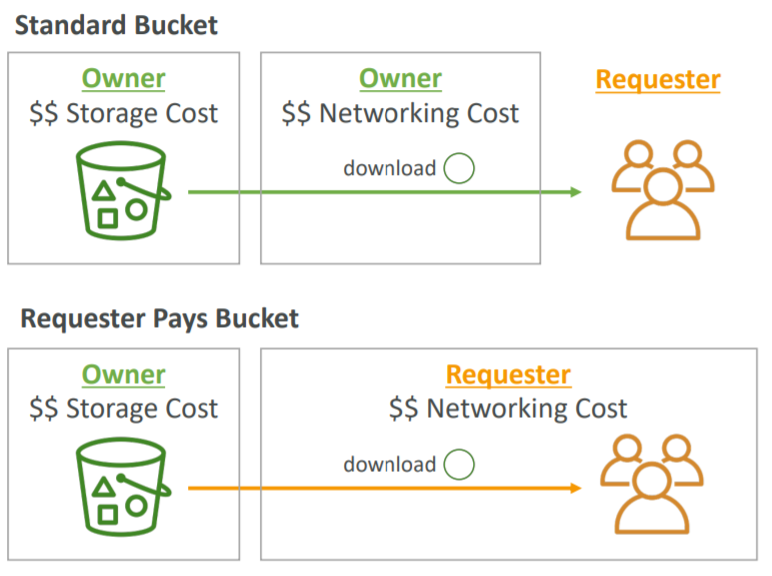

1. In general, bucket owner pay for all Amazon S3 storage and data transfer costs associated with their bucket
2. With Requester Pays buckets, the requester instead of the bucket owner pays the cost of the request and the data download from the bucket
3. The requester must be authenticated (cannot be anonymous)

## S3 Object Lock and Glacier Vault Lock

### S3 Object Lock

1. Versioning must be enabled
2. You can use S3 Object Lock to store objects using a write once, read many (WORM) model.
3. Object locks can be on individual objects or applied across the bucket as a whole.
4. It can help you prevent objects from being deleted of modified for a fixed amount of time or indefinitely.
5. It comes in two different modes
   1. Governance Mode
      1. In this mode, users cannot overwrite or delete an object version or alter its lock settings unless they have special permissions.
      2. With this mode, you protect objects against being deleted by most users, but you can still grant some users permission to alter the retention settings or delete the object if necessary.
   2. Compliance mode
      1. In this mode, a protected object version cannot be overwritten or deleted by any user, including the root user in your AWS account.
      2. When an object is locked in compliance mode, its retention mode cannot be changed, and its retention period cannot be shortened.
      3. It ensures an object version cannot be overwritten or deleted for the duration of the retention period.

### Glacier Vault Lock

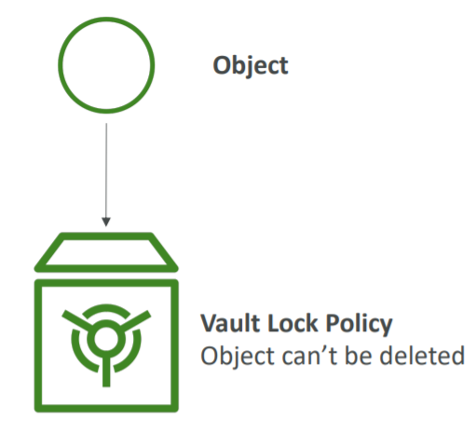

1. It allows you to easily deploy and enforce compliance controls for individual S3 Glacier vaults with a Vault Lock Policy.
2. Adopt a WORM (Write Once Read Many) model
3. Lock the policy for future edits (can no longer be changed)
4. The object is sent to Glacier and we can create a Vault Lock Policy specifying object cannot be deleted and the policy itself also cannot be deleted

### Retention Period

1. A retention period protects an object version for a fixed amount of time.
2. When you place a retention period on an object version, Amazon S3 stores a timestamp in the object version’s metadata to indicate when the retention period expires.
3. After the retention period expires, the object version can be overwritten or deleted unless you also placed a legal hold on the object version.

### Legal holds

1. S3 Object Lock also enables you to place a legal hold on an object version.
2. Like a retention period, a legal hold prevents an object version from being overwritten or deleted.
3. However, a legal hold does not have an associated retention period and remain in effect until removed.
4. Legal holds can be freely placed and removed by any user who has the s3:PutObjectLegalHold permission.

## S3 for Solutions Architect

1. Operations
   1. No operations needed
2. Security
   1. IAM
   2. Bucket Policies
   3. ACL
   4. Encryption (Server/ Client)
   5. SSL
3. Reliable
   1. 99.999999999% durability
   2. 99.99% availability
   3. Multi AZ
   4. CRR
4. Performance
   1. Scales to thousands of read/ writes per second
   2. Transfer acceleration
   3. Multi-part upload for big files
5. Cost
   1. Pay per storage usage
   2. Network cost
   3. Requests number

# Amazon Athena

## Introduction

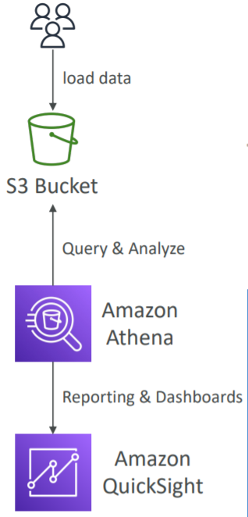

1. Serverless
2. Perform analytics against S3 objects
3. Uses standard SQL language to query the files
4. Pricing: pay per query and $5 per TB of data scanned
5. Use compressed or columnar data for cost-savings (less scan)
6. Can be connected to other data sources with lambda
7. Athena can query data in CSV, TSV, JSON, Parquet and ORC formats
8. Uses a managed Data Catalog (AWS Glue) to store information and schemas about the databases and tables
9. SQL queries can also be run against these data sources. But we should use lambda function for this purpose to connect Athena to data source
   1. Amazon CloudWatch Logs
   2. Amazon CloudWatch Metrics
   3. Amazon DynamoDB
   4. Amazon Redshift
   5. MySQL
   6. Redis
   7. Apache HBase
   8. PostgreSQL

## Optimizing Athena for Performance

1. Partition your data
2. Bucket your data – bucket the data within a single partition
3. Use compression – AWS recommend using either Apache Parquet or Apache ORC
4. Optimize file sizes
5. Optimize columnar data store generation – Apache Parquet and Apache ORC are popular columnar data stores
6. Optimize ORDER BY and Optimize GROUP BY
7. Use approximate functions
8. Only include the columns that you need

## Athena for Solutions Architect

1. Operation
   1. No operations needed, serverless
2. Security
   1. IAM + S3 Security
3. Reliability
   1. Managed service
   2. Uses Presto engine, highly available
4. Performance
   1. Queries scale based on data size
5. Cost
   1. Pay per query/ per TB of data scanned

# AWS CloudFront

## Introduction

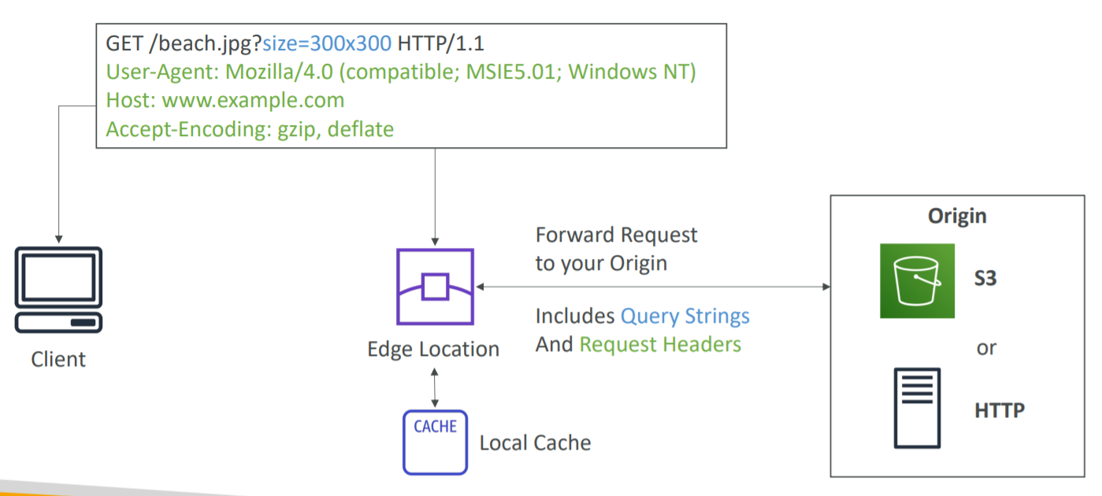

* Allows global distribution of content
* Makes content available globally
* Delivers data and applications globally with low latency
* Speeds up delivery of static and dynamic web content
* Uses Edge Location to cache content
* Integrates with many AWS services (S3, EC2, ELB, Route 53, Lambda)
* Protects from DDoS attack
* IP address blocking, geo-restriction
* Edge locations are not just READ only. You can write to them too.
* Objects in Edge Location are cached for the life of TTL (Time to Live) (default 24 hours)
* You can clear cached objects, but you will be charged. This is called invalidating the cache.
* Distribution
  + This is the name given to CDN which consists of a collection of Edge Locations.
  + With CloudFront, you will get two different types of distribution
    - Web distribution: typically used for websites
    - RTMP: used for Media Streaming
* Decreasing the TTL is best for dynamic content
* Increasing TTL is better for performance and reduces load on origin
* TTL is defined at the behaviour level
* This can be used to define different TTLs for different file types (e.g. png vs jpg)

## CloudFront - Origins

1. This is the origin of the files that the CDN will distribute.
2. S3 bucket
3. Custom Origin (HTTP)
   1. Application Load Balancer
   2. EC2 Instance
   3. S3 website
   4. Any HTTP backend you want

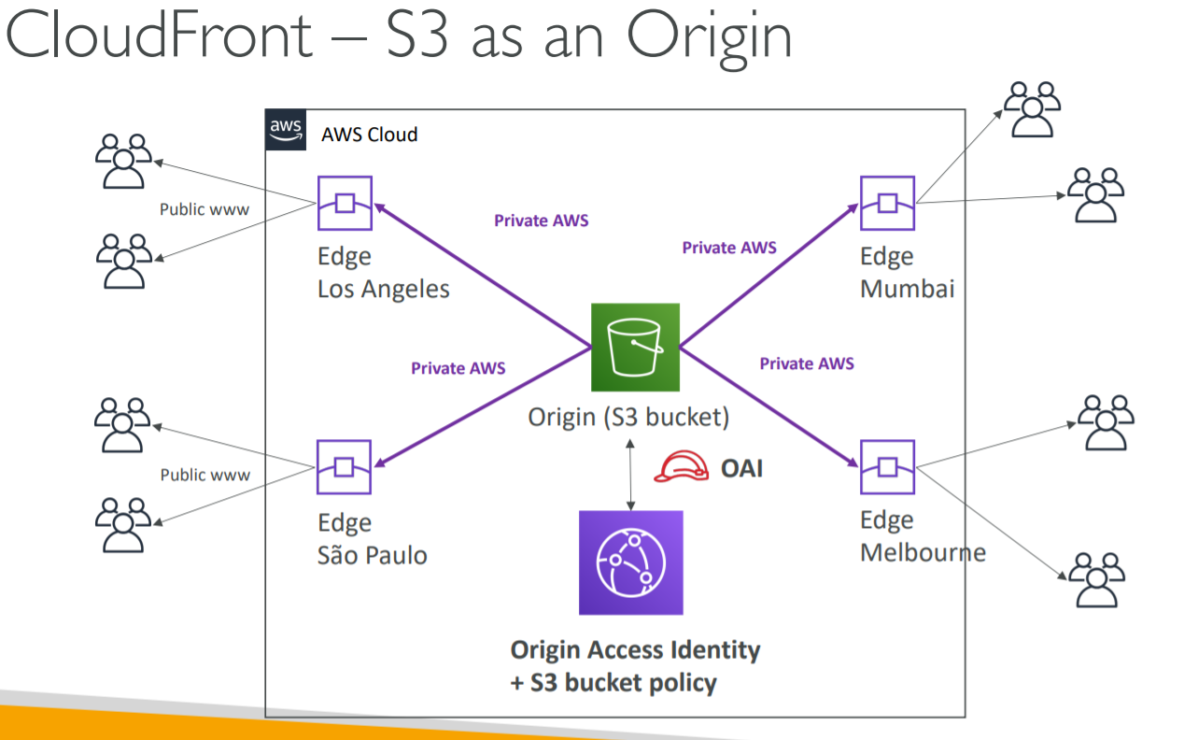

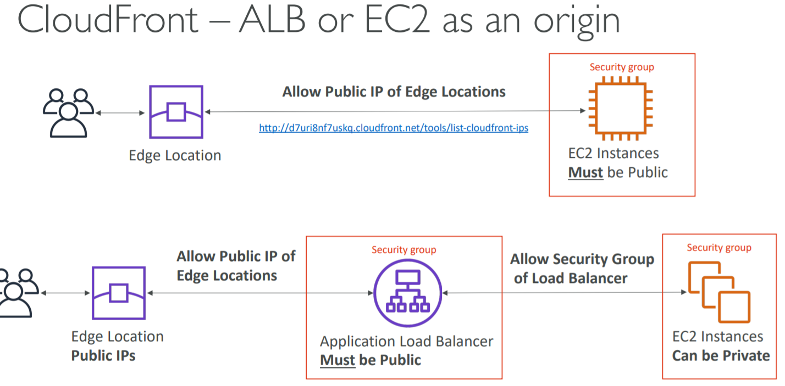

## CloudFront – Geo Restriction

1. You can restrict who can access your distribution
   1. Whitelist
      1. Allow your users to access your content only if they are in one of the countries on a list of approved countries
   2. Blacklist
      1. Prevent your users from accessing your content if they are in one of the countries on a blacklist of banned countries
2. The “country” is determined using a 3rd party Geo-IP database
3. Use Case
   1. Copyright Laws to control access to content

## CloudFront - Signed URL/Signed Cookies

1. Use signed URLs/Cookies when you want to secure content so that only the people you authorize are able to access it.
2. A signed URL is for individual files. 1 URL = 1 file
3. A signed cookie is for multiple files, 1 cookie = multiple files
4. When we create a signed URL or signed cookie, we attach a policy. The policy can include:
   1. URL expiration
   2. IP ranges
   3. Trusted signers (which AWS accounts can create signed URLs)
5. If your origin is EC2, then use CloudFront Signed URL. If your origin is S3, use S3 signed URL.
6. How long should the URL be valid for?
   1. Shared content (movie, music): make it short (a few minutes)
   2. Private content (private to the user): you can make it last for years

## CloudFront – Pricing

1. CloudFront Edge Locations are all around the world
2. The cost of data out per edge location varies
3. You can reduce the number of edge locations for cost reduction
4. Three price classes are
   1. Price Class All: all regions- best performance
   2. Price Class 200: most regions, but excludes the most expensive regions
   3. Price Class 100: only the least expensive regions

## CloudFront - Multiple Origin and Path Pattern

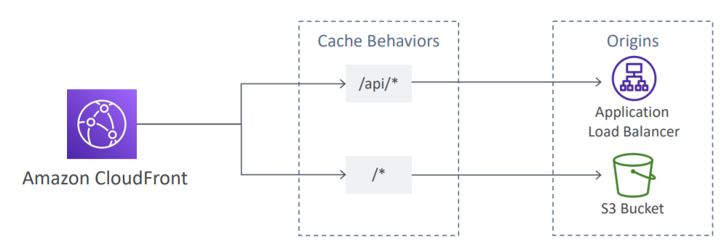

1. Route to different origins based on path pattern
   1. /images/*
   2. /api/*
   3. /*
2. Default origin is then used for any requests that don’t match a specified path pattern

## CloudFront - Origin Groups

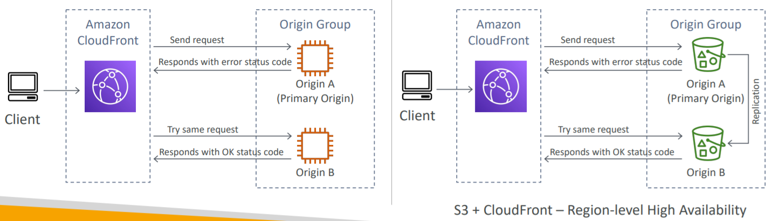

1. To increase high-availability and do failover
2. Origin Group- one primary and one secondary origin
3. If the primary origin fails, the second one is used

## CloudFront - Field Level Encryption

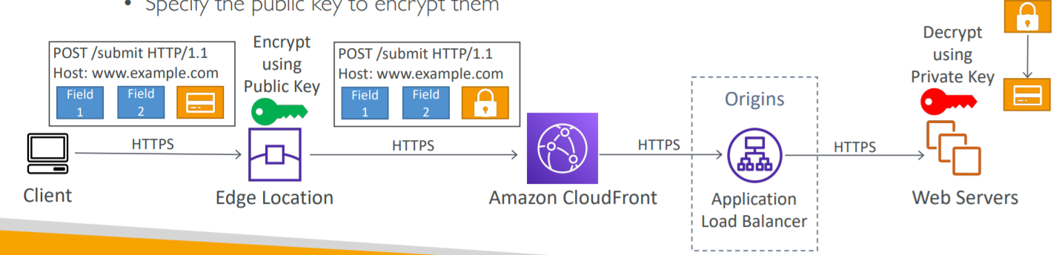

1. Adds an additional layer of security along the HTTPS
2. Sensitive information encrypted at the edge close to user
3. Uses asymmetric encryption
4. Usage
   1. Specify set of fields in POST requests that you want to be encrypted (up to 10 fields)
   2. Specify the public key to encrypt them

## CloudFront - Origin Access Identity (OAI)

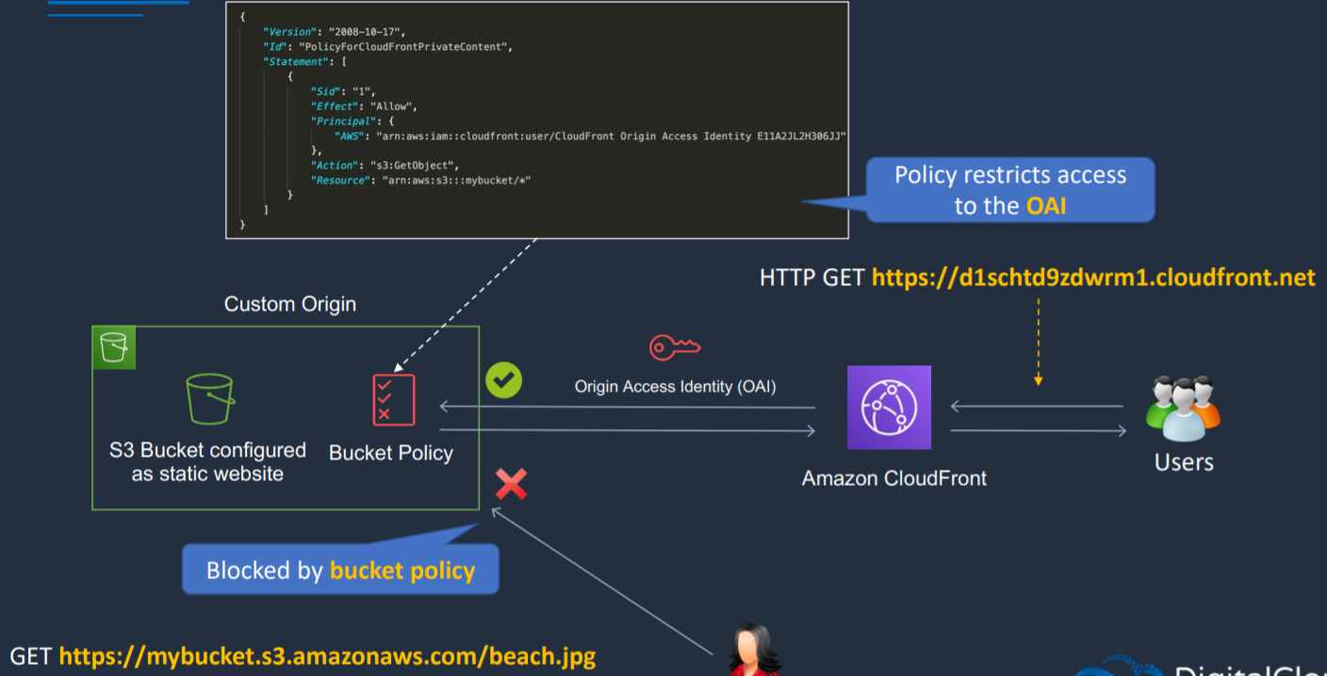

1. Way to make sure that content is served by a CloudFront and no one is able to circumvent CloudFront and go to origin
2. OAI is used with S3
3. It is not used with EC2

## Caching based on Request Headers

1. CloudFront lets you choose whether you want CloudFront to forward headers to your origin and to cache separate versions of a specified object based on the header values in viewer requests.
2. This allows you to serve different versions of your content based on the device the user is using, the location of the viewer, the language the viewer is using, and a variety of other criteria.

# Unicast IP vs Anycast IP

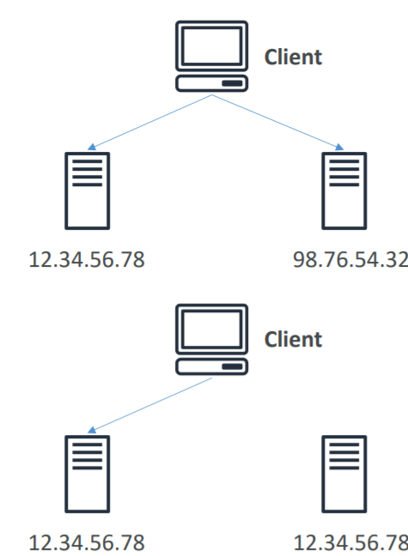

1. Unicast IP
   1. One server holds one IP address
2. Anycast IP
   1. All servers hold the same IP address, and the client is routed to the nearest one

# AWS Global Accelerator

## Introduction

1. Networking Service that improves performance and availability of your application upto 60% using AWS Global Network Infrastructure
2. When the Internet is congested, AWS Global Accelerator optimizes path to your application to keep packet loss, jitter, and latency consistently low
3. You are provided with two global static IPs that acts as fixed entry point to your application
4. On the back end, add or remove your AWS application end points like Application Load Balancer, Network Load Balancer, EC2 instances and Elastic Ips without making user facing changes
5. Automatically reroutes traffic to nearest healthy available endpoint to mitigate endpoint failure
6. Performs health check of end point
7. AWS Global Accelerator continually monitors the health of application endpoints and will detect an unhealthy endpoint and redirect traffic to healthy endpoints in less than 1 minute.
8. Works with Elastic IP, EC2 instances, ALB, NLB, private or public

## Similarities between CloudFront and Global Accelerator

1. Both use Edge Location and Amazon Global Network Infrastructure
2. Both are integrated with Amazon Shield to protect DDoS attack

## Difference between CloudFront and Global Accelerator

CloudFront

1. Improves performance for both cacheable content (such as images and videos) and dynamic content (such as API acceleration and dynamic site delivery)
2. Content is served at the edge

Global Accelerator

1. Improves performance for a wide range of applications over TCP or UDP
2. Proxying packets at the edge to applications running in one or more AWS Regions
3. Good fit for non-HTTP use cases, such as gaming (UDP), IoT (MQTT), or Voice over IP
4. Good for HTTP use cases that require static IP addresses
5. Good for HTTP use cases that require deterministic, fast regional failover

# Snow Family

## Introduction

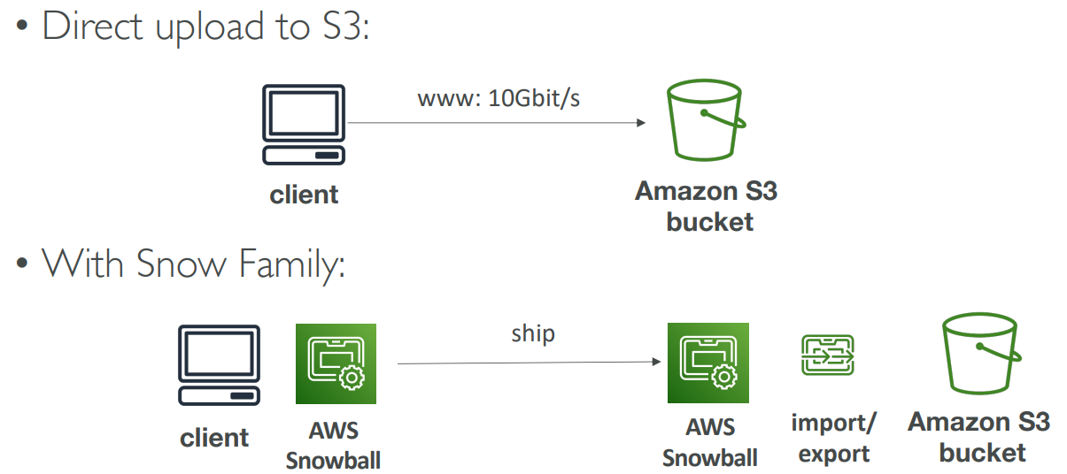

1. Offline devices to perform data migrations
2. If it takes more than a week to transfer over the network, use Snowball devices
3. Data is migrated through physical route not network route
4. Use cases
   1. Data Migration- Snowcone, Snowball Edge, Snowmobile
   2. Edge computing- Snowcone, Snowball Edge

## Snow Families

This includes

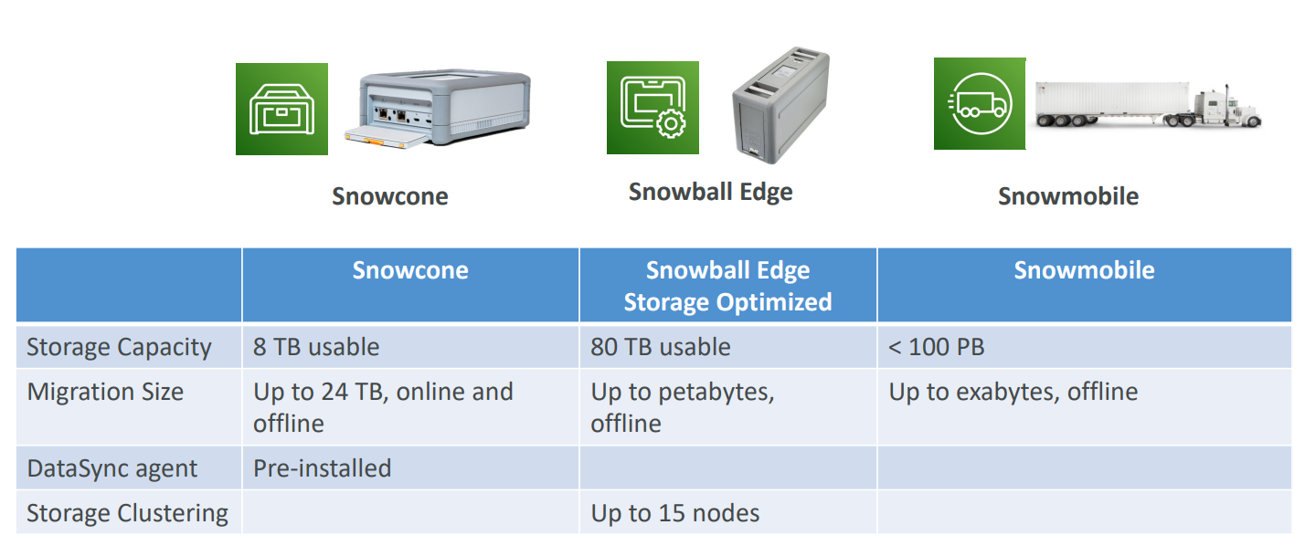

1. Snowcone
2. Snowball and Snowball Edge
3. Snowmobile

### Snowcone

1. Allows you to transfer large amount of on-premises data to cloud using physical device
2. Smallest member of data transport devices, 8 terabytes of storage
3. Small, portable computing, anywhere, rugged, and secure, withstand harsh environment
4. Used for edge computing, storage, and data transfer
5. Can transfer data offline or online with AWS DataSync agent

### Snowball and Snowball Edge

1. Petabyte scale of data transport
2. It is not just data migration device but is also an edge computing device i.e., it allows local processing
3. Snowball edge supports EC2 and lambda
4. Pay per data transfer job
5. Provide block storage and Amazon S3-compatible object storage
6. It can import to S3 and export from S3.
7. Snowball Edge comes in two flavours
   1. Snowball Edge Storage Optimized
      1. 80 TB of HDD capacity for block volume and S3 compatible object storage
      2. Storage Clustering (up to 15 nodes) (Object storage clustering available)
   2. Snowball Edge Compute Optimized
      1. 42 TB of HDD capacity for block volume and S3 compatible object storage
      2. Provides optional GPU

### Snowmobile

1. Multi-petabyte or exabyte scale (100PB) of data transport
2. Data is transported using 45-foot-long shipping container
3. People use this when they are completely shipping their on-premises database and moving to AWS
4. With these trucks, there is GPS tracking, alarm monitoring, 24X7 video surveillance, and as escort security vehicle during transport
5. Better than snowball if you transfer more than 10 PB

Note

1 EB = 1,000 PB = 1,000,000 TB

## Edge Computing

### Introduction

1. Process data while it is being created on an edge location
   1. A truck on the road
   2. A ship on the sea
   3. A mining station underground
2. These locations may have
   1. Limited/ no Internet access
   2. Limited/ no easy access to computing power
3. We setup a Snowball Edge/ Snowcone device to do edge computing

### Snow Family - Edge Computing

1. Snowcone (smaller)
   1. 2 CPUs
   2. 4 GB of memory
   3. Wired or wireless access
   4. USB-C power using a cord or optional battery
2. Snowball Edge- Compute Optimized
   1. 42 TB usable storage
   2. 52 vCPUs
   3. 208 GiB of RAM
3. Snowball Edge- Storage Optimized
   1. 80 TB usable storage
   2. Up to 40 vCPUs
   3. 80 GiB of RAM
4. All of these can run EC2 instances and AWS lambda functions using AWS IoT Greengrass

## AWS OpsHub

1. Historically, to use Snow Family devices, you needed a CLI (Command Line Interface tool)
2. Today, you can use AWS OpsHub (a software you install on your computer/laptop) that provides Graphical Interface to manage your Snow Family Devices.

## Solution Architecture: Snowball into Glacier

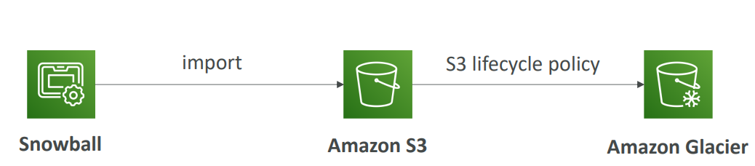

1. Snowball cannot import to Glacier directly
2. You must use Amazon S3 first, in combination with an S3 lifecycle policy

# AWS Transfer Family

1. Fully managed service for file transfers into and out of Amazon S3 or Amazon EFS using FTP protocol
2. Supported protocols
   1. AWS Transfer for FTP (File Transfer Protocol (FTP))
   2. AWS Transfer for FTPS (File Transfer Protocol over SSL (FTTPS))
   3. AWS Transfer for SFTP (Secure File Transfer Protocol (SFTP))
3. Pay per provisioned endpoint per point + data transfers in GB

# Decoupling Applications

## Patterns of application communication

1. Synchronous Communication (application to application)
2. Asynchronous/ Event based Communication (application to queue to application)

## Decoupling your applications

1. Using SQS: queue model
2. Using SNS: pub/sub model
3. Using Kinesis: real-time streaming model

# SQS (Simple Queuing Service)

## Introduction

1. Producers send message to queue
2. Consumers will poll messages from queue
3. Fully managed service, used to decouple applications
4. SQS is pull-based, not push based. We should have EC2 Instance polling the queue.
5. Messages can be 256 KB in size or less.
6. Messages can be kept in the queue from 1 minute to 14 days; the default retention period is 4 days.

## SQS - Queue Types

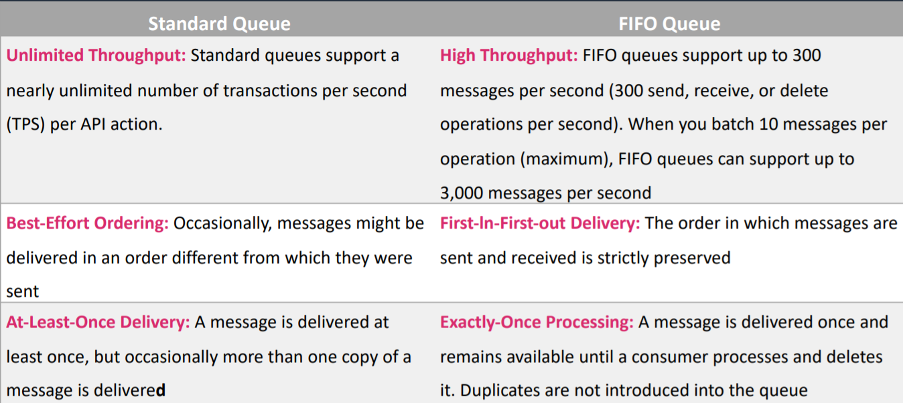

### SQS - Standard Queue

1. Unlimited throughput, unlimited number of messages in queue
2. Can have duplicate messages (at least once delivery)
3. Can have out of order messaging
4. Message persists in SQS until a consumer deletes it. Consumers delete messages after processing them

### SQS - FIFO Queue

1. FIFO- First In First Out (ordering of messages in the queue)
2. Exactly-once send capability (by removing duplicates)
3. Messages are processed in order by the consumer
4. To create FIFO queue, we should name queue as queue_name.fifo
5. Has limited throughout of 300 msg/s without batching and 3000 msg/s with batching
6. FIFO Queues require the Message Group ID and Message Duplication ID parameters to be added to messages
   1. Message Group ID – the tag that specifies that a message belongs to a specific message group messages that belong to the same message group are guaranteed to be processed in a FIFO manner
   2. Message Deduplication ID – The token used for deduplication of messages within the deduplication interval

## Ordering data into SQS

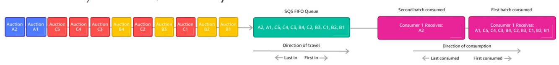

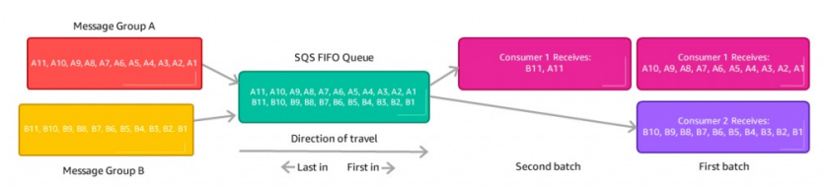

1. For SQS Standard, there is no ordering
2. For SQS FIFO, if you do not use a Group ID, messages are consumed in the order they are sent, with only one consumer
3. For SQS FIFO, if you use a Group ID, there can be multiple consumers per group and messages to one group will be received by one consumer

## SQS - Security

1. Encryption
   1. In-flight encryption using HTTPS API
   2. At-rest encryption using KMS keys
   3. Client-side encryption if the client wants to perform encryption/decryption itself
2. Access Controls
   1. IAM policies to regulate access to the SQS API
3. SQS Access Policies (similar to S3 bucket policies)
   1. Useful for cross-account access to SQS queues
   2. Useful for allowing other services (SNS, S3, ..) to write to an SQS queue

## SQS - Queue Access Policy

1. Use case
   1. Cross Account Access
   2. Publish S3 Event Notifications to SQS Queue

## SQS - Message Visibility Timeout

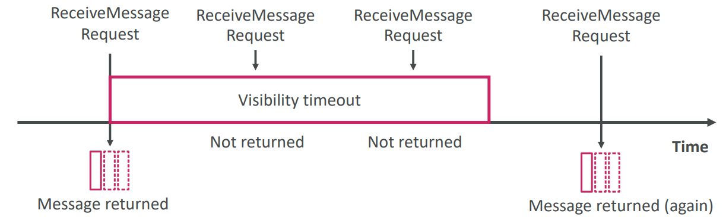

1. Visibility timeout is the amount of time that the message is invisible in the SQS queue after a reader picks up that message. Provided the job is processed before the visibility timeout expires, the message will then be deleted from the queue. If the job is not processed within that time, the message will become visible again and another reader will process it. This could result in same message being delivered twice.
2. After a message is polled by a consumer, it becomes invisible to other consumers for visibility timeout period
3. By default, the “message visibility timeout” is 30 seconds. That means the message has 30 seconds to be processed
4. Visibility timeout can be set from 0 seconds and 12 hours
5. After the message visibility timeout is over, the message is “visible” in SQS
6. If a message is not processed within the visibility timeout, it will be processed twice
7. A consumer could call the ChangeMessageVisibility API to get more time
8. If visibility timeout is high (hours), and consumer crashes, re-processing will take time
9. If visibility timeout is too low (seconds), we may get duplicates

## SQS - Dead Letter Queue

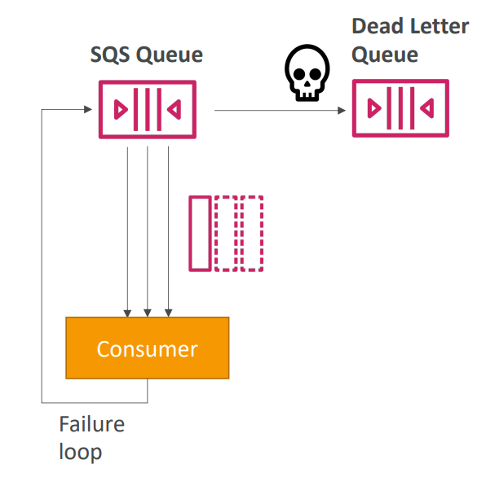

1. If a consumer fails to process a message within the Visibility Timeout, the message goes back to the queue
2. We can set a threshold of how many times a message can go back to the queue
3. After the MaximumReceives threshold is exceeded the message goes into a dead letter queue (DLQ)
4. Useful for debugging
5. Value of MaximumReceives can be between 1 and 1000
6. It is not a queue type. It is a standard or FIFO queue that has been specified as dead-letter queue in the configuration of another standard or FIFO

## SQS - Delay Queue

1. Delay a message (consumers don’t see it immediately) up to 15 minutes
2. Range- 0 sec-15 minutes
3. Default is 0 seconds (message is available right away)

## SQS - Long Polling

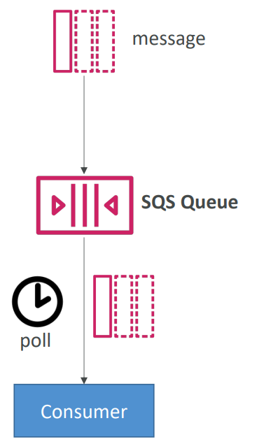

1. It as a way to optimize number of API calls made to SQS while decreasing latency
2. When a consumer requests messages from the queue, it can optionally “wait” for messages to arrive if there are none in the queue
3. This is called Long Polling
4. Long Polling decreases the number of API calls made to SQS while increasing the efficiency and latency of your application
5. The wait time can be between 1 sec to 20 sec (20 sec preferable)
6. Long Polling is preferable to Short Polling
7. SQS Short Polling return immediately (eve if the message queue is empty)
8. Long Polling can be enabled at the queue level or at the API level using WaitTimeSeconds

## SQS - Request-Response Systems

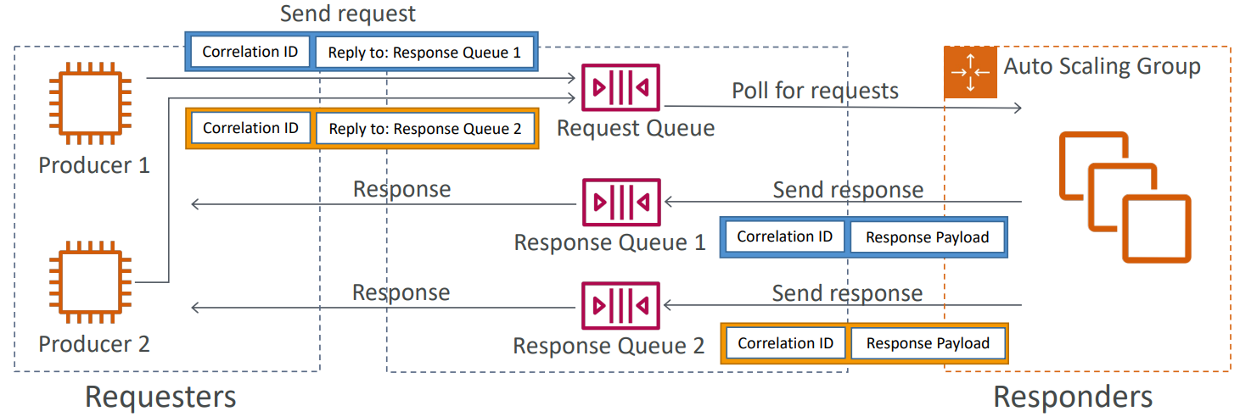

1. Requester creates a temporary queue for receiving each response message
2. To implement Request- Response Systems, use SQS Temporary Queue Client
3. It leverages virtual queues instead of creating/deleting queues (cost-effective)

## SQS with Auto Scaling Group (ASG)

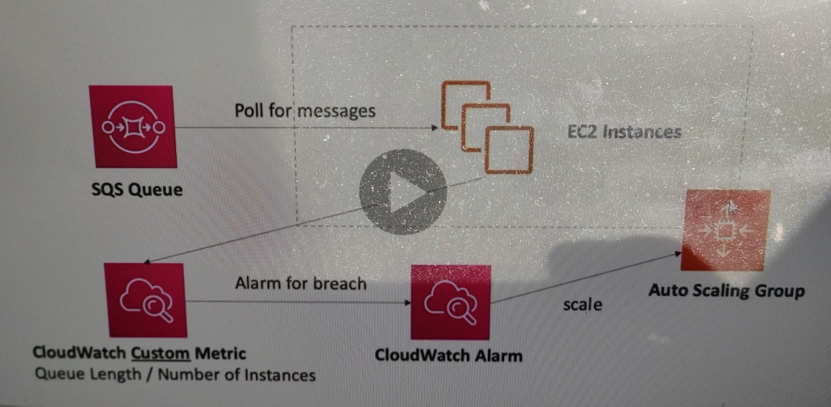

# SNS (Simple Notification Service)

## Introduction

1. SNS is push based delivery service (no polling)
2. Publisher Subscriber mechanism to send one message to many receivers
3. The “event producer” only sends message to one SNS topic
4. As many “event receivers” (subscriptions) as we want to list to the SNS topic notifications
5. Each subscriber to the topic will get all the messages (note: new feature to filter messages)
6. Up to 10,000,000 subscribers per topic
7. 100,000 topics limit
8. Subscribers can be
   1. HTTP/HTTPS
   2. SQS
   3. SMS messages
   4. Lambda
   5. Emails
   6. Mobile Notifications
9. Endpoint can be
   1. HTTP
   2. HTTPS
   3. Email
   4. Email-JSON
   5. AWS Lambda
   6. Amazon SQS
   7. SMS
   8. Amazon Kinesis Data Firehouse
10. SNS integrates with a lot of AWS services
    1. CloudWatch
    2. CloudFormation
    3. Amazon S3
    4. Auto Scaling Groups Notifications

## SNS - How to publish

1. Topic Publish (using SDK)
   1. Create a topic
   2. Create a subscription (one or many)
   3. Publish to the topic
2. Direct Publish (for mobile apps SSDK)
   1. Create a platform application
   2. Create a platform endpoint
   3. Publish to the platform endpoint
   4. Works with Google GCM, Apple APNS, Amazon ADM..

## SNS - Security

1. Encryption
   1. In-flight encryption using HTTPS API
   2. At-rest encryption using KMS keys
   3. Client-side encryption if the client wants to perform encryption/decryption itself
2. Access Control
   1. IAM policies to regulate access to the SNS API
3. SNS Access Policies (similar to S3 bucket policies)
   1. Useful for cross-account access to SNS topics
   2. Useful for allowing other services (S3) to write to an SNS topic

## SNS - FIFO Topic

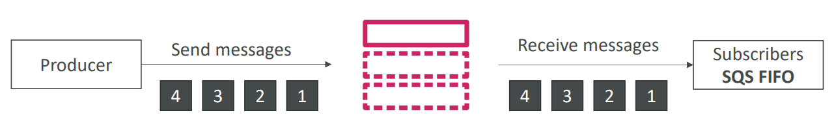

1. Similar feature as SQS FIFO
   1. Ordering by Message Group ID (all messages in the same group are ordered)
   2. Deduplication using a Deduplication ID or Content Based Deduplication
2. Can only have SQS FIFO queues as subscribers
3. Limited throughput (same throughput as SQS FIFO)

## SNS - Message Filtering

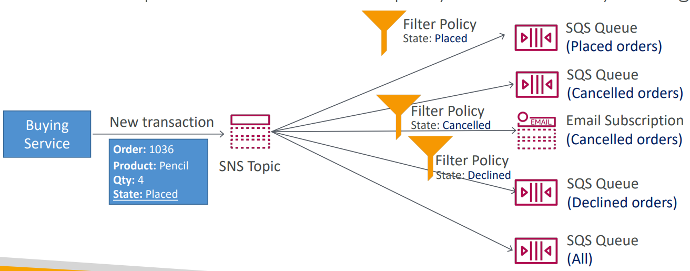

1. JSON Policy used to filter messages sent to SNS topic’s subscription
2. If a subscription does not have a filter policy, it receives every message

## SNS + SQS: Fan Out

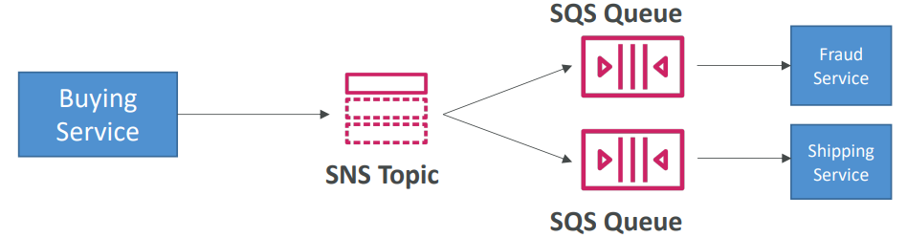

1. Push once in SNS, receive in all SQS queues that are subscribers
2. Fully decoupled, no data loss
3. Make sure your SQS queue access policy allows for SNS to write

### Application: S3 Events to multiple queues

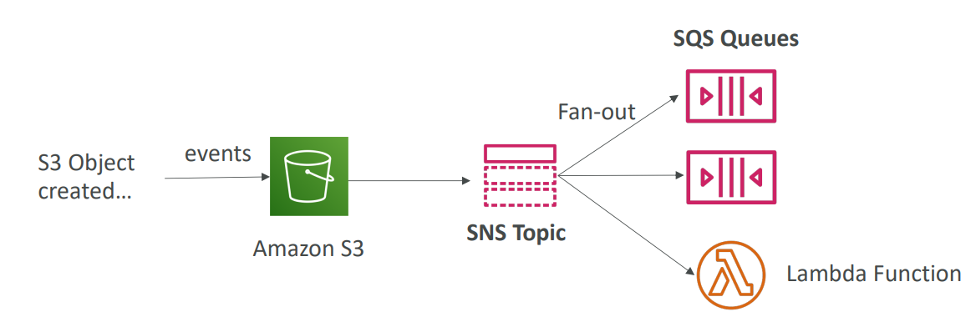

1. For the same combination of event type (eg. Objects create) and prefix (eg. Images/) you can only have one S3 Event rule
2. If you want to send the same S3 event to many SQS queues, use fan-out

## SNS FIFO + SQS FIFO: Fan Out

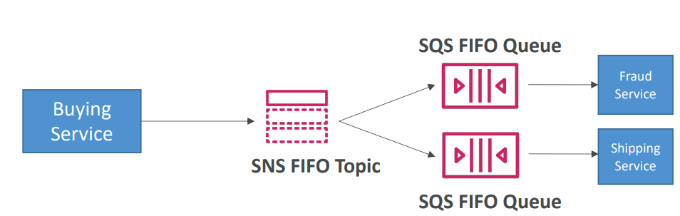

1. In case you need fan out + ordering + deduplication

# Kinesis

## Introduction

1. Makes it easy to collect, process and analyze streaming data in real-time
2. Four components of Kinesis
   1. Kinesis Data Streams- capture, process, and store data streams
   2. Kinesis Data Firehouse- load data streams into AWS data stores
   3. Kinesis Data Analytics- analyze data streams with SQL or Apache Flink
   4. Kinesis Video Streams- capture, process, and store video streams

## Components of Kinesis

### Kinesis Data Streams

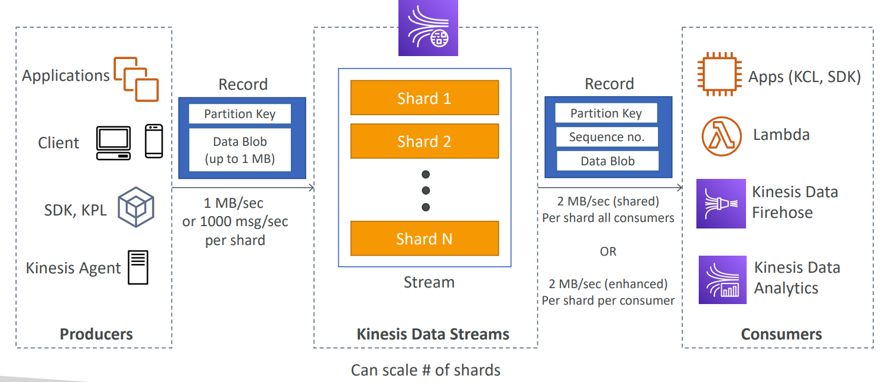

1. A place to store data produced by producers.
2. Data is contained in shards
3. Data that shares the same partition goes to the same shard (ordering)
4. Data is persistent
5. Once data is inserted in Kinesis, it can’t be deleted (immutability)
6. Ability to reprocess (replay) data
7. By default, data is stored for 24 hours. However, it can store it up to 7 days.
8. Producers
   1. AWS SDK
   2. Kinesis Producer Library (KPL)
   3. Kinesis Agent
9. Consumers
   1. Write your own: Kinesis Client Library (KCL), AWS SDK
   2. Managed: AWS lambda, Kinesis Data Firehouse, Kinesis Data Analytics
10. Kinesis Client Library (KCL)
    1. Helps you consume and process data from a Kinesis data stream
    2. Each shard is processed by exactly one KCL worker and has exactly one corresponding record processor
    3. One worker can process any number of shards, so it is fine if the number of shards exceeds the number of instances
11. Kinesis Streams consist of shards
    1. 5 transactions per second for reads, up to a maximum total data read rate of 2MB per second and up to 1,000 records per second for writes, up to a maximum total data write rate of 1 MB per second
    2. The data capacity of your stream is a function of number of shards that you specify for the stream. The total capacity of stream is the sum of capacities of its shards.

### Kinesis Data Firehouse

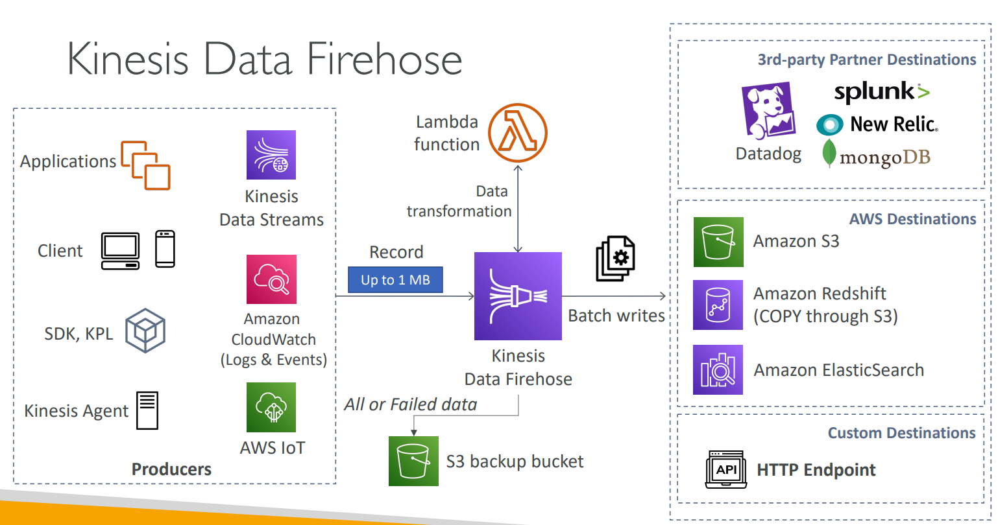

1. There is no data persistence.
2. Data should be analyzed as soon as it comes into Kinesis Firehouse using lambda.
3. With Firehouse, the data is always loaded directly to the destination. It is not stored within firehouse itself. And optionally, you can transform it or process it with AWS Lambda before it is actually stored in the destination
4. Can send failed or all data to backup S3 bucket
5. Near real time delivery (~60 seconds latency)
6. Fully Managed Service, no administration, automatic scaling, serverless
7. There are no shards, completely automated (scalability is elastic). With data streams, you have to add shards when you need to scale
8. Can send data to
   1. AWS: Redshift/ Amazon S3/ ElasticSearch
   2. 3rd party partner: Splunk/ MongoDB/ DataDog/ NewRelic
   3. Custom: send to any HTTP endpoint

### Kinesis Data Analytics

1. Performs analytics for data coming in from Kinesis Data Streams and Kinesis Data Firehouse
2. Destinations can be Kinesis Data Streams, Kinesis Data Firehouse or AWS Lambda

## Kinesis Data Streams vs Firehouse

|  |  |
| --- | --- |
| **Kinesis Data Stream** | **Kinesis Data Firehouse** |
| 1. Real time delivery (200ms latency) 2. Data is persistent 3. Scaling by increasing number of shards 4. stores data for later processing by app 5. Supports replay capability | 1. Near real time delivery(~60 sec latency) 2. No persistence 3. Automatic scaling 4. Firehouse which delivers data directly to AWS services |

## Ordering data into Kinesis

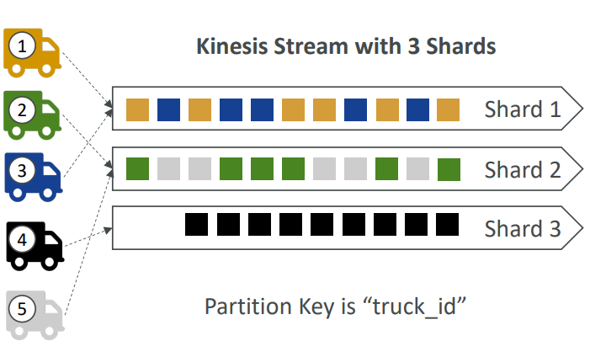

1. Imagine you have 100 trucks (truck_1, truck_2, .. truck_100) on the road sending their GPS positions regularly into AWS.
2. You want to consume the data in order for each truck, so that you can track their movement accurately
3. How should you send that data into Kinesis
4. Answer: send using a “partition key” value of the “truck_id”
5. The same key will always go to the same shard

## SQS vs SNS vs Kinesis

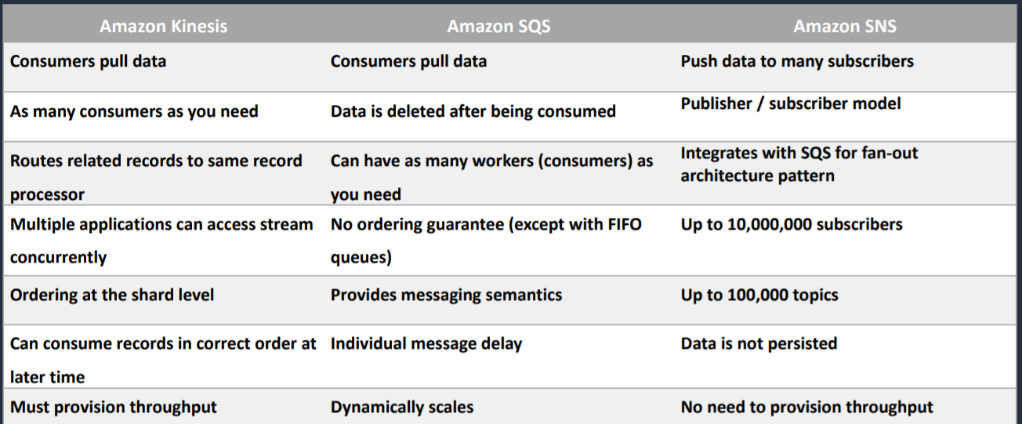

Kinesis -> consumers pull data, as many consumers as you want, multiple app can access stream concurrently, must provision throughput

SQS -> scales dynamically, message is deleted after being consumed

SNS -> no need to provision throughput

# Amazon MQ

## Introduction

1. SQS, SNS are “cloud-native” services, and they are using proprietary protocols from AWS
2. Traditional applications running from on-premises may use open protocols such as: MQTT, AMQP, STOMP, Openwire, WSS
3. When migrating to the cloud, instead of re-engineering the application to use SQS and SNS, we can use Amazon MQ
4. Amazon MQ = managed Apache ActiveMQ
5. Has both queue feature (SQS) and topic features (SNS)
6. It does not scale as much as SQS/SNS
7. It runs on a dedicated machine, can run in High Availability with failover

## MQ - High Availability

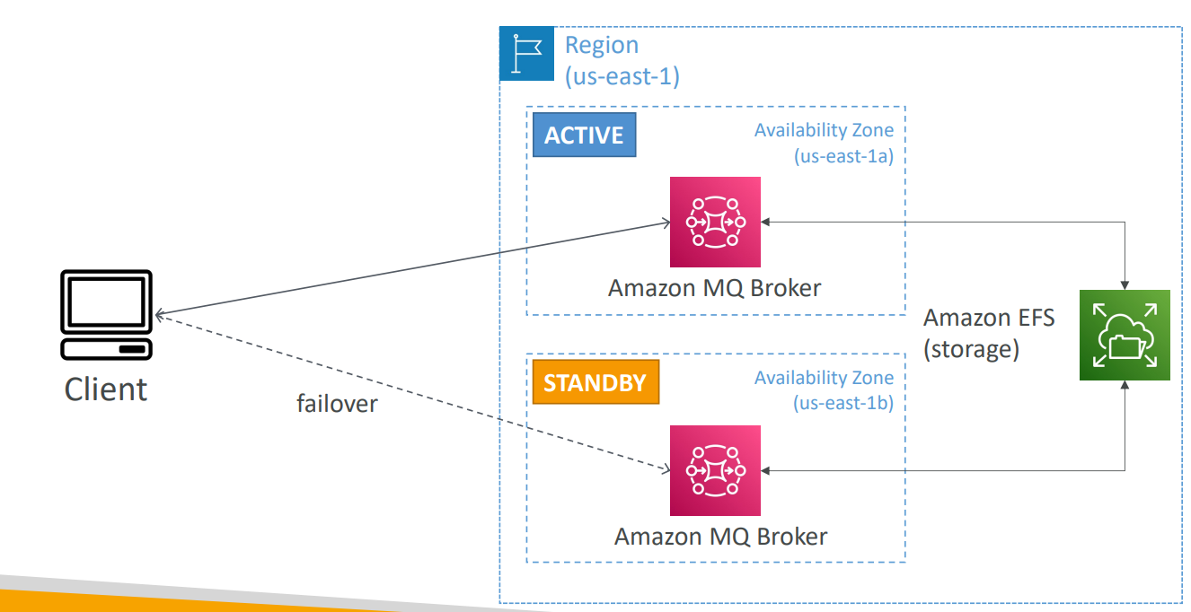

# Containers on AWS

## ECS

### Introduction

1. Elastic Container Service
2. Fully managed container orchestration, not serverless
3. Launch Docker Containers on AWS
4. You must provision and maintain the infrastructure
5. AWS takes care of starting/stopping containers
6. Amazon Elastic Container Service (ECS) has two Launch Types:
   1. Amazon EC2 Launch Type
   2. Fargate Launch Type
7. Windows container support
8. Amazon ECS Anywhere – works on-premises

### ECS Launch Type

1. Determines the type of infrastructure on which your tasks and services are hosted
   1. EC2 Launch Type
   2. Fargate Launch Type

#### EC2 Launch Type

1. You explicitly provision EC2 Instances
2. You are responsible for managing EC2 instances
3. Charged per running EC2 instance
4. There is support for few different storage services like Docker volumes, EFS and FSx for Windows File Server
5. You handle cluster optimization

#### Fargate Launch Type

1. Fargate automatically provisions resources
2. Fargate provisions and manages compute
3. Charged for running tasks
4. EFS integration
5. Fargate handles cluster optimization

### IAM Roles with ECS

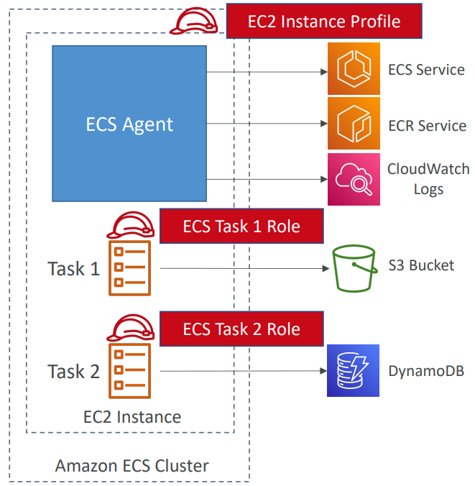

1. IAM Instance Role
   1. Provide permissions to the host
2. IAM Task Role
   1. Provide permissions to the container (task)

### Load Balancing for EC2 Launch Type

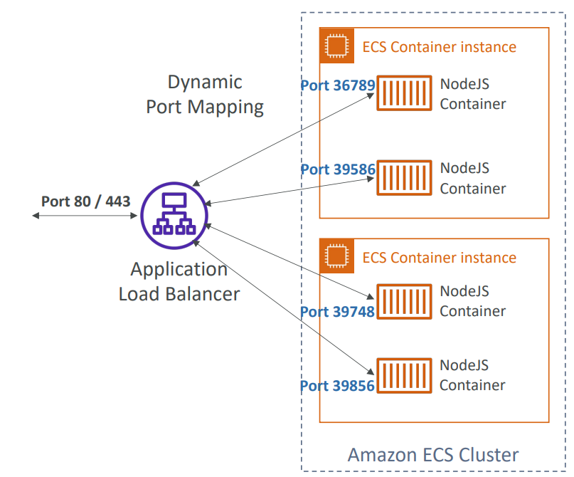

1. You get a dynamic port mapping
2. ALB supports finding the right port on your EC2 Instances
3. You must allow on the EC2 instance’s security group any port from the ALB security group

### ECS tasks invoked by Event Bridge

1. If you want to automate and invoke ECS task, we can use Event Bridge

### ECS Scaling

#### Introduction

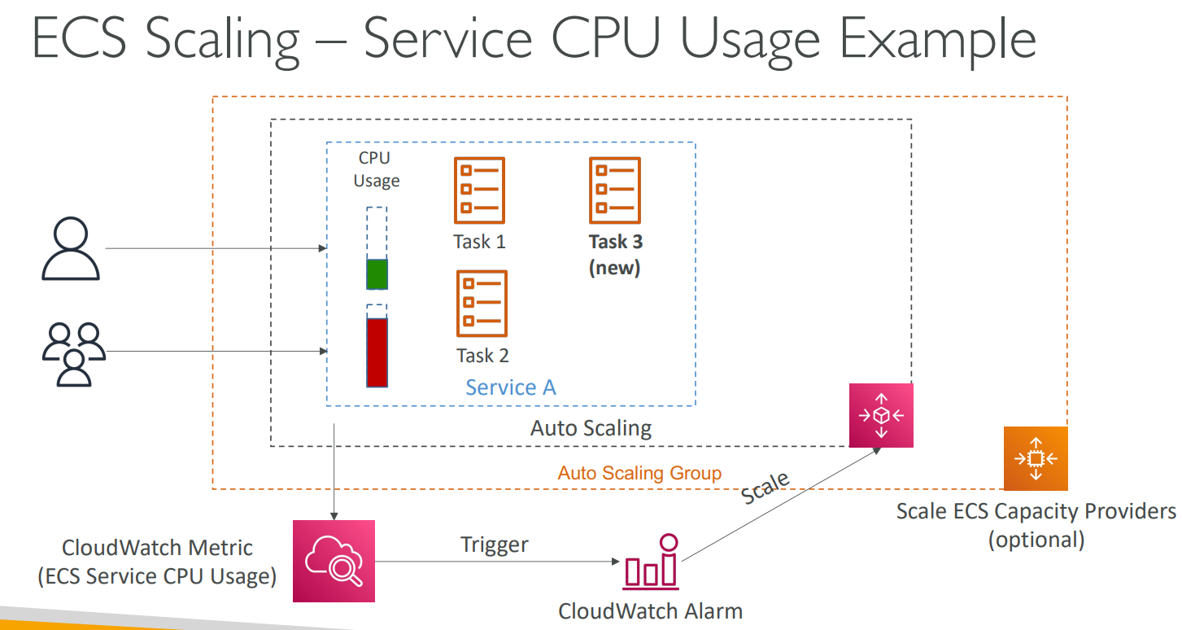

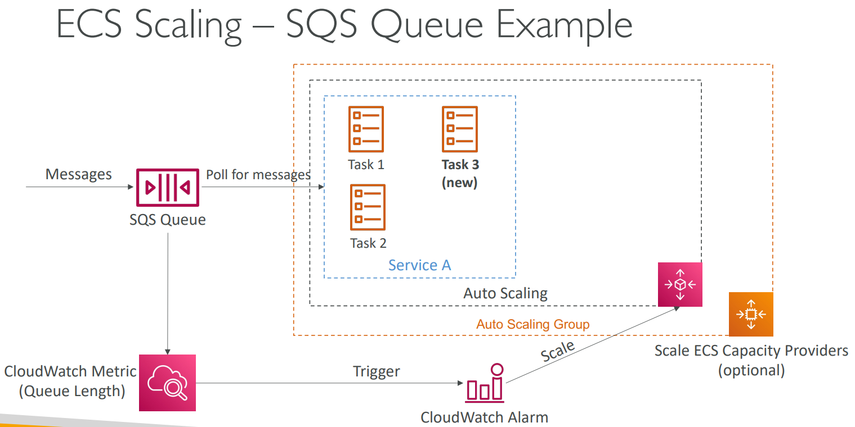

1. ECS can be scaled based on different metrics
   1. Based on Service CPU Usage
   2. Based on SQS Queue Length

#### Types of ECS AutoScaling

1. Service Auto scaling
2. Cluster Auto Scaling

##### Service Auto Scaling

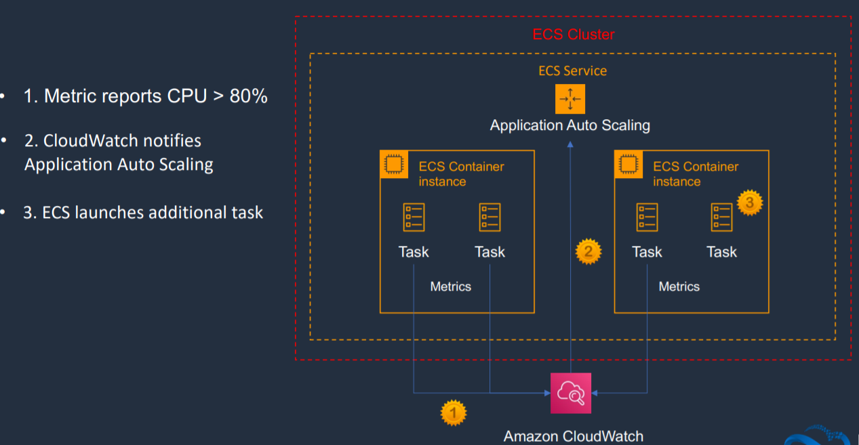

1. Additional task is launched

##### Cluster auto scaling

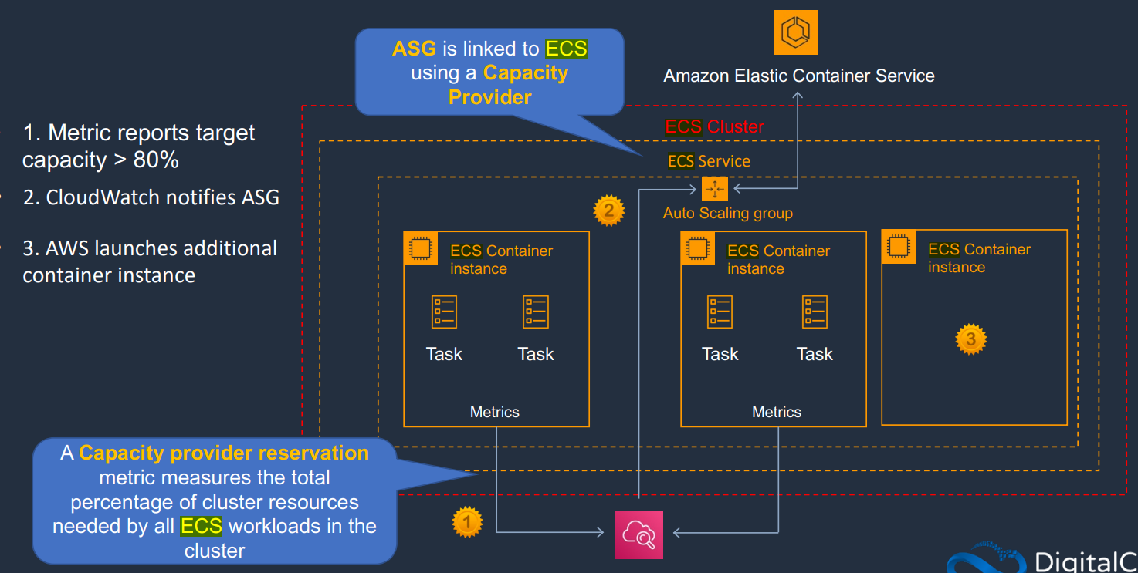

1. Launches new container instance
2. Uses Capacity Provider

### ECS Rolling Updates

1. When updating from V1 to V2, we can control how many tasks can be started and stopped, and in which order

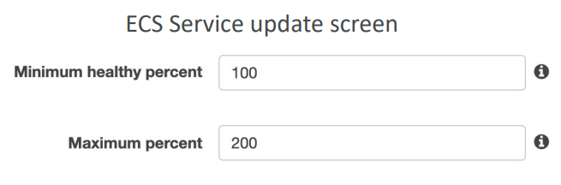

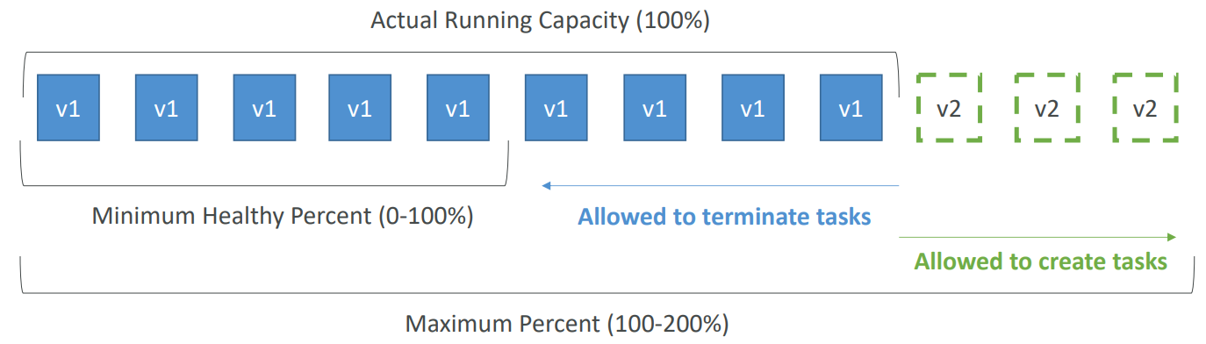

Min 50%, Max 100%

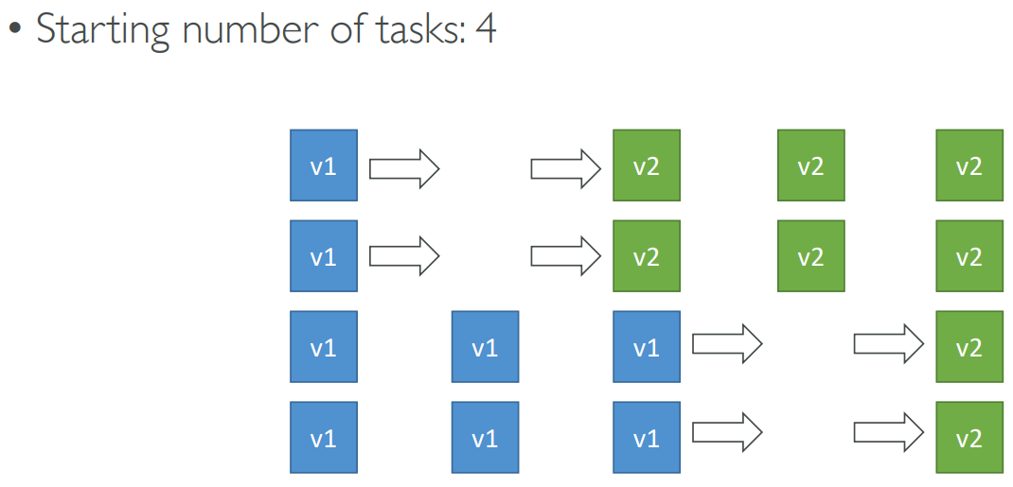

Min 100%, Max 150%

P[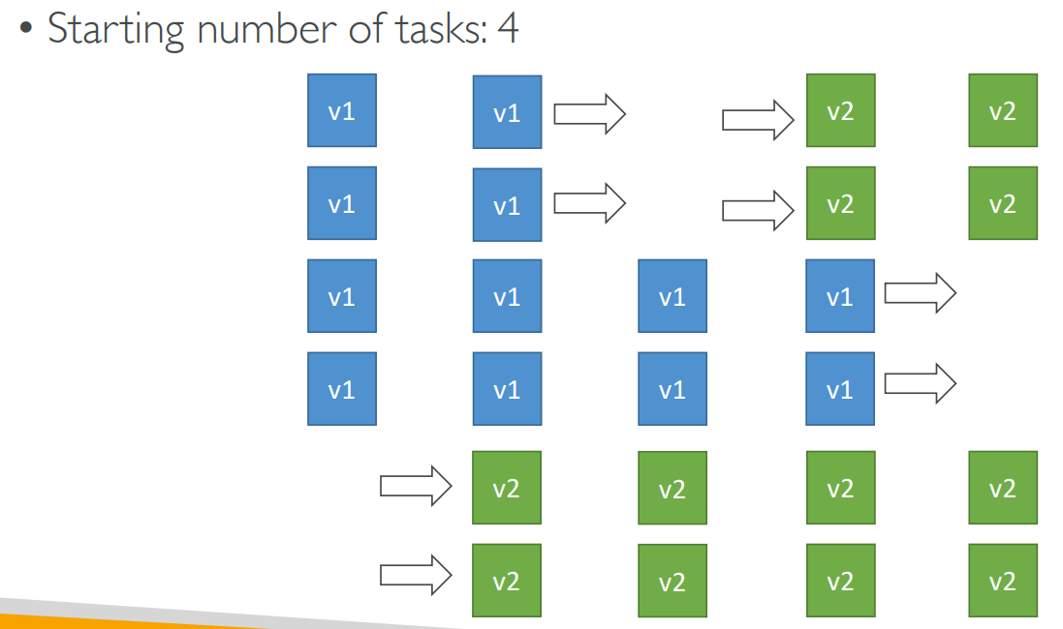

## Fargate

### Introduction

1. Serverless
2. Launch Docker containers on AWS
3. You do not provision and maintain the infrastructure

### IAM Role with Fargate

1. IAM Task Role
   1. With Fargate launch type, only IAM task roles can be applied

### Load Balancing for Fargate

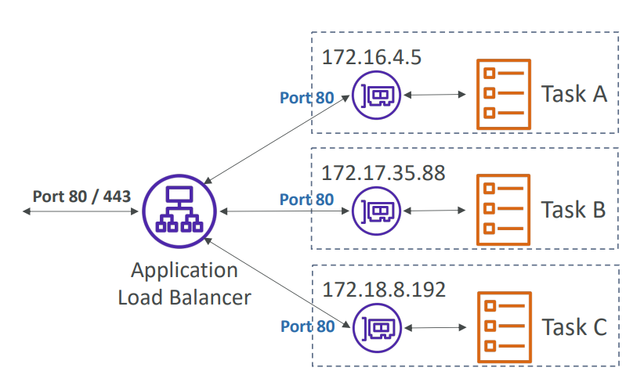

1. Each task has a unique IP
2. You must allow on the ENI’s security group the task port from the ALB security group

## Data Volumes - EFS File Systems

1. Works for both EC2 tasks and Fargate tasks
2. Ability to mount EFS volumes onto multiple tasks
3. Tasks launched in any AZ will be able to share the same data in the EFS volume
4. Fargate + EFS = serverless + data storage without managing servers
5. Use case
   1. Persistent multi-AZ shared storage for your containers

## Amazon EKS (Elastic Kubernetes Service)

1. Amazon Elastic Kubernetes Service
2. Like ECS, supports both EC2 and Fargate
3. Use case
   1. If your company is already using Kubernetes on-premises or in another cloud, and wants to migrate to AWS using Kubernetes
4. Kubernetes is cloud-agnostic (can be used in any cloud – Azure, GCP ..)

# Serverless Services

1. Developers do not have to manage servers
2. They just deploy code
3. Initially, they used to deploy functions so called Function as a Service
4. Serverless does not mean there are no servers it means you just don’t manage/ provision/ see them
5. Serverless in AWS
   1. AWS Lambda
   2. Amazon S3
   3. Aurora Serverless
   4. DynamoDB
   5. ElastiCache
   6. AWS API Gateway
   7. AWS Cognito
   8. AWS SNS & SQS
   9. AWS Kinesis Data Firehouse
   10. Step Functions
   11. Fargate
   12. Glue
   13. Amazon EventBridge
   14. SSM Parameter Store
   15. Athena

# Lambda

## Introduction

1. Serverless compute service that allows you to run your code without managing servers
2. Allows developers to focus on core business logic for the application they are developing instead of worrying about managing servers
3. Scales automatically
4. Provides monitoring dashboard
5. Lambda functions can be written in popular programming languages like Java, Go, Node Js, C#, Python
6. You can author your code using your favorite development environment locally and upload or you can write code via the console.
7. Lambda can execute your code in response to some events
8. Can have memory between 128 MB to 10240 MB
9. Timeout- 3 sec to 15 min
10. You specify the amount of memory you need to allocate to your lambda functions
11. Lambda is an event driven compute service
12. AWS Lambda language support
    * Node.js (JavaScript)
    * Python
    * Java (Java 8 compatible)
    * C# (.NET Core)
    * Golang
    * C# /Powershell
    * Ruby
    * Custom Runtime API (community supported, ex Rust)
    * Lambda Container Image
      + The container image must implement the Lambda Runtime API
      + ECS/ Fargate is preferred for running arbitrary Docker images
13. Use case
    * Serverless Thumbnail creation
    * Serverless CRON job
14. Lambda function can trigger another lambda function, 1 event = x functions if functions trigger other functions
15. Lambda functions are independent, 1 event=1 function
16. X-Ray helps to debug serverless applications
17. ALB, Cognito, Lex, Alexa, API Gateway, CloudFront, and Kinesis Data Firehose are all valid direct (synchronous) triggers for Lambda functions. S3 is one of the valid asynchronous triggers.

## Lambda Pricing

1. Pay per calls
   1. First 1 million requests are free
   2. $0.2 per 1 million requests thereafter
2. Pay per duration (in increment of 1 ms)
   1. 400,000 GB-seconds of compute time per month is free
      1. == 400,000 seconds if function is 1 GB RAM
      2. == 3,200,000 seconds if function is 128 MB RAM
   2. After that $1 for 600,000 GB-seconds

## Lambda Functions Invocations

1. Synchronous Invocation
   1. ALB, Cognito, Lex, Alexa, API Gateway, CloudFront, and Kinesis Data Firehose are all valid direct (synchronous) triggers for Lambda functions
   2. This can come from CLI, SDK, API Gateway
   3. Result is returned immediately
   4. Error handling must happen on the client side (retry, exponential backoff, etc)
   5. If it does not work, application should be coded to try again
   6. Exponential backoff -> try processing after some time
2. Asynchronous Invocation
   1. This can come from S3, SNS, CloudWatch Events
   2. Lambda will retry upto 3 times
   3. Processing must be idempotent (due to retries) -> should process same result each time processed
3. Event source mapping
   1. SQS, Kinesis Data Streams, DynamoDB Streams
   2. Lambda does polling

## Lambda Functions Concurrency

1. More lambda functions will be executed as more function gets invoked without completion of prior invocation
2. Burst concurrency quotas
   1. Limit number of lambda invocations in parallel
   2. Count varies depending on which region you are in
   3. If the concurrency limit is exceeded throttling occurs with error “Rate exceeded” and 429 “TooManyRequestsException”

## Lambda limits to know – per region

1. Execution
   1. Memory allocation: 128 MB-10GB (1 MB increments)
   2. Maximum execution time: 900 seconds (15 minutes)
   3. Environment variables (4 KB)
   4. /tmp space: 512 MB
   5. Concurrency executions: 1000 (can be increased)
2. Deployment
   1. Lambda function deployment size (compressed .zip): 50 MB
   2. Size of uncompressed deployment (code + dependencies): 250 MB
   3. Size of environment variables: 4 KB

## Lambda@Edge

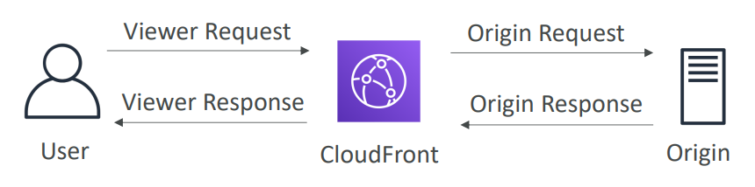

1. Lambda@Edge function runs code in each CloudFront Edge, globally
2. Run node.js and python lambda functions to customize the content CloudFront delivers
3. Executes functions closer to the viewer
4. You can use lambda to change CloudFront requests and responses
   1. After CloudFront receives a request from a viewer (viewer request)
   2. Before CloudFront forwards the request to the origin (origin request)
   3. After CloudFront receives the response from the origin (origin response)
   4. Before CloudFront forwards the response to the viewer (viewer response)

# Amazon DynamoDB

## Introduction

* Fully managed NoSQL database
* Serverless
* Stored on SSD storage
* Push button scaling means that you can scale the DB at any time without incurring downtime.
* DynamoDB is a Web service that uses HTTP over SSL (HTTPS) as a transport and JSON as a message serialization format.
* Amazon DynamoDB stores three geographically distributed replicas of each table to enable high availability and data durability.
* Data is synchronously replicated across 3 AZs in a region
* DynamoDB can be used for storing session state.
* Provides two read models
  + Eventual Consistent Reads
    - Default
    - Repeating a read after a short time should return the updated data
  + Strongly Consistent Reads
    - Returns a result that reflects all writes that received a successful response prior to the read
    - If you want to read data within one second of being written to table

## Features of DynamoDB

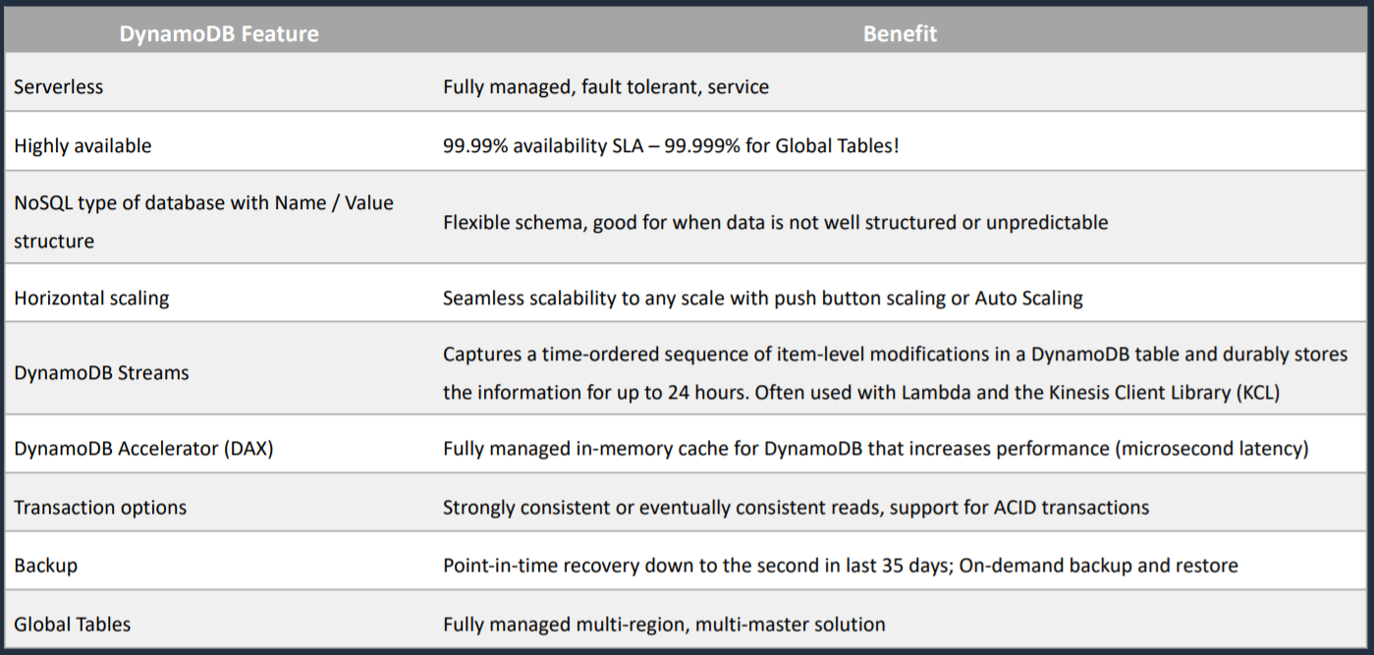

## Basics of DynamoDB

1. DynamoDB is made of Tables
2. Each table has a Primary Key (must be decide at creation time)
3. Primary key is the combination of Partition Key and Sort Key (optional)
4. Each table can have an infinite number of items (=rows)
5. Each item has attributes (can be added over time- can be null), anything except primary is attribute

## DynamoDB Accelerator (DAX)

1. In-memory cache for DynamoDB
2. Microseconds latency for cached data. Improves performance from milliseconds to microseconds
3. 10x performance improvement
4. 5 minutes TTL for cache (default)
5. Can be a read-through cache and a write-through cache

## DAX vs ElastiCache

1. DAX is optimized for DynamoDB
2. ElastiCache supports more datastores
3. With ElastiCache you have more management overhead (e.g. invalidation)
4. With ElastiCache you need to modify application code to point to cache

## DynamoDB - Read/ Write Capacity Modes

1. Control how you manage your tables capacity (read/write throughput)
2. Provisioned Mode (default)
   1. You specify the number of reads/writes per second
   2. Pay for provisioned Read Capacity Unit (RCU) and Write Capacity Unit (WCU)
3. On-Demand Mode
   1. Read/Write automatically scale up/down with your workloads
   2. No capacity planning needed
   3. Pay for what you use, more expensive
   4. Great for unpredictable workloads

## DynamoDB - Streams

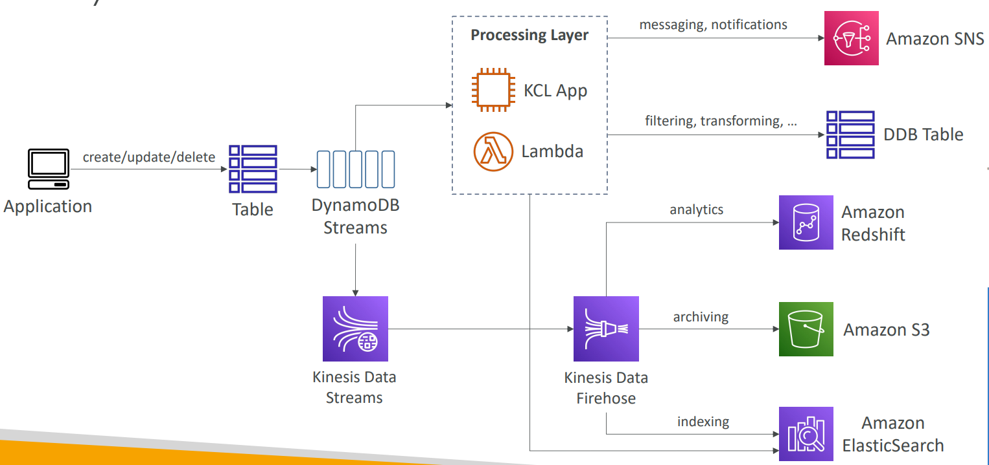

1. Ordered stream of item-level modifications (create/update/delete) in a table
2. Can configure the information that is written to the stream
   1. KEYS_ONLY – only the key attributes of the modified item
   2. NEW_IMAGE – the entire item, as it appears after it was modified
   3. OLD_IMAGE – the entire item, as it appeared before it was modified
   4. NEW_AND_OLD_IMAGES – both the new and old images of the item

## DynamoDB - Global Tables

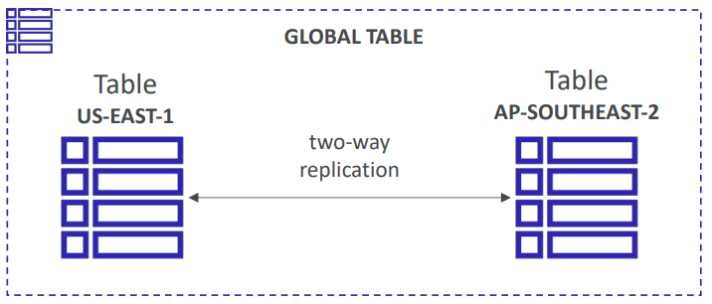

1. Make a DynamoDB table accessible with low latency in multiple regions
2. Active-Active Replication
3. Applications can READ and WRITE to the table in any region
4. To enable DynamoDB Global Table, we must first enable DynamoDB Streams as a pre-requisite
5. The replication is asynchronous and actually replies upon DynamoDB streams
6. Global tables is multi-region and also a multi-active database, sometimes known as multi-master

## DynamoDB – Time To Live (TTL)

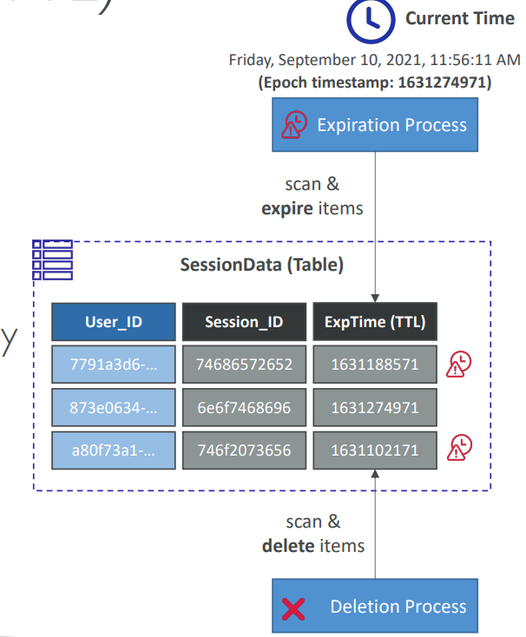

1. Automatically delete items after an expiry timestamp
2. With TTL enabled on a table, you can set a timestamp for deletion on a per-item basis
3. Use case
   1. Reduce stored data by keeping only current items
   2. Adhere to regulatory obligations that says rows can be kept only for 7 days

## DynamoDB – Indexes

1. Global Secondary Indexes (GSI) and Local Secondary Indexes (LSI)
2. Allow to query on attributes other than the primary key

## DynamoDB – Transactions

1. Way to write to either multiple tables or none of them as part of one specific write
2. Up to 25 items or 4 MB of data

## DynamoDB - Security

1. Encryption at rest using KMS
2. Site-to-site VPN
3. Direct Connect (DX)
4. IAM Policies and Roles
5. Fine-grained access: allows users to access only certain attribute within DynamoDB table items
6. CloudWatch and CloudTrail: monitor tables using CloudWatch and CloudTrail
7. VPC endpoints for DynamoDB to enable EC2 instances in your VPC to use their private IP addresses, to access DynamoDB with no exposure to the public internet.

## On-Demand Backup and Restore

1. Full backups at any time
2. Zero impact on table performance or availability
3. Retained until deleted
4. Operates within same region as the source table
5. Cannot do backup and restore across regions

## Point-in-Time Recovery (PITR)

1. It is not enabled by default
2. Helps you to protect against accidental writes and reads
3. Restore to any point in last 35 days
4. DynamoDB maintains incremental backups of your data
5. You have to go in and turn this on manually and the latest restorable timestamp is typically 5 minutes in the past.

## DynamoDB for Solutions Architect

1. Operations
   1. No operations needed
   2. Auto scaling capability
   3. Serverless
2. Security
   1. Full security through IAM policies, KMS encryption, SSL in flight
3. Reliability
   1. Multi AZ
   2. Backups
4. Performance
   1. Single digit millisecond performance
   2. DAX for caching reads
   3. Performance does not degrade if your application scales
5. Cost
   1. Pay per hour based on EC2 and storage usage
   2. No need to guess in advance any capacity- can use auto scaling

# AWS API Gateway

## Introduction

1. Amazon API Gateway is a fully managed service that makes it easy for developers to create, publish, maintain, monitor, and secure serverless APIs at any scale.
2. With a few clicks in the AWS Management Console, you can create an API that acts as a “front door” for applications to access data, business logic, or functionality from your back-end services.
3. Back-end services may include [Amazon Elastic Compute Cloud (Amazon EC2)](https://aws.amazon.com/ec2/), code running on [AWS Lambda](https://aws.amazon.com/lambda/), or any web application.
4. Supports restful APIs, including rest APIs and HTTP APIs as well as web socket APIs
5. Integrations
   1. Lambda Function
   2. HTTP
   3. AWS Service
6. API Gateway Integrations
   1. For a lambda function you can have
      1. Lambda proxy integration
      2. Lambda custom integration
   2. For an HTTP endpoint you can have
      1. HTTP proxy integration
      2. HTTP custom integration
   3. For an AWS service action you have the AWS integration of the non-proxy type only

## API Gateway Deployment Types/ Endpoint Types

1. Edge-Optimized Endpoint
2. Regional Endpoint
3. Private Endpoint

### Edge-Optimized Endpoint

1. Reduced latency for requests from around the world

### Regional Endpoint

1. Reduced latency of requests that originate in the same region

### Private Endpoint

1. Can be accessed from your VPC using an interface VPC endpoint (ENI)
2. Securely expose your REST APIs only to other services within your VPC or connect via Direct Connect

## API Gateway – Caching

1. You can enable API caching in Amazon API Gateway to cache your endpoint’s response.
2. With caching, you can reduce the number of calls made to your endpoint and also improve the latency of the requests to your API
3. When you enable caching for a stage, API Gateway caches responses from your endpoint for a specified time-to-live (TTL) period, in seconds.

## API Gateway – Throttling

1. API Gateway sets a limit on a steady state and a burst of request submissions against all APIs in your account
2. Limits
   1. By default, API Gateway limits the steady state request rate to 10,000 requests per second
   2. The maximum concurrent requests is 5000 requests across all APIs within an AWS account
   3. If you go over 10,000 requests per second or 5000 concurrent requests you will receive a 429 Too Many Requests error response

## API Gateway – Usage Plans and API Keys

1. Usage plan can be Premium and Basic
2. API Keys help to distinguish between premium plan and basic plan

## API Gateway – Security

### IAM Permissions

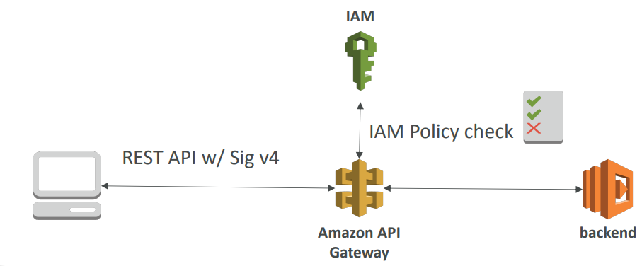

1. API Gateway verifies IAM permissions passed by the calling application
2. Leverages “Sig v4” capability where IAM credential are in headers
3. Great for users/ roles already within your AWS account

### Lambda Authorizer (formerly Custom Authorizers)

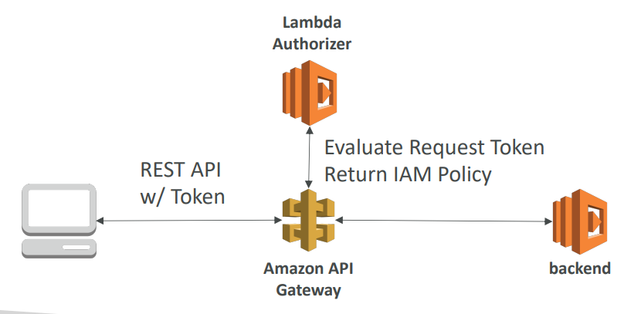

1. Uses AWS Lambda to validate the token in header being passed
2. Lambda must return an IAM policy for the user
3. Option to cache result of authentication
4. Helps to use OAuth/ SAML/ 3rd party type of authentication

### Cognito User Pools

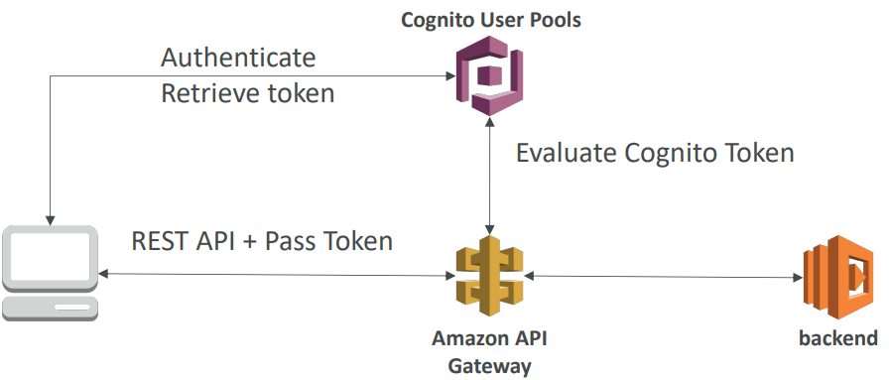

1. Cognito fully manages user lifecycle
2. API gateway verifies identity automatically from AWS Cognito
3. No custom implementation required
4. Cognito only helps with authentication, not authorization

### API Gateway – Security (Summary)

1. IAM
   1. Great for users/ roles already within your AWS account
   2. Handle authentication + authorization
   3. Leverages Sig v4
2. Custom Authorizer
   1. Great for 3rd party tokens
   2. Very flexible in terms of what IAM policy is returned
   3. Handle Authentication + Authorization
   4. Pay per lambda invocation (can use caching to minimize number of invocations made)
3. Cognito User Pool
   1. You manage your own user pool (can be backed by Facebook, Google login, etc ..)
   2. No need to write any custom code
   3. Must implement authorization in the backend

## Same Origin Policy

1. Under this policy, a web browser permits scripts contained in a first web page to access data in a second web page, but only if both web pages have the same origin.
2. This is done to prevent Cross-Site Scripting (XSS) attacks.
3. This is enforced by web browsers and ignored by tools like Postman and curl

## CORS (Cross Origin Resource Sharing)

1. It is being able to talk to a web page in another domain and request resources from it
2. If we get error saying Origin Policy cannot be read at the remote resource, you need to enable CORS on API Gateway
3. CORS is always enforced by client’s browser

# AWS Cognito

## Introduction

1. Amazon Cognito provides authentication, authorization and user management services for your web/mobile applications.
2. It supports both traditional way of authentication which is by providing username and password as well as using third party social logins like Facebook, Gmail, etc

## Components of AWS Cognito

1. The main components of AWS Cognito are:
   1. User Pools
   2. Identity Pools
2. Both of these components can be used individually or together.

### AWS Cognito - User Pools (CUP)

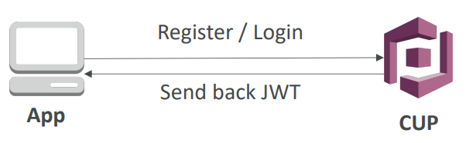

1. A user pool is **a user directory in Amazon Cognito**.
2. With a user pool, your users can sign into your web or mobile applications either through Amazon Cognito or through social identity providers like Google, Facebook, Amazon, or Apple, and through SAML identity providers.
3. Either user sign in directly or through third party, all members of a user pool have a directory profile that you can access through your SDK
4. After successfully authenticating user, it sends back a JSON Web Tokens (JWT)

### AWS Cognito - Federated Identity Pools

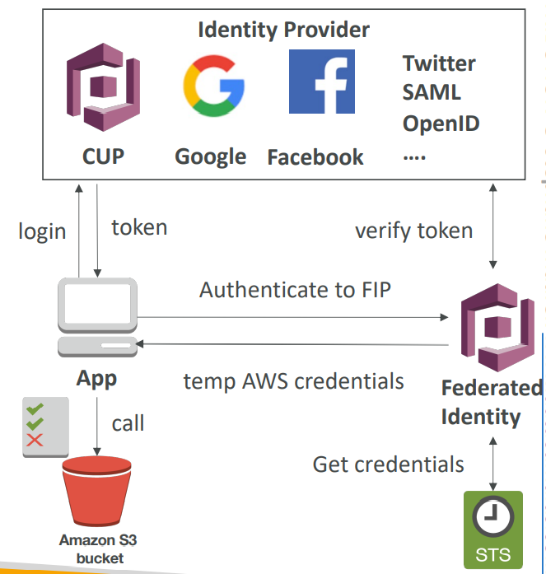

1. With Identity pools, we can obtain temporary limited AWS credentials to access other AWS services.
2. Integrate with Cognito User Pools as an identity provider
3. Example
   1. Provide temporary access to write to S3 bucket using Facebook Login

## AWS Cognito Sync

1. Cognito tracks the association between user identity and various different devices they sign-in from
2. In order to provide seamless user experience for your application, Cognito uses Push Synchronization to push updates and synchronize user data across multiple devices
3. Cognito uses SNS to send a notification to all the devices associated with a given user identity whenever data stored in the cloud changes
4. Cross device synchronization (any platform – IOS, Android, etc ..)
5. Offline capability (synchronization when back online)
6. Requires Federated Identity Pool in Cognito (not User Pool)

# AWS SAM (Serverless Application Model)

1. Framework for developing and deploying serverless applications
2. All the configuration is YAML code
   1. Lambda functions
   2. DynamoDB tables
   3. API Gateway
   4. Cognito User Pools
3. SAM can help you to run Lambda, API Gateway, DynamoDB locally
4. SAM can use CodeDeploy to deploy lambda functions

# Redshift

## Introduction

1. Scalable data warehouse solution
2. Data warehouse solution that supports querying, reporting, analytics, and business intelligence
3. BI Tools such as AWS Quicksight or Tableau integrate with it
4. Redshift is based on PostgreSQL, but it is not used for OLTP
5. RedShift is 10x faster than a traditional SQL DB. 10x better performance than other data warehouses
6. RedShift uses columnar data storage
7. Massively Parallel Query Execution (MPP)
   1. Redshift automatically distributes data and query load across all nodes.
8. RedShift provides advanced compression
   1. Redshift does not require indexes or materialized views, and so uses less space than traditional relational database systems
9. RedShift provides continuous/incremental backups
10. RedShift always keeps three copies of your data
    1. The original.
    2. A replica on compute nodes (within the cluster).
    3. A backup copy on S3.
11. Redshift can be configured as follows
    1. Single Node (160 Gb)
    2. Multi Node
       1. Leader node: for query planning, results aggregation
       2. Compute node: for performing the queries, send results to leader
12. From 1 node to 128 nodes, up to 128 TB of space per node

## Redshift – Backups

1. Enabled by default with a 1-day retention period
2. Maximum retention period is 35 days

## Redshift – Pricing

Redshift is priced as follows:

1. Compute Node Hours
   1. Total number of hours you run across all your compute nodes for the billing period
   2. You are billed for 1 unit per node per hour, so a 3-node data warehouse cluster running persistently for an entire month would incur 2,160 instance hours
   3. You will not be charged for leader node hours. Only compute nodes will incur charge.
2. Backup
3. Data transfer (only within a VPC, not outside it)

## Redshift – Security

1. Encrypted in transit using SSL
2. Encrypted at rest using AES-256 encryption

## Redshift – Availability

1. Currently only available in 1 AZ
2. Can restore snapshots to new AZs in the event of an outage

## Redshift – Snapshots and Disaster Recovery

1. Redshift has no “Multi-AZ” mode
2. For recovery, we need to take snapshots. Snapshots are point-in-time backups of a cluster stored internally in S3
3. Snapshots are incremental (only what has changed is saved)
4. You can restore a snapshot into a new cluster
5. There are two modes for snapshots
   1. Manual
   2. Automated
      1. Every 8 hours
      2. Every 5 GB
      3. On a schedule
6. You can configure Amazon Redshift to automatically copy snapshots (automated or manual) of a cluster to another AWS Region

## Loading data into Redshift

There are 3 ways to ingest data into Redshift

1. EC2 Instance using JDBC driver
2. S3 using COPY command
3. Amazon Kinesis Data Firehouse

## Redshift Spectrum

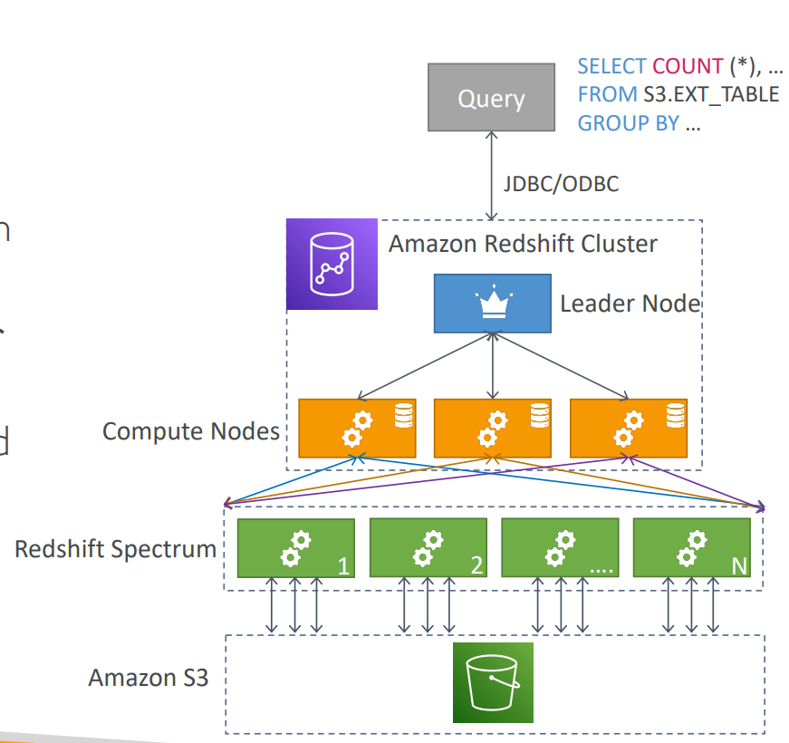

1. Query data that is already in S3 without loading it
2. Must have a Redshift cluster available to start the query

## Redshift for Solutions Architect

1. Operation
   1. Like RDS
2. Security
   1. IAM
   2. VPC
   3. KMS
   4. SSL
3. Reliability
   1. Auto healing features
   2. Cross region snapshot copy
4. Performance
   1. 10x performance vs other data warehousing
   2. Compression
5. Cost
   1. Pay per node provisioned
   2. 1/10th of the cost vs other warehouses
6. Vs Athena
   1. Faster queries/ joins/ aggregations due to indexes

# Glue

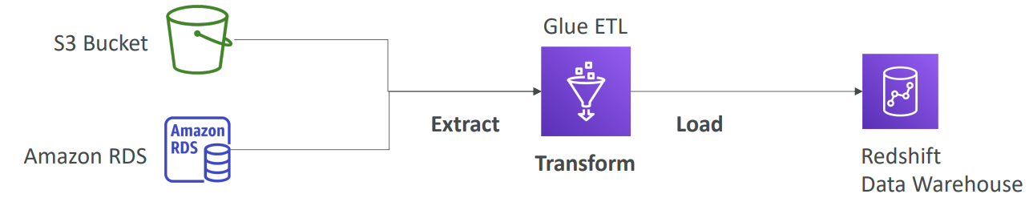

1. Serverless
2. Prepares data for analytics
3. ETL (Extract, Transform, Load)
4. Recommends and generates ETL code to transform your source data into target schemas.
5. Glue automatically generates Scala or Python code for ETL jobs that you can further customize using tools you are already familiar with.
6. AWS Glue runs the ETL jobs on a fully managed, scale-out Apache Spark environment to load your data into its destination.
7. AWS Glue automatically discovers and profiles data via the Glue Data Catalog
8. Glue can automatically discover both structured and semi-structured data stored in data lakes on [**Amazon S3**](https://aws.amazon.com/s3/), data warehouses in [**Amazon Redshift**](https://aws.amazon.com/redshift/), and various databases running on AWS like RDS and one running on EC2
9. You can use crawler to populate the AWS Glue Data Catalog with tables

# Neptune

## Introduction

1. Fully managed graph database
2. No SQL
3. Highly available across 3 AZ
4. Up to 15 replicas
5. Point-in-time recovery

## Neptune for Solutions Architect

1. Operations
   1. Similar to RDS
2. Security
   1. IAM
   2. VPC
   3. KMS
   4. SSL
   5. IAM Authentication
3. Reliability
   1. Multi-AZ
   2. Clustering
4. Performance
   1. Best suited for graph clustering to improve performance
5. Cost
   1. Pay per node provisioned

# ElasticSearch/ OpenSearch

## Introduction

1. Managed service
2. Amazon ElasticSearch is now OpenSearch
3. In DynamoDB, you can only find by primary key or indexes
4. With ElasticSearch, you can search any field, even partial matches
5. It is common to use ElasticSearch as a complement to another database
6. Comes with Kibana (visualization) and Logstash (log ingestion)
7. ElasticSearch along with Kibana and Logstash is called ELK Stack
8. Security through Cognito and IAM, KMS encryption, SSL and VPC
9. Elasticsearch is a popular open-source search and analytics engine for use cases such as log analytics, real-time application monitoring, and click stream analytics.

## ElasticSearch for Solutions Architect

1. Operation
   1. Similar to RDS
2. Security
   1. Cognito
   2. IAM
   3. VPC
   4. KMS
   5. SSL
3. Reliability
   1. Multi-AZ
   2. Clustering
4. Performance
   1. Performance is based on ElasticSearch project
   2. Can scale to petabytes of data
5. Cost
   1. Pay per node provisioned

# CloudWatch

## Introduction

* Collection of services like CloudWatch Alarms, CloudWatch Logs, CloudWatch Metrics, CloudWatch Events
* Cloud Watch is for performance monitoring. Cloud Trail is for auditing.
* CloudWatch monitors performance. CloudTrail monitors API calls in the AWS platform.
* CloudWatch is accessed via API, command-line interface, AWS SDKs, and the AWS Management Console.
* CloudWatch integrates with IAM.
* CloudWatch Logs keeps logs indefinitely by default.
* CloudTrail logs can be sent to CloudWatch Logs for real-time monitoring.
* CloudWatch retains metric data as follows:
  + Data points with a period of less than 60 seconds are available for 3 hours.
  + Data points with a period of 60 seconds (1 minute) are available for 15 days.
  + Data points with a period of 300 seconds (5 minute) are available for 63 days.
  + Data points with a period of 3600 seconds (1 hour) are available for 455 days (15 months).
* Basic monitoring = 5 mins (free for EC2 Instances, EBS volumes, ELBs and RDS DBs).
* Detailed monitoring = 1 min (chargeable)
* Do not store logs on non-persistent disks:
* Best practice is to store logs in CloudWatch Logs or S3.

## CloudWatch Metrics

### Introduction

1. CloudWatch provides metrics for every service in AWS
2. Metric is a variable to monitor (CPUUtilization, NetworkIn, ..)
3. Metrics have timestamps

### EC2 Detailed Monitoring

1. EC2 Instance metrics have metrics “every 5 minutes”
2. With detailed monitoring (for a cost), you get data “every 1 minute”
3. This will help you to react faster in case of changing metrics and scale using ASG
4. AWS Free Tier allows us to have 10 detailed monitoring metrics

Note

EC2 Memory Usage is by default not pushed (must be pushed from inside the instance as a custom metric)

### CloudWatch Custom Metrics

1. Possibility to define and send your own custom metrics to CloudWatch
2. Example: memory (RAM) usage, disk space, number of logged in users
3. Use API call PutMetricData
4. Metric resolution (two possible value)
   1. Standard- 1 minute (60 sec)
   2. High resolution- 15/10/30 sec – higher cost
5. Important: Accepts metric data points two weeks in the past and two hours in the future
6. AWS metrics are standard resolution by default

### CloudWatch Dashboards

1. Great way to setup custom dashboards for quick access to key metrics and alarms
2. Dashboards are global
3. Dashboards can include graphs from different AWS accounts and regions
4. You can change time zone and time range of the dashboards
5. You can setup automatic refresh (10s, 1m, 5m, 15m)
6. Dashboards can be shared with people who don’t have an AWS account (public email address, 3rd party SSO provider through Amazon Cognito)
7. Pricing
   1. 3 dashboards (up to 50 metrics) for free
   2. $3/dashboard/month afterwards

## CloudWatch Logs

### Introduction

1. CloudWatch Logs is used to monitor application logs
2. Can define log expiration policies (never expire, 30 days, etc)
3. CloudWatch Logs can send logs to
   1. Amazon S3
   2. AWS Lambda
   3. Kinesis Data Streams
   4. Kinesis Data Firehouse

### CloudWatch Logs – Metric Filter & Insights

1. CloudWatch Logs can use filter expressions
   1. Examples find a specific IP inside of a log
   2. Or count occurrences of “ERROR” in your logs
2. Metric filters can be used to trigger CloudWatch Alarms
3. CloudWatch Logs Insights can be used to query logs and add queries to CloudWatch Dashboards

### CloudWatch Logs – S3 Export

1. Log data can take up to 12 hours to become available for export
2. The API call is CreateExportTask
3. Not near-real time or real time. Use Logs Subscriptions instead

### CloudWatch Logs – Subscriptions

1. Subscriptions are filters that are applied on top of CloudWatch Logs and we can send to destinations which can be Lambda function (managed by AWS or custom), Kinesis Data Firehouse, Kinesis Data Streams

### CloudWatch Logs - Aggregation Multi-Account and Multi-Region

1. Logs from multiple accounts and multiple regions can be centralized

### CloudWatch Logs for EC2

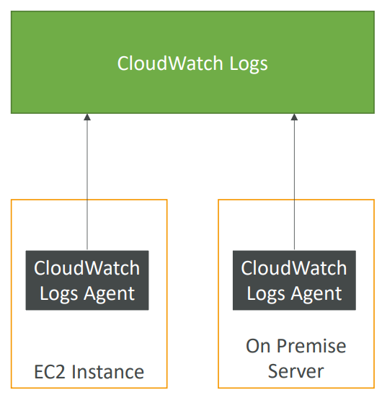

1. By default, no logs from your EC2 machine will go to CloudWatch
2. You need to run a CloudWatch log agent on EC2 to push the log files you want
3. Make sure IAM permissions are correct
4. CloudWatch log agent can be setup on-premises too

### CloudWatch Logs Agent and Unified Agent

1. For virtual servers (EC2 instances, on-premises servers, ..)
2. CloudWatch Logs Agent
   1. Old version of the agent
   2. Can only send to CloudWatch Logs
3. CloudWatch Unified Agent
   1. Collect additional system level metrics such as RAM, processes, etc
   2. Collect logs to send to CloudWatch Logs
   3. Centralized configuration using SSM Parameter Store
   4. Unified CloudWatch Agent sends system-level metrics for EC2 and on-premises servers
   5. System-level metrics include memory and disk usage
   6. CloudWatch Unified Agent – Metrics
      1. CPU (active, guest, idle, system, user, steal)
      2. Disk metrics (free, used, total)
      3. Disk IO (writes, reads, bytes, iops)
      4. RAM (free, inactive, used, total, cached)
      5. Netstat (number of TCP and UDP connections, net packets, bytes)
      6. Processes (total, dead, bloqued, idle, running, sleep)
      7. Swap space (free, used, used %)

## CloudWatch Alarm

### Introduction

1. Alarms are used to trigger notifications for any metric
2. Two types of alarms
   1. Metric Alarm – performs one or more actions based on a single metric
   2. Composite Alarm – uses a rule expression and considers multiple alarms
3. Has various options
   1. Sampling
   2. %
   3. Max
   4. Min
4. Alarm States
   1. OK- means alarm is not triggered
   2. INSUFFICIENT_DATA- there is no sufficient data to determine state of alarm
   3. ALARM- threshold has reached so alarm is set

### CloudWatch Alarm Targets

1. Amazon EC2 – stop, terminate, reboot, or recover an EC2 Instance
2. EC2 Auto Scaling Group- trigger Auto Scaling Action
3. Amazon SNS - Send notification to SNS

### EC2 Instance Recovery

There is status check which can be instance check or system check. We can define CloudWatch Alarm on both these checks. We can recover instance when alarm is reached.

1. Status Check
   1. Instance status- check the EC2 VM
   2. System status- check the underlying hardware
2. Recovery
   1. When we recover instance, it will have same Private, public, elastic IP, metadata, placement group

### CloudWatch Alarm - Good to know

1. Alarm can be created based on CloudWatch Logs Metrics Filters
2. To test alarms and notifications, set the alarm state to alarm using CLI

aws cloudwatch set-alarm-set –alarm-name “myalarm” –state-value ALARM –state-reason “testing purposes”

## CloudWatch Events

### Introduction

1. CloudWatch Event Source can be
   1. Event Pattern
      1. Intercept events from AWS services (sources) like EC2 Instance Start, CodeBuild Failure, S3, Trusted Advisor
      2. can intercept any API call with CloudTrail integration
   2. Schedule or Cron
      1. Example: Create an event every 4 hours
2. Use case
   1. Send email notification when EC2 instance is in pending state

# Amazon EventBridge

## Introduction

1. EventBridge is the next evolution of CloudWatch Events
2. By default, when we use CloudWatch Events, we are using Default event bus which is the event bus generated by AWS services within your account.
3. In EventBridge, multiple buses are added
   1. Partner Event bus: it is used to receive events not from AWS but from SaaS service or application
   2. Custom Event Bus: your own application can publish their own events and have other applications react to this event
4. An event is a signal that a system’s state has changed
5. With EventBridge, we have Event Sources which can be AWS Services, Custom Apps, third party SaaS Apps
6. AWS service targets include Lambda, SNS, SQS and API Gateway
7. State change on these resources get sent as events to EventBridge event bus
8. Rules can be created to define how you want to process these events

## Amazon EventBridge Schema Registry

1. The schema registry allows you to generate code for your application that will know in advance how data is structured in the event bus
2. Schema can be versioned

## Amazon EventBridge vs CloudWatch Events

1. EventBridge allows extension to add event buses for your custom applications and your third-party SaaS apps.
2. Event Bridge has the Schema Registry capability
3. EventBridge has a different name to mark the new capabilities
4. Over time, the CloudWatch Events name will be replaced with EventBridge

# AWS CloudTrail

## Introduction

1. It is a global service
2. Provides governance, compliance, and audit for your AWS account
3. Can put logs from CloudTrail into CloudWatch Logs or S3
4. If a resource is deleted in AWS, investigate CloudTrail first
5. Logs remain in it for 90 days.
6. A CloudTrail logs any events to S3 for indefinite retention
   1. Can enable log file integrity validation
7. delivers log files to an Amazon S3 bucket
8. CloudTrail is per AWS account.
9. You can consolidate logs from multiple accounts using an S3 bucket
10. CloudTrail log file integrity validation feature allows you to determine whether a CloudTrail log file was unchanged, deleted, or modified since CloudTrail delivered it to the specified Amazon S3 bucket.
11. With CloudTrail, you can create a trail that applies to either one region or all regions.
12. CloudTrail delivers log files within 15 minutes of user activity.
13. CloudTrail is enabled by default.
14. Log files are encrypted.

## CloudTrail Events

We can view three kinds of events in CloudTrail

1. Management Events
2. Data Events
3. CloudTrail Insight Events

### Management Events

1. Operations that are performed on resources in your AWS account
2. Example
   1. Configuring security
   2. Configuring rules for routing data
   3. Setting up logging
3. By default, trails are configured to log management events
4. Can separate Read Events (that don’t modify resources) from Write Events ( that may modify resources)

### Data Events

1. By default, data events are not logged (because they are high volume operations)
2. Example
   1. Amazon S3 object-level activity (ex: GetObject, DeleteObject, PutObject)
   2. AWS lambda function execution activity
3. Can separate Read and Write Events

### CloudTrail Insight Events

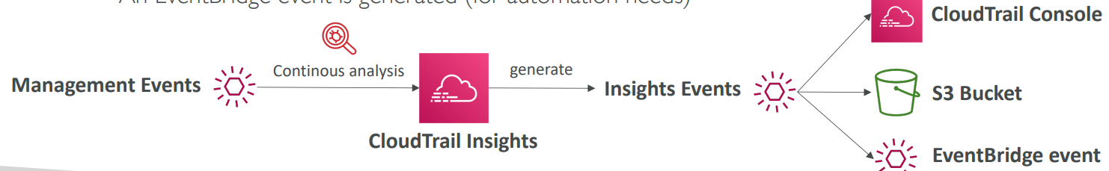

1. Enable CloudTrail Insights to detect unusual activity in your account
   1. Inaccurate resource provisioning
   2. Hitting service limits
   3. Bursts of AWS IAM actions
   4. Gaps in periodic maintenance activity
2. CloudTrail Insights analyzes normal management events to create a baseline and then

continuously analyzes write events to detect unusual patterns.

1. Identify and respond to unusual activity associated with write API calls by continuously analyzing CloudTrail management events

## CloudTrail Events Retention

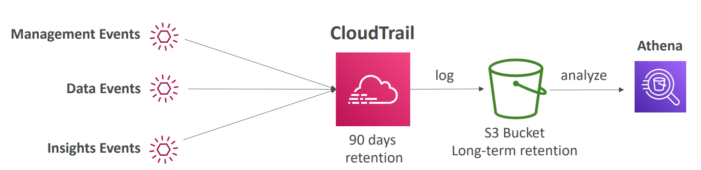

1. Events are stored for 90 days in CloudTrail.
2. To keep events beyond this period, log them to S3 and use Athena.

# AWS Config

## Introduction

1. Allows you to access, audit and evaluate configuration of your resources
2. Track configuration changes over time
3. Send notifications for every configuration changes
4. Delivers configuration history file to S3
5. Questions that can be solved by AWS Config
   1. Is there unrestricted SSH access to my security groups?
   2. Do my buckets have any public access?
   3. How has my ALB configuration changed over time?
6. AWS Config is a per-region service

## Config Rules

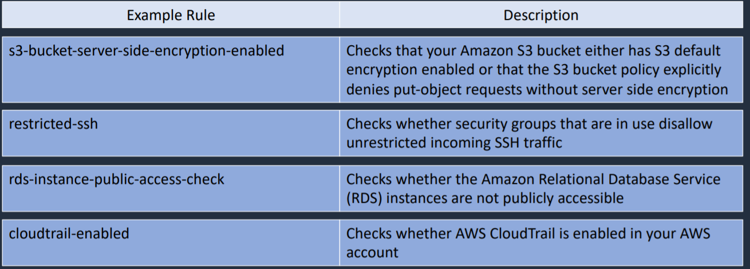

1. Can use AWS managed config rules (over 75)
2. Can make custom config rules (must be defined in AWS lambda)
   1. Example
      1. Evaluate if each EBS disk is of type gp2
      2. Evaluate if each EC2 instance is t2.micro
3. Rules can be evaluated/triggered
   1. For each config change
   2. And /or at regular time intervals
4. AWS Config rules does not prevent actions from happening (no deny)
5. Pricing
   1. No free tier
   2. $0.003 per configuration item recorded per region
   3. $0.001 per config rule evaluation per region

## AWS Config Resources

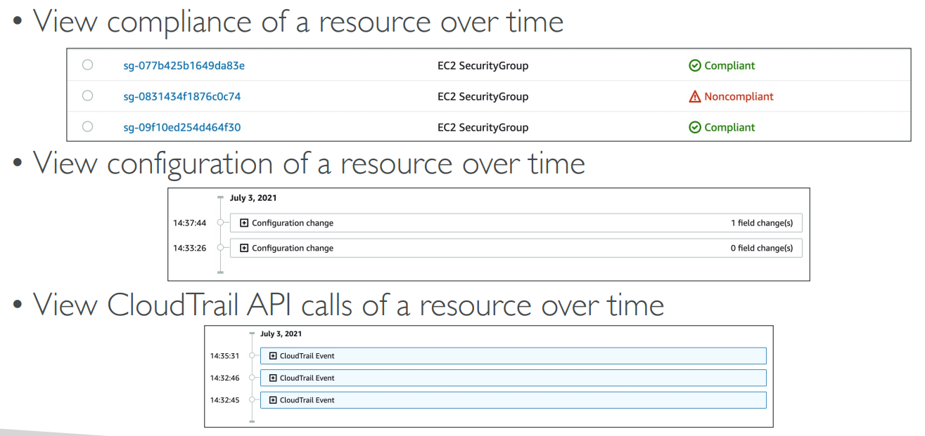

1. View compliance of a resource over time
2. View configuration of a resource over time
3. View CloudTrail API calls of a resource over time

## Config Rules – Remediation

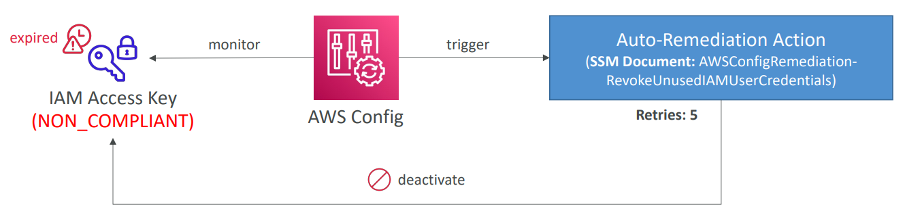

1. Although we cannot deny anything happening through AWS Config, we can automate remediation of non-complaint resources using SSM Automation Documents
2. We can either use AWS-Managed Automation Documents or create custom Automation Documents. We can create custom Automation Documents that invokes Lambda function
3. You can set Remediation retries if the resource is still non-compliant after auto-remediation (retry for 5 times)

## Config Rules – Notifications

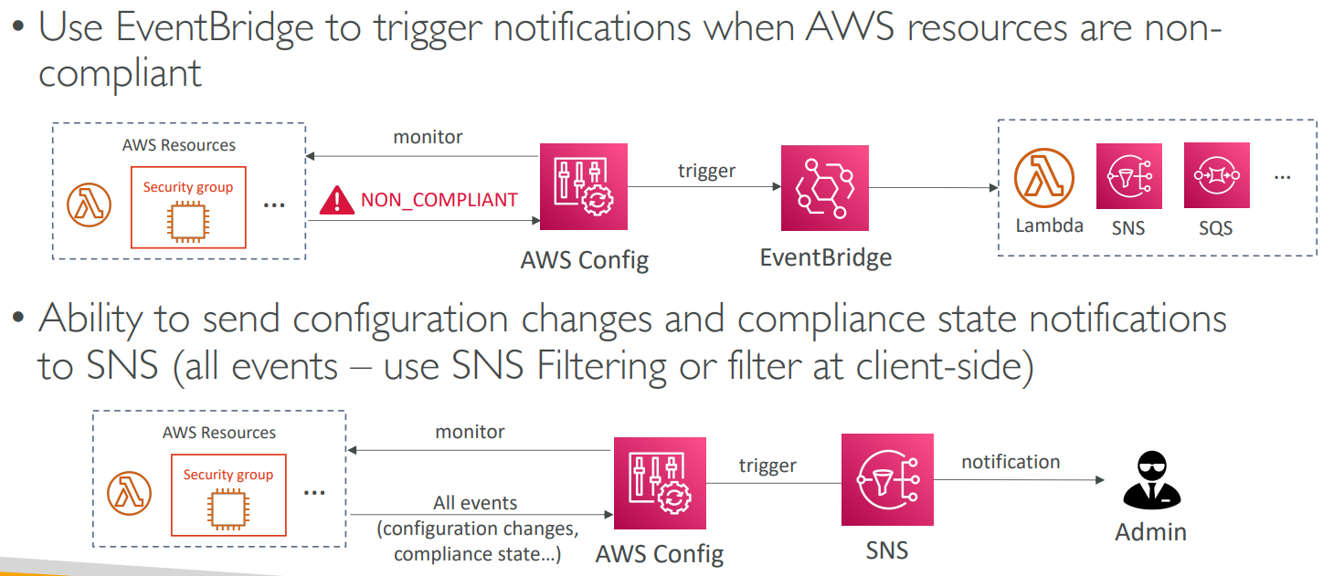

1. Use EventBridge to trigger notifications when AWS resources are non-complaint
2. Ability to send configuration changes and compliance state notifications to SNS (use SNS filtering at client side)

# STS (Security Token Service)

## Introduction

1. Allows to grant limited and temporary access to AWS resources
2. Token is valid for up to one hour (must be refreshed)
3. There are bunch of APIs in STS
   1. AssumeRole
      1. Within your own account: for enhanced security
      2. Cross Account Access: assume role in target account to perform actions there
   2. AssumeRoleWithSAML
      1. Return credentials for users logged with SAML
   3. AssumeRoleWithWebIdentity
      1. Return credentials for users logged with an Identity Providers such as Facebook Login, Google Login, OIDC compatible
      2. AWS recommends against using this, and using Cognito instead
   4. GetSessionToken
      1. For MFA, from a user or AWS account root user

## Identity Federation in AWS

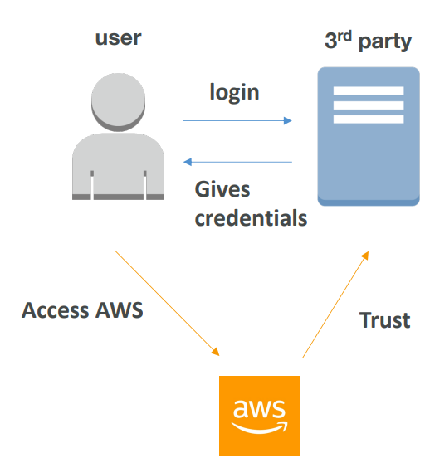

There is a user and there is a 3rd party source and AWS has to trust that 3rd party source for managing our users. User will login to 3rd party get credentials from it and will be able to access AWS.

Federation lets users outside of AWS to assume temporary role for accessing AWS resources.

## APIs in STS

### AssumeRole

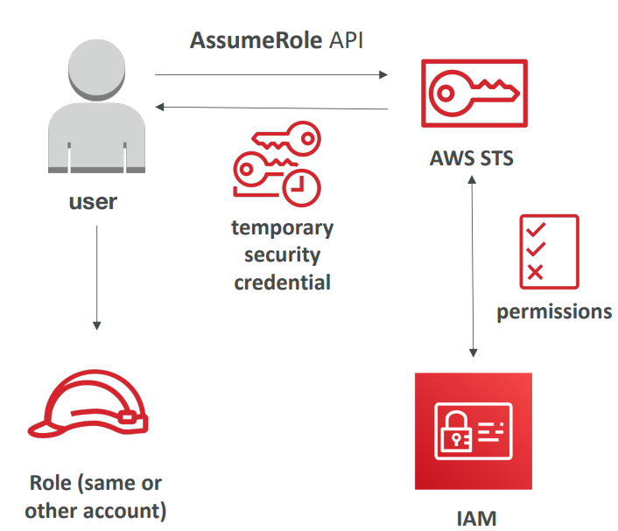

We have a user who wants to assume role in same or other account. So, we need to invoke AWS STS by using AssumeRole API. STS will check with IAM if we have permission to do so. Then it will return us temporary credentials and these credentials can be used in our account to assume that role.

Temporary credentials can be valid between 15 minutes to 1 hour

### AssumeRoleWithSAML

1. Needs to setup a trust between AWS IAM and SAML
2. Uses the STS API: AssumeRoleWithSAML

Federation through SAML is the “old way” of doing things

Amazon Single Sign On (SSO) Federation is the new managed and simpler way

### AssumeRoleWithWebIdentity

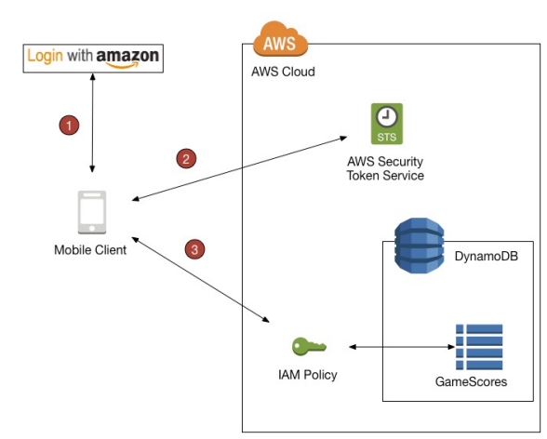

We log in with Identity Provider. We then exchange it with STS and then we have access to AWS.

1. Not recommended by AWS
2. Use Cognito instead which allows for anonymous users, data synchronization, MFA

AWS Cognito

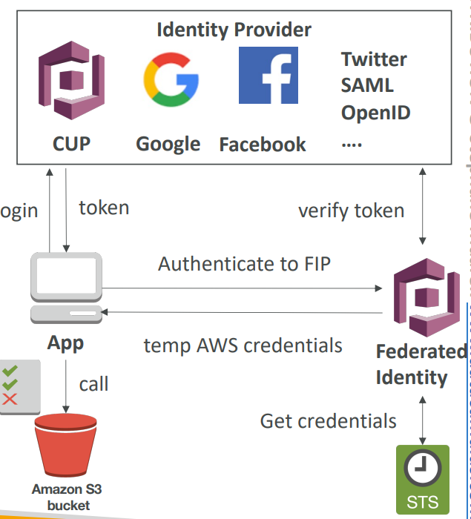

Suppose, there is an application which can be mobile application or a web application. And it is going to login with an identity provider. The identity provider can be Google, Facebook, Amazon, Twitter etc. We login with it and we get back a token, this token can be exchanged with Cognito Federated Identity which is going to verify the token first and then get the credentials from STS in the backend and give us back some temporary AWS credentials. These credentials can be used to access Amazon S3 bucket.

1. Provide direct access to AWS Resources from the Client Side (mobile, web app)
2. Example: provide temporary access to write to S3 bucket using Facebook login
3. Problem: we don’t want to create IAM users for our application users
4. How?
   1. Log in to federated identity provider- or remain anonymous
   2. Get temporary AWS credentials back from the Federated Identity Pool
   3. These credentials come with a pre-defined IAM policy stating their permissions

# Microsoft Active Directory

## Introduction

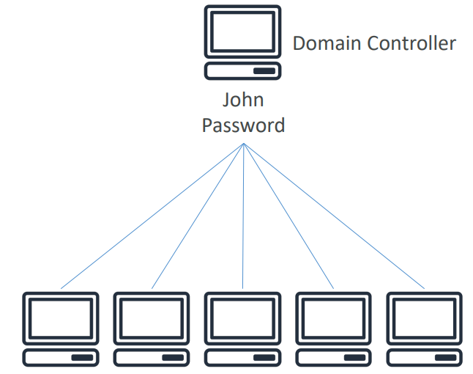

1. Found on any Windows Server with AD Domain Services
2. Database of objects: User Accounts, Computers, Printers, File Shares, Security Groups
3. Centralized security management, create account, assign permissions
4. Objects are organized in trees
5. A group of trees is a forest

## AWS Directory Services

1. Provides you a way to create an Active Directory on AWS
2. There are 3 flavours on it
   1. AWS Managed Microsoft AD
   2. AD Connector
   3. Simple AD

### AWS Managed Microsoft AD

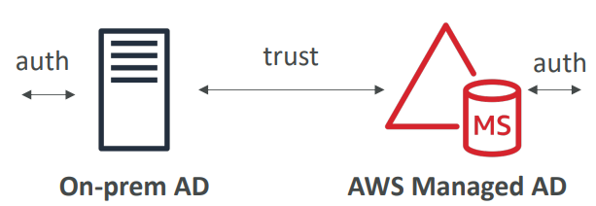

1. Create your own AD in AWS
2. Can manage users locally
3. It supports MFA
4. Can create a trust connection with your on-premises AD

### AD Connector

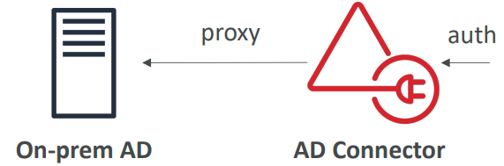

1. Directory Gateway (proxy) to redirect to on-premises AD
2. Users are managed on the on-premises AD

### Simple AD

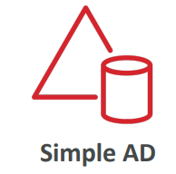

1. AD-compatible managed directory on AWS
2. Cannot be joined with on-premises AD

# AWS Organizations

## Introduction

1. Global service
2. Allows you to centrally manage AWS accounts under one umbrella
3. The main account is the master account- you can’t change it
4. Other accounts are member accounts
5. Consolidated billing includes
   1. Paying account – independent and cannot access resources of other accounts
   2. Linked accounts – all linked accounts are independent, Limit of 20 linked accounts for consolidated billing (default)
   3. All linked accounts are independent.

## Benefits of AWS Organizations

1. Consolidated Billing- one bill for multiple accounts
2. Cost Savings- reduce cost by sharing resources across accounts
3. Account Governance- you have a quick and automated way to create accounts and invite existing accounts to join your organization

## Organizational Units (OU)

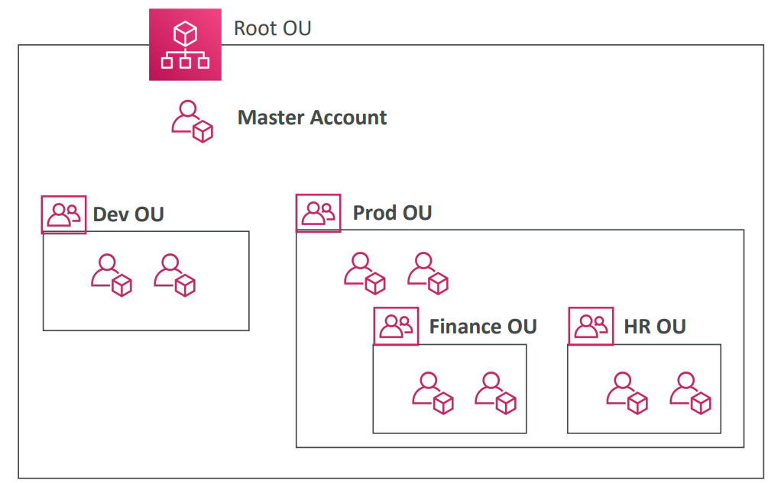

1. Accounts are organized using Organizational Units
2. OU can be
   1. Based on Business Unit (Sales OU, Marketing OU, ..)
   2. Based on Environmental Lifecycle (dev/prod/test)
   3. Based on Project based (proect1/project2/project3)
   4. And many more based on use case

## SCP (Service Control Policies)

1. SCPs control the maximum available permissions
2. Applied at the OU or Account level
3. Does not apply to the Master Account
4. SCP is applied to all users and roles of the account, including root
5. SCP does not affect resource based policies
6. SCP does not affect service-linked roles

## SCP Hierarchy

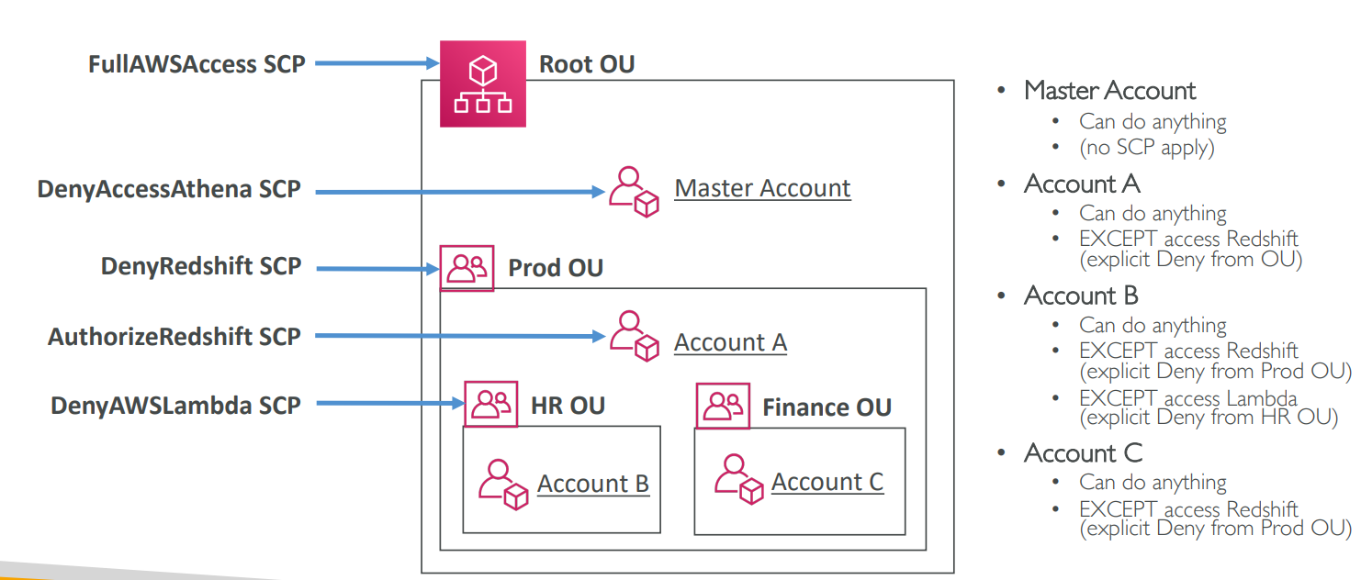

## Moving Accounts between Organizations

1. Member accounts can only be part of one organization although they can be moved from one organization to another which is called migration.
2. Accounts can be migrated between organizations. Use AWS Organizations console if there are few accounts. Use the AWS Organizations API or AWS CLI if there are many accounts to migrate
3. To migrate accounts from one organization to another
   1. Remove the member account from the old organization
   2. Send an invite to the new organization
   3. Accept the invite to the new organization from the member account
4. If you want master account of old organization to also join the new organization, do the following
   1. Remove the member accounts from the organizations using procedure above
   2. Delete the old organization
   3. Repeat the process above to invite the old master account to the new organization

# AWS Resource Access Manager (RAM)

## Introduction

1. Share AWS resources that you own with other AWS accounts
2. Share with any account or within your Organization
3. Avoid resource duplication
4. Second account should accept request from first account.
5. Resources that can be shared using RAM include
   1. AWS App Mesh
   2. Amazon Aurora
   3. AWS Certificate Manager Private Certificate Authority
   4. AWS CodeBuild
   5. Amazon EC2
   6. EC2 Image Builder
   7. AWS Glue
   8. AWS License Manager
   9. AWS Network Firewall
   10. AWS Outposts
   11. Amazon S3 on Outposts
   12. AWS Resource Groups
   13. Amazon Route 53
   14. AWS Systems Manager incident Manager
   15. Amazon VPC
6. Resource shares are created with
   1. AWS RAM Console
   2. AWS RAM APIs
   3. AWS CLI
   4. AWS SDKs

## RAM - VPC Example

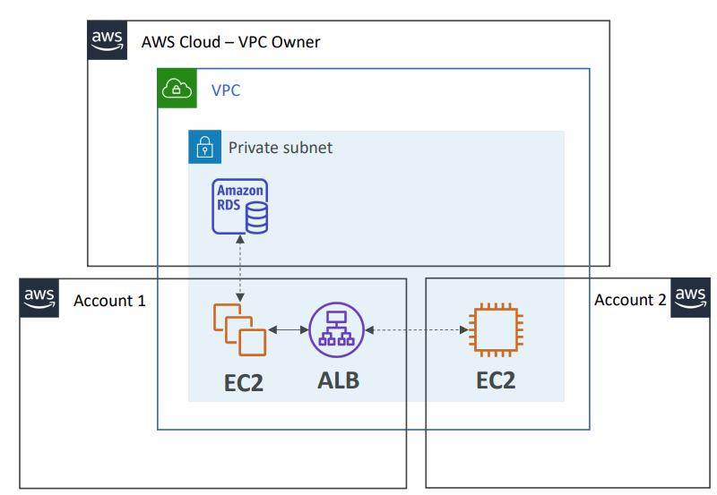

1. Network is shared among multiple account
2. Anything deployed in VPC can talk to other resources in VPC
3. But each account is responsible for its own resources
4. One account cannot view, modify, or delete resources in other accounts
5. In above example, private subnet is shared between account 1, account 2 and VPC owner. Resources launched by VPC owner (Amazon RDS) cannot be viewed, modified by account1 or account2. Similarly, resources launched by account1 (EC2, ALB) cannot be viewed, modified by VPC owner and account2. Also, resources launched by account2 (EC2) cannot be viewed, modified by VPC owner and account1.

# AWS Single Sign-On (SSO)

## Introduction

1. Centrally manage Single Sign-On to access multiple accounts and 3rd party business applications
2. Once you log in to Single Sign-On portal, you can log in to any of your AWS accounts like Dropbox, Office 365, Slack, without reentering your login.
3. You can log in once and you have access to all the things that Single Sign-on is configured to access.
4. If we have tons of accounts within our organization, we can set up AWS Single Sign-On and we will have access to login to all accounts within that organization. So, one login for all the accounts.
5. Supports SAML 2.0 markup
6. Integrated with AWS Organizations
7. Integration with on-premises Active Directory

# Encryption

## Types of Encryption

### Asymmetric Encryption

1. Also known as public key cryptography
2. Messages encrypted with the public key can only be decrypted with the private key
3. Messages encrypted with the private key can be decrypted with the public key
4. Examples SSL/TLS and SSH

### Symmetric Encryption

1. Same key is used for encryption and decryption

## Encryption in flight (SSL)

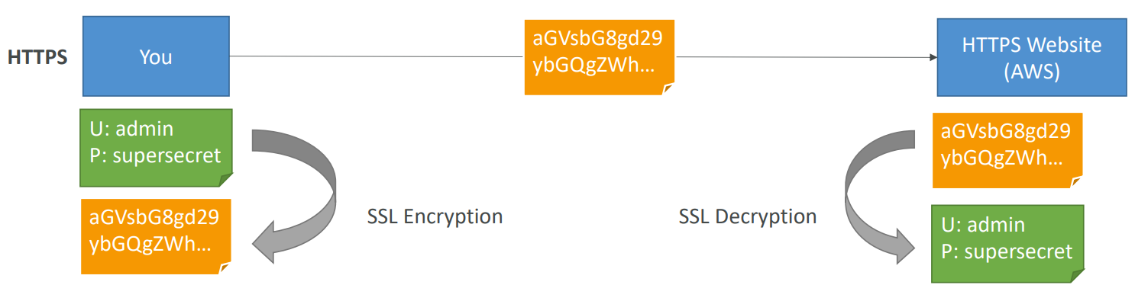

1. Data is encrypted before sending and decrypted after receiving
2. SSL certificates help with encryption
3. Encryption in flight ensures no man in the middle attack can happen

## Server-Side encryption at rest

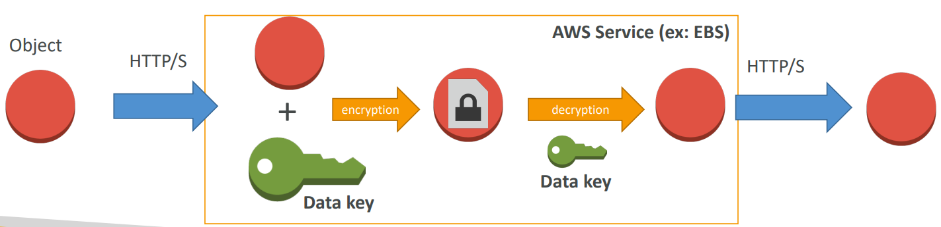

1. Data is encrypted after being received by the server
2. The encryption/decryption keys must be managed somewhere, and the server must have access to it

## Client-Side Encryption

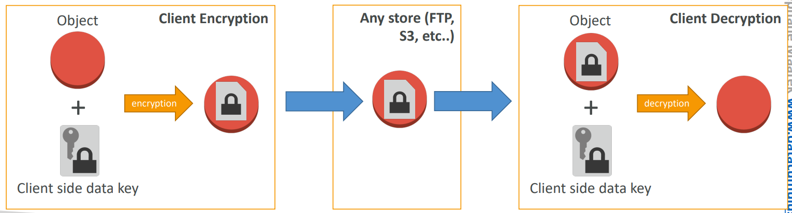

1. Data is encrypted by the client and never deployed by the server
2. Data will be decrypted by a receiving client
3. The server should not be able to decrypt the data
4. Could leverage Envelope Encryption

# AWS KMS (Key Management Service)

## Introduction

1. Allows you to generate and store encryption keys
2. Automatically enabled for certain services like CloudTrail logs, S3 Glacier, Storage Gateway
3. AWS KMS is integrated with AWS CloudTrail which provides you the ability to audit who used which keys, on which resources, and when.
4. Both symmetric and asymmetric keys
5. FIPS 140-2 level 2
6. + pay for API call to KMS ($0.003/1000 calls)
7. KMS can only help in encrypting up to 4KB of data per call
8. If data > 4 KB, use envelope encryption
9. KMS keys are bound to specific region. So, when we create a KMS key in region A, it cannot be transmitted over region B.
10. Use case
    1. Create encrypted Amazon EBS Volumes

## Data Encryption Keys

1. Data keys are encryption keys that you can use to encrypt data, including large amounts of data and other data encryption keys

## Types of CMKs

1. Customer Managed CMK
2. AWS Managed CMK
3. AWS Owned CMK

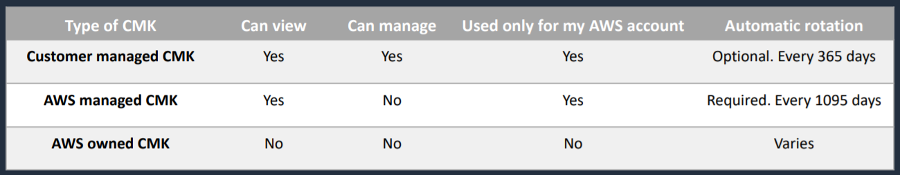

### Customer Managed CMK

1. Gives you full control over the lifecycle and permissions that determine who can use the key and under which conditions
2. Allows key rotation

### AWS Managed CMK

1. Free
2. Are created automatically when you first create an encrypted resource in an AWS service

### AWS Owned CMK

1. Used by AWS on a shared basis across many accounts; you typically won’t see these

## Symmetric vs Asymmetric CMK

1. Symmetric (AES-256 keys)
   1. Single encryption key is used for encryption and decryption
   2. Necessary for envelope encryption
   3. When you create a customer master key in KMS, by default, you get a symmetric CMK
   4. Encryption algorithm is based on AES-256
   5. First offering of KMS
   6. You cannot access the key unencrypted
   7. Symmetric CMKs never leave AWS KMS unencrypted
   8. AWS services integrated with KMS use symmetric CMKs
   9. Must call KMS API to use this key
2. Asymmetric (RSA & ECC key pairs)
   1. Public and private key pair
   2. Public key is used for encryption. Private key is used for decryption
   3. Public key is downloadable
   4. You cannot access the private key unencrypted
   5. private keys of asymmetric CMKs never leave AWS KMS unencrypted
   6. AWS services integrated with KMS do not support asymmetric CMKs
   7. They are often used to sign messages and verify signatures
   8. Use case: Perform encryption outside of AWS by users who can’t call the KMS API

## Copying Snapshots across accounts

1. Create a snapshot, encrypted with your own CMK
2. Attach a KMS Key Policy to authorize cross-account access
3. Share the encrypted snapshot
4. (in target) create a copy of the snapshot, encrypt it with a KMS Key in your account
5. Create a volume from the snapshot

## Copying Snapshots across regions

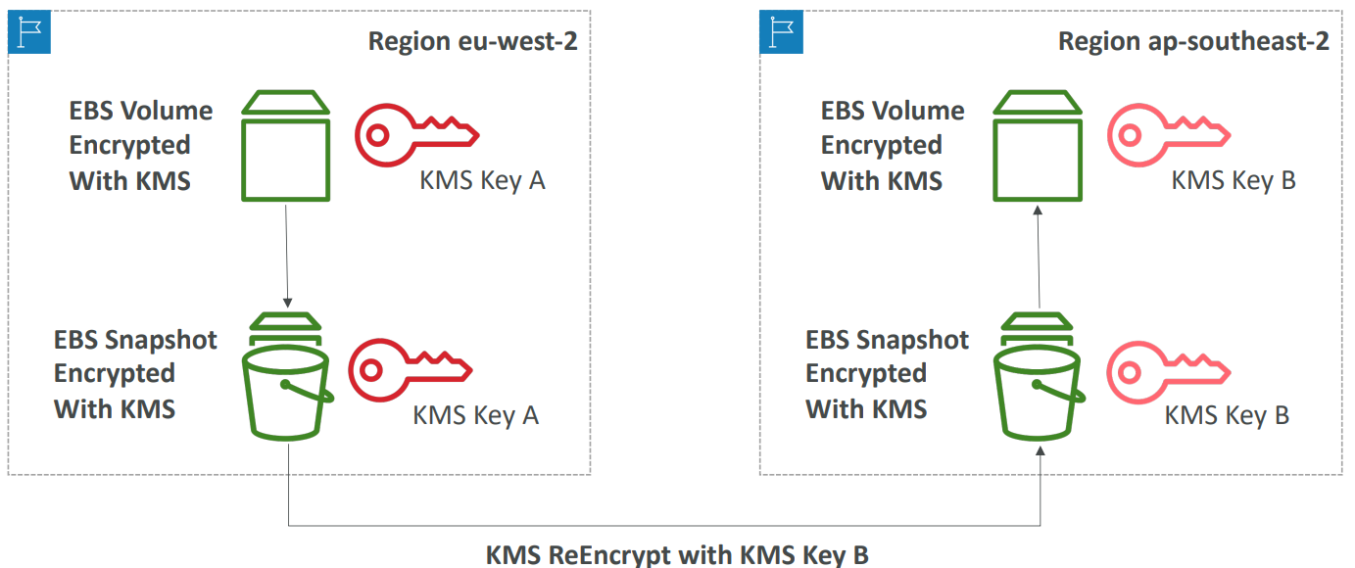

KMS keys are bound to specific region. So that means that when you create a KMS key in region A it cannot be transmitted over to region B.

Let’s say we have an encrypted EBS volume with KMS and a KMS key in the region eu-west-2 and we would like to copy that volume across to a new region for example to ap-southeast-2. So, because KMS keys are linked to a specific region you would need to do a specific operation.

So, here is the process and this applies to EBS volumes, redshift snapshots and much more that is encrypted using AWS KMS.

So, first you would create a snapshot of your volume and any snapshot made from an encrypted volume is also encrypted with KMS and the same key. Then, you need to copy that snapshot over to the new region, but you will specify a new KMS key to re-encrypt the data with. So, the KMS key B in the other region and now you have a snapshot encrypted with KMS in the other region but with a new key. And finally when you recreate a volume from that snapshot then that volume will be encrypted with a new KMS Key B.

So, the important point to see is because KMS keys are bound to a specific region, when you copy snapshots over, they have to be re-encrypted.

## KMS Key Policies

1. Control access to KMS keys
2. Default KMS Key Policy
   1. Default KMS Key is very permissive
   2. It is created by default if you don’t provide a specific KMS Key Policy
   3. It is going to give access to the root user which means that your entire AWS account has the right to use this KMS key, if they have IAM policy available obviously
   4. Complete access to the key to the root user = entire AWS account
   5. So to give users access to KMS keys using this default KMS key policy, you need to create the correct IAM policy and attach it to user
3. Custom KMS Key Policy
   1. Define users, roles that can access the KMS key
   2. Define who can administer the key
   3. Useful for cross-account access of your KMS key

## KMS Automatic Key Rotation

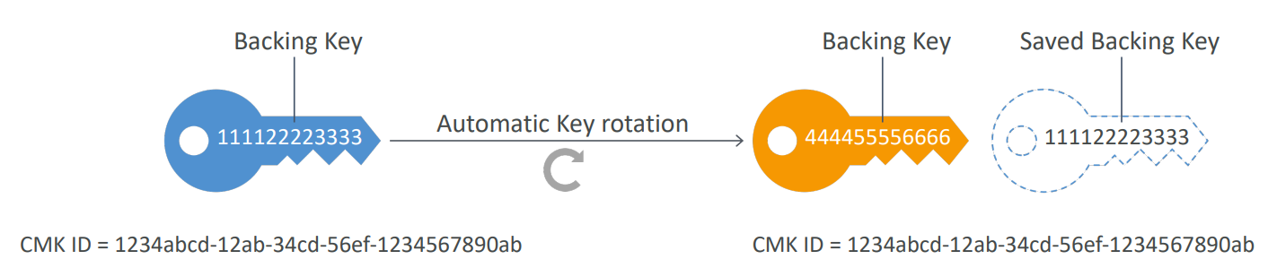

1. For Customer-managed CMK (not AWS managed CMK)
2. If enabled: automatic key rotation happens every 1 year
3. Previous key is kept active so you can decrypt old data
4. New key has the same CMK ID (only the backing key is changed)

## KMS Manual Key Rotation

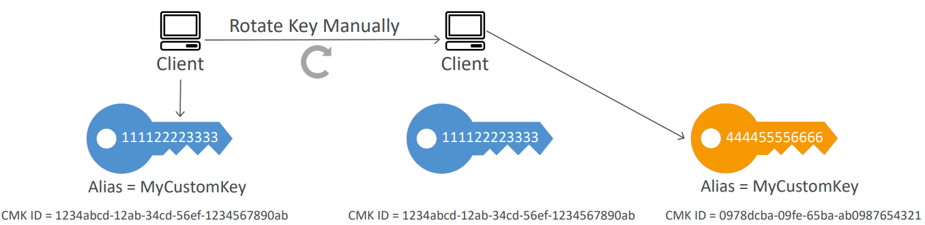

1. When you want to rotate key every 90 days, 180 days, etc
2. New key has a different CMK ID
3. You will keep previous key active so you can decrypt old data
4. Better to use aliases in this case (to hide the change of key for the application)
5. It is good solution to rotate CMK that are not eligible for automatic rotation (like asymmetric CMK)

## KMS Alias Updating

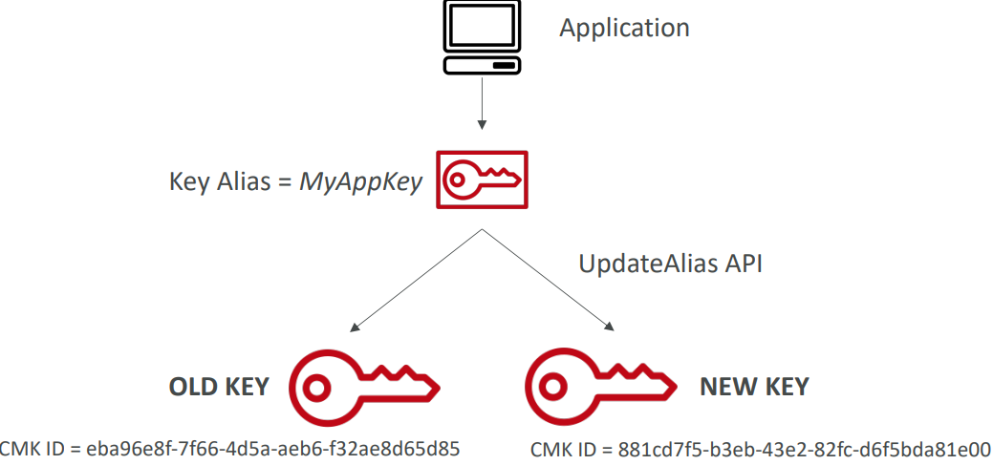

1. It is better to use alias in case to hide the change of key for the application
2. Your application only interacts from the API perspective with your key alias say MyAppKey. Then the old key, old key alias is the one that you had before rotation and after rotation you are going to create a new key and you are going to issue an UpdateAlias API code and this updated alias will have the alias point to the new key and therefore from the application perspective the change will not be detected. It will just be transparent

# SSM Parameter Store

## Introduction

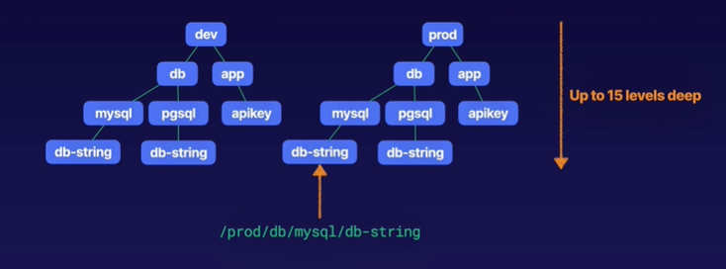

1. Serverless, scalable, durable
2. Secure storage for configuration and secrets in AWS
3. Values can be stored encrypted (KMS) or plaintext. You can have optional encryption with KMS
4. You have versioning of your configuration and secrets. We can track versions of values in parameter store
5. Value of parameter can be 4096 characters long
6. It has ability to store parameters in hierarchies. This hierarchy can be upto 15 levels deep.
7. GetParametersByPath API can be used to retrieve all parameters in a hierarchy
8. No native rotation of keys

## SSM Parameter Store Hierarchy

1. /my-department/
   1. my-app/
      1. Dev/
         1. db-url
         2. db-password
      2. prod/
         1. db-url
         2. db-password
   2. other-app/
2. /other-department/
3. We are also able to reference secrets from the Secrets Manager
   1. /aws/reference/secretsmanager/secret_ID_in_Secrets_Manager
4. You are also able to reference parameters directly from AWS
   1. /aws/service/ami-amazon-linux-latest/amzn2-ami-hvm-x86_64-gp2

## Standard and advanced parameter tiers

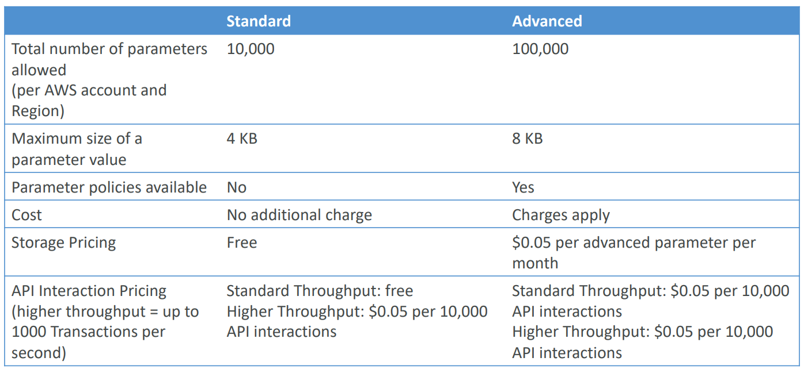

## Parameter Policies

1. This is for advanced parameters
2. Allows to assign a TTL to a parameter (expiration date) to force updating or deleting sensitive data such as passwords
3. Can assign multiple policies at a time

## Sample Parameter Policies

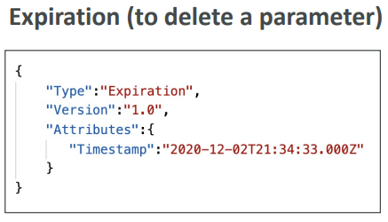

This says my password expires in 2020-12-02

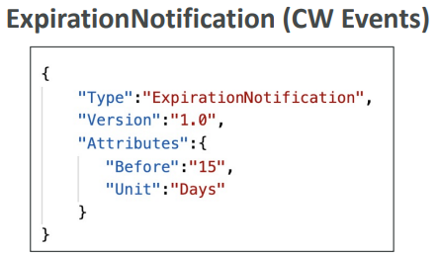

This says send me a notification through CloudWatch Events 15 days before the expiration happens

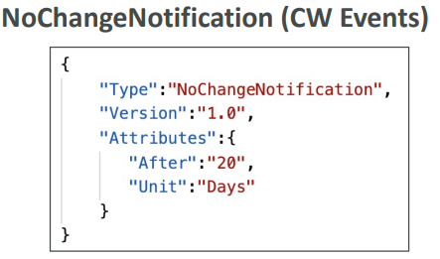

If my parameter has not been changed in 20 days then send me a notification through CloudWatch Events.

## Retrieve parameters stored

1. aws ssm get-parameters –names /my-app/dev/db-url /my-app/dev/db-password
2. aws ssm get-parameters –names /my-app/dev/db-url /my-app/dev/db-password –with-decryption
3. Get parameters within path /my-app/dev/
   1. aws ssm get-parameters-by-path –path /my-app/dev/
4. Get parameters within path /my-app/ recursively
   1. aws ssm get-parameters-by-path –path /my-app/ --recursive
   2. aws ssm get-parameters-by-path –path /my-app/ --recursive –with-decryption

## Retrieve parameters stored using lambda function

import boto3

ssm=boto3.client(‘ssm’, region_name=’es-east-3’)

def lambda_handler (event, context):

db_url=ssm.get_parameters (Names=[‘/my-app/dev/db-url’])

print(db_url)

db_password=ssm.get_parameters (Names=[‘/my-app/dev/db-password’], withDecryption=True)

print(db_password)

# AWS Secret Manager

## Introduction

1. Service for storing secrets
2. Difference between secrets manager and the parameter store is that secrets manager is more oriented towards secret and has a capability to force the rotation of your secrets
3. Has capability to force rotation of secrets every X day
4. Has capability to automate generation of secrets on rotation using lambda
5. Pricing
   1. 40 cents ($0.40) per secret per month
   2. 5 cents ($0.05) for 10,000 API calls
   3. 30 days free trail available

## AWS Secrets Manager vs SSM Parameter Store

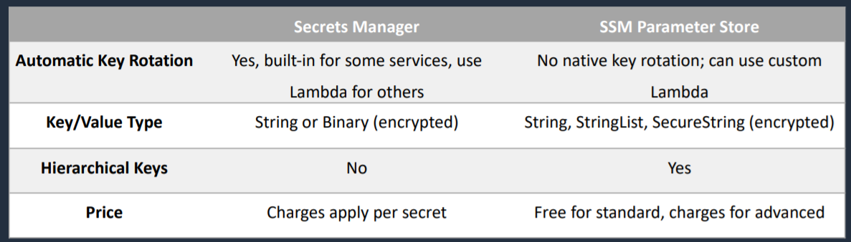

# CloudHSM

## Introduction

1. Generate and store encryption keys
2. Dedicated hardware
3. In CloudHSM, AWS provisions encryption hardware. You will manage your own encryption keys entirely (not AWS)
4. AWS has no visibility of your encryption keys
5. It is best if you want to implement SSE-C type of encryption
6. Managed service and automatically scales
7. FIPS 140-2 level 3 validated HSM
8. Supports both symmetric and asymmetric encryption
9. No free tier available
10. Must use CloudHSM Client Software
11. Is a single tenant dedicated hardware solution that runs in a multi-AZ cluster for high availability

In CloudHSM

1. IAM permissions are used to do a create, read, update and delete of an HSM Cluster at a high level
2. CloudHSM Software is used to manage keys and manage the users and their permissions to access the keys

In KMS

1. Everything is managed using IAM

## CloudHSM – High Availability

1. CloudHSM clusters are spread across Multi AZ
2. Great for availability and durability

## KMS vs CloudHSM

For asymmetric key on-premises, CloudHSM can be used but not KMS.

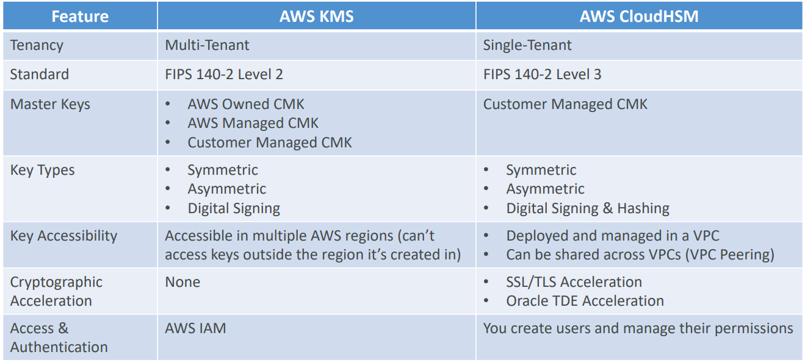

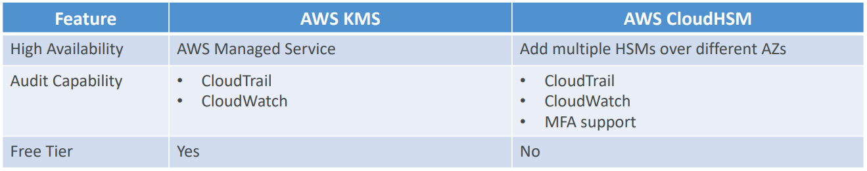

# AWS Shield

## Introduction

1. Protects against DDOS attacks
2. Two tiers of AWS Shield
   1. AWS Shield Standard
   2. AWS Shield Advanced

## Tiers of AWS Shield

### AWS Shield Standard

1. Automatically enabled for all customers at no cost
2. Protects against common layer 3 and 4 attacks
   1. SYN/UDP floods
   2. Reflection attacks

### AWS Shield Advanced

1. Paid service
2. $3,000 per month per organization and 1 year commitment
3. Enhanced protection for EC2, ELB, CloudFront, Global Accelerator, Route 53
4. Business and Enterprise support customers get 24X7 access to the DDoS Response Team (DRT)
5. DDoS cost protection- this is the form of insurance against any attacks that would otherwise result to your AWS bill

# AWS WAF (Web Application Firewall)

## Introduction

1. Protects your web applications from common web exploits (layer 7)
2. WAF makes it easy to create rules that block common web exploits like SQL injection and cross site scripting
3. Prevents from DDoS attack
4. Can be integrated with ALB, API Gateway, AppSync, CloudFront
5. If traffic is blocked by WAF, it returns HTTP 403 forbidden error
6. To use WAF, we need to define Web ACL (Web Access Control List)
   1. Rules can include IP addresses, HTTP headers, HTTP body or URI strings
   2. Protects from common attacks- SQL Injection and Cross-Site Scripting (XSS)
   3. Can set size constraints
   4. Geo-match to block specific countries
   5. Rate-based rules (to count occurrences of events) – for DDoS protection
7. We can configure filtering rules to allow/deny traffic based on IP addresses, Query string parameters
8. AWS WAF allows 3 different behaviors:
   1. Allows all requests except the ones you specify
   2. Block all requests except the ones you specify
   3. Count the requests that match the properties you specify

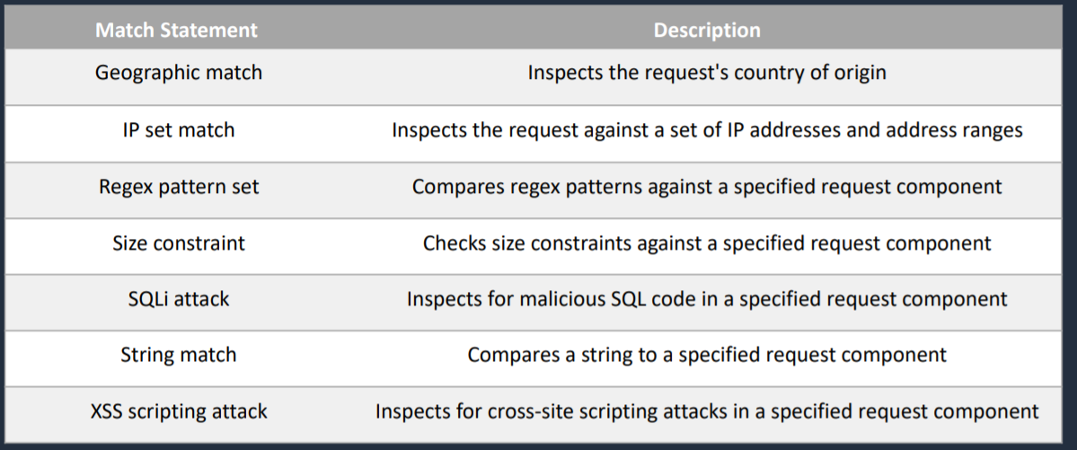

# AWS Firewall Manager

## Introduction

1. Centrally configure and manage firewall rules across an AWS Organizations
2. Using this, you can deploy WAF rules for your ALB, API Gateway or CloudFront distributions
3. You can also create AWS Shield Advanced Policies to automatically discover resources like ALB, ELB, CLB, Elastic IPs, CloudFront Distributions
4. You can also use AWS Firewall to configure security groups across multiple accounts in your AWS organization and continuously audit them to detect overly permissive or misconfigured rules that apply to EC2 instances and Elastic Network Interfaces (ENIs)

# GuardDuty

## Introduction

1. Intelligent threat detection system to protect AWS account
2. Uses machine learning algorithms, anomaly detection techniques, 3rd party data to detect an attack on your accounts
3. On click to enable (30 days trail)
4. No need to install software
5. Input data includes
   1. CloudTrail Logs to detect unusual API calls and unauthorized deployments
   2. VPC Flow Logs to detect unusual internal traffic and unusual IP address
   3. DNS Logs to detect compromised EC2 instances sending encoded data within DNS queries
6. Can setup CloudWatch Event rules to be notified in case of findings and CloudWatch Events rules can target AWS Lambda or SNS
7. Can protect against CryptoCurrency attacks

# Amazon Inspector

## Introduction

1. Automated Security Assessments for EC2 instances
2. AWS Inspector Agent must be installed on OS in EC2 instances
3. After the assessment, you get a report with a list of vulnerabilities
4. What does AWS Inspector evaluate?
   1. For Network assessments (agentless)
      1. Network Reachability
   2. For Host assessments (with agent)
      1. Common Vulnerabilities and Exposures
      2. Center for Internet Security (CIS) Benchmarks
      3. Security Best Practices

# Amazon Macie

## Introduction

1. Uses machine learning to discover, classify and protect sensitive data stored in S3
2. Helps identify and alert you to sensitive data, such as Personally Identifiable Information (PII)
3. Includes dashboards, reports, and alerting
4. Great for PCI-DSS compliance and preventing ID theft

# CIDR

## Introduction

1. Classless Inter Domain Routing
2. They help to define IP address range
   1. WW.XX.YY.ZZ/32-> one IP
   2. 0.0.0.0/0-> all IPs
   3. 192.168.0.0/26-> 192.168.0.0 – 192.168.0.63 (64 IP addresses)
3. CIDR consists of two components
   1. Base IP
      1. Represents an IP contained in the range (XX.XX.XX.XX)
      2. Example: 10.0.0.0, 192.168.0.0
   2. Subnet Mask
      1. Defines how many bits can change in the IP
      2. Example: /0, /24, /32
         1. /8 – 255.0.0.0
         2. /16 – 255.255.0.0
         3. /24 – 255.255.255.0
         4. /32 – 255.255.255.255

## Understanding CIDR – Subnet mask

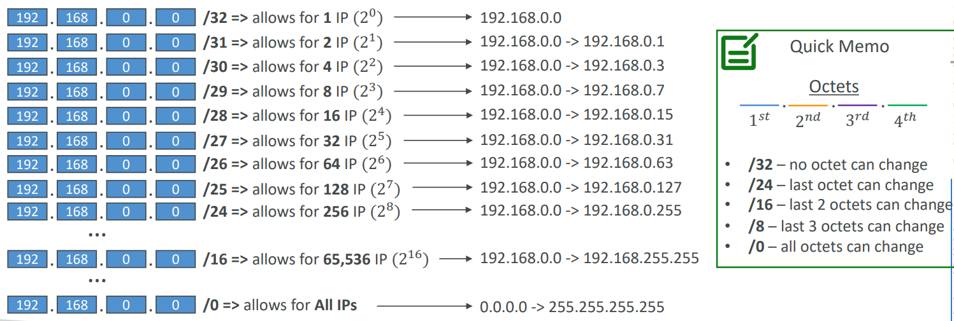

1. Subnet Mask basically allows part of the underlying IP to get additional next values from the base IP

192.168.0.0/0 -------------------- 0.0.0.0 -> 255.255.255.255

192.168.0.0/16 ------------------- 192.168.0.0 -> 192.168.255.255

192.168.0.0/24 –------------------ 192.168.0.0 -> 192.168.0.255

192.168.0.0/32 –------------------ 192.168.0.0

192.163.0.0/24 ------------------ 192.163.0.0 -> 192.163.0.255

192.168.0.0/16 –----------------- 192.168.0.0 -> 192.168.255.255

134.56.78.123/32 --------------- 134.56.78.123

## CIDR – Rules and Guidelines

1. CIDR block size can be between /16 and /28
2. The CIDR block must not overlap with any existing CIDR block associated with the VPC
3. You cannot increase or decrease the size of an existing CIDR block
4. The first four and last IP address are not available for use
5. AWS recommends you use CIDR blocks from the RFC 1918

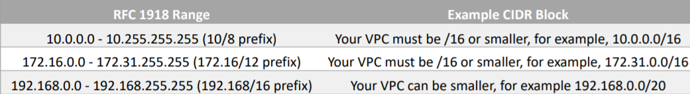

## Public IP vs Private IP (IPv4)

1. The Internet Assigned Numbers Authority (IANA) established certain blocks of IPv4 addresses for the use of private (LAN) and public (Internet) addresses
2. Private IP can only allow certain values
   1. 10.0.0.0 -10.255.255.255 (10.0.0.0/8)-> in big network
   2. 172.16.0.0 – 172.31.255.255 (172.16.0.0/12)-> AWS default VPC in that range
   3. 192.168.0.0 – 192.168.255.255 (192.168.0.0/16)-> eg. Home network
3. All the rest of the IP addresses on the Internet are public

# VPC

## Default VPC

1. New EC2 instances are launched into the default VPC if no subnet is specified
2. All subnets in default VPC are internet accessible
3. By default, default VPC will have 3 subnets across 3 AZ

## Introduction to VPC

1. Virtual Private Cloud
2. VPC is regional service
3. A default VPC is created in each region with a subnet in each AZ
4. VPC spans across multiple AZ
5. Subnet cannot span across multiple AZ
6. Public Subnets are subnets that have
   1. “Auto-assign public IPv4 address” set to “Yes”
   2. The subnet route table has an attached Internet Gateway
7. You can have multiple VPCs in an AWS region (max 5 per region – soft limit)
8. Max CIDR per VPC is 5, for each CIDR:
   1. Min size is /28 (16 IP addresses)
   2. Max size is /16 (65536 IP addresses)
9. Because VPC is private, only the private IPv4 ranges are allowed
   1. 10.0.0.0 -10.255.255.255 (10.0.0.0/8)
   2. 172.16.0.0 – 172.31.255.255 (172.16.0.0/12)
   3. 192.168.0.0 – 192.168.255.255 (192.168.0.0/16)
10. Your VPC CIDR should not overlap with that of another VPC pr other networks
11. There is option called Tenancy while creating VPC and we can choose between Default and Dedicated. This defines whether EC2 Instances launched within this VPC with have dedicated hardware or shared hardware.
12. Largest subnet in VPC is 10.0.0.0/16

## VPC - Subnet (IPv4)

1. AWS reserves 5 IP addresses (first 4 and last 1) in each subnet
2. These 5 IP addresses are not available for use and can’t be assigned to an EC2 instance
3. Example: if CIDR block 10.0.0.0/24, then reserved IP addresses are:
   1. 10.0.0.0 – Network Address
   2. 10.0.0.1 – Reserved by AWS for the VPC router
   3. 10.0.0.2 – Reserved by AWS for mapping to Amazon-provided DNS
   4. 10.0.0.3 – Reserved by AWS for future use
   5. 10.0.0.255 – Network Broadcast Address
4. If you need 29 IP addresses for EC2 instances
   1. You cannot choose a subnet of size /27 (32 IP addresses, 32-5 = 27 < 29)
   2. You need to choose a subnet of size /26 (64 IP addresses, 64-5 = 59 > 29)

## Internet Gateway

1. Allows resources in VPC to connect to the Internet
2. One VPC can only be attached to one Internet Gateway and vice versa
3. Internet Gateway on their own do not allow Internet access. For this, we must also edit Route Tables
4. Internet Gateway performs NAT

## Egress-only Internet Gateway

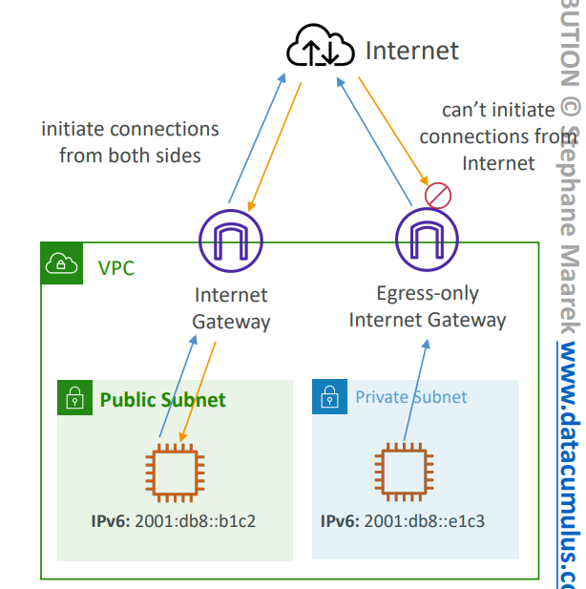

1. Used only for IPv6 traffic
2. Allows instances in your VPC outbound connections over IPv6 while preventing the Internet to initiate an IPv6 connection to your instances
3. You must update the Route Tables

## Baston Hosts

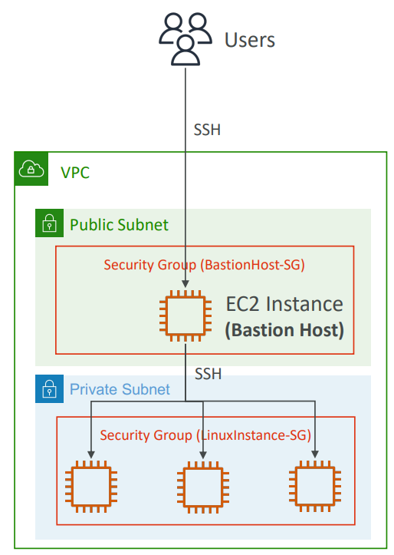

1. It is EC2 Instance in public subnet that provides us a way to SSH into our private EC2 instances from the Internet
2. Make sure the bastion host only has port 22 traffic from the IP address you need, not from the security groups of your other EC2 instances
3. Bastions are called Jump Boxes in Australia.
4. **You cannot use a NAT Gateway as a Bastion host. You can use NAT Instance as Bastion Host.**

## NAT Instance

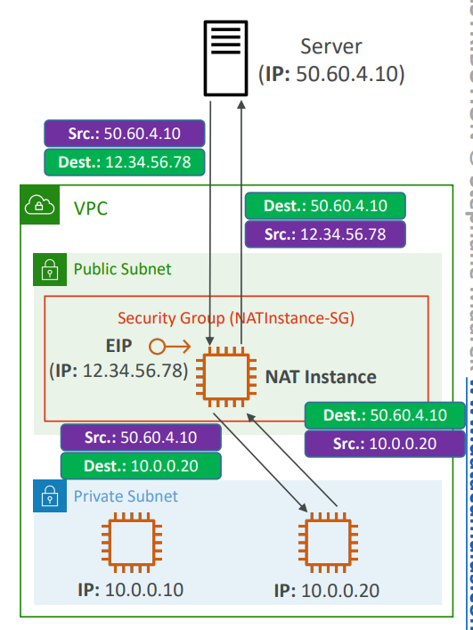

1. It is outbound only
2. Allows EC2 instances in private subnets to connect to the Internet
3. Must be launched in a public subnet
4. Must disable setting: Source/Destination Check. This is because a NAT instance must be able to send and receive traffic when the source or destination is not itself.
5. Must have Elastic IP attached to it

## NAT Gateway

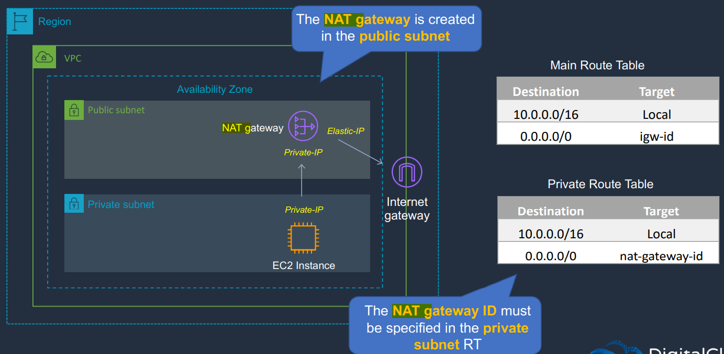

1. It is outbound only
2. There can only be one NAT gateway inside one AZ. NAT Gateways cannot span AZs
3. No need to disable Source/Destination checks
4. If you have resources in multiple AZ and they share one NAT Gateway, in the event that the NAT gateway’s AZ is down, resources in the other AZ lose internet access. To create an AZ-independent architecture, create a NAT gateway in each AZ and configure your routing to ensure that resources use the NAT gateway in the same AZ.
5. Cannot be used by EC2 instance in the same subnet (only from other subnets)
6. Require an IGW (Private Subnet -> NATGW -> IGW)
7. Does not have security group
8. Bandwidth-45 Gbps

## NAT Gateway with High Availability

1. NAT Gateway is resilient within a single AZ
2. Must create multiple NAT Gateways in multiple AZs for fault-tolerance

## NAT Gateway vs NAT Instance

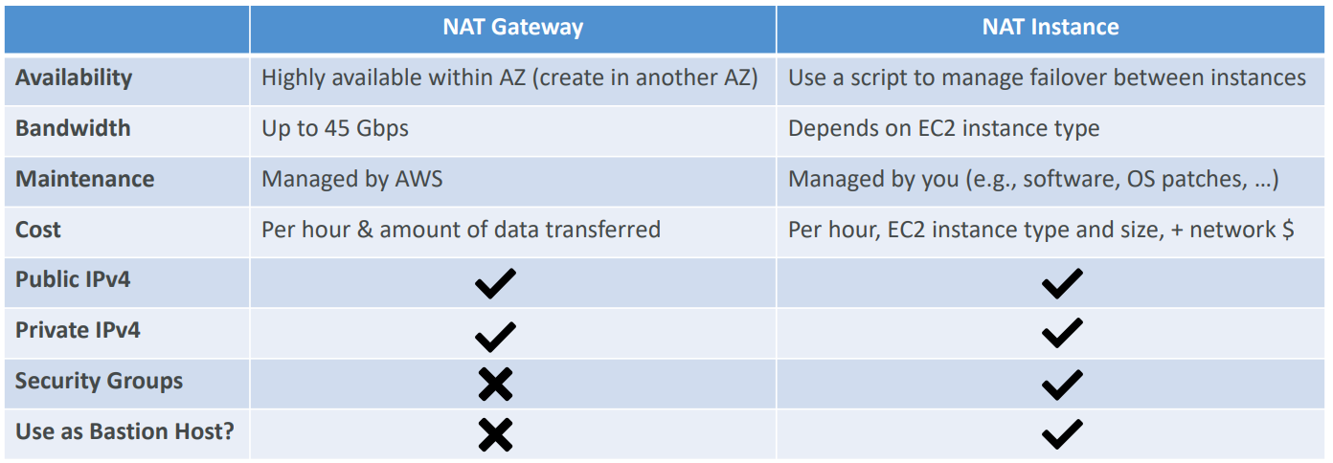

## DNS Resolution in VPC

There are two DNS settings that we can find in VPC

1. DNS Resolution called enable DnsSupport

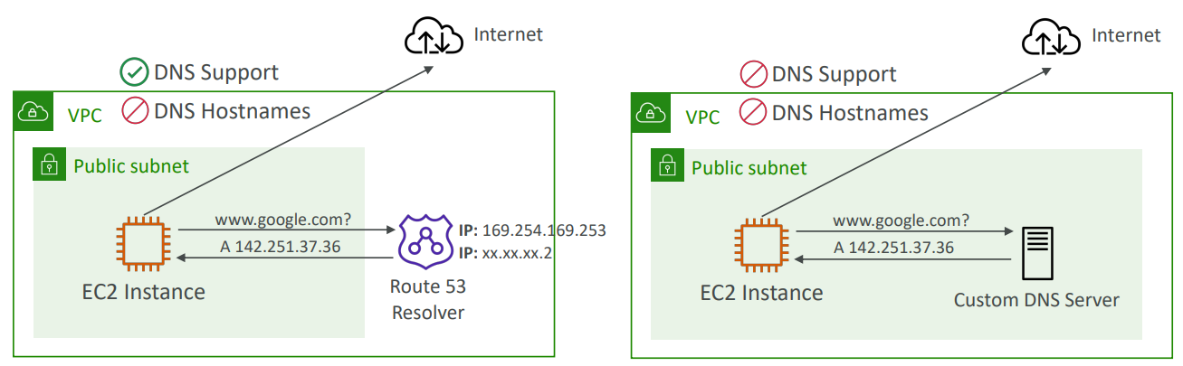

* 1. By default, this setting is True
  2. This is to decide if DNS resolution from Route 53 Resolver server is supported for the VPC
  3. This means that EC2 Instances within your VPC will be able to query Amazon Provider DNS Server at 169.254.169.253 or the reserved IP address at the base of the VPC IPv4 network range plus two (.2)

1. DNS Hostnames (enable DnsHostnames)

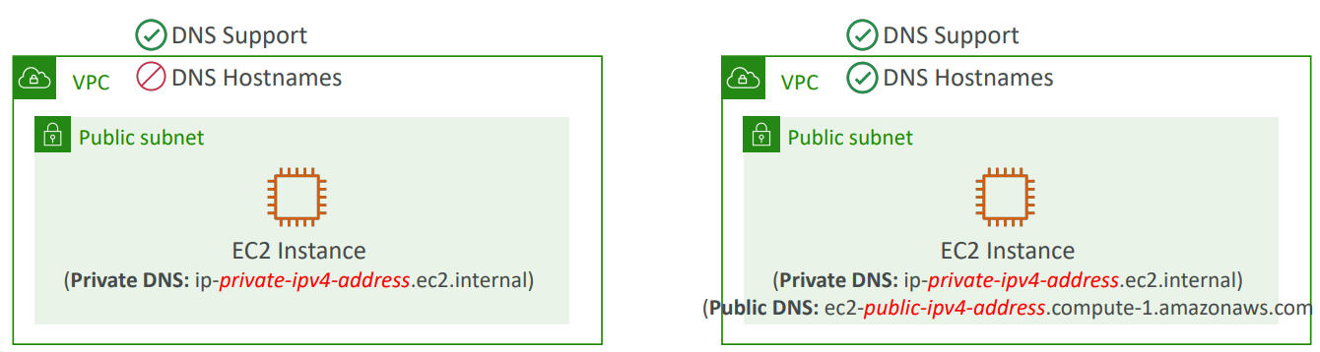

* 1. By default, it is True for default VPC and False for newly created VPC
  2. Won’t do anything unless enableDnsSupport is True
  3. If it is True, public hostname will be assigned to EC2 instance if it has a public IPv4

1. Why do we want to enable both settings?

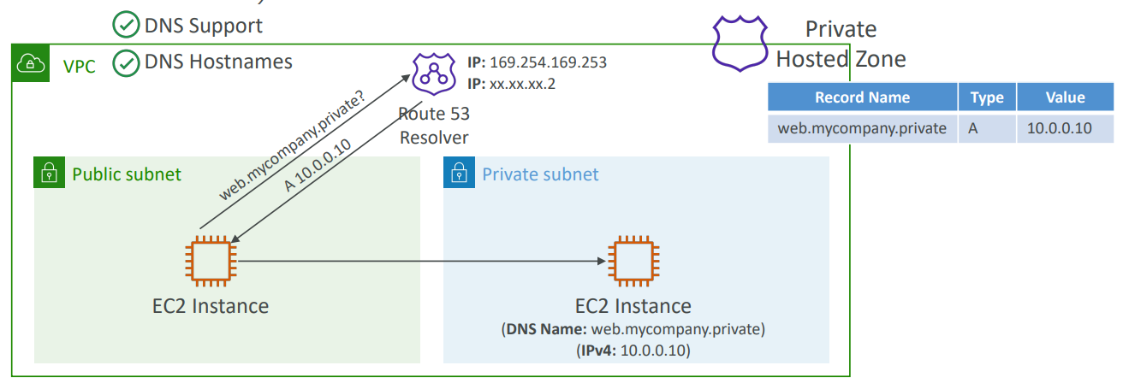

## Security Groups and NACL (Network Access Control List)

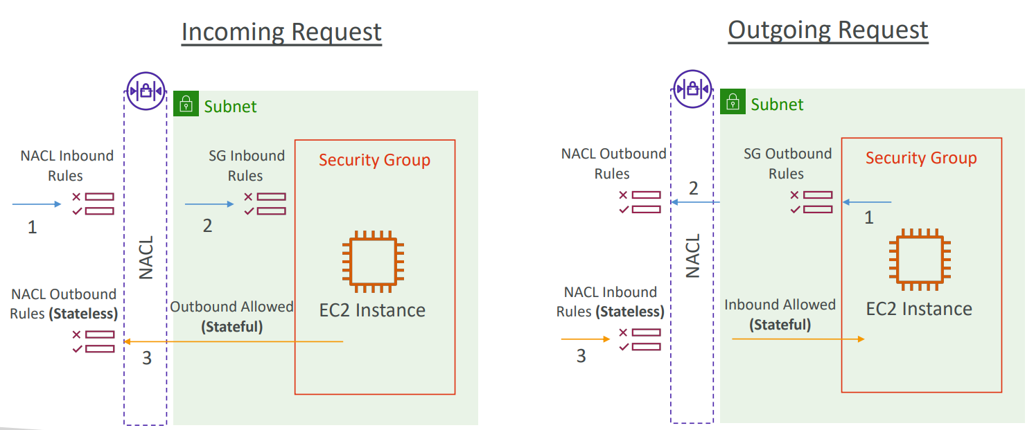

### Security group

1. Firewall at instance level
2. Supports allow rule only
3. It is stateful: return traffic is automatically allowed, regardless of any rules
4. All rules are evaluated before deciding whether to allow traffic

### NACL

1. Network Access Control List
2. Firewall at subnet level
3. Supports both allow and deny rule
4. Stateless
5. You can define NACL rules
   1. Rules have a number (1-32766)
   2. Higher precedence with a lower number
   3. First rule match will drive the decision
   4. Example: if you define #100 ALLOW 10.0.0.10/32 and #200 DENY 10.0.0.10/32, the IP address will be allowed because 100 has a higher precedence over 200
   5. The last rule is an asterisk (*) and denies a request in case of no rule match
   6. AWS recommends adding rules by increment of 100
6. Default NACL accepts everything inbound/ outbound with the subnets it is associated with
7. You can create custom network ACLs. By default, each custom network ACL denies all inbound and outbound traffic until you add rules.
8. Each subnet in your VPC must be associated with a NACL. If you don’t explicitly associate a subnet with a NACL, the subnet is automatically associated with the default NACL.
9. Block IP addresses using NACL not Security Groups.
10. You can associate a NACL with multiple subnets. However, a subnet can be associated with only one NACL at a time. When you associate a NACL with a subnet, the previous association is removed.

### Security Group vs NACL

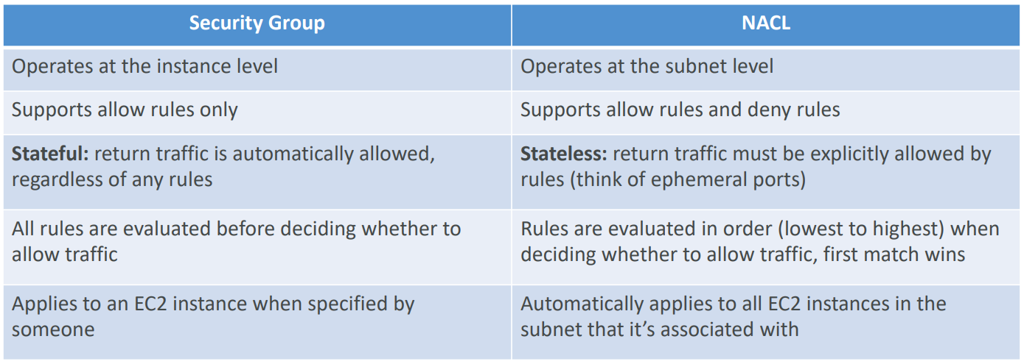

## Ephemeral Ports

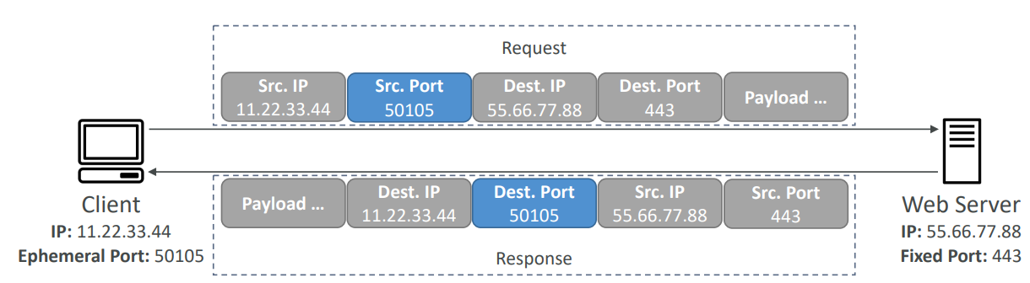

1. For any two endpoints to establish a connection, they must use ports
2. Clients connect to a defined port, and expect a response on an ephemeral port
3. They are called ephemeral as these ports are random and assign for that connection life

## VPC - Reachability Analyzer

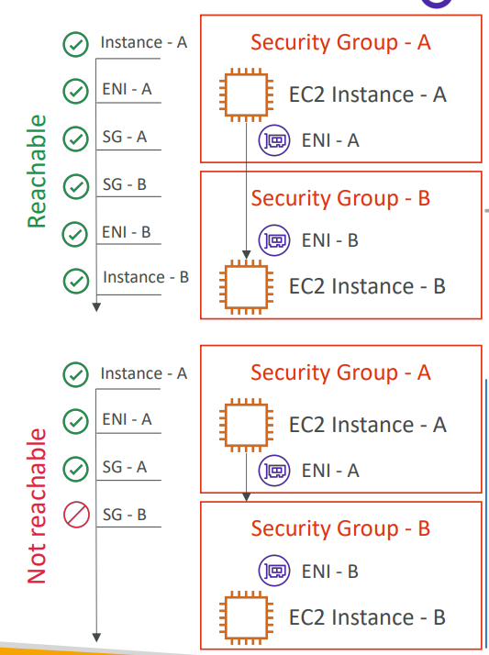

1. A network diagnostics tool that troubleshoots network connectivity between two endpoints in your VPCs
2. It builds a model of the network configuration, then checks the reachability based on these configurations (it does not send packets)
3. When the destination is
   1. Reachable- it produces hop-by-hop details of the virtual network path
   2. Not reachable- it identifies the blocking components(s)
4. Use case
   1. Troubleshoot connectivity issues
   2. Ensure network configuration is an intended
5. Price: $0.10 (10 cents) per analysis

## VPC Peering

1. Privately connect two VPCs using AWS network
2. Make them behave as if they were in the same network
3. Does not use Internet. Makes use of AWS Global Network
4. Must have overlapping CIDRs
5. VPC Peering connections is not transitive
6. You can create VPC Peering connection between VPCs in different AWS accounts/regions
7. You must update route tables in each VPCs subnets to ensure EC2 instances can communicate with each other

## VPC Endpoint

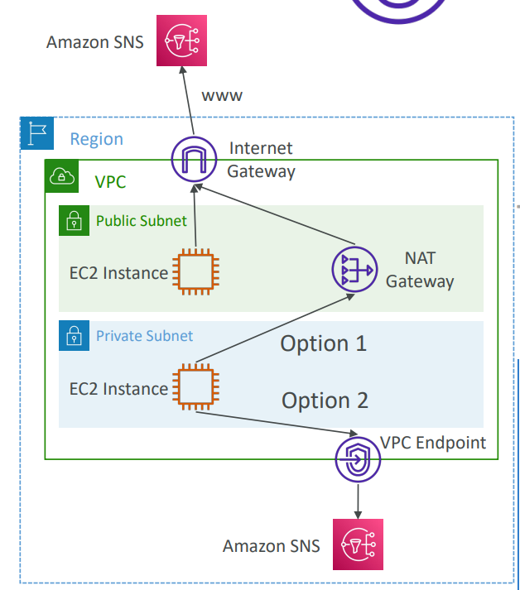

1. AWS PrivateLink
2. Way to connect instances in private subnet to public AWS service using a private IP
3. They remove the need of Internet Gateway, NAT Gateway to access AWS Services
4. Types of Endpoints
   1. Interface Endpoints
      1. Supports most AWS services
   2. Gateway Endpoints
      1. Supports S3 and DynamoDB

## VPC Flow Logs

1. Feature that enables you to capture information about the IP traffic going to and from network interfaces in your VPC
2. They can be in VPC level or Subnet level or Network Interface level
   1. VPC Flow Logs
   2. Subnet Flow Logs
   3. Elastic Network Interface (ENI) Flow Logs
3. Helps to monitor and troubleshoot connectivity issues
4. Flow logs data can be sent to S3 or CloudWatch Logs
5. VPC flow log contains
   1. Version
   2. Account-id
   3. Interface-id
   4. Srcaddr – help to identify problematic IP
   5. Dstaddr – help to identify problematic IP
   6. Srcport – help to identify problematic ports
   7. Dstport – help to identify problematic ports
   8. Protocol
   9. Packets
   10. Bytes
   11. Byte
   12. Start
   13. End
   14. Action – success or failure of the request due to Security Group/ NACL
   15. Log-status
6. You cannot enable flow logs for VPCs that are peered with your VPC unless the peer VPC is in your account. That means both VPCs should be in same account.
7. After you have created a flow log, you cannot change its configuration; for example, you cannot associate a different IAM role with the flow log.

How do we use VPC Flow Logs to troubleshoot Security Group and NACL issues?

1. Look at the “ACTION” field
2. In case of incoming requests
   1. If INBOUND is rejected, it can be NACL or SG issue
   2. If INBOUND is accepted but OUTBOUND is rejected, it is NACL issue
3. In case of outgoing requests
   1. If OUTBOUND is rejected, it can be NACL or SG issue
   2. If OUTBOUND is accepted but INBOUND is rejected, it is NACL issue

## Site to Site VPN

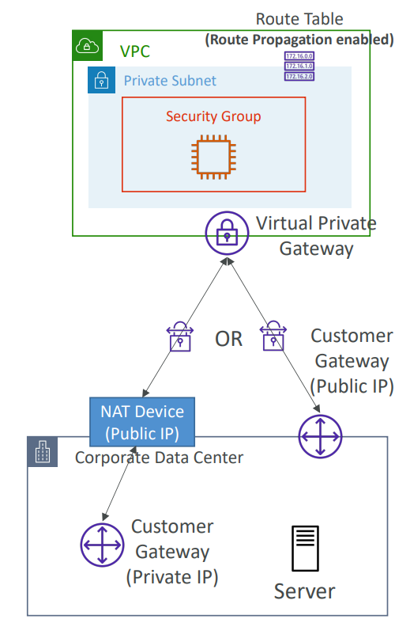

1. Connect on-premises network into AWS and have a private network established over the Internet
2. Virtual Private Gateway is deployed on AWS side
3. Customer Gateway is deployed on the customer side
4. When you have these two components, you can then establish an encrypted VPN connection over the Internet
5. Requires two things
   1. Virtual Private Gateway
      1. VPN on AWS side
   2. Customer Private Gateway
      1. VPN on customer side
      2. What IP to use?
         1. If your customer gateway is public, enable connection between Virtual Private Gateway and Customer Gateway using Public IP
         2. If your customer gateway is private, there should be NAT device and IP address to be used is Public IP of NAT device
6. If you need to ping your EC2 instances from on-premises, make sure you add the ICMP protocol on the inbound of your security groups

## AWS VPN CloudHub

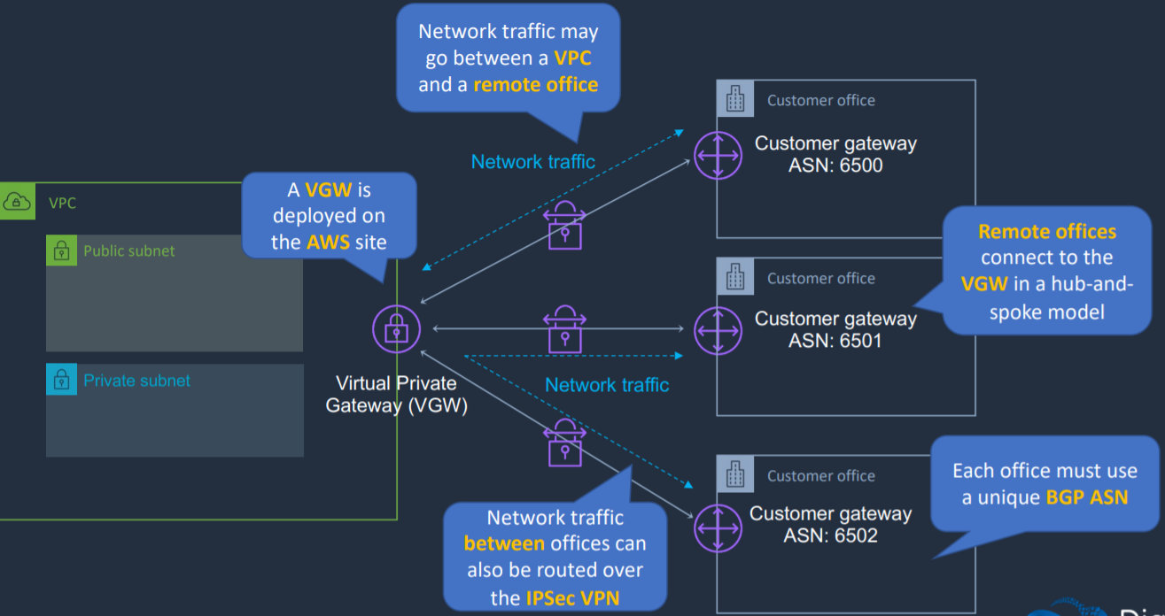

1. Connecting multiple customer gateways to a single virtual private gateway so that customer data center can communicate with AWS and also with other customer data center
2. Hub-and-spoke model
3. Low cost, easy to manage
4. It operates over the public internet, but all traffic between the customer gateway and the AWS VPN CloudHub is encrypted

## Direct Connect (DX)

### Introduction

1. Private connectivity between AWS and your data center
2. Establish private connection
3. Physical fiber connection is established running at either 1 or 10 GB per second
4. Speeds from 50Mbps to 500Mbps can also be accessed via an APN partner
5. 100 Gbps is now featuring in selected locations
6. Benefits
   1. Low latency
   2. High bandwidth/throughput
   3. Lower costs for organizations that transfer large volumes of data
   4. Supports BGP peering and routing
7. Takes time to provision
8. DX connections are not encrypted
9. We can use IPsec s2s VPN connection over this connection to add encryption in transit
10. It takes more than 1 month to establish connection using Direct Connect

### Direct Connect – Connection Types

1. Dedicated Connections
   1. 1 Gbps and 10 Gbps capacity
   2. Physical ethernet port dedicated to a customer
   3. Request made to AWS first, then completed by AWS Direct Connect Partners
2. Hosted Connections
   1. 50 Mbps, 500 Mbps to 10 Gbps
   2. Capacity can be added or removed on demand
   3. 1, 2, 5, 10 Gbps available at select AWS Direct Connect Partners

### Direct Connect – Encryption

1. When we use direct connect, it is private and data in transit is not encrypted
2. If we want encryption on top of Direct Connect, we can use AWS Direct Connect + VPN which provides an IPsec-encrypted private connection
3. Good for an extra level of security

### Direct Connect – Resiliency

1. High Resiliency for Critical Workloads

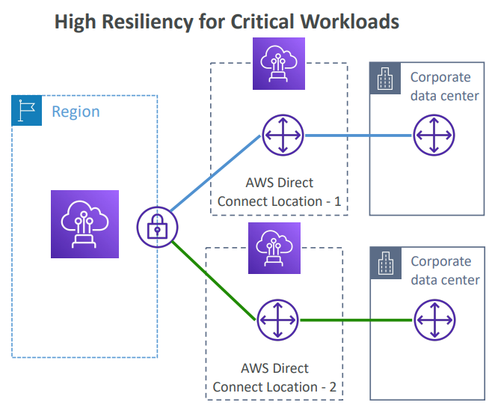

* 1. One connection at multiple locations

1. Maximum Resiliency for Critical Workloads

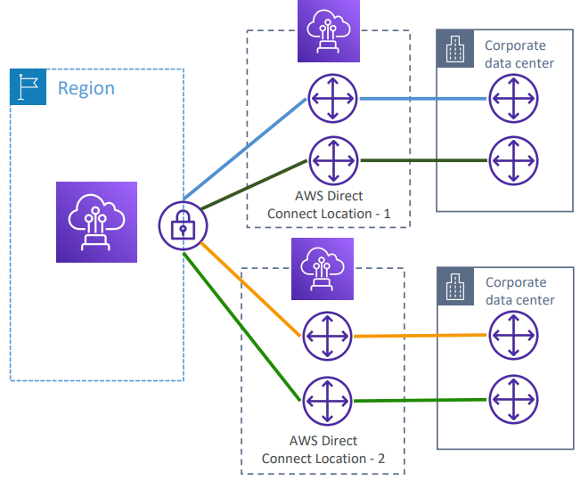

* 1. Maximum resiliency is achieved by separate connections terminating on separate devices in more than one location

## Direct Connect Gateway

### Introduction

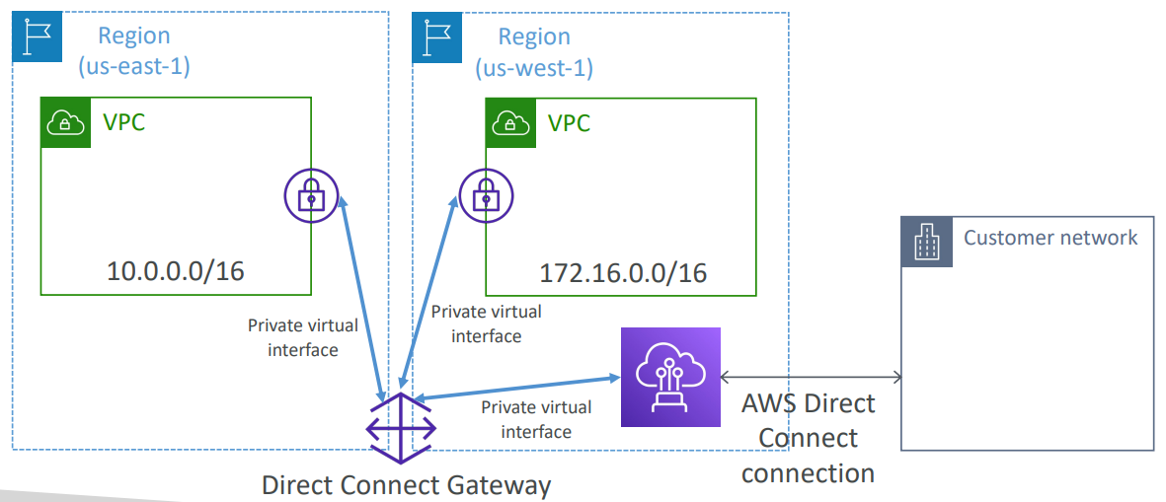

1. If you want to setup a Direct Connect between on-premises network and one or more VPC in many different regions (same account), you must use a Direct Connect Gateway

### Without and With Direct Connect Gateway

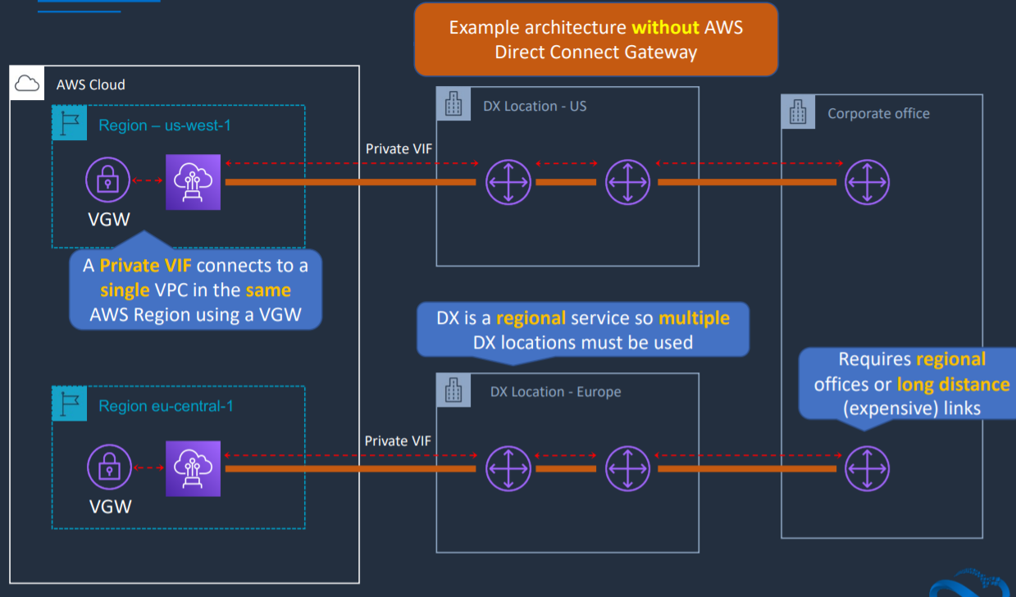

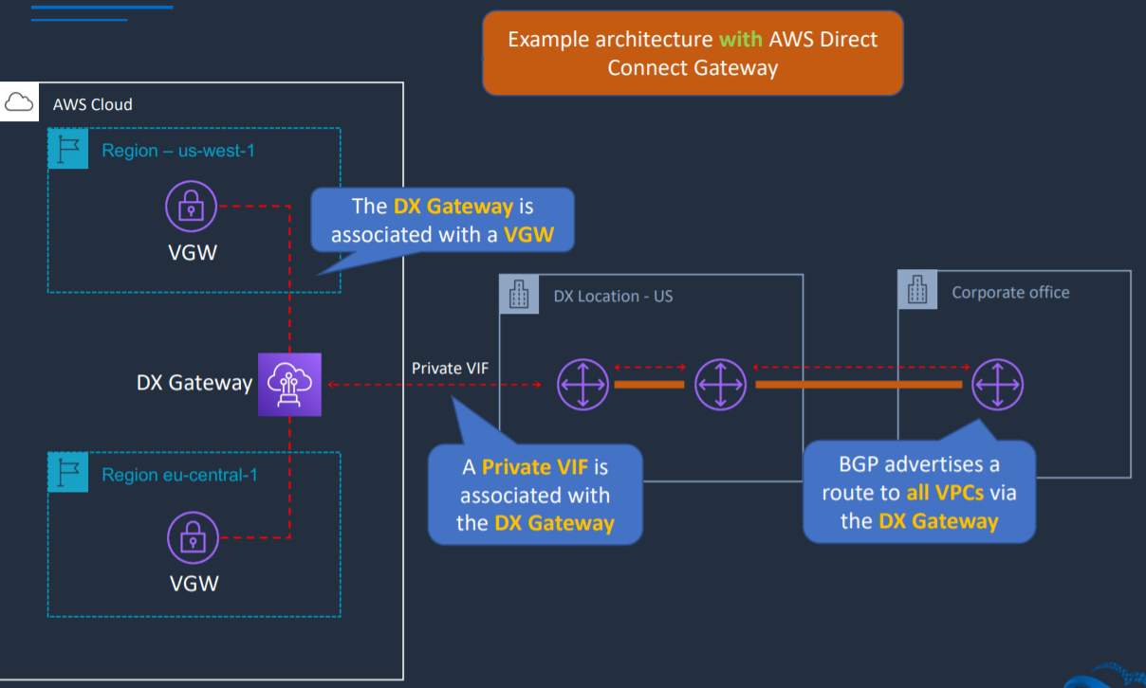

## AWS PrivateLink (VPC Endpoint Services)

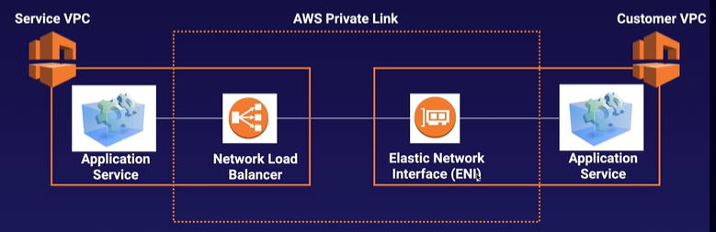

1. Way of sharing your applications within your own VPC to multiple VPCs
2. Best way to expose a service VPC to tens, hundreds, or thousands of customer VPCs
3. Does not requires VPC peering; no route tables, NAT, IGWs, etc.
4. Requires a Network Load Balancer on the service VPC and an ENI on the customer VPC
5. If the NLB is in multiple AZ, and the ENI is in multiple AZ, the solution is fault tolerant

## Transit Gateway

### Introduction

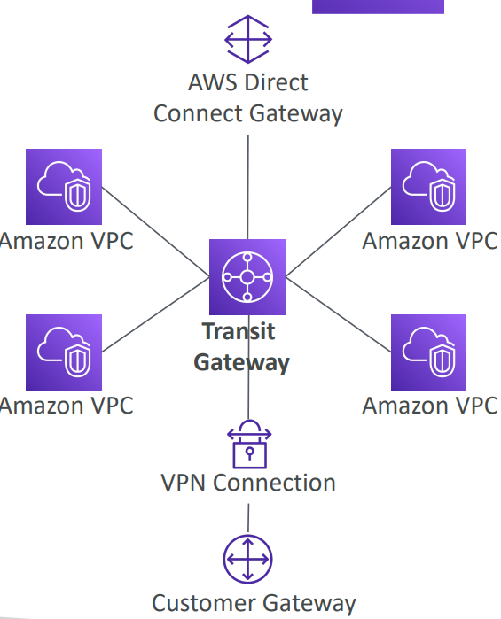

1. Hub-and-spoke (Star) connection for having transitive peering between thousands of VPC and on-premises
2. Works with Direct Connect, VPN Connections
3. Can work cross-region/ cross-account
4. Supports IP Multicast (it is the only service in AWS that supports IP Multicast)

### Transit Gateway – Share Direct Connect between multiple accounts

1. Another usecase of Transit Gateway is to share direct connect connections between multiple accounts
2. You can use AWS Resource Manager to share Transit Gateway with other accounts

### Transit Gateway - Site-to-Site VPN ECMP

1. Another usecase of Transit Gateway is to increase bandwidth of your multiple Site-to-Site VPN Connection using ECMP
2. Equal-cost Multi-path routing
3. Routing strategy to allow to forward a packet over multiple best path
4. If you do VPN to Virtual Private Gateway
   1. You will get one connection into one VPC
   2. This connection will give 1.25 Gbps as maximum throughput
   3. In this case VPN connections are made up of 2 tunnels
5. But, if you are using VPN into Transit Gateway
   1. You will get one site to site VPN into many VPC
   2. 1 connection gives 2.5 Gbps of throughput using ECMP (2 tunnels)
   3. 2 connections give 5 Gbps of throughout
   4. 3 connections give 7.5 Gbps of throughput

## VPC – Traffic Mirroring

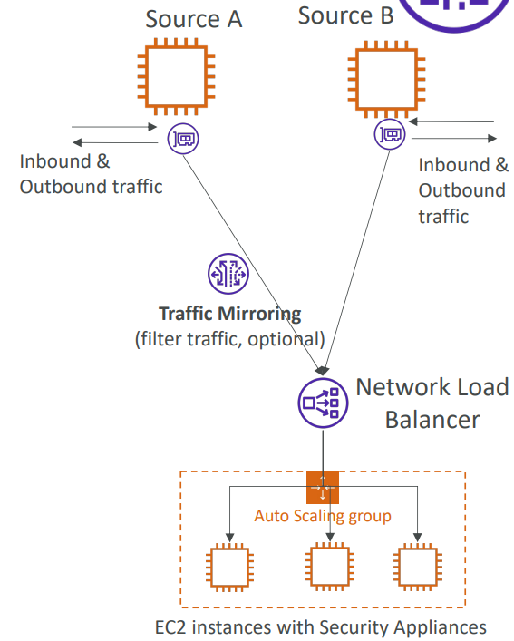

1. VPC Traffic Mirroring is an AWS feature used to copy network traffic from the elastic network interface of an EC2 instance to a target for analysis.
2. This is used in network security, network performance monitoring, customer experience management, and network troubleshooting.
3. Capture all packets or capture the packets of your interest using filtering
4. Source and Target can be in the same VPC or different VPCs (VPC peering)

# IPv6

## Introduction

1. IPv6 is the successor of IPv4
2. IPv6 is designed to provide 3.4x10^38 unique IP addresses
3. Every IPv6 address is public and Internet- routable (no private range)
4. Format-> x:x:x:x:x:x:x:x (x is hexadecimal range and can be from 0000 to ffff)
5. Examples
   1. 2001:db8:3333:4444:5555:6666:7777:8888
   2. :: -> all 8 segments are zero
   3. 2001:db8:: -> last 6 segments are zero
   4. ::1234:5678 -> first 6 segments are zero
   5. 2001:db8::1234:5678 -> the middle 4 segments are zero

## IPv6 in VPC

1. IPv4 cannot be disabled for your VPC and subnets
2. You can enable IPv6 (they are public IP addresses) to operate in dual-stack mode
3. Your EC2 instances will get at least a private internal IPv4 and a public IPv6

## IPv6 Troubleshooting

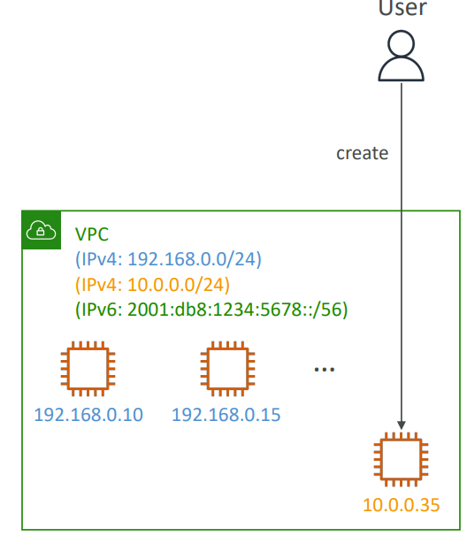

1. IPv4 cannot be disabled for your VPC and subnets
2. So, if you cannot launch an EC2 instance in your subnet
   1. It is not because it cannot acquire an IPv6 (the space is very high)
   2. It is because there are no available IPv4 in your subnet
3. Solution
   1. Create a new IPv4 CIDR in your subnet

# Costs in AWS

## Networking Costs

1. Any traffic going into your EC2 instance is free (Any incoming traffic into EC2 is free)
2. Any traffic between two instances will be free assuming that they are using Private IP to communicate (instances in same AZ)
3. If two instances in different AZ in same region need to communicate with each other using Private IP, cost is $0.01 per GB
4. If two instances in different AZ in same region need to communicate with each other using Public IP/ Elastic IP, cost is $0.02 per GB
5. If two instances in different region need to communicate with each other, cost is $0.02 per GB

Takeaway

1. Use private IP instead of Public IP for good savings and better network performance
2. If there are instances that need to communicate much with each other, use same AZ for maximum savings

## Minimizing egress traffic network cost

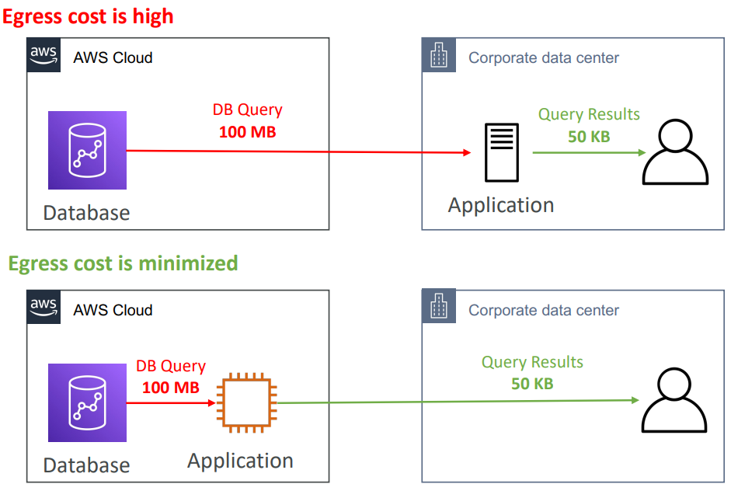

1. Egress traffic: outbound traffic from AWS to outside
2. Ingress traffic: inbound traffic- from outside to AWS (typically free)
3. Try to keep as much internet traffic within AWS to minimize costs
4. Direct Connect location that are co-located in the same AWS Region result in lower cost for egress network

## S3 Data Transfer Pricing – Analysis for USA

1. S3 ingress (upload): free
2. S3 to Internet (download): $0.09 per GB
3. S3 Transfer Acceleration
   1. Faster transfer times (50 to 500% better)
   2. Additional cost on top of Data Transfer Pricing +$0.04 to $0.08 per GB
4. S3 to CloudFront: any data transfer between S3 and CloudFront is free
5. CloudFront to Internet: $0.085 per GB
6. S3 Cross Region Replication: $0.02 per GB

## Pricing NAT Gateway vs Gateway VPC Endpoint

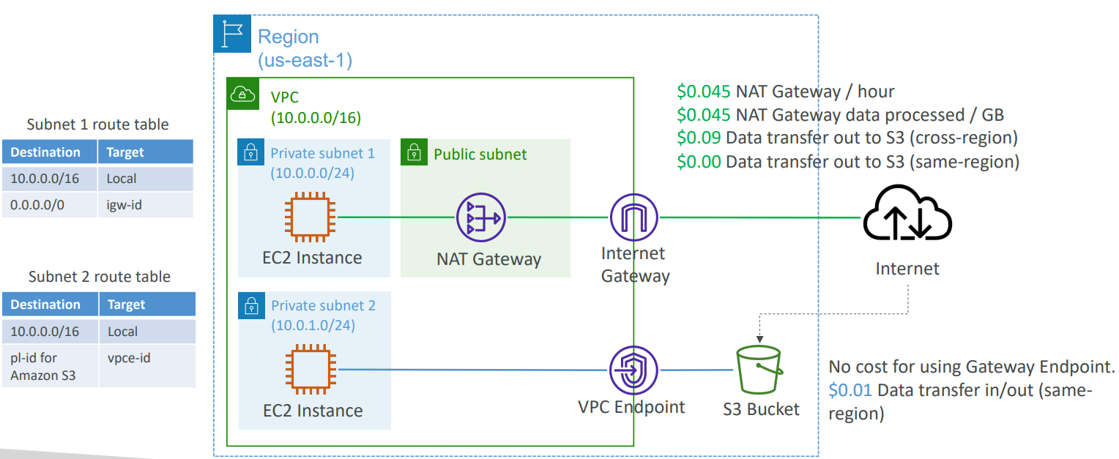

1. NAT Gateway
   1. $0.045 NAT Gateway/hour
   2. $0.045 NAT Gateway data processed/GB
   3. $0.09 data transfer out to S3 (cross-region)
   4. $0.00 data transfer out to S3 (same-region)
2. Gateway VPC Endpoint
   1. No cost for using Gateway Endpoint
   2. $0.01 data transfer in/out (same region)

# Disaster Recovery

## Introduction

1. Disaster Recovery (DR) is about preparing for and recovering from a disaster
2. Kinds of disaster recovery
   1. On-premises -> On-premises (traditional, expensive)
   2. On-premises -> AWS Cloud (hybrid recovery)
   3. AWS Cloud Region A -> AWS Cloud Region B

## RPO and RTO

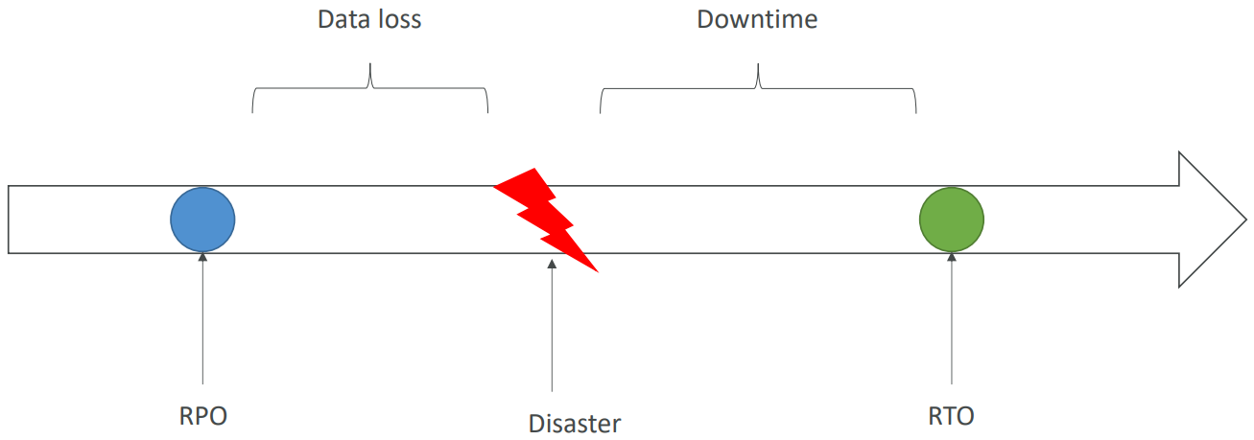

RPO (Recovery Point Objective): How much of a data loss are you willing to accept in case of a disaster happens

RTO (Recovery Time Objective): Between the disaster and RTO, is application down time

## Disaster Recovery Strategies

1. Backup and Restore
2. Pilot Light
3. Warm Standby
4. Hot Site / Multi Site Approach

### Backup and Restore

1. Has high RTO
2. Cheap way to do backup and restore

### Pilot Light

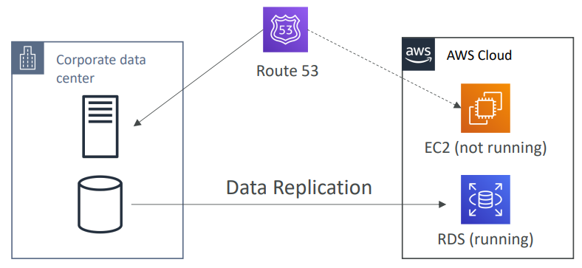

1. A small version of the app is always running in the cloud
2. Useful for critical core (pilot light)
3. Faster than Backup and Restore as critical systems are already up
4. Low RTO

### Warm standby

1. Full system is up and running but at minimum size
2. Upon disaster, we can scale to production load
3. Low RTO

### Multi-Site/ Hot Site Approach

1. Very low RTO (minutes or seconds)
2. Very expensive
3. Full production scale is running AWS and On Premise

## Disaster Recovery Tips

1. Backup
   1. EBS Snapshots, RDS automated backups/snapshots, etc
   2. Regular pushes to S3/S3 IA/ Glacier, Lifecycle Policy, CRR
   3. From on-premises: Snowball or Storage Gateway
2. High Availability
   1. Use Route 53 to migrate DNS over from Region to Region
   2. RDS Multi-AZ, ElastiCache Multi-AZ, EFS, S3
   3. Site to Site VON as a recovery from Direct Connect
3. Replication
   1. RDS Replication (Cross Region), AWS Aurora + Global Databases
   2. Database replication from on-premises to RDS
   3. Storage Gateway
4. Automation
   1. CloudFormation/ Elastic Beanstalk to re-create a whole new environment
   2. Recover/Reboot EC2 instances with CloudWatch if alarms fail
   3. AWS lambda functions for customized automations
5. Chaos testing
   1. Create disaster on their own by randomly terminating EC2 to make sure that their infrastructure is capable to survive failures
   2. Netflix has a “simian-army” randomly terminating EC2

# Migration Services

## Database Migration Service (DMS)

### Introduction

1. Migrate database from on-premises to AWS
2. Supports
   1. Homogenous migrations: Oracle to Oracle
   2. Heterogenous migrations: SQL to Aurora
3. Supports Continuous Data Replication using CDC (Change Data Capture)
4. To use DMS, you need to create an EC2 instance and that EC2 instance will perform replication task for you
5. AWS DMS creates the tables and associated primary keys if they don’t exist on the target. You can pre-create the target tables manually, or you can use AWS Schema Conversion Tool (SCT) to create some or all of the target tables, indexes, views, triggers, etc.
6. DMS Source and Target
   1. Source
      1. On-premises and EC2 instances databases: Oracle, MS SQL Server, MySQL, MariaDB, PostgreSQL, MongoDB, SAP, DB2
      2. Azure: Azure SQL Database
      3. Amazon RDS: all including Aurora
      4. Amazon S3
   2. Targets
      1. On-premises and EC2 instances databases: Oracle, MS SQL Server, MySQL, MariaDB, PostgreSQL, SAP
      2. Amazon RDS
      3. Amazon Redshift
      4. Amazon DynamoDB
      5. Amazon S3
      6. ElasticSearch Service
      7. Kinesis Data Streams
      8. DocumentDB

### AWS Schema Conversion Tool (SCT)

1. Used when source and destination schema do not have same engine
2. Converts database schema from one engine to another
   1. Oracle -> PostgreSQL
3. You do not need to use SCT if you are migrating the same DB engine
   1. On-premises PostgreSQL -> RDS PostgreSQL does not require SCT

### Data Migration – Continuous Replication

1. DMS Replication Instance will do the full load and change data capture (CDC) to have continuous replication

## Server Migration Service

1. AWS Server Migration Service (SMS) is used for incremental replication of on-premises live servers to AWS.

## Application Discovery Service

1. Helps you to plan migration projects to AWS Cloud
2. Works with other services to migrate servers

## Migration hub

AWS Migration Hub can be used to track status of migration.

## AWS DataSync

1. It is used to move large amount of data from on-premises to AWS
2. Can synchronize to Amazon S3 (any storage classes- including Glacier), Amazon EFS, Amazon FSx for Windows
3. The actual migration of data is scheduled and automated
4. Replication tasks can be scheduled hourly, daily, weekly (not continuous)
5. Leverage DataSync Agent to connect to your systems
6. Can setup a bandwidth limit in case you need to have limitations and not use all Internet connection when DataSync is running
7. Destinations can be
   1. Amazon Simple Storage Service (S3)
   2. Amazon FSx for Windows File Server
   3. Amazon Elastic File System
8. Use case
   1. Move data from on-premises to AWS
   2. Move data from EFS to EFS in cloud
9. Data is encrypted in transit with TLS
10. Can improve performance for data transfers up to 10x faster than traditional tooling

## AWS Backup

1. Fully managed service
2. Centrally manage and automate backups across AWS services
3. Supported services
   1. Amazon EC2
   2. Amazon EBS
   3. Amazon EFS
   4. Amazon FSx
   5. Amazon RDS (All DBs engine)
   6. Amazon Aurora
   7. Amazon DynamoDB
   8. AWS Storage Gateway (Volume Gateway)
4. Supports cross-region backups
5. Supports cross-account backups
6. Supports PITR for supported services
7. On-demand and Scheduled backups
8. Tag-based backup policies
9. You create backup policies known as Backup Policies
   1. Backup Frequency (every 12 hours, daily, weekly, monthly, cron expression)
   2. Backup window
   3. Transition to Cold Storage (Never, Days, Weeks, Months, Years)
   4. Retention Period (Always, Days, Weeks, Months, Years)

# Other Services

## Technology Stack for CICD

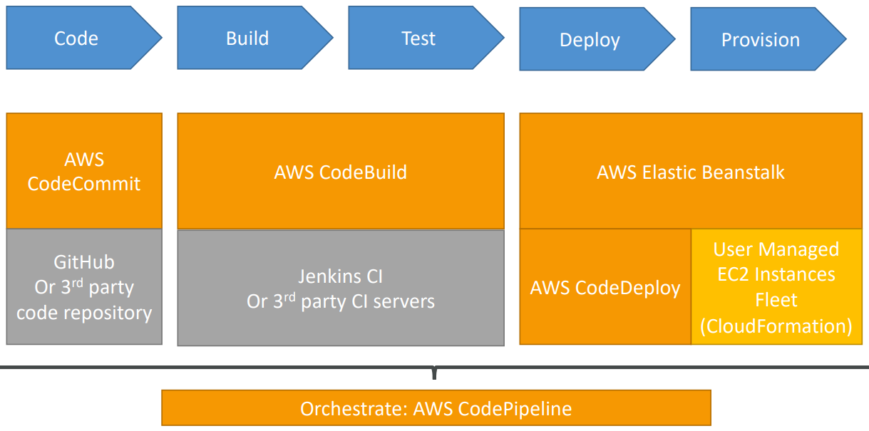

## CloudFormation

### Introduction

1. Infrastructure as Code
2. JSON or YAML
3. Benefits
   1. Infrastructure as code
      1. No need to create resources manually
      2. Code can be version controlled by using Git
      3. Changes to infrastructure are reviewed through code
   2. Cost
      1. Each resource within the stack is tagged with an identifier so you can easily see how much a stack cost you
      2. You can estimate the costs of your resources using the CloudFormation template
      3. Saving strategies: In Dev you could automate deletion of templates at 5 PM and recreated at 8 AM, safely
   3. Productivity
      1. Ability to destroy and re-create an infrastructure on the cloud on the fly
      2. Automated generation of Diagram for your templates
      3. Declarative programming (no need to figure out ordering and orchestration)
   4. Separation of concern
      1. Create many stacks for many apps
4. How CloudFormation works?
   1. Templates have to be uploaded in S3 and then referenced in CloudFormation
   2. To update a template, we cannot edit previous ones. We have to upload a new version of the template to AWS
   3. Stacks are identified by a name
   4. Deleting a stack deletes every single artifact that was created by CloudFormation

### Benefits

1. Infrastructure is provisioned consistently, with fewer mistakes
2. Less time and effort than configuring resources manually
3. You can use version control and peer review for your CloudFormation templates
4. Free to use (you are only charged for the resources provisioned)
5. Can be used to manage updates and dependencies
6. Can be used to rollback and delete the entire stack as well

### Deploying CloudFormation templates

1. Manual way
   1. Editing templates in the CloudFormation Designer
   2. Using the console to input parameters, etc
2. Automated way
   1. Editing templates in a YAML file
   2. Using the AWS CLI to deploy templates
   3. Recommended way when you fully want to automate your flow

### CloudFormation Building Blocks

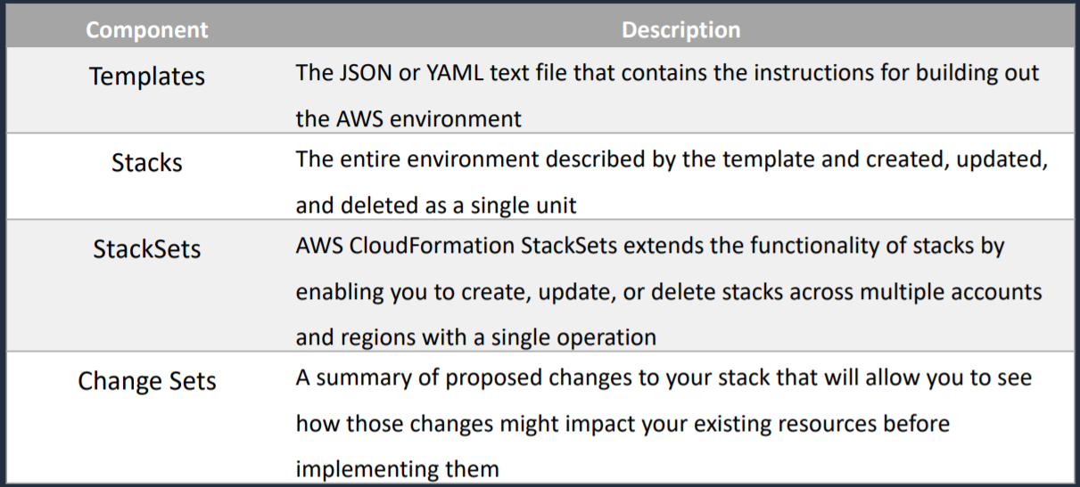

## QuickStart

1. Quick Start is a bunch of CloudFormation templates already built by AWS Solutions Architects allowing you to create complex environments very quickly

## AWS Step Functions

1. Serverless
2. AWS Step Functions is used to build distributed applications as a series of steps in a visual workflow
3. Represent flow as a JSON state machine
4. Features: sequence, parallel, conditions, timeouts, error handling
5. Maximum execution time of 1 year
6. How it works
   1. Define the step of your workflow in the JSON based Amazon State Language. The visual console automatically graphs each step in the order of execution
   2. Start an execution to visualize and verify the steps of your application are operating as intended. The console highlights the real-time status of each step and provides a detailed history of every execution.
   3. AWS Step Functions operates and scales the steps of your application and underlying compute for you to help ensure your application executes reliably under increasing demand

## AWS SWF (Simple Workflow Service)

1. Not serverless
2. Code runs on EC2 (not serverless)
3. 1-year max runtime
4. Concept of “activity step” and “decision step”
5. Has built-in “human intervention” step
6. Example
   1. Order fulfillment from web to warehouse to delivery
7. Step functions is recommended to be used for new applications, except
   1. If you need external signals to intervene in the processes
   2. If you need child processes that return values to parent processes
8. Ensures that a task is assigned only once and is never duplicated
9. SWF Actors
   1. Workflow Starters
      1. An application that can initiate (start) a workflow.
   2. Deciders
      1. Controls the flow of activity tasks in a workflow execution
      2. If something has finished (or failed) in a workflow, a decider decides what to do next.
   3. Activity Workers
      1. Carry out activity tasks

## EMR (Elastic Map Reduce)

1. Helps creating Hadoop clusters (Big Data) to analyze and process vast amount of data
2. The clusters can be made of hundreds of EC2 instances
3. Also supports Apache Spark, HBase, Presto, Flink

## AWS OpsWorks

1. Allows you to use Chef or Puppet to automate configuration of your servers and deploy code on-premises or the cloud
2. Automate software configurations and infrastructure management for your application
3. Can deploy applications on-premises
4. OpsWorks has three offerings, [AWS OpsWorks for Chef Automate](https://aws.amazon.com/opsworks/chefautomate/), [AWS OpsWorks for Puppet Enterprise](https://aws.amazon.com/opsworks/puppetenterprise/), and [AWS OpsWorks Stacks](https://aws.amazon.com/opsworks/stacks/)
5. It is an alternative to AWS SSM
6. Use case
   1. Automate software configurations and infrastructure management for your application

## AWS Workspaces

1. Managed, secure Cloud desktop
2. Great to eliminate management of on-premises VDI (Virtual Desktop Infrastructure)
3. On demand, pay per by usage
4. It is secure, encrypted, network isolated
5. Integrated with Microsoft Active Directory

## AppSync

1. Store and sync data across mobile and web applications in real-time
2. Makes use of GraphQL
3. Offline data synchronizations (replaces Cognito Sync)

## Cost Explorer

1. Allows you to visualize and forecast cost and usage over time
2. View past 12 months
3. Forecast upto 3 months
4. Choose an optimal Savings Plan (to lower prices on your bill)

## Elastic Transcoder

1. Convert media files form their original source format into different formats that will play on smartphones, tablets, PCs, etc.
2. Pay based on minutes that you transcode and the resolution at which you transcode

# Well Architectured Framework

## General Guiding Principles

1. Stop guessing your capacity needs
2. Test systems at production scale
3. Automate to make architectural experimentation easier
4. Allow for evolutionary architectures
5. Drive architectures using data
6. Improve through game days – simulate massive amount of traffic and see if your architecture does hold ground

## 5 pillars of Well Architectured Framework

1. Operational Excellence
2. Security
3. Reliability
4. Performance Efficiency
5. Cost Optimization

### Operational Excellence

1. Ability to run and monitor systems to deliver business values and to continually improve supporting processes and procedures
2. Design Principles
   1. Perform Operation as code
   2. Anticipate failure
   3. Learn from failure
   4. Make small, reversible changes
   5. Annotate documentation
   6. Refine operations procedures frequently
3. AWS Services
   1. Prepare-CloudFormation, Config
   2. Operate- CloudFormation, Config, CloudTrail, CloudWatch, X-Ray
   3. Evolve- CloudFormation, CodeBuild, CodeCommit, CodeDeploy, CodePipeline

### Security

1. Protect information
2. Principles
   1. Implement a strong identity foundation
   2. Enable traceability
   3. Apply security at all layers
   4. Automate security best practices
   5. Protect data in transit and at rest
   6. Keep people away from data
   7. Prepare for security events
3. Services
   1. IAM- IAM, AWS-STS, MFA, Organizations
   2. Detective Controls- Config, CloudWatch, CloudTrail
   3. Infrastructure Protection- CloudFront, VPC, Shield, WAF, Inspector
   4. Data Protection- KMS, S3, ELB, EBS, RDS
   5. Incident Response- IAM, CloudFormation, CloudWatch Events

### Reliability

1. Recover from failure quickly
2. Design Principles
   1. Test recovery Procedures
   2. Automatically recover from failure
   3. Scale horizontally
   4. Stop guessing capacity
   5. Manage changes in automation
3. Services
   1. Foundations- IAM, VPC, Service limits, Trusted advisor
   2. Change Management- AutoScaling, CloudWatch, CloudTrail, Config
   3. Failure Management- Backup, CloudFormation, S3, S3 Glacier, Route 53

### Performance efficiency

1. Ability to use compute resources efficiently to meet system requirements and to maintain that efficiency as demand changes and technologies devices
2. Design Principles
   1. Democratize advance technologies- advance technologies become services and hence you can focus more on production development
   2. Go global in minutes
   3. Use serverless architectures
   4. Experiment more often
   5. Mechanical sympathy- be aware of all AWS Services
3. AWS Services
   1. Selection- AutoScaling, Lambda, EBS, S3, RDS
   2. Review- CloudFormation
   3. Monitoring- CloudWatch, Lambda
   4. Tradeoffs- RDS, ElastiCache, Snowball, CloudFront

### Cost optimization

1. At lowest price
2. Design principles
   1. Adopt a consumption model- pay only for what you use
   2. Measure overall efficiency- use CloudWatch
   3. Stop spending money on data center operations- AWS does organization part, focus on main goal
   4. Analyze and attribute expenditure- use tag, identify system usage and costs and attribute expenditure
   5. Use managed and application-level services to reduce cost of ownership
3. AWS Services
   1. Expenditure Awareness- Budget, Cost and Usage Report, Cost Explorer, RI Reporting
   2. Cost-Effective Resources- Spot instances, RI, S3 Glacier
   3. Matching supply and demand- Autoscaling, Lambda
   4. Optimizing Over time- Trusted Advisor, Cost and Usage Report

## AWS Well-Architectured Tool

1. Helps you review the state of your workloads and compares them to the latest AWS architectural best practices
2. we need to answer series of questions and it will generate report out of this

## Trusted Advisor

### Introduction

1. Provides real-time guidance to help you provision your resources following AWS best practices
2. Helps you to understand AWS best practices
3. Checks your account and makes recommendations
4. It has service limit dashboard that helps you monitor service limits (50 service limit checks)
5. Trusted Advisor scans your AWS infrastructure and compares is to AWS best practices in five categories:
   * Cost Optimization
   * Performance
   * Security
   * Fault Tolerance
   * Service Limits
6. 7 sets of trusted advisor checks (basic and developer plan)
   * S3 Bucket Permissions
   * Security Groups – Specific Ports Unrestricted
   * IAM Use
   * MFA on Root Account
   * EBS Public Snapshots
   * RDS Public Snapshot
7. Full Trusted Advisor – Available for Business and Enterprise support plans
   1. Ability to set CloudWatch alarms when reaching limits
   2. Programmatic Access using AWS Support API

### Trusted Advisor Checks Example

1. Cost optimization
   1. Low utilization EC2 instances
   2. Idle load balancers
   3. Under-utilized EBS volumes
   4. Reserved instances and savings plans optimizations
2. Performance
   1. High utilization EC2 instances, CloudFront, CDN Optimizations
   2. EC2 to EBS throughout optimizations
   3. Alias records recommendations
3. Security
   1. MFA enable on Root Account
   2. IAM key rotation
   3. S3 Bucket Permissions for Public access
   4. Security groups with unrestricted ports
4. Fault Tolerance
   1. EBS snapshots age
   2. Availability Zone Balance
   3. ASG Multi-AZ
   4. RDS Multi-AZ
   5. ELB Configuration
5. Service Limits

# On-premises Services with AWS

AWS services that you can use on-premises are

1. Database Migration Service (DMS)
2. Server Migration Service (SMS)
3. AWS Application Discovery Service
4. VM Import/Export
   1. Migrate existing applications in to EC2
   2. Can be used to create a DR strategy on AWS or use AWS as a second site
   3. You can also use it to export your AWS VMs to your on-premises data center
5. Download Amazon Linux 2 as an ISO
   1. AWS allows you to download Amazon Linux 2 as an ISO
   2. Works with all major virtualization providers, such as VMware, Hyper-V, KVM, VirtualBox (Oracle), etc

# Caching Strategies in AWS

1. Caching is a balancing act between up-to-date, accurate information and latency.
2. The following service have caching capabilities
   1. CloudFront
   2. API Gateway
   3. ElastiCache – Memcached and Redis
   4. DynamoDB Accelerator (DAX)

# Amazon Resource Name (ARN)

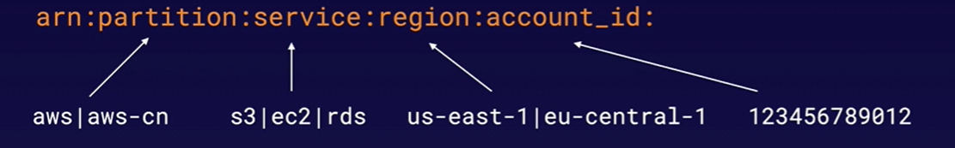

1. Helps you to uniquely identify each resource in AWS
2. All ARNs begin with
   1. arn:partition:service:region:account_id:
3. And end with
   1. Resource
   2. Resource_type/resource
   3. Resource_type/resource/qualifier
   4. Resource_type/resource:qualifier
   5. Resource_type:resource
   6. Resource_type:resource:qualifier
4. Example
   1. arn:aws:iam::123456789012:user/mark
   2. arn:aws:s3::my_awesome_bucket/image.png
   3. arn:aws::dynamodb:us-east-1:123456789012:table/orders
   4. arn:aws:ec2:us-east-1:123456789012:instance/*

# Dead Letter Queue (DLQ)

There are three different services in AWS that use dead letter queue

1. SNS: messages published to a topic that fail to deliver are sent to an SQS queue; held for further analysis or reprocessing
2. SQS: messages sent to SQS that exceed the queue’s maxReceiveCount are sent to a DLQ
3. Lambda: result from failed asynchronous invocations; will retry twice and send to either an SQS queue or SNS topic